**Problem Statement**

* People who want to create their own website should know any of the programming language which essential.
* But people with low profile background doesn’t have any knowledge on the programming languages, they cannot create the websites.
* Our projects will create an interface that helps anybody to create these websites without any knowledge on the programming languages.

**Abstract**

* Now a days developers plays an important role in digital marketing as they create or update the interface between the public and different individual firms.
* This interface is nothing but the website or an we application which consists of both frontend and backend development work, constructed by programming languages like HTML, CSS, JavaScript. Etc.

**Objectives**

* As we know there are many categories of websites based on the type of the field or the firm in an organization.
* For each model there was a template built-in, so that they can reduce the work.
* Inside the website we provide all the attributes which makes the website more reactive for the user.
* Users who have basic idea on programming to create the websites, for those people we embedded a search menu to search the attributes and make their website more reactive.

**Preview**

Website Home Page

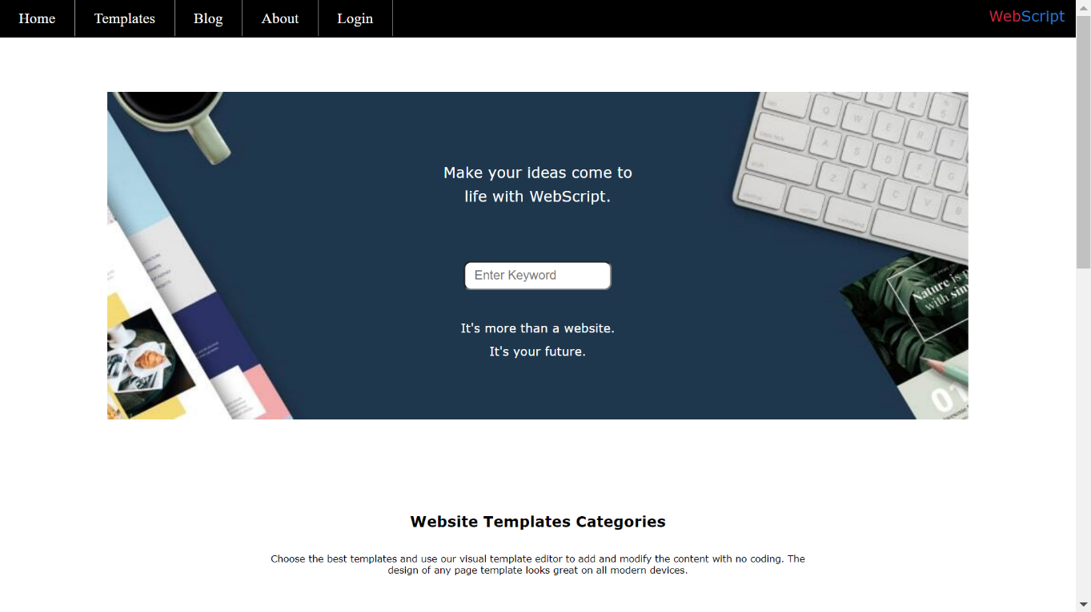

Website Templates

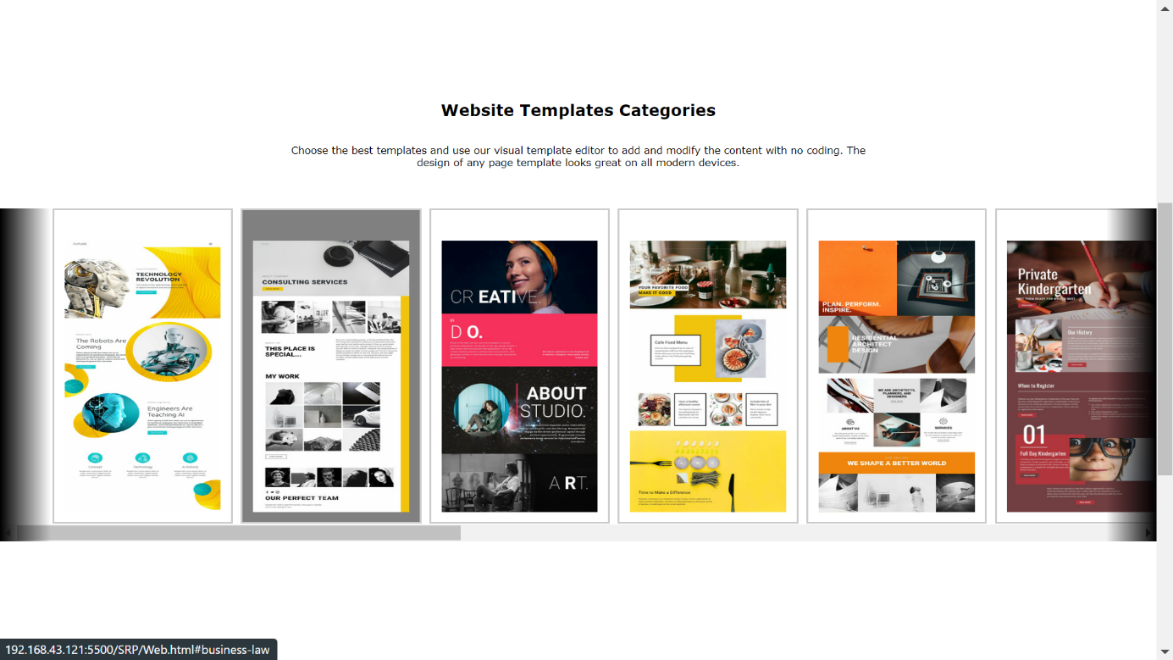

Blog Templates

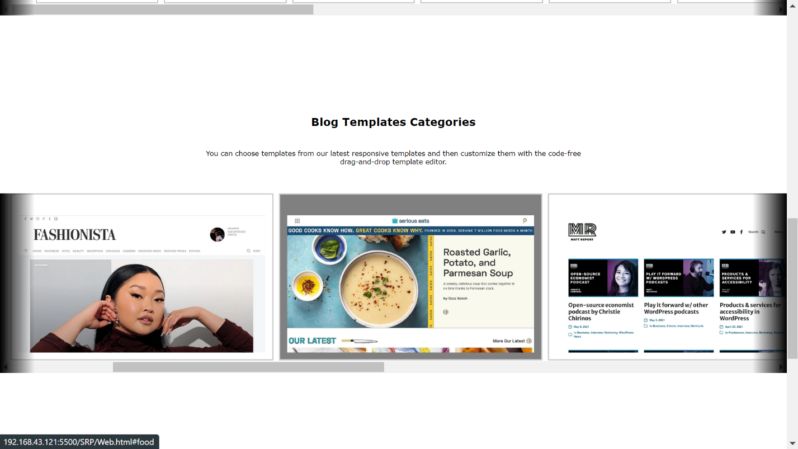

Options For Templates and Blog Categories

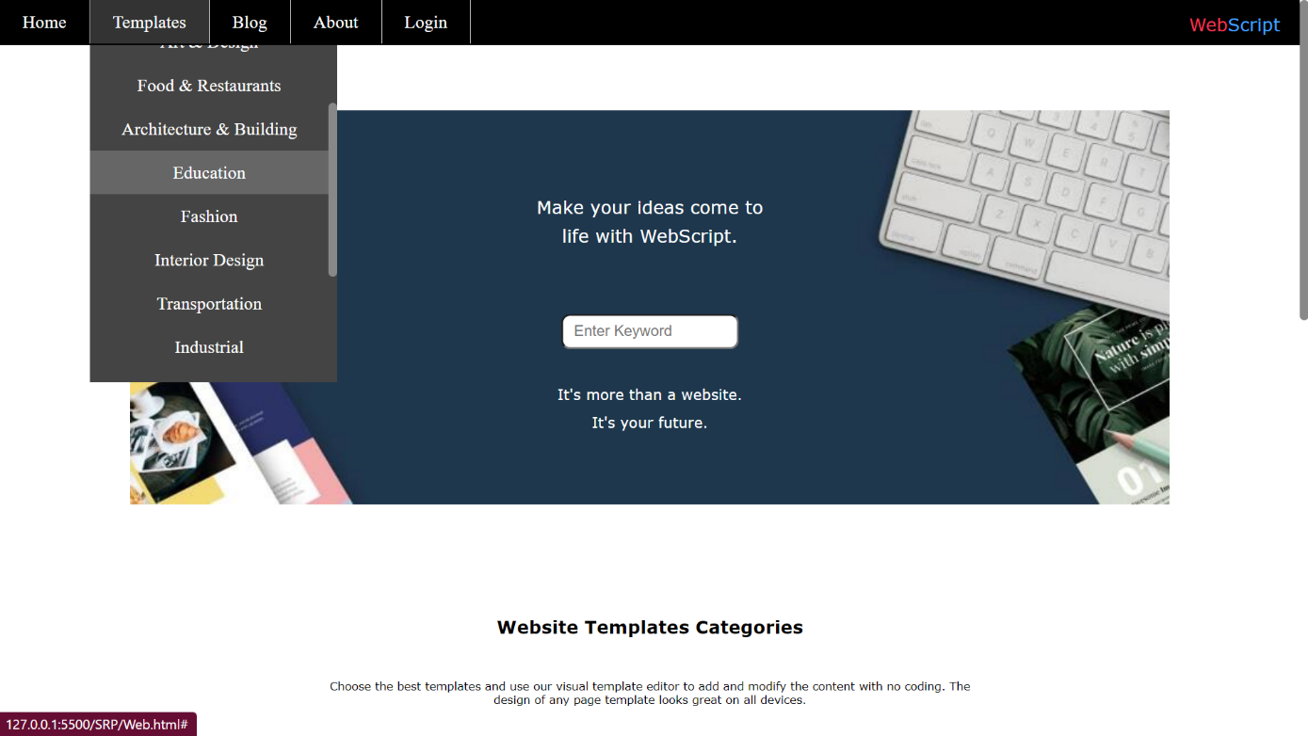 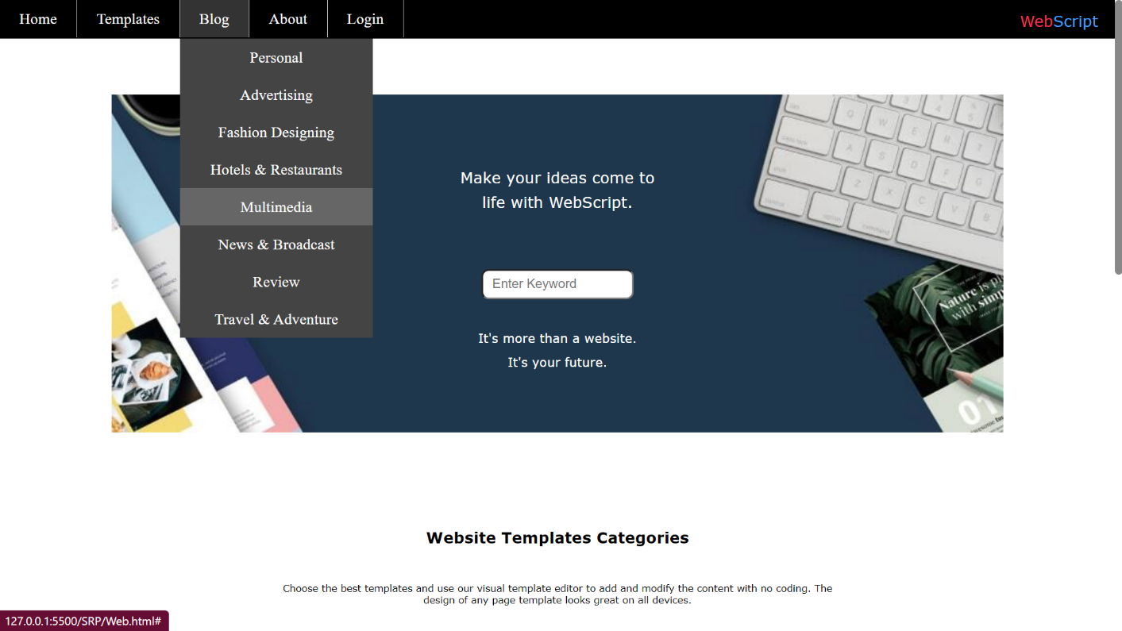

Signup Page

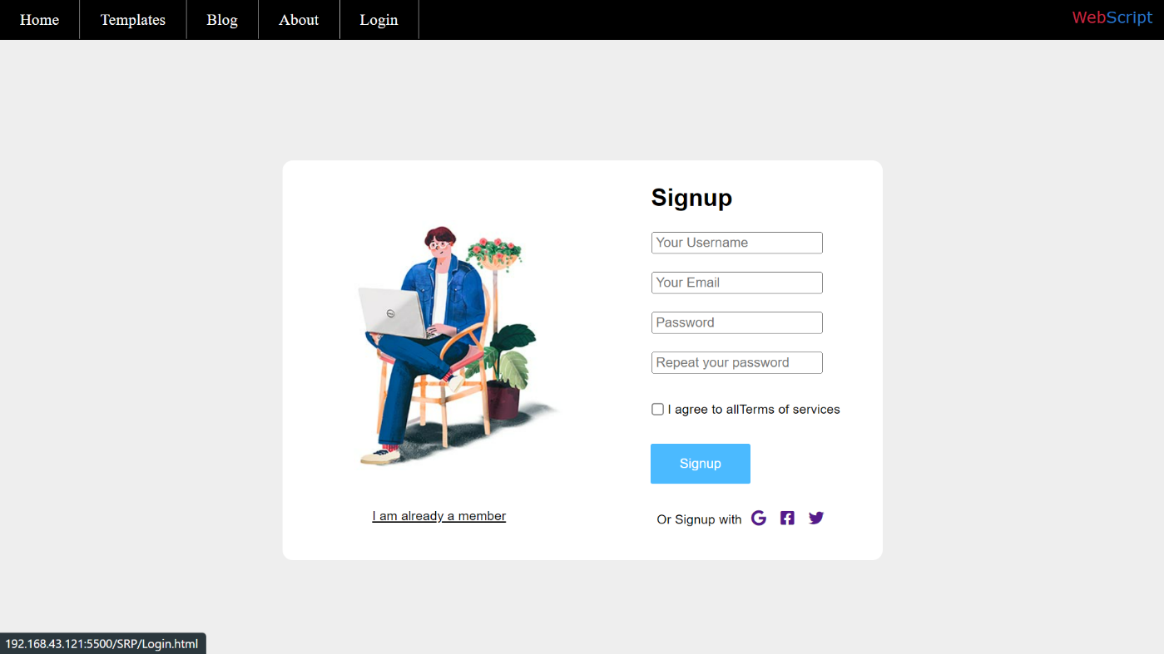

Login Page

