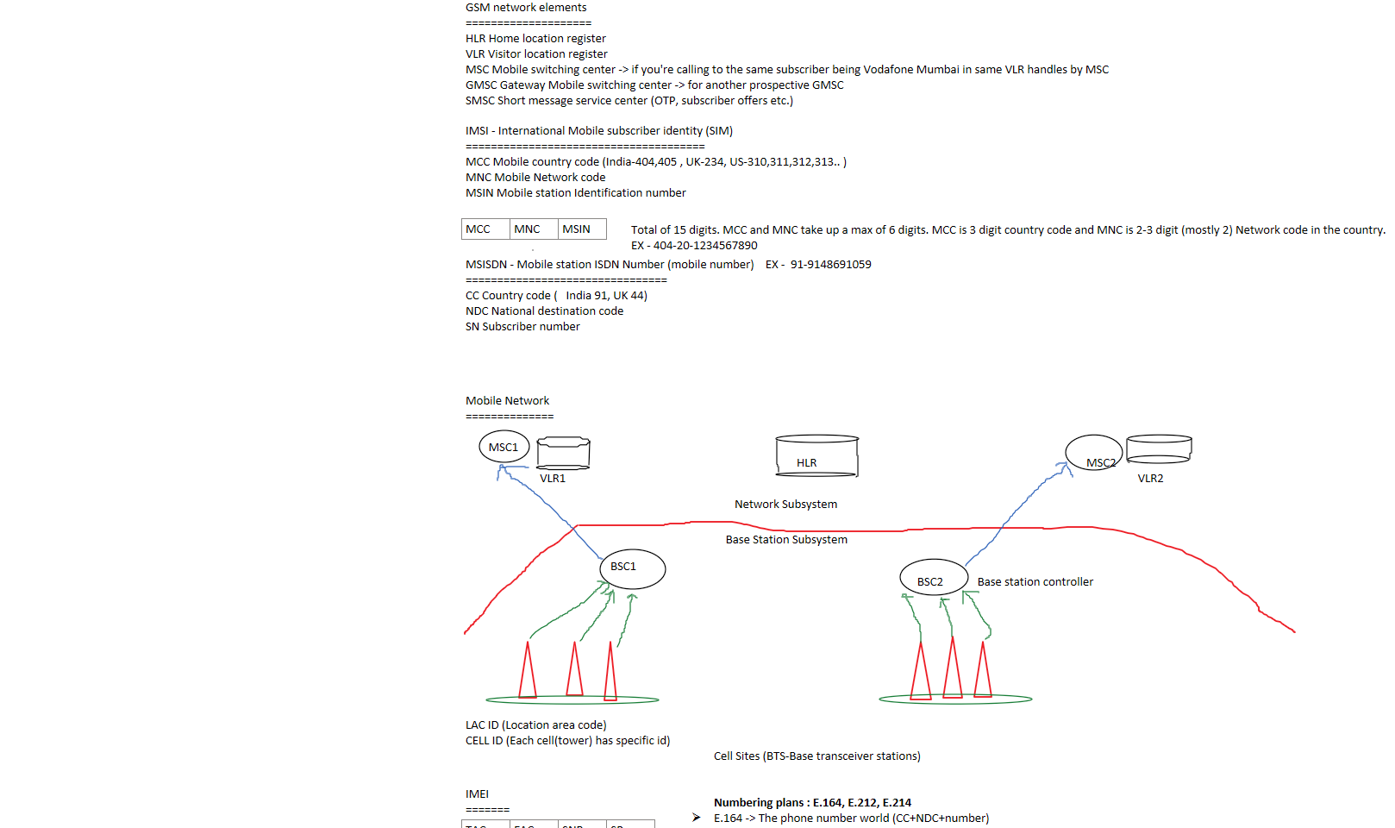  
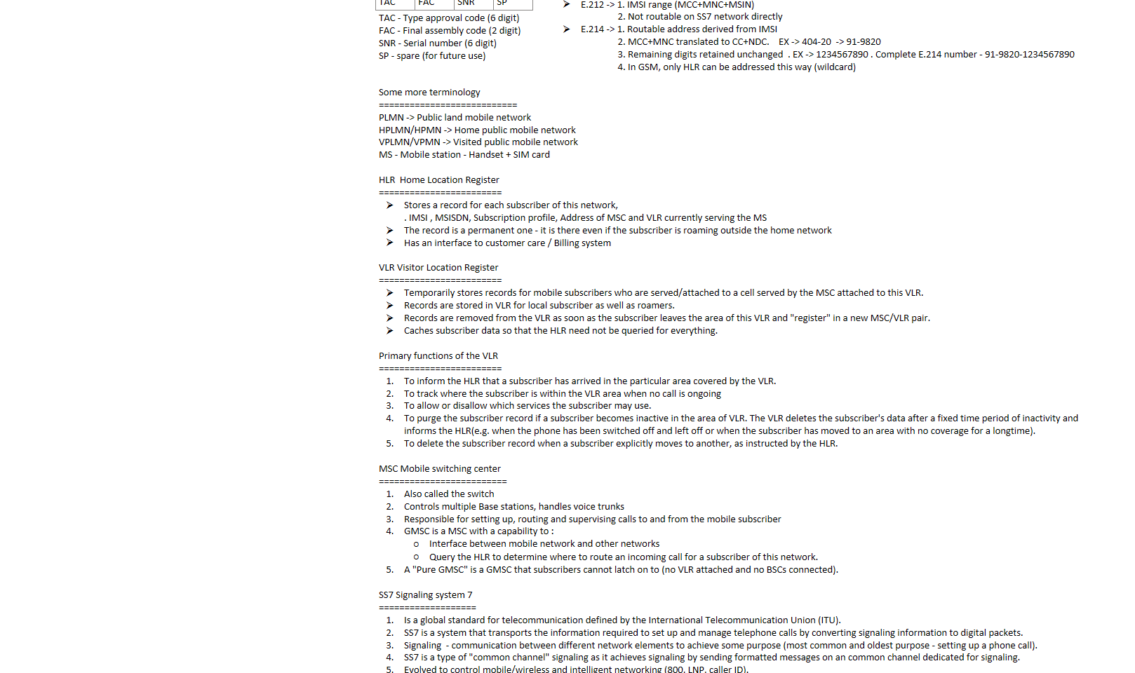  
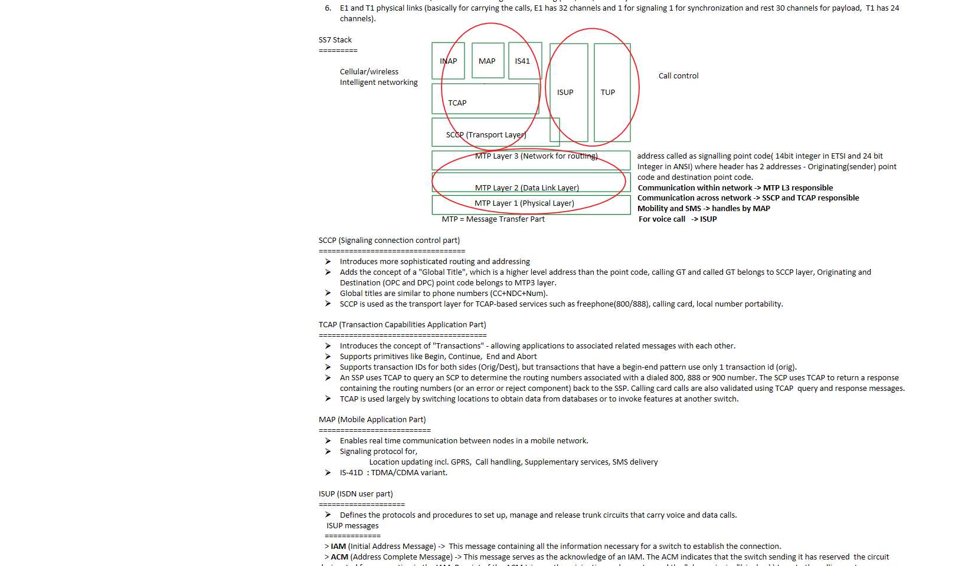  
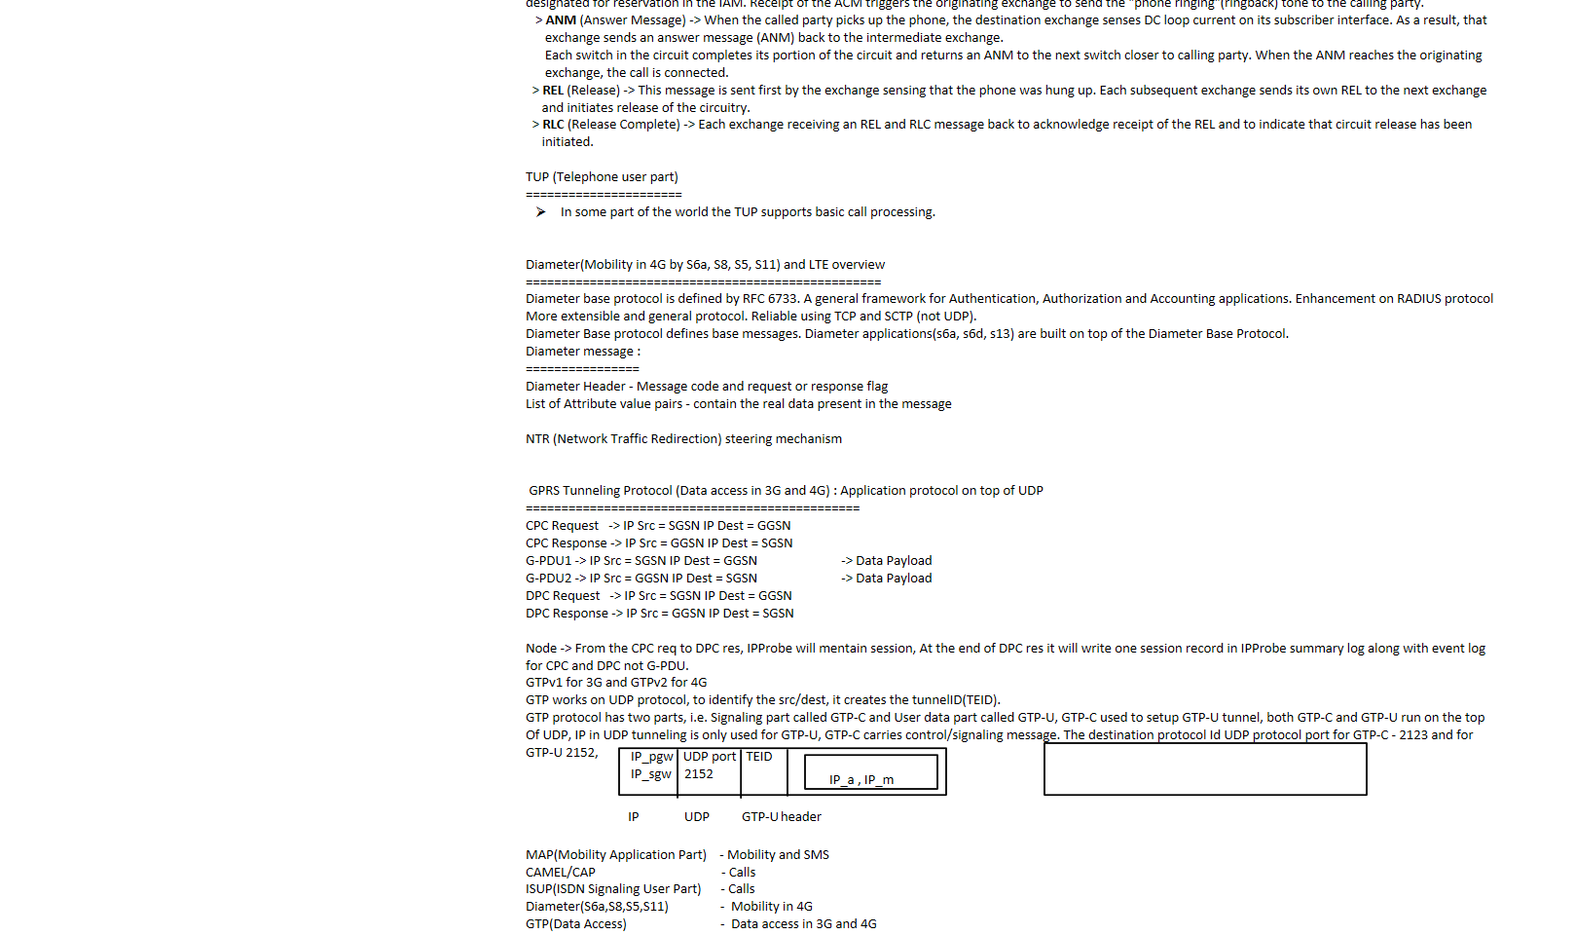  
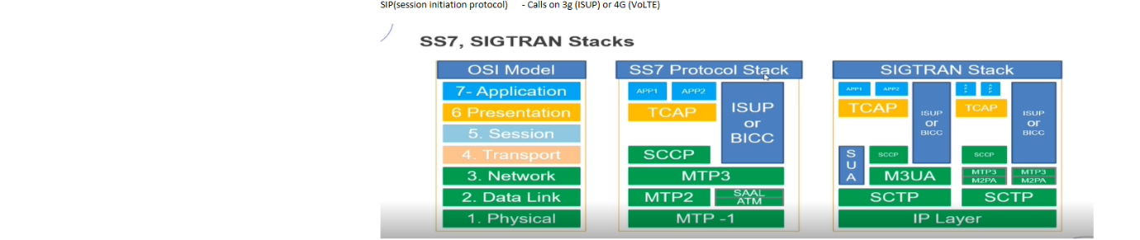

Home Network

Visited Network / Roaming Network

Host Network / Tenant Network

Partner Network

Roamer Type = Inbound + Outbound + Local

Host & partner network

====================

Consider a T-Mobile subscriber, who is travelling from US to India and get latched on Vodafone India network. So here the host network will T-Mobile and partner network will Vodafone India.

