DOES ENVIRONMENTAL-AWARENESS SHAPE PURCHASE DECISIONS FOR SECOND-HAND OR REFURBISHED SMARTPHONES?

Submitted by:
Group – 7

OBJECTIVE
The central question driving this research is straightforward but layeredwhy do people actually buy refurbished or second-hand smartphones? More specifically, does caring about the environment genuinely push someone toward buying a used phone or is it just something people say because it sounds good? To answer this, we set out with three clear objectives.
First, we wanted to understand how consumers perceive refurbished smartphones in terms of quality, reliability, and value and what motivates them to consider purchasing one. Second, we wanted to examine whether environmental concern and climate consciousness play a real role in shaping that purchase decision, or whether they remain at the level of attitude without influencing actual behaviour. Third, we wanted to cross-validate these findings across two very different data sources what students say in a structured survey versus what real buyers write in their own words on Amazon so that our conclusions were grounded in more than just one perspective. The primary question of the study remains:
“Does environmental-awareness shape purchase decisions for second-hand or refurbished smartphones”
And the secondary questions to answer this are:
- What is the consumer perception regarding the quality, reliability, and value of refurbished or second-hand smartphones.
- What role do environmental concern and sustainability awareness play in motivating consumers to purchase refurbished smartphones
METHODOLOGY
Methodology of Analysis for Secondary Question 1
Attitude-Behaviour Gap
This analysis was conducted using Microsoft Excel by converting the Likert scale questions’ (Q6, Q11, Q12)responses to common numerical representative of the question. First, the Likert Scale was numerically coded in the following fashion:
- Strongly Disagree = 1
- Disagree = 2
- Neutral = 3
- Agree = 4
- Strongly Agree = 5
Then, the frequency of each such response for calculated for the Likert scale questions, multiplied with the prescribed value, and the average score was taken as a representative for the question. For example:
In Q11.1 – “Buying a refurbished phone instead of a new one is a meaningful way to reduce e-waste”, the values of the Likert scale responses were as following when multiplied by the frequency:
Response | Prescribed coding (C) | Frequency (F) | Value (C*F)
Strongly Disagree1 | 1 | 4 | 4
Disagree | 2 | 4 | 8
Neutral | 3 | 13 | 39
Agree | 4 | 13 | 54
Strongly Agree | 5 | 12 | 60
Table 1. Likert Scale value derivation for Question11.1
$$Total Responses(T)= 46$$
$$Sum of Values= \sum{Value=163}$$
$$Score of the question= \frac{\sum{Value}}{T}≈ 3.54$$
This was done to calculate other composite scores for Likert Scale Questions. The table of all such derived Likert Scale question scores is following:
Question | Score
Q6.1 | 3.13
Q6.2 | 3.60
Q6.3 | 3.26
Q11.1 | 3.54
Q11.2 | 3.34
Q11.3 | 3.17
Q11.4 | 3.00
Q12 | 2.80
Table 2. Calculated Scores for all the Likert Scale Questions
Chi-Square Test
This test aimed to assess the likelihood of environmental concerns influencing your primary motivation to buy refurbished smartphones. The variables used for this analysis were – The frequency of Environmental Thinking (Independent) and Primary Purchase Motivation (dependent).
The hypothesis for this test is following:
Null Hypothesis (H₀):Environmental thought does not influence the primary purchase motivation of individuals.
Alternate Hypothesis (H₁):Environmental thought influences the primary purchase motivation of individuals.
First, we make an observed frequency table:
 | Environmental-consciousness | Low-price | Premium model at lower price | Row Total
Never | 0 | 6 | 3 | 9
Rarely | 0 | 5 | 14 | 19
Often | 2 | 4 | 10 | 16
Always | 1 | 0 | 1 | 2
Col. Total | 3 | 15 | 28 | 46
Table 3. Chi-Square Test observed frequency table
From this data, we built an “Expected Frequency Table” using the formula:
$$Expected= \frac{Row Total × Column Total}{Grand Total}$$

We get the following expected frequency table:
 | Environmental-consciousness | Low-price | Premium model at lower price
Never | 0.59 | 2.93 | 5.48
Rarely | 1.24 | 6.20 | 11.57
Often | 1.04 | 5.22 | 9.74
Always | 0.13 | 0.65 | 1.22
Table 4. Chi-Square test expected frequency table
Now, we calculate the Chi-Square statistic:
$$χ^{2}=\frac{Σ{\left(Observed - Expected\right)}^{2}}{Expected}$$
$$χ^{2}=14.55$$
Calculating degree of freedom for the Chi-Square distribution:
$$df = (rows - 1) × (columns - 1) = (4-1) × (3-1) = 6$$
Now, we can calculate the statistical Significance of the test statistic by calculating the p-value:
$$p=\int_{14.55}^{∞}{{f(x)}_{df=6}}$$
$$p=0.24$$
Technical Note:Seven of twelve expected cell counts fall below 5, which violates the standard Chi-Square assumption. Fisher's Exact Test (Monte Carlo simulation, B = 10,000) was run as confirmation and returned p = 0.021 which is consistent with the Chi-Square result and confirming the conclusion is robust to this violation.

Methodology of Analysis for Secondary Question 2
Data Collection and Sentiment Scoring
This study utilizes 3,336 Amazon customer reviews for refurbished iPhones from 2022, compiled by Anisi et al. (2025). Initial sentiment text analysis was executed using TextBlob to extract regular metrics. Every review text generates a specific polarity score p within the range [−1, +1] alongside a subjectivity metric s spanning [0, 1]. TextBlob systematically manages contextual inversions like "not good" to prevent false positive classifications. The dataset baseline reflects a mean polarity of 0.277, showing a general positive inclination across the market segment.
Fuzzy Sentiment Classification
To eliminate artificial boundaries found in crisp logic classification, a Mamdani fuzzy framework was built. Three distinct triangular membership functions partition the polarity universe:
μNeg(x) =trimf(x;−1, −1,−0.3)
μNeu(x) =trimf(x;−0.5, 0,0.5)
μPos(x) = trimf(x; 0.3, 1,1)
Partial memberships resolve structural ambiguity. Defuzzification translates these states using a weighted centroid calculation:
$$p̂=(Σμk·λk)/(Σμk),whereλ∈\{-1,0,+1\}$$
The resulting values segment the corpus into precise bins: Negative, Neutral-Negative, Neutral, Neutral-Positive, and Positive.
Sustainable Intent and Text Analytics
Environmental purchasing indicators were established through a two-tiered scoring strategy. Isolated sustainability keywords receive a basic weight, while deliberate motivational phrases receive double value. The total formulation states:
$$C = (1.0 · e) + (2.0 · m)$$
Scores equal to or exceeding 0.25 indicate genuine climate motivation. Salient terminology variations across user groups are isolated using standard TF-IDF vectorization configurations:
$$TF-IDF(t,d,D)=tf(t,d)·log(|D|/|\{d∈D:t∈d\}|)$$
Finally, consumer drivers are cross examined across ten core device features by tracking mention frequency alongside human annotated context satisfaction scores scaled from 0 to 5.
ANALYSIS
Analysis for Secondary Question 1
Descriptive Statistics
We received a total of 46 responses from students on the TISS Campus. 78% of these were male and 22% female respondents. The highest number of responses were recorded from undergraduate students (56.5%) with Postgraduate students being the second-highest (41.3%). 61% of the total participants accepted that getting a premium model at a lower price was their primary motivation with only 6.5% claiming for environmental-consciousness to be the motivation.
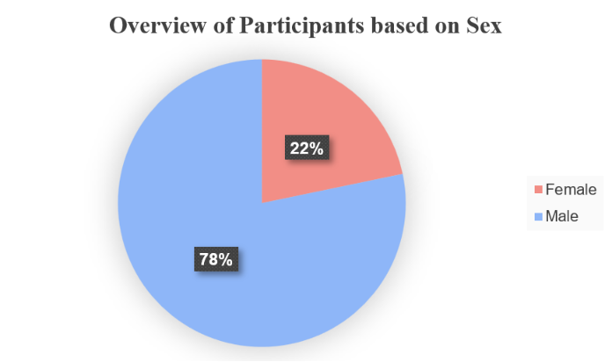
Figure 1. Gender-wise pie-chart of participants
Analysis-1: Attitude-Behaviour Gap
We see that the Eco-consciousness score which is the average of the environment Likertquestions in Q6 (i.e. 3.13+3.60+3.26/3) roughlystood at 3.35, however, the purchase intent mean-score dropped down to 2.80, which is start contrast between the attitude and the actual consumer behaviour.
According to respondents' responses, purchasing previously owned items prevents e-waste (mean = 3.54) and determines whether the purchase has an impact on the environment (mean = 3.35). However, their actual intention to actually act this way is below average (mean = 2.80). The gap between buying and purchasing is very obvious in these numbers.
Analysis-2: Chi-Square test to check relationship between Environmental Concern X Purchase Motivation
The Chi-Square statistical analysis indicates there is a statistically significant association (p = 0.021) between an individual’s environmental habits and the reason they would purchase refurbished smartphones. Based on the responses, individuals are typically more concerned about the price or performance of their smartphone and those who "Always" or "Frequently" consider their environmental impact tend to demonstrate a strong preference for sustainability as a primary purchasing driver. Therefore, e-waste awareness alone does not provide enough motivation to change buying behaviours; rather, only when an environmentally conscious-consideration is ingrained into one's thinking does it act as a stronger driver than price as a purchasing factor within the refurbished smartphone market.
Conclusion of Analysis for Secondary Question 1
TISS have an eco-consciousness score of 3.35, indicating an environmentally conscious approach and that they have the knowledge regarding the same. However, compared to their evaluation of potential purchases which scored at 2.80, the gap between attitude and behaviour is stark. This shows that even though there is awareness, they are not as likely to pivot to making sustainable purchase decisions.The chi-square test was helpful in establishing that if individuals are more likely to think of the environmental impact of their purchase decisions, they are more likely to engage in sustainable buying behaviour.
Overall, it is observed that if individuals are to be nudged towards buying refurbished smartphones, mere awareness of environmental implications will not suffice, we need to go a level deeper towards internalizing the thought of environmental consideration to the extent of it being a factor while pondering over buying decisions.

Analysis for Secondary Question 2
Introduction
People buy refurbished phones for different reasons. Some do it to save money. Some claim they care about the environment. But are climate conscious buyers actually driving this market, or is this just a nice story sellers tell?
To find this out we ran sentiment analysis, keyword detection, and text mining on 3,336 Amazon reviews for refurbished iPhones all scraped and labelled from real buyers through python and its various modules and libraries.
Sentiment Analysis Using Fuzzy Logic
The Standard sentiment tools are too blunt. They label a polarity score of 0.3 as "neutral" even though it leans positive. So we used fuzzy logic via the scikit library of python instead. Each review gets a raw polarity score from -1 (very negative) to +1 (very positive) using TextBlob. Fuzzy membership functions (trimf) then assign that score partial membership across three classes:
Class | Parameters | Shape
Negative | trimf([-1, -1, -0.3]) | peaks at -1
Neutral | trimf([-0.5, 0, 0.5]) | peaks at 0
Positive | trimf([0.3, 1, 1]) | starts at 0.3
Table 5. Score across 3-classes
A score of 0.3, for instance, belongs ~60% to Positive and ~40% to Neutral simultaneously and not just one bucket. Defuzzification (weighted centroid method) then converts these memberships back to a single score:
$$Final Score = Σ(membership × label) / Σ(membership)$$where Negative = −1, Neutral = 0, Positive = +1
Mean raw polarity was 0.277 whereas after defuzzification it shifted to 0.350 which confirmed the overall overview positive.
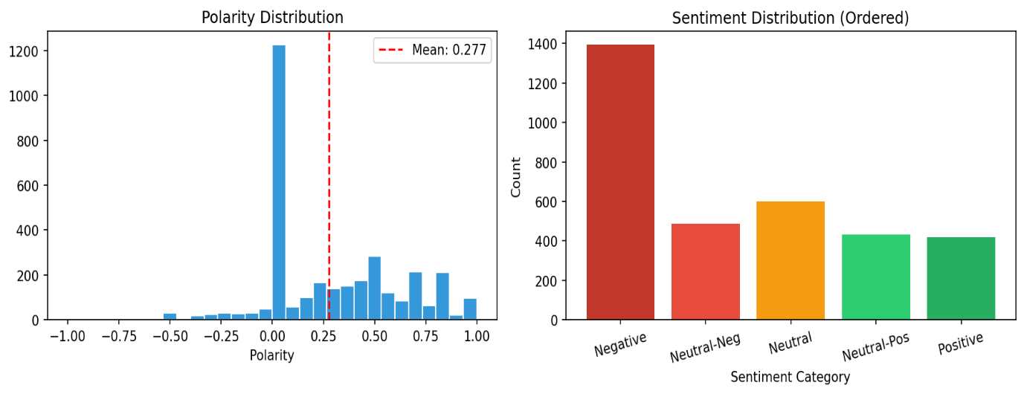Figure 2. Polarity distribution (left) and ordered sentiment category counts (right).
Climate and Sustainability Keyword Detection
The central research question: are buyers choosing refurbished phones because they care about the environment? So for this we used a two-stage keyword detection approach:
Stage 1:
Explicit climate keywords terms like "environment", "eco", "recycled", "carbon", "landfill", "sustainability", "e-waste", and similar.
Stage 2:
Strong motivation phrases like "help the planet", "reduce my footprint", "environmentally friendly", "want to reduce".
Each review received a climate score computed as:
$$climate_score = min(explicit_count×0.15+motivation_count×0.25, 1.0)$$
Explicit keywords contribute 0.15 per match; motivation phrases contribute 0.25, reflecting a stronger signal of true intent. Scores cap at 1.0. The 412 reviews (12.4%) mentioned at least one climate-related term. Only 16 reviews scored ≥ 0.25, meaning genuinely climate-motivated buyers represent just 0.15% of the full sample.
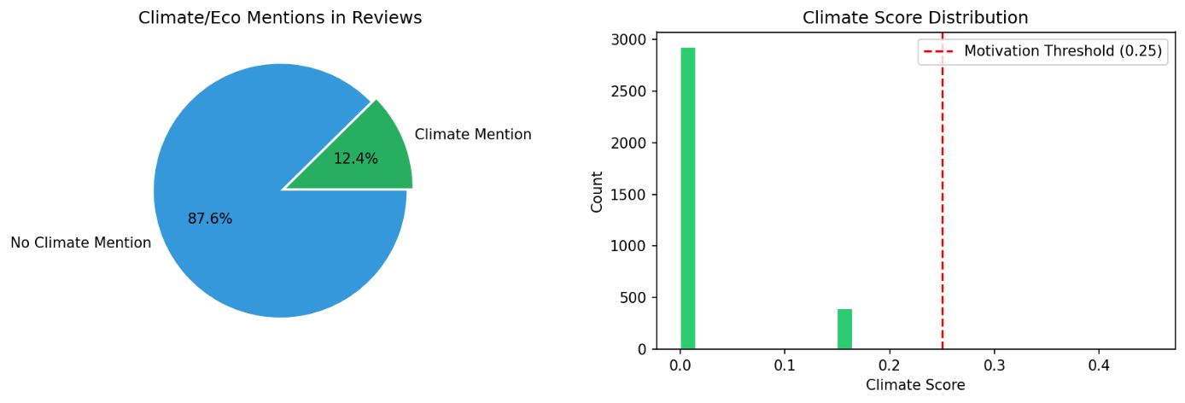Figure 3. Share of reviews containing any climate or eco mention (left)and the distribution of climate scores across the corpus (right).
N-gram Analysis Using TF-IDF
To understand what language buyers actually use, we applied TF-IDF (Term Frequency–Inverse Document Frequency) via scikit-learn'sTfidfVectorizer. TF-IDF weights how often a term appears in a single review against how rare it is across all reviews, surfacing terms that are distinctive rather than just frequent.
We extracted unigrams, bigrams, and trigrams across the full corpus. Dominant unigrams were phone, great, good, new, battery. Top bigrams included battery life, brand new, phone came, works great, like new. Top trigrams: came screen protector, phone works great, looks brand new.
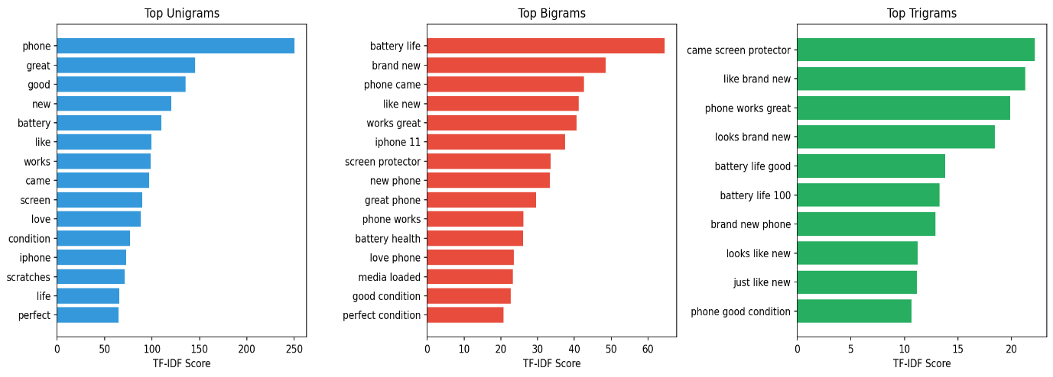
Figure 4. Top-15 unigrams (blue), top-15 bigrams (red), and top-10 trigrams (green) by TF-IDF score across all 3,336 reviews.
Comparing climate-aware and non-climate reviews using the same TF-IDF approach, phrase distributions were nearly identical. Both groups led with battery and condition language. Climate buyers showed slightly higher rates of "definitely recommend" and "highly recommend", but no eco-specific terms appeared in their top phrases.
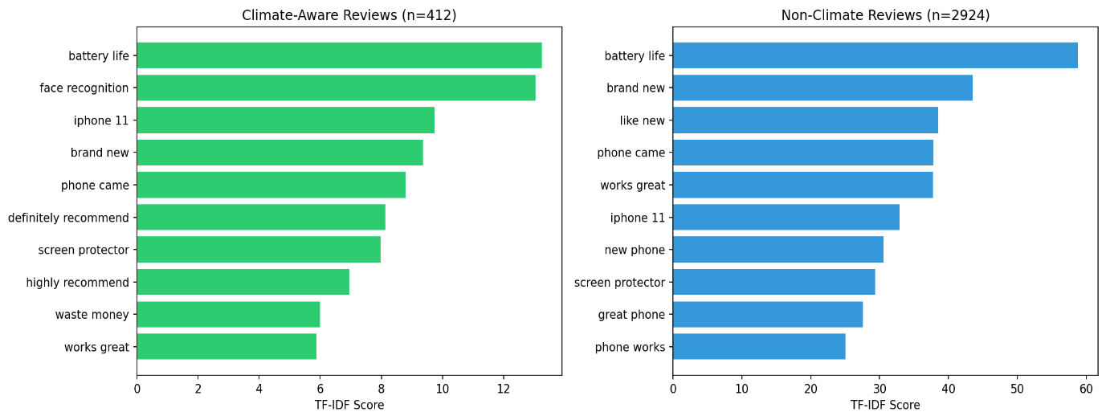
Figure 5. Top bigrams for climate-aware reviews (left) vs non-climate reviews (right).
Comparing positive and negative reviews separately reveals a cleaner contrast. Positive reviews cluster around condition and performance phrases whereas negative reviews surface battery health, scratches, and screen issues as specific pain points.
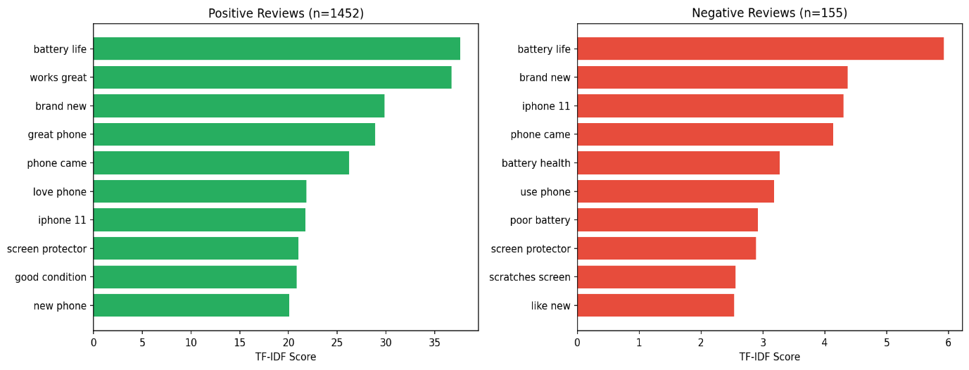
Figure 6. Top bigrams for positive reviews (left) vs negative reviews (right). Negative reviews are dominated by specific defect language, while positive reviews reflect "like new" expectations being met.
Purchase Decision Factors
To quantify what drives the purchase decision, we tracked keyword mention rates across the corpus. Price-related terms (like - price, cost, money, cheap, affordable, worth, deal, save) appeared in 16.0% of reviews. Positive quality descriptors (like - new, perfect, pristine, flawless) appeared in roughly the same share; negative quality terms (like- scratched, damaged, dented, defective) were far less frequent.
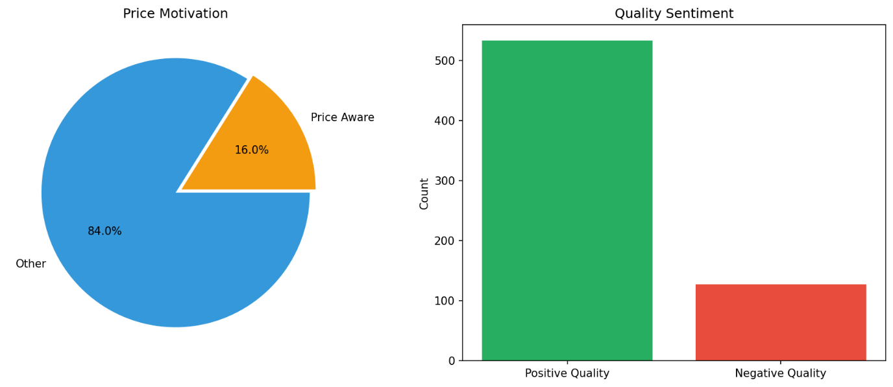Figure 7. Price motivation share (left) and quality sentiment counts (right).
Ten product features were manually annotated with Context-Aware (CA) scores on a 0-5 scale, where 0 is very negative context and 5 is very positive. Top 5 discussed features are as below.
Feature | Mentions | Avg CA Score
Battery Health | 695 | 2.33
Screen/Display | 524 | 2.11
Shell Condition | 439 | 2.74
Brand | 251 | 2.48
Price | 198 | 2.47
Table 6. Top five product features by mention frequency, with average context-aware satisfaction scores.
Battery health was mentioned more than any other feature in the reviews which accounts for nearly four times as often as price keyword. Shell condition (body conditions) earned the highest average satisfaction score.
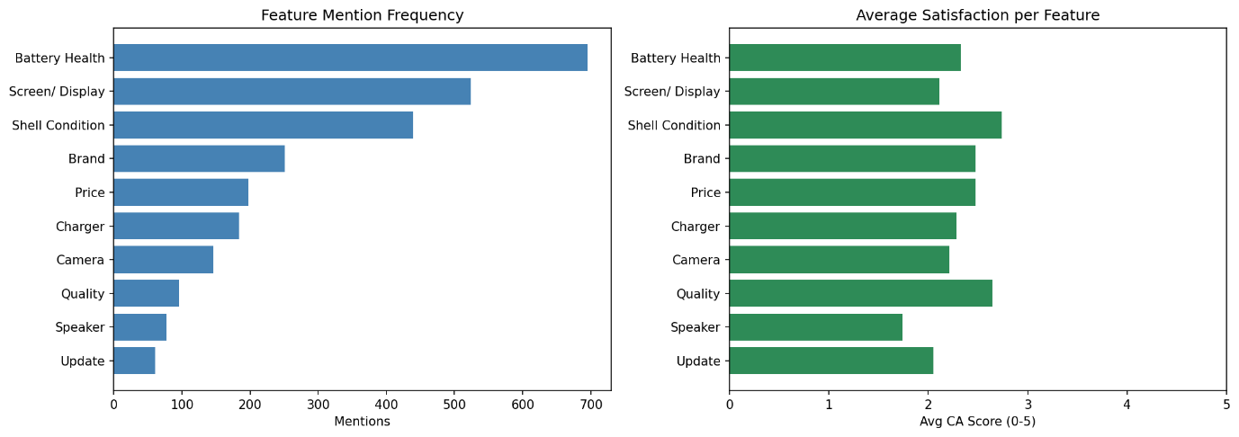
Figure 8. Feature mention frequency (left) and average context-aware satisfaction score (right) for all ten annotated product features.
Conclusionof Analysis for Secondary Question 2
The data tells a clear story and that is the price motivation (16.0%) outruns climate motivation (0.15%) by a factor of roughly 100. Buyers choose refurbished iPhones because they want a working phone in good condition at a lower price. Battery life is the primary concern. Arriving "like new" is the primary expectation. The environment comes up in about one in eight reviews but almost never as the actual reason for buying.
The value-action gap shows up plainly here: consumers may hold environmental values without those values driving the purchase decision. Eco-marketing alone will not move units in this category. The effective pitch leads with price and physical condition, with sustainability as a secondary frame at best.
REFERENCES
Anisi, A., Okudan-Kremer, G., & Olafsson, S. (2025). Mining product reviews for important product features of refurbished iPhones. Information, 16(4), 276.https://doi.org/10.3390/info16040276

Conducted using Python

