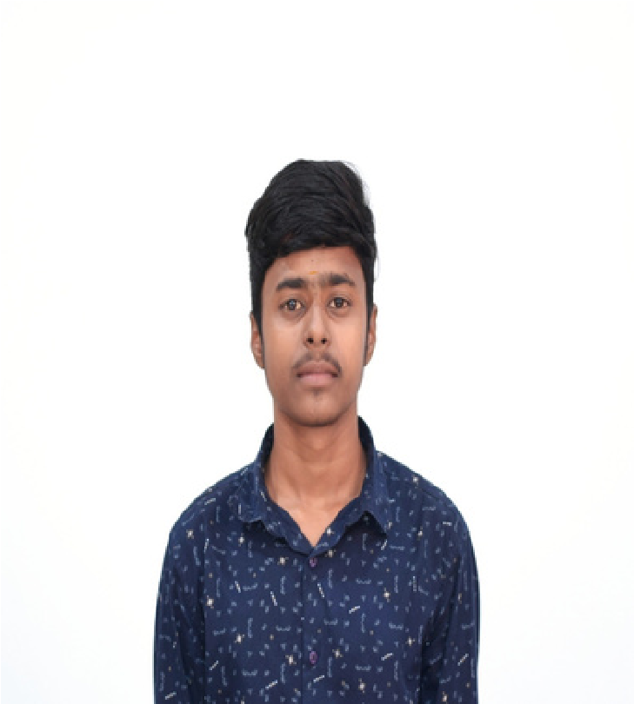

**ABOUT ME**

9360330483

2326ja43@kgcas.com

Coimbatore

**B.Sc Information Technology**

**KG College of Arts and Science**

**CMS School**

**HLC**

%

65

70

%

Java

C

C++

Linux

**Education**

**TECHNICAL SKILL**

English

Tamil

**Language**

**RAVI RAJ**

Certified in Learnathon 2023-2024

Introduction to MONGODB

Certified in DEEPRACER 2023

100+

Coursera Certifications

**Automated Backup System**

Developed an automated backup system

to securely back up important files and

data on local machines to cloud storage

(

Google Drive, Dropbox). Implemented

scheduling for regular backups and

notification alerts in case of failure.

**Smart Home IoT System**

Built a prototype of a smart home system

where devices like lights, thermostats, and

security cameras can be controlled remotely

through a mobile app. Integrated sensors to

monitor environmental conditions like

temperature and humidity.

I

am

a

motivated

and

detail-oriented

Computer

Technology student with a passion for learning and

solving

technical

challenges.

I

have

a

strong

foundation in programming, software development,

and

IT

systems.

My

goal

is

to

apply

my

technical

skills

and

knowledge

to

contribute

to

innovative

projects and gain hands-on experience in the tech

industry.

I

am

eager

to

collaborate

with

diverse

teams

and

continue

expanding

my

expertise

in

computer science and technology.

**CERTIFICATIONS**

**PROJECTS**

