INFOSYS SPRINGBOARD INTERNSHIP 4.0

**Project Documentation On**

**Online Gym Management (Java)**

**By**

## Ketan Sondarva Ramesh Lodangi Spandana Thallapelly Ravi Ranjan kumar

Under the Guidance of

**SURAMYA BISWAS**

**TABLE OF CONTENTS**

**CHAPTER 1:** INTRODUCTION **Page 1**

**CHAPTER 2:** REQUIREMENT SPECIFICATION **Page 2**

**CHAPTER 3:** TECHNOLOGIES AND TOOLS **Page 5**

**CHAPTER 4:** PROJECT DEPENDENCIES **Page 6**

**CHAPTER 5:** PROJECT STRUCTURE & PACKAGES DETAILS **Page 9**

**CHAPTER 6:** VIEWS CREATED AND STATIC RESOURCES **Page 12**

**CHAPTER 7:** UML DIAGRAMS **Page 13**

**CHAPTER 8:** DATA DICTIONARY **Page 16**

**CHAPTER 9:** MODULES IMPLEMENTED **Page 18**

**CHAPTER 10:** CONCLUSION AND FUTURE WORK **Page 19**

# CHAPTER 1: INTRODUCTION

The Gym Management System is a comprehensive web application designed to streamline the operations of gyms and health clubs, offering a user-friendly interface built using Spring Boot. The system ensures secure user authentication and registration processes, allowing only authorized members and administrators access. It features an intuitive gym slot scheduling interface, enabling users to view and select available time slots for various activities. Administrators can efficiently manage slot availability, adjusting the number of seats for each activity and time slot based on demand. The system also provides detailed management of slot booking information, allowing users to book slots while administrators can track and manage these bookings. Additionally, it includes a robust feedback management system, helping administrators to collect and utilize user feedback for service improvement. The comprehensive admin dashboard offers an overview of gym operations, including user management, slot scheduling, and booking statistics, thereby enhancing the overall efficiency and user experience for both gym members and administrators.

## Project Statement

The Online Gym Management System endeavors to facilitate a comprehensive digital framework for gym operations, enhancing interactivity and efficiency. By integrating multiple functionalities, this application stands to improve user engagement and organizational workflow.

## Importance of Gym Management Software

Such software is pivotal in optimizing the management of memberships and activities, ensuring that both clients and administrators enjoy a seamless interaction experience.

## Key Benefits of Application

The software aims to streamline operations, boost customer satisfaction, and provide management with analytical insights through extensive reporting capabilities

# CHAPTER 2: REQUIREMENT SPECIFICATION

## User Authentication and Registration User Registration:

* + Allow new user registration
  + Secure password storage

## User Login:

* + User login with username and password
  + Validate user credentials

## Gym Slot Scheduling Interface View Slots:

* + Display list of available gym slots

## Slot Selection:

* + Select and view slot details
  + Slot availability checking

## Slot Availability Management Manage Slots:

* + Create and update gym slots
  + Decrease the availability when seat get booked
  + Increase the availability booked seat get cancelled

## Slot Display:

* + Indicate fully booked and also the available slots

## Slot Booking Information Management Book Slots:

* + Book available gym slots
  + Real-time seat availability update

## View Bookings:

* + View booked slots

## Cancel Bookings:

* + Cancel bookings and update availability

## Booking Records:

* + View and manage booking records

## Feedback Management Submit Feedback:

* + Submit user feedback (Customer)

## View Feedback:

* + View all submitted feedback (Admin)

## Admin Dashboard Overview:

* + Perform admin related task and manage reports

## Management Interfaces:

* + Add gym item, add slot, Manage users, slots, services and feedback

## Reports:

* + Generate reports on slot utilization, user activity, and feedback trends. There are Gym Item Report, Slot Report, Booking Report and User Details Report etc.

# CHAPTER 3: TECHNOLIES AND TOOLS

* + - Spring Boot
    - Spring MVC
    - Spring Data JPA
    - Java Server Pages (JSP)
    - MySQL
    - JavaScript
    - Cascading Stylesheet (CSS)
    - Maven (Build Tool)
    - Git & GitHub (Version Control)
    - Eclipse Enterprise Edition (IDE)

# CHAPTER 4: PROJECT DEPENDENCIES

## Spring Boot Version

- Version: 2.7.12

## Project Dependencies

1. Spring Boot Starter Data JPA
   * Group ID: org.springframework.boot
   * Artifact ID: spring-boot-starter-data-jpa
   * Description: Provides support for using Spring Data JPA with Spring Boot.
2. Validation API
   * Group ID: javax.validation
   * Artifact ID: validation-api
   * Version: 2.0.1.Final
   * Description: Provides a set of standard Java APIs for bean validation.
3. Spring Boot Starter Web
   * Group ID: org.springframework.boot
   * Artifact ID: spring-boot-starter-web
   * Description: Provides support for building web applications, including RESTful applications, using Spring MVC.
4. MySQL Connector/J
   * Group ID: com.mysql
   * Artifact ID: mysql-connector-j
   * Scope: runtime
   * Description: JDBC driver for MySQL.
5. Spring Boot Starter Tomcat
   * Group ID: org.springframework.boot
   * Artifact ID: spring-boot-starter-tomcat
   * Scope: provided
   * Description: Provides support for embedded Tomcat, which is a servlet container.
6. Spring Boot Starter Test
   * Group ID: org.springframework.boot
   * Artifact ID: spring-boot-starter-test
   * Scope: test
   * Description: Provides support for testing Spring Boot applications.
7. Apache Tomcat Jasper
   * Group ID: org.apache.tomcat
   * Artifact ID: tomcat-jasper
   * Version: 9.0.65
   * Description: JSP compiler for Tomcat.
8. JSTL (JavaServer Pages Standard Tag Library)
   * Group ID: javax.servlet
   * Artifact ID: jstl
   * Version: 1.2
   * Description: Standard tag library for JSP.
9. Jakarta Servlet JSP JSTL
   * Group ID: org.glassfish.web
   * Artifact ID: jakarta.servlet.jsp.jstl
   * Version: 3.0.1
   * Description: JSTL implementation for Jakarta EE.
10. Spring Boot Starter Security
    * Group ID: org.springframework.boot
    * Artifact ID: spring-boot-starter-security
    * Description: Provides support for authentication and authorization using Spring Security.

# CHAPTER 5: PROJECT STRUCTURE & PACAGES DETAILS

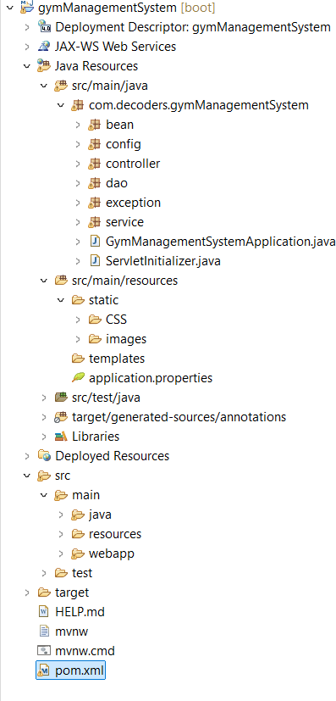

**Parent Package:** com.decoders.gymManagementSystem

## Classes:

**GymManagementSystemApplication:**

It is main class which does all the autoconfiguration of the spring boot application so that we do not need to do the configuration manually.

## ServletInitilizer:

Need to invoke the servlet of the JSP file used in web application whenever the request comes for the particular file.

## Sub Packages:

1. **bean:** for declaring entity classes

## classes:

* + GymBook
  + GymItem
  + GymUser
  + Feedback
  + Item
  + Slot
  + SlotItem
  + SlotItemEmbed

1. **config**: for security and application configuration:

## classes:

* + EncoderConfig
  + SecurityConfig

1. **controller**: for define the mappings for the incoming http request to the server

## classes:

* + GymController
  + LoginController
  + ExceptionController

1. **dao**: Classes and interfaces that contains logic for interaction with databas

**Rpository interfaces**: helps to perform database operation on entity class

* + GymItemRepository
  + GymBookRepository
  + GymUserReposiroty
  + SlotRepository
  + SlotItemRepository
  + FeedbackRepository

**Dao interfaces:** contains method that will got implemented in implementation classes in order to provide the business logic

* + GymItemDao
  + GymBookDao
  + GymUserDao
  + SlotDao
  + SlotItemDao
  + FeedbackDao

**Dao implementation classes:** Provide implementation of the dao interfaces, contains business logic of the application

* + GymItemDaoImpl
  + GymBookDaoImpl
  + GymUserDaoImpl
  + SlotDaoImpl
  + SlotItemDaoImpl
  + FeedbackDaoImpl

1. **exception**: contains classes for the user defined exception
   * BookingExistsException
   * SeatNotAvailableException
2. **service**: this package contains classes that used to implement the business logic
   * GymItemService
   * GymUserService

## CHAPTER 6: VIEWS CREATED AND STATIC RESOURCES USED (in JSP)

**Views:**

* Registration
* Login
* Gym Item entry page
* Gym Item report page
* Slot scheduling page
* Slot report page
* Exception page
* Gym Booking for Customers
* Gym Booking for Admins (admin can book gym slot for customer)
* Confirmation page (i.e. when slot gets booked)
* Customer Feedback Entry page
* Feedback list page
* Booking cancellation page
* Booking Cancellation Report
* Customer Report
* Admin Dashboard / Admin Panel

## Static Resources:

* **CSS files:**

Contains CSS file for a Designing table in Report pages, for forms used in entry pages and for admin panel.

## Images:

Contains Images used as Background image in registration, login and other pages.

# CHAPTER 7: UML DIAGRAMS

* 1. **Class Diagram:**

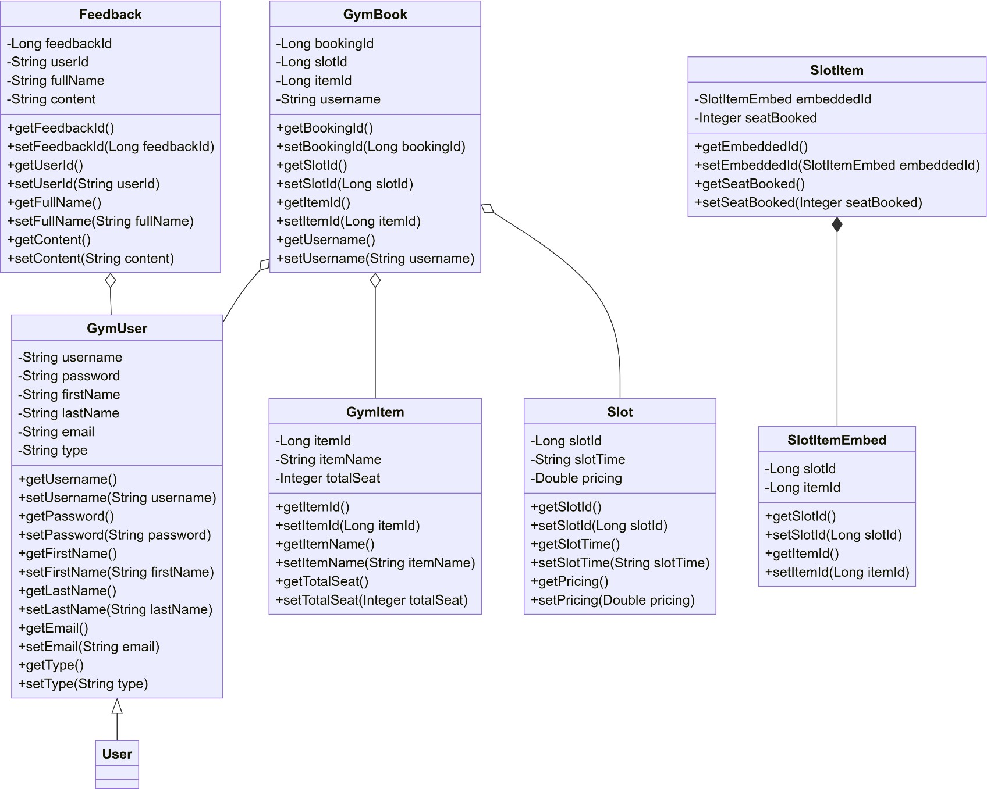

* 1. **ER Diagram**

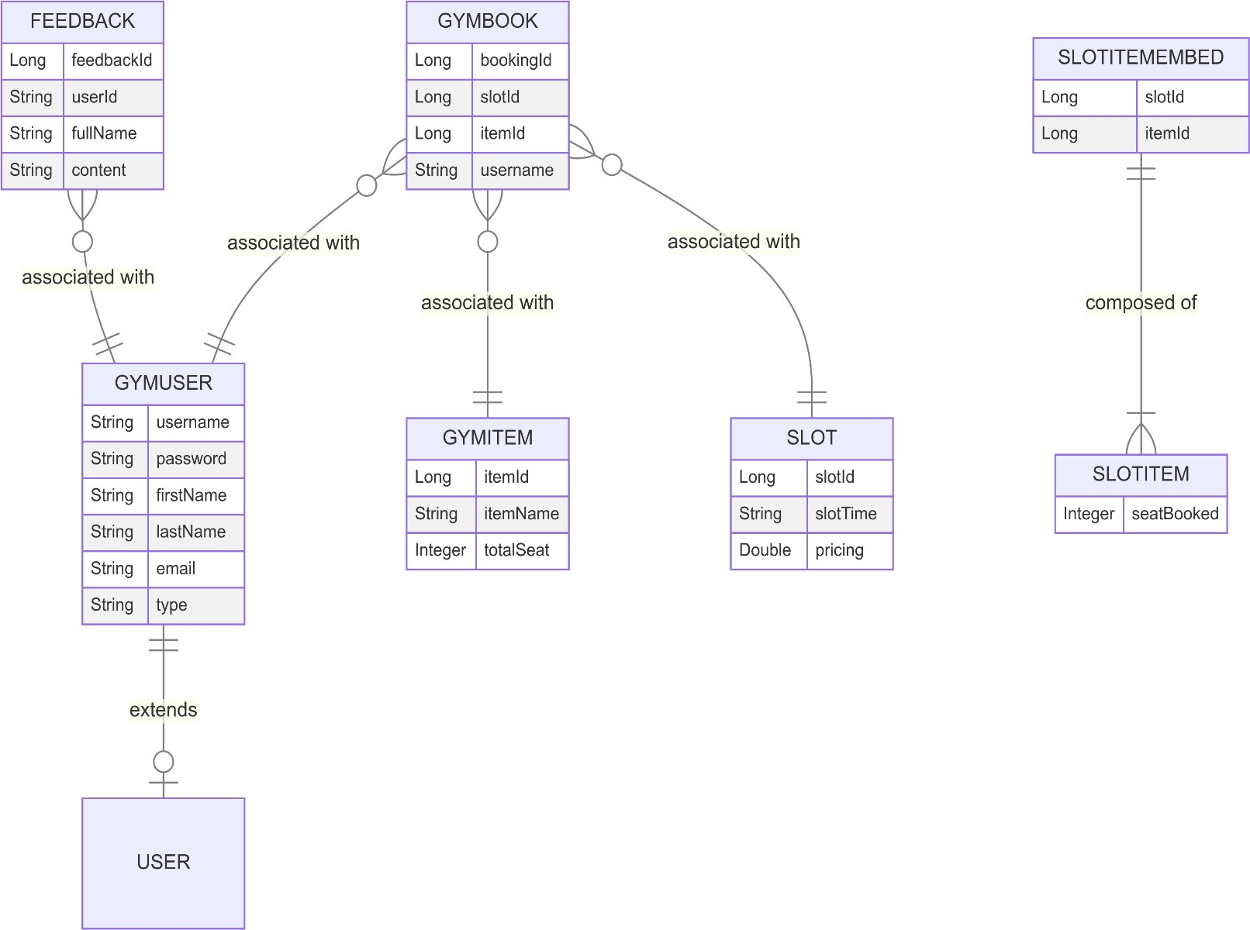

* 1. **Use Case Diagram**

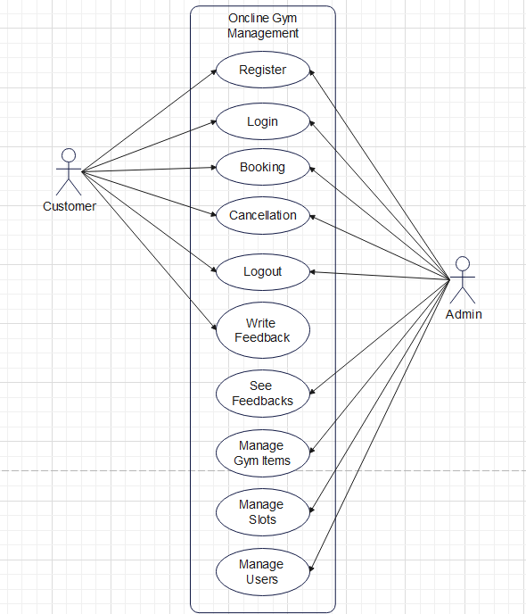

# CHAPTER 8: DATA DICTIONARY

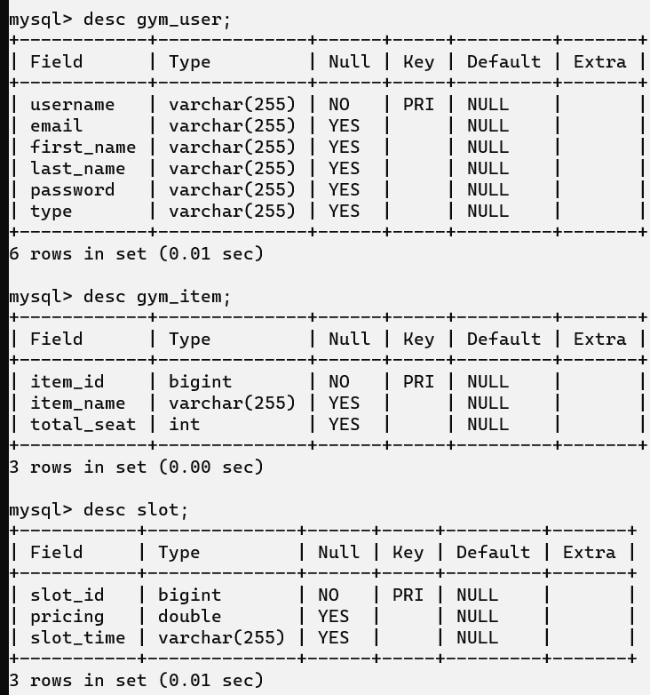

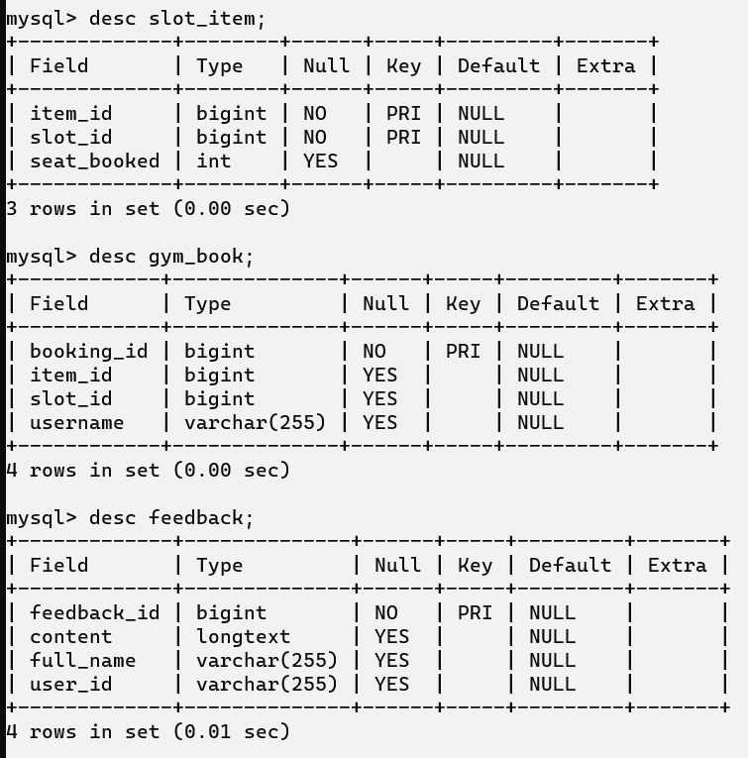

**CHAPTER 9: MODULES IMPLEMENTED**

## User Authentication and Registration (Session Based)

Used spring security for encrypting password while receiving it from user on registration, spring security session-based

authentication is used: session for user is maintained until the lifecycle of the application or user explicitly logout.

## Gym Item addition and Slot Scheduling Interface

Admin can provide verity of the slots by slot entry interface where admin enter the Slot Time and price of the slot. Entered slot will be received by the application and stored in the database.

Admin can provide gym item / service which will be shown to the user, for that Gym Item Entry page is provide. Customer can select slot and then gym item.

## Slot availability Management

Slot increases when user books a particular gym service and decrease when seat got cancelled, these functionalities implemented in this module.

## Slot Booking and cancellation Information Management

Booking report for admin and customer, admin can see the list customer with services they have booked and customer can see his/her own bookings and also able to cancel the booking.

## Feedback Management

Customer can give feedback for the gym service and admin can see the list of the feedback given by the customers.

## Admin Dashboard

Dashboard for admin to perform all gym management related tasks like add new service, slot, manage users, booking cancellations etc.

# CHAPTER 10: CONCLUSION AND FUTURE WORK

The Gym Management System project successfully integrates various essential features to streamline gym operations and enhance user experience. With robust functionalities like user authentication, slot scheduling, and feedback management, the system provides a comprehensive solution for both gym members and administrators. The secure and efficient management of gym slot availability and booking information ensures a smooth and organized gym environment. The admin dashboard offers a powerful interface for managing users, slots, and feedback, contributing to effective gym administration. Overall, this project demonstrates a well- rounded application of modern web technologies to meet the needs of a gym management system.

## Future Enhancements

1. Mobile Application:
   * Develop a mobile app to provide users with easy access to gym slot booking and management features on the go.
2. Payment Integration:
   * Integrate payment gateways for online payments of gym memberships and slot bookings.
3. Advanced Analytics:
   * Implement advanced analytics to track user engagement, slot utilization, and feedback patterns for data-driven decision-making.
4. Personalized Notifications:
   * Add personalized notifications for users about upcoming bookings, available slots, and gym events via email and SMS.
5. Social Media Integration:
   * Enable social media login and sharing options to enhance user engagement and streamline the registration process.
6. Enhanced Security Features:
   * Introduce multi-factor authentication and advanced security protocols to further protect user data and system integrity.
7. Virtual Training Sessions:
   * Offer virtual training sessions and online classes to provide additional value to gym members.
8. Integration with Wearable Devices:
   * Integrate with wearable fitness devices to track user activity and provide personalized fitness recommendations.