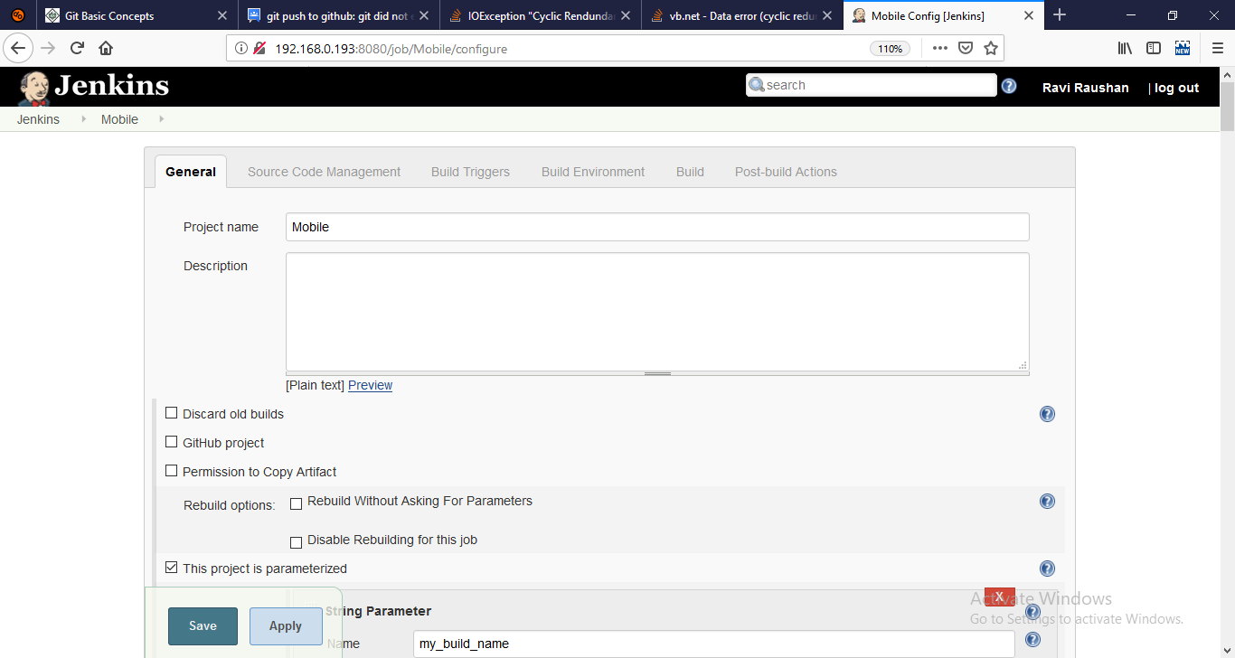

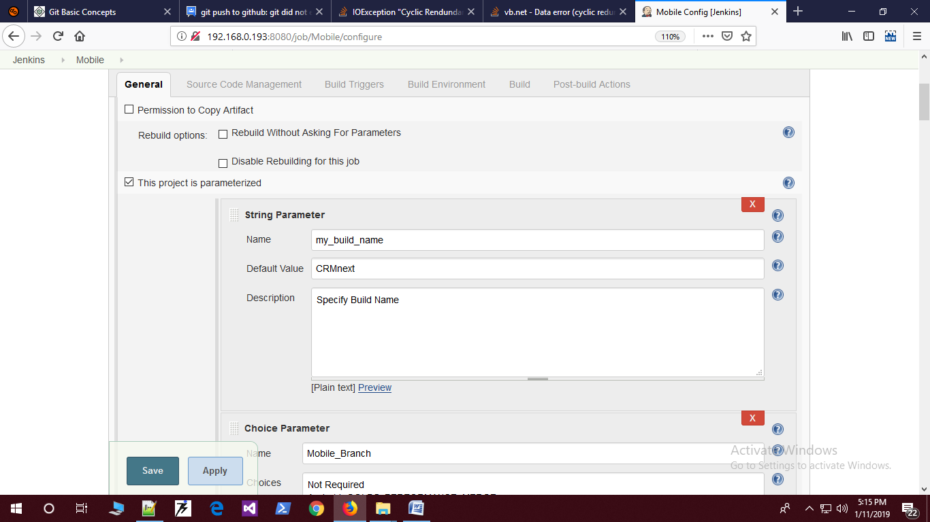

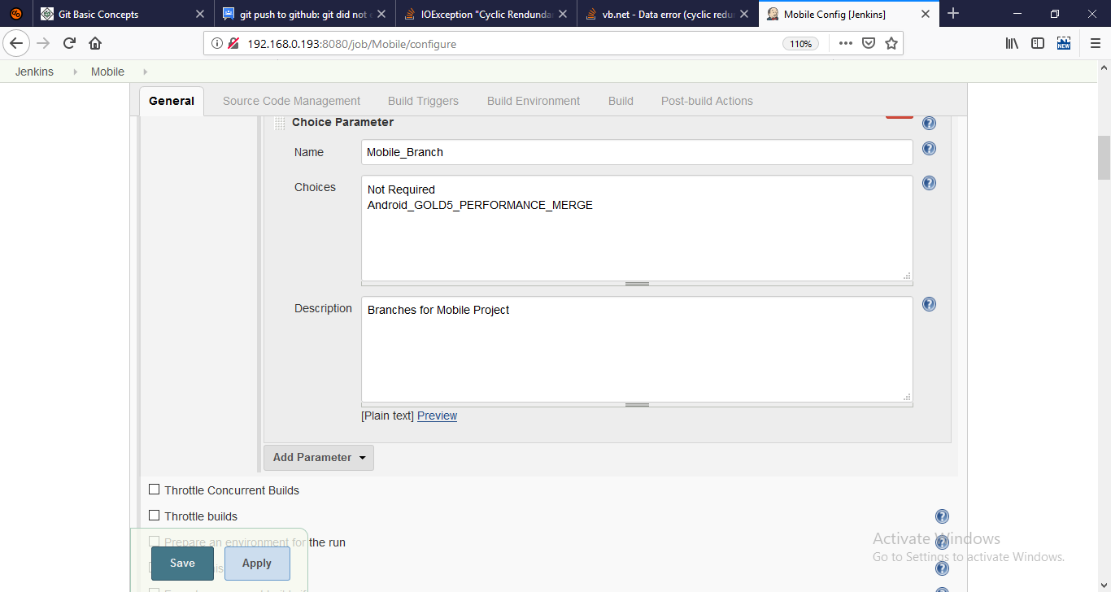

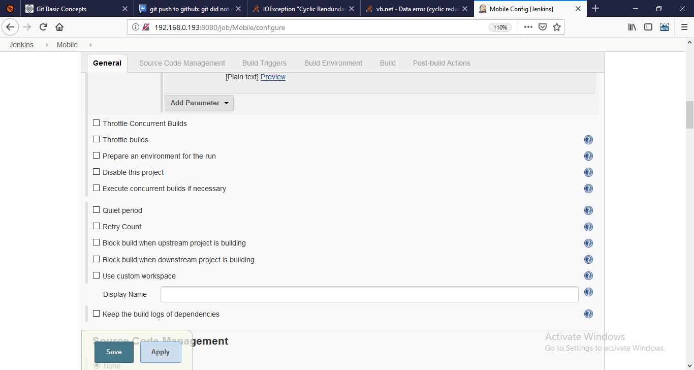

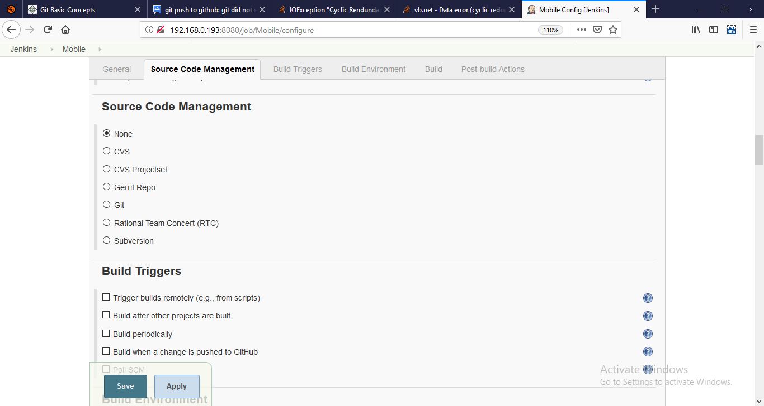

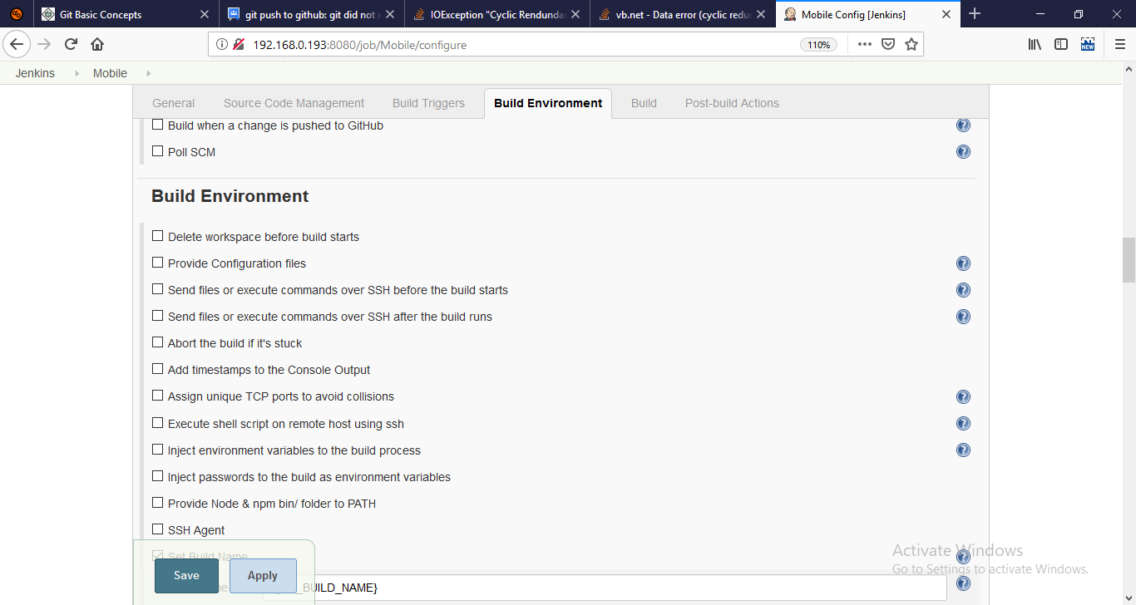

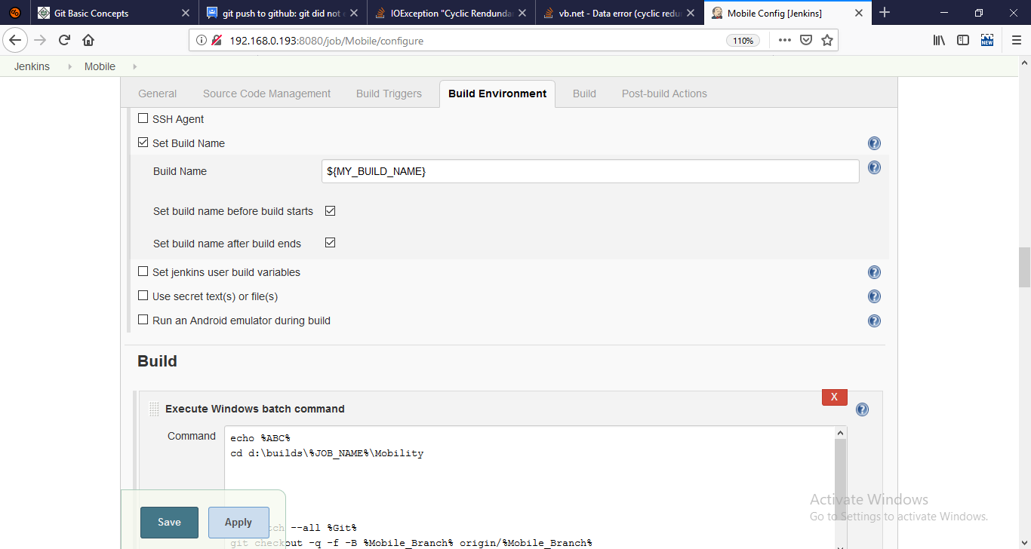

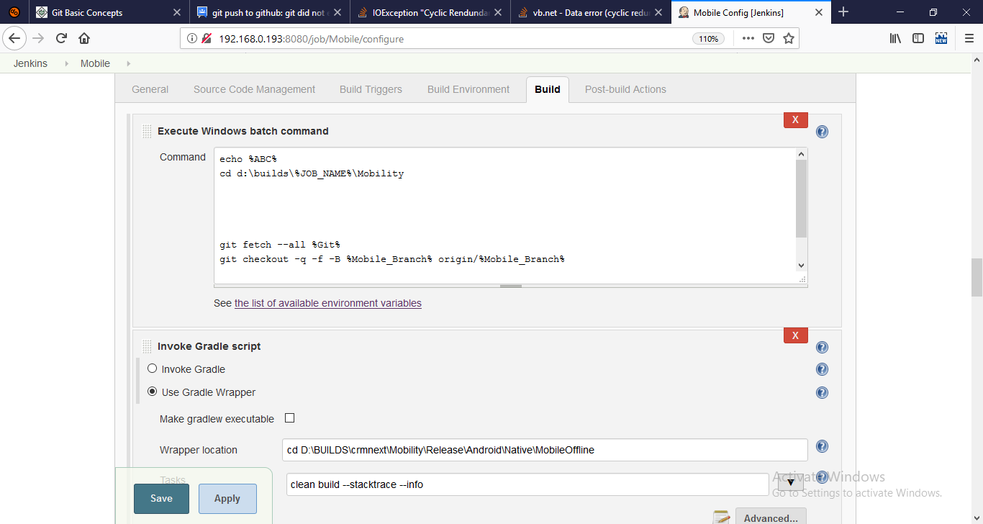

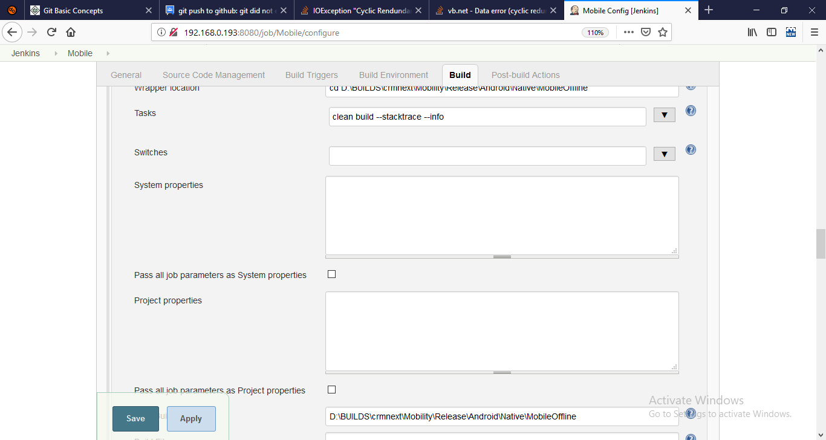

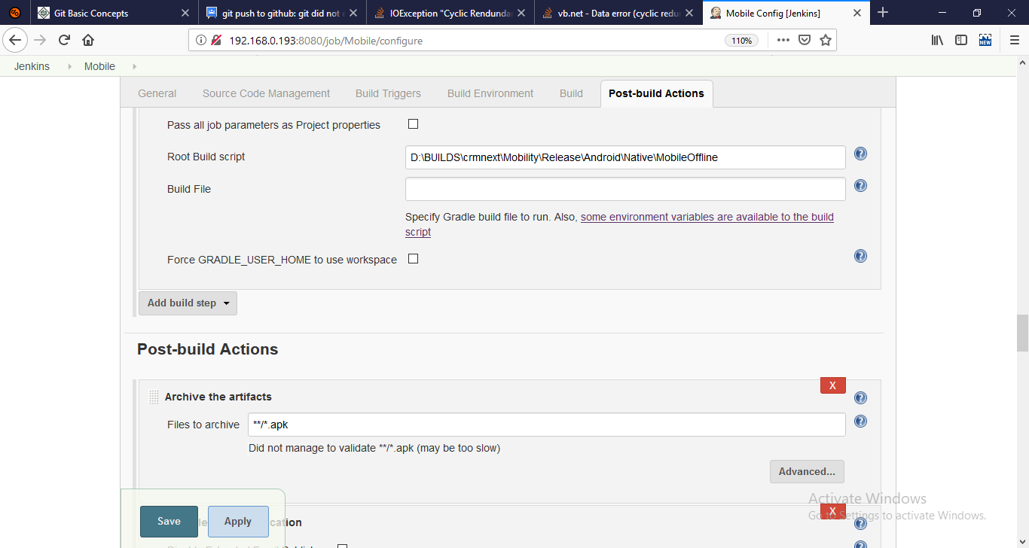

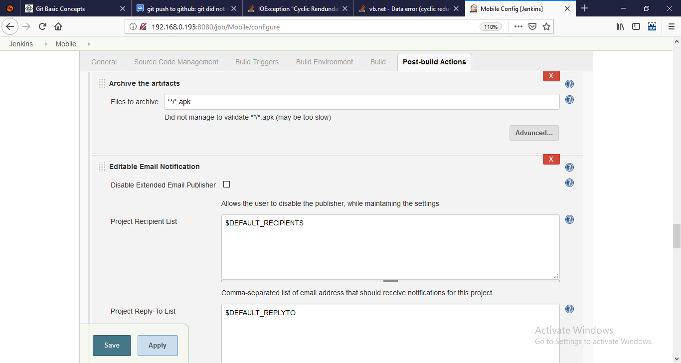

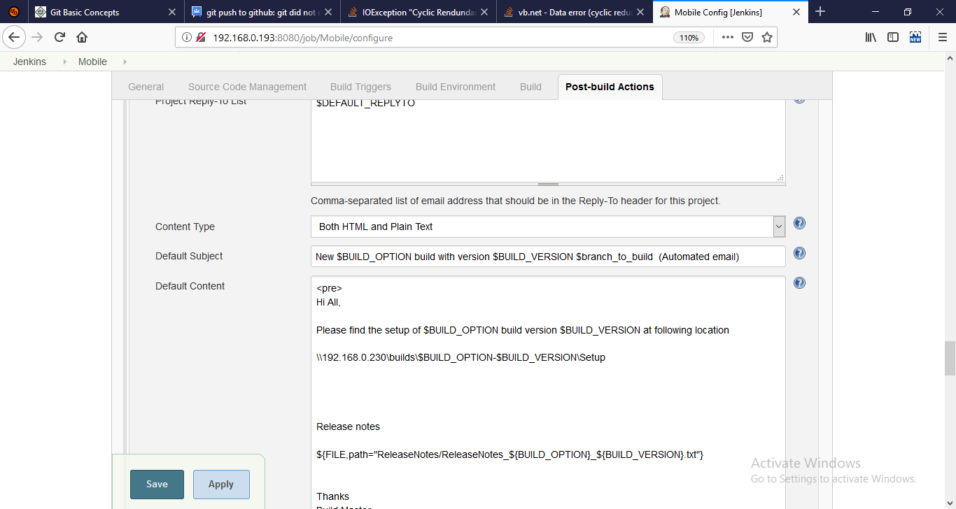

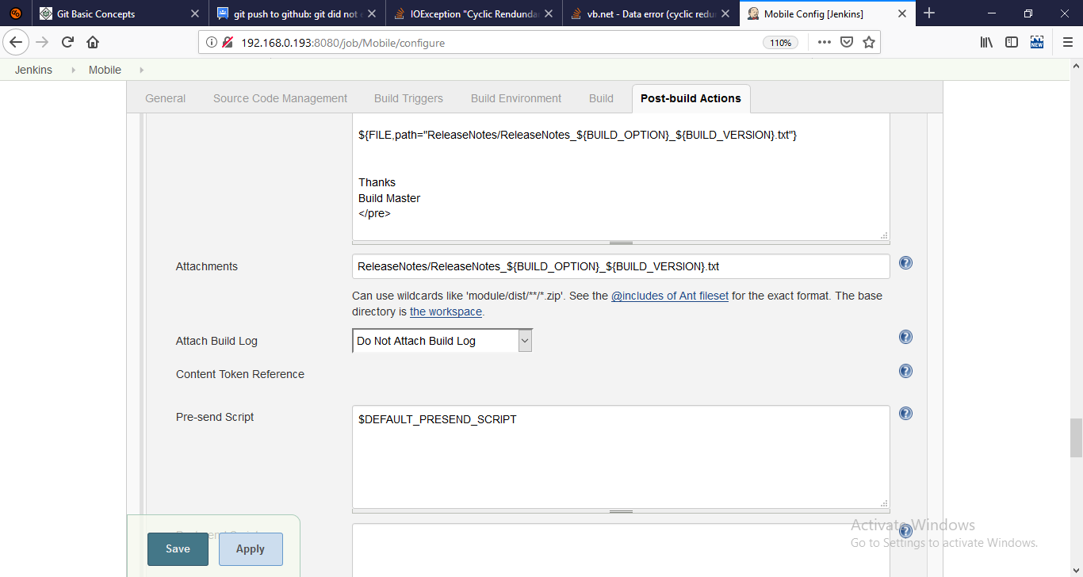

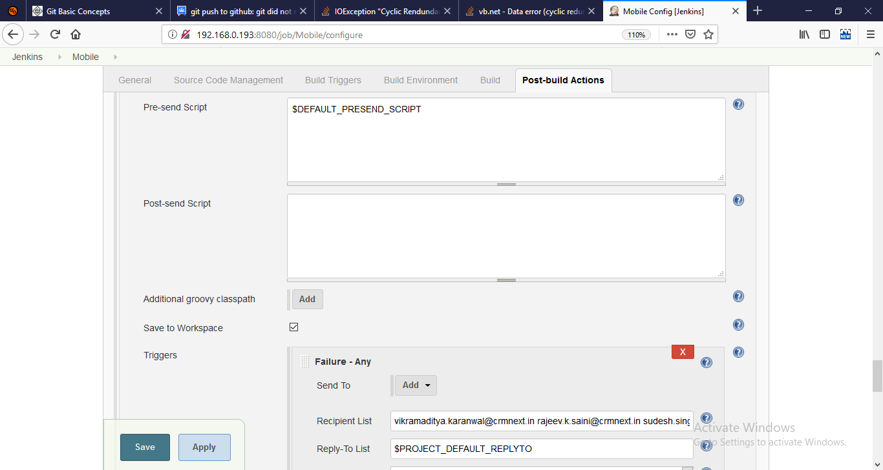

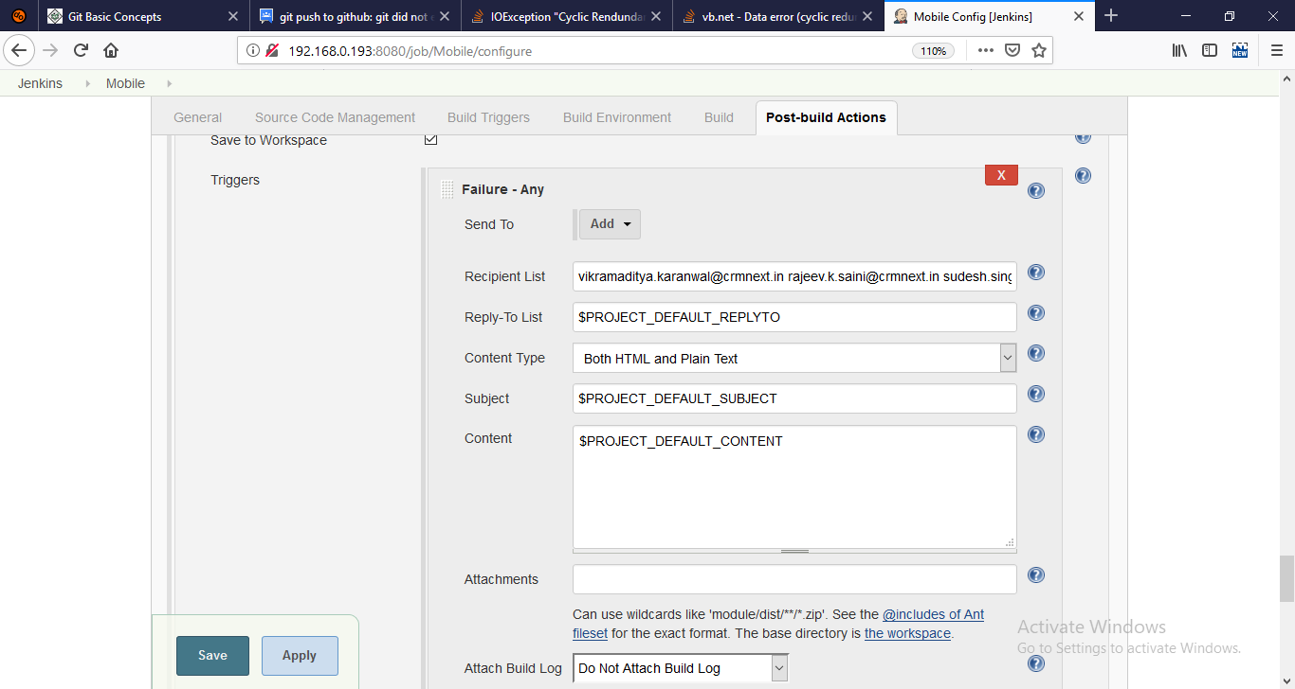

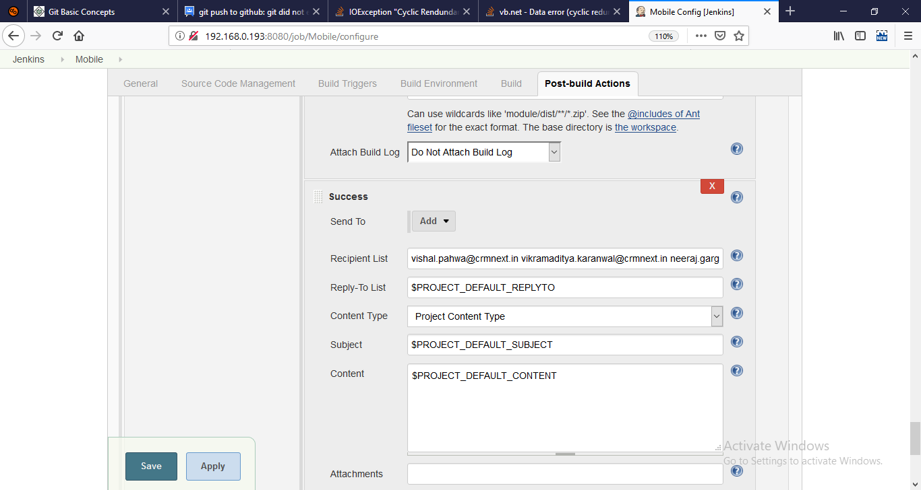

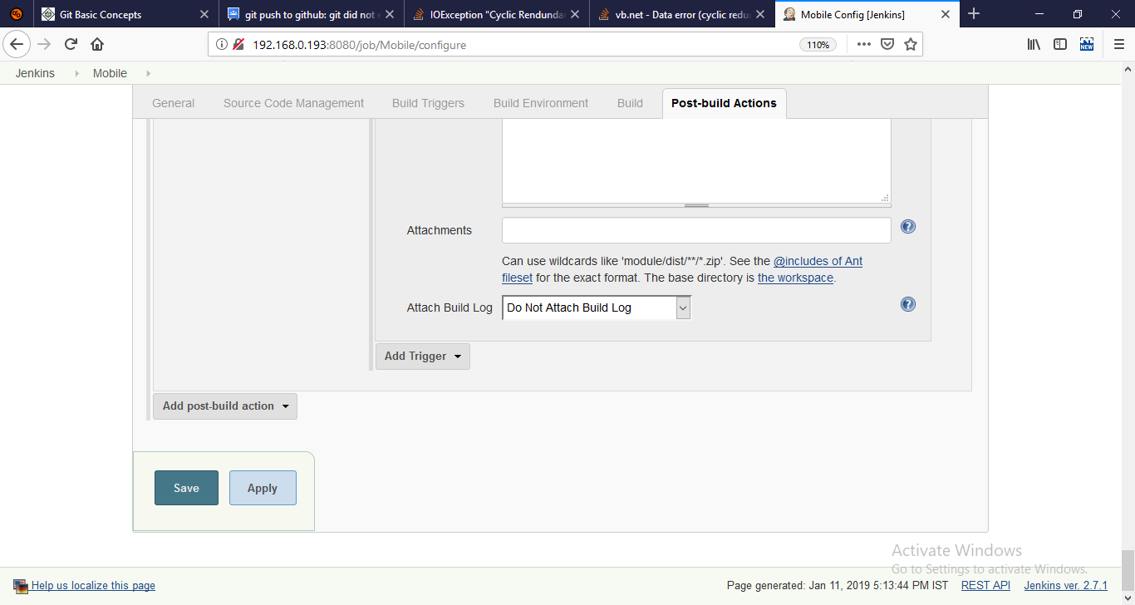

Mobile

my_build_name

CRMnext

Specify Build Name

Mobile_Branch

Not Required

Android_GOLD5_PERFORMANCE_MERGE

Branches for Mobile Project

${MY_BUILD_NAME}

git fetch --all %Git%

git checkout -q -f -B %Mobile_Branch% origin/%Mobile_Branch%

cd D:\BUILDS\crmnext\Mobility\Release\Android\Native\MobileOffline

clean build --stacktrace –info

D:\BUILDS\crmnext\Mobility\Release\Android\Native\MobileOffline

**/*.apk

$DEFAULT_RECIPIENTS

$DEFAULT_REPLYTO

Both HTML and Plain Text

New $BUILD_OPTION build with version $BUILD_VERSION $branch_to_build (Automated email)

<pre>

Hi All,

Please find the setup of $BUILD_OPTION build version $BUILD_VERSION at following location

\\192.168.0.230\builds\$BUILD_OPTION-$BUILD_VERSION\Setup

Release notes

${FILE,path="ReleaseNotes/ReleaseNotes_${BUILD_OPTION}_${BUILD_VERSION}.txt"}

Thanks

Build Master

</pre>

ReleaseNotes/ReleaseNotes_${BUILD_OPTION}_${BUILD_VERSION}.txt

Do Not Attach Build Log

$DEFAULT_PRESEND_SCRIPT

vikramaditya.karanwal@crmnext.in rajeev.k.saini@crmnext.in [sudesh.singh@crmnext.in](mailto:sudesh.singh@crmnext.in)

$PROJECT_DEFAULT_REPLYTO

$PROJECT_DEFAULT_SUBJECT

$PROJECT_DEFAULT_CONTENT

vishal.pahwa@crmnext.in vikramaditya.karanwal@crmnext.in neeraj.garg@crmnext.com naveen.c.vaila@crmnext.in gourav.aggarwal@crmnext.in developers@crmnext.in quality@crmnext.in pag@crmnext.com [mobileteam@crmnext.com](mailto:mobileteam@crmnext.com)

$PROJECT_DEFAULT_REPLYTO

Project Content Type

$PROJECT_DEFAULT_SUBJECT

$PROJECT_DEFAULT_CONTENT