1. Create a bridge network called prices-net.



2. Run a container called base-price with the linuxacademycontent/prices-base-price:1 image. Configure this container to use the prices-net network.

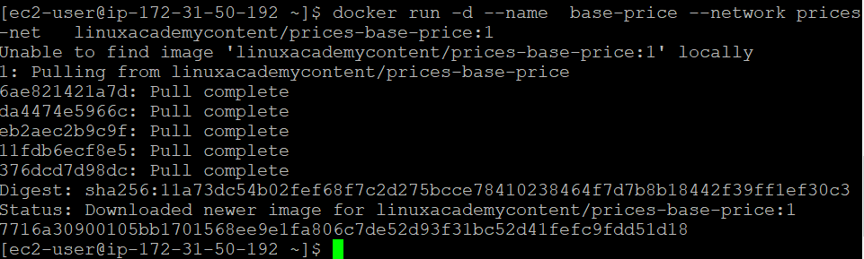

3. Run a container called sales with the linuxacademycontent/prices-sales:1 image. Configure this container to use the prices-net network.

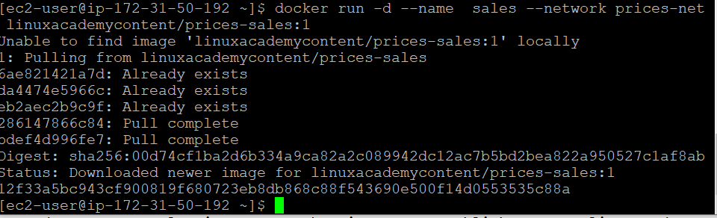

4. Run a container called total-price with the linuxacademycontent/prices-total-price:1 image.

Configure this container to use the prices-net network. Publish this container's port 80 to port 8080 on the host.

