Your fruit stand company has some software that calculates and serves a list of products and their prices, taking into account items that are on sale and how the sales affect the total price. This software consists of three components: a base-price component which serves the base prices of fruits sold by the fruit stand, a sales component which provides a list of items that are on sale and how much each item is discounted, and a total-price component which communicates with the other two and calculates the final price for each item.

These components have been running on a single Docker host, but as your business is expanding, it is time to upgrade to a swarm cluster for greater flexibility. Run these three application components as services in your swarm cluster, and provide them with a custom overlay network to facilitate isolated communication between them.

Configure these application components on the Swarm cluster so that the following specifications are met:

1. Create an overlay network called prices-overlay-net.

docker network create -d overlay prices-overlay-net

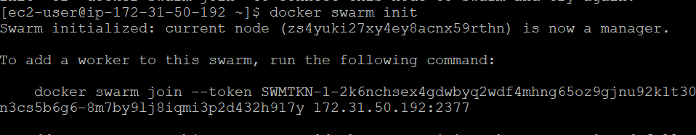



1. Create a service called base-price with 3 replicas using the linuxacademycontent/prices-base-price:1 image. Configure the service to use the prices-overlay-net network.

docker service create --name base-price --replicas 3 --network prices-overlay-net linuxacademycontent/prices-base-price:1

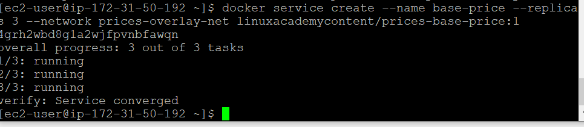

1. Create a service called sales with 3 replicas using the linuxacademycontent/prices-sales:1 image. Configure the service to use the prices-overlay-net network.

docker service create --name sales --replicas 3 --network prices-overlay-net linuxacademycontent/prices-sales:1

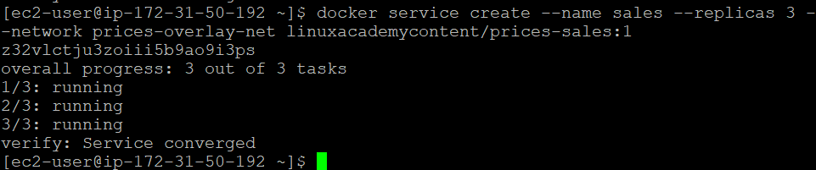

4. Create a service called total-price with 2 replicas using the linuxacademycontent/prices-total-price:1 image. Configure the service to use the prices-overlay-net network. Expose this service's port 80 on port 8080.

docker service create --name total-price --replicas 2 -p 8080:80 --network prices-overlay-net linuxacademycontent/prices-total-price:1

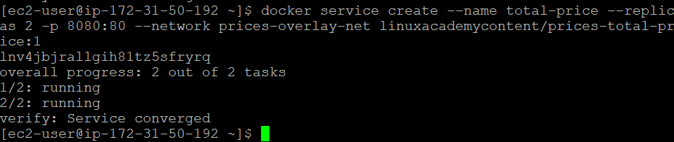

If everything is set up correctly, you should be able to access the total prices list with:

curl localhost:8080.

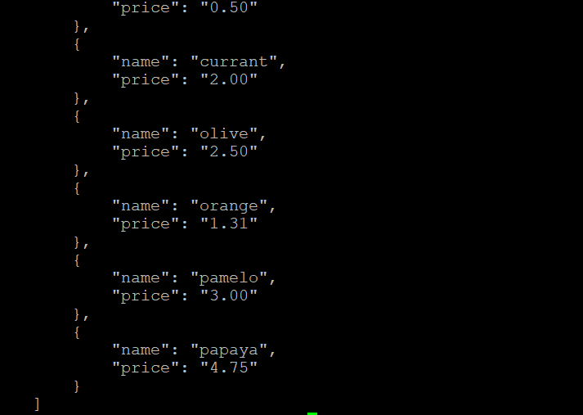

Good luck!