One of your company's developers noticed that the word readme was mispelled in the web api's git repository readme file.

The company policy dictates that all modifications are to be made in branches, and that these branches are to remain intact and not deleted. until reviewed by a senior developer.

You have been asked to log into the central server used for maintaining the git repository for the web api, which is located in the <user-name>'s home directory, and correct the spelling within the file. You are to use a branch named 'fix-readme', and merge the corrected file back into the master branch when finished. Again, do not remove your branch. Once you have completed this task, hand the system over to the lead developer for approval.

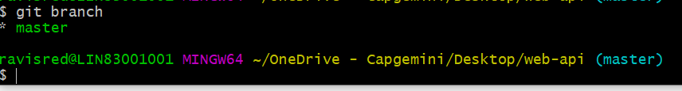

New branch created :

