**Data visualization:**

Data visualization is the graphical representation of information and data. By using visual elements like charts, graphs, and maps, data visualization tools provide an accessible way to see and understand trends, outliers, and patterns in data.

In the world of Big Data, data visualization tools and technologies are essential to analyze massive amounts of information and make data-driven decisions.

**The advantages and benefits of good data visualization:**



Our eyes are drawn to colors and patterns. We can quickly identify red from blue, square from circle. Our culture is visual, including everything from art and advertisements to TV and movies.

Data visualization is another form of visual art that grabs our interest and keeps our eyes on the message. When we see a chart, we quickly see trends and outliers. If we can see something, we internalize it quickly. It’s storytelling with a purpose. If you’ve ever stared at a massive spreadsheet of data and couldn’t see a trend, you know how much more effective a visualization can be.

**The different types of visualizations**

When you think of data visualization, your first thought probably immediately goes to simple bar graphs or pie charts. While these may be an integral part of visualizing data and a common baseline for many data graphics, the right visualization must be paired with the right set of information. Simple graphs are only the tip of the iceberg. There’s a whole selection of visualization methods to present data in effective and interesting ways.

**Common general types of data visualization:**

* Charts
* Tables
* Graphs
* Maps
* Info graphics
* Dashboards

**More specific examples of methods to visualize data:**

* Area Chart
* Bar Chart
* Box-and-whisker Plots
* Bubble Cloud
* Bullet Graph
* Cartogram
* Circle View
* Dot Distribution Map
* Gantt Chart
* Heat Map
* Highlight Table
* Histogram
* Matrix
* Network
* Polar Area
* Radial Tree
* Scatter Plot (2D or 3D)
* Stream graph
* Text Tables
* Timeline
* Tree map
* Wedge Stack Graph
* Word Cloud
* And any mix-and-match combination in a dashboard!

**Support Vector Machine (SVM):**

Support vector machine is another simple algorithm that every machine learning expert should have in his/her arsenal. Support vector machine is highly preferred by many as it produces significant accuracy with less computation power. Support Vector Machine, abbreviated as SVM can be used for both regression and classification tasks. But, it is widely used in classification objectives.

**What is Support Vector Machine?**

The objective of the support vector machine algorithm is to find a hyperplane in an N-dimensional space(N — the number of features) that distinctly classifies the data points.

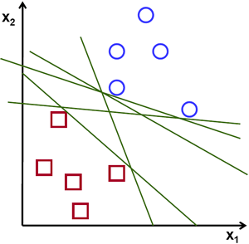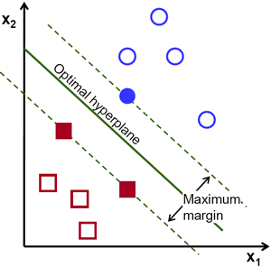

To separate the two classes of data points, there are many possible hyperplanes that could be chosen. Our objective is to find a plane that has the maximum margin, i.e the maximum distance between data points of both classes. Maximizing the margin distance provides some reinforcement so that future data points can be classified with more confidence.

**KEY WORDS :**

**Hyperplanes -**

Hyperplanes are decision boundaries that help classify the data points. Data points falling on either side of the hyperplane can be attributed to different classes. Also, the dimension of the hyperplane depends upon the number of features. If the number of input features is 2, then the hyperplane is just a line. If the number of input features is 3, then the hyperplane becomes a two-dimensional plane. It becomes difficult to imagine when the number of features exceeds 3.

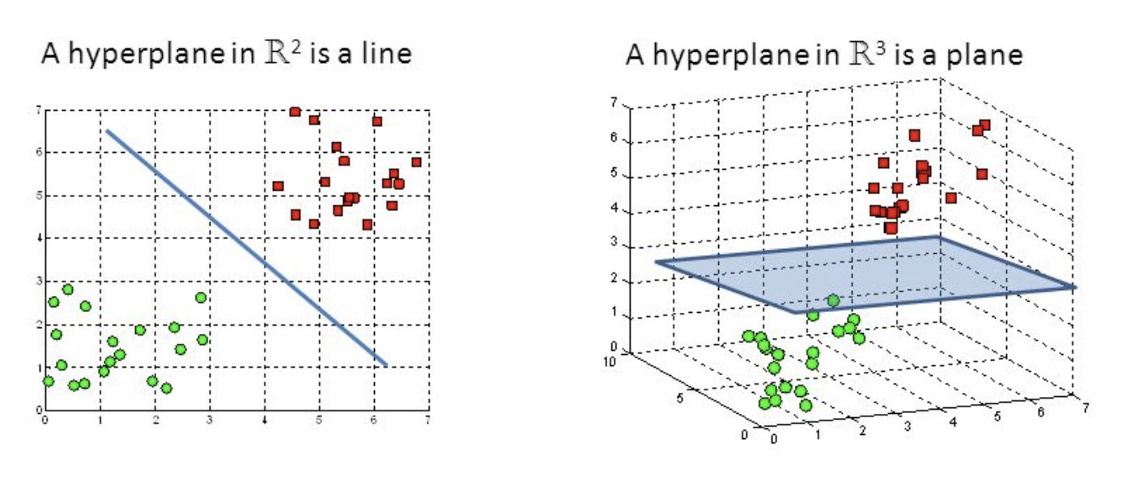

Fig : Hyperplanes in 2D and 3D feature space

**Support Vectors -**

Support vectors are data points that are closer to the hyperplane and influence the position and orientation of the hyperplane. Using these support vectors, we maximize the margin of the classifier. Deleting the support vectors will change the position of the hyperplane. These are the points that help us build our SVM.

