AccountOne: 0x0c0669Cd5e60a6F4b8ce437E4a4A007093D368Cb

AccountTwo: 0x7A1f3dFAa0a4a19844B606CD6e91d693083B12c0

Set Accounts:

Transaction 1 Ether (1000000000000000000 Wei):

Transaction 2: 10 Ether sent.

Transaction 3: 5 Ether sent.

Transaction 4: Withdraw 5 Ether (5000000000000000000 Wei) into AccountTwo.

Transaction 5: Withdraw 10 Ether (10000000000000000000 Wei) into AccountOne.

lasttoWithdraw function response (Account One expected):

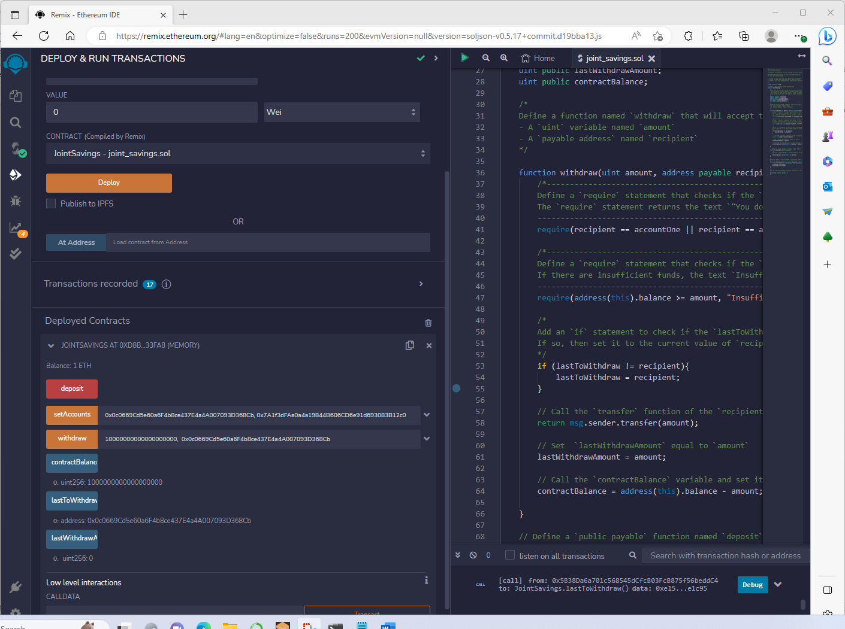

Transaction 6: Withdraw 10 Ether (10000000000000000000 Wei) into AccountOne.