Disaster Prediction Search and Rescue Operation Using Machine Learning
During disaster search and rescue (SAR) operations often hinder because of collapse building debris. Rescue team often suffer to reach victim on time which may cause death to victim. To easy search operations we are combining Robotic Hardware along with Machine Learning algorithms. Robots can easily reached dangerous locations and then apply Machine Learning algorithm to detect presence of human or their body parts.
During disaster ML algorithms must work accurately for human detection so we are employing CNN deep learning algorithm which is best known for optimize features extraction and this extracted features will get trained with various ML algorithms such as Random Forest, SVM and Decision Tree. Each algorithm performance is evaluated in terms of Accuracy, Precision, Recall, Confusion Matrix and FSCORE. All algorithms able to get more than 90% accuracy on CNN optimized features.
For accurate prediction Dataset will play an important role but on internet no such dataset exists so we downloaded some disaster images from internet which is created using Virtual Disaster. Dataset size was so small so we applied augmentation algorithm to increase dataset images count. Dataset can be downloaded from below GITHUB URL
https://github.com/noahzn/VictimDet/tree/main
We have coded this project using JUPYTER notebook and below are the code and output screens with blue colour comments.
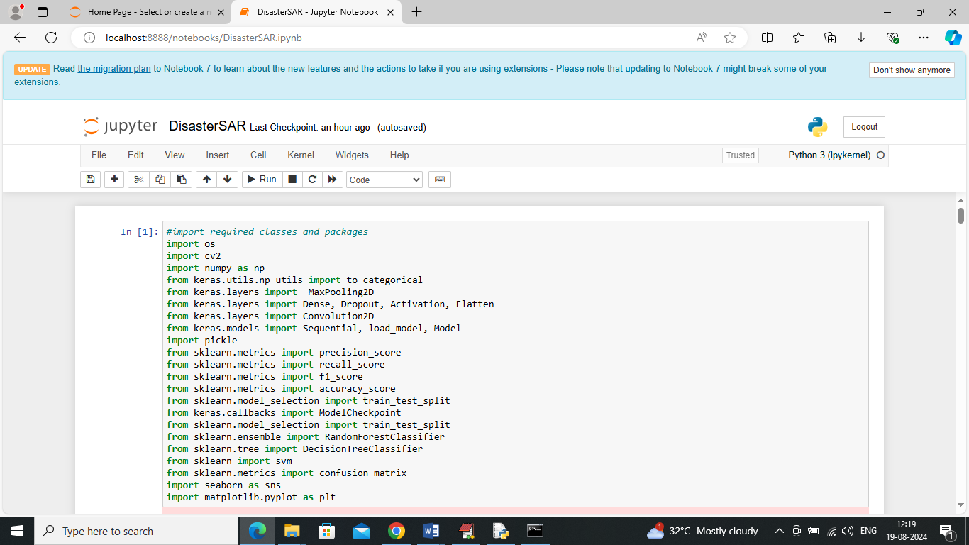
In above screen importing required packages and classes
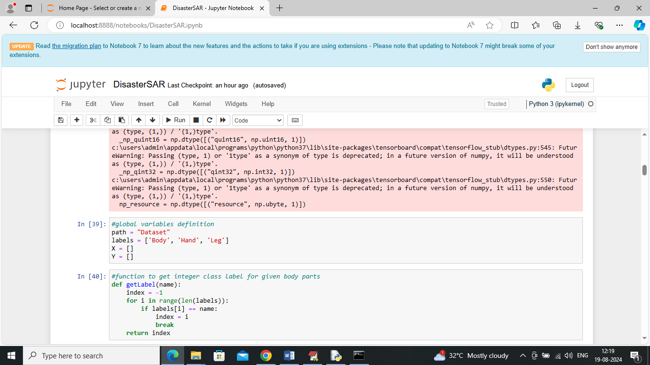
In above screen defining global variables and then define function to return integer label for given image such as 0 for Body, 1 for Hand and 2 for Leg
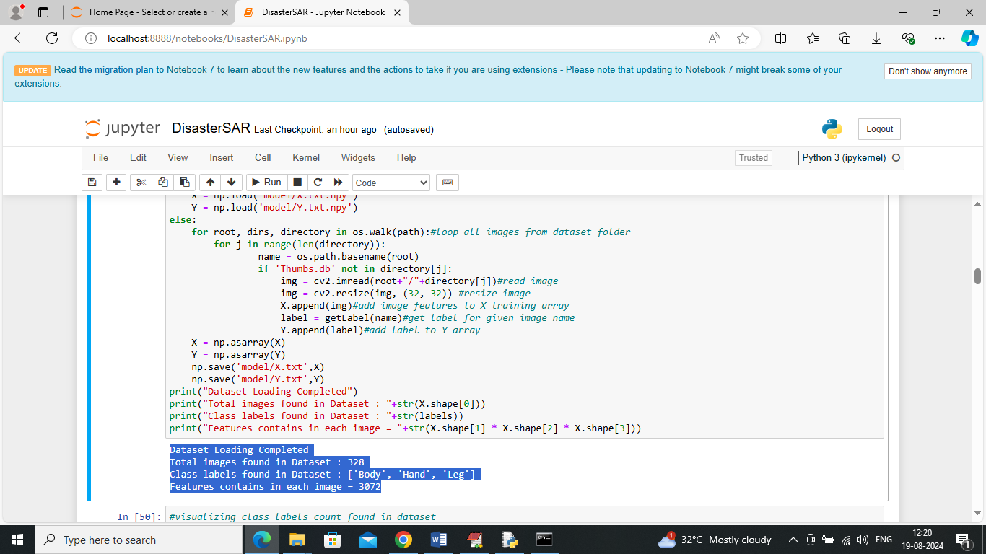
In above screen looping and reading all images from dataset and then resizing and adding all image features and class label to X and Y array. After executing of above block will get blue colour output where we are displaying total number of images, names of classes and number of features contains by each image
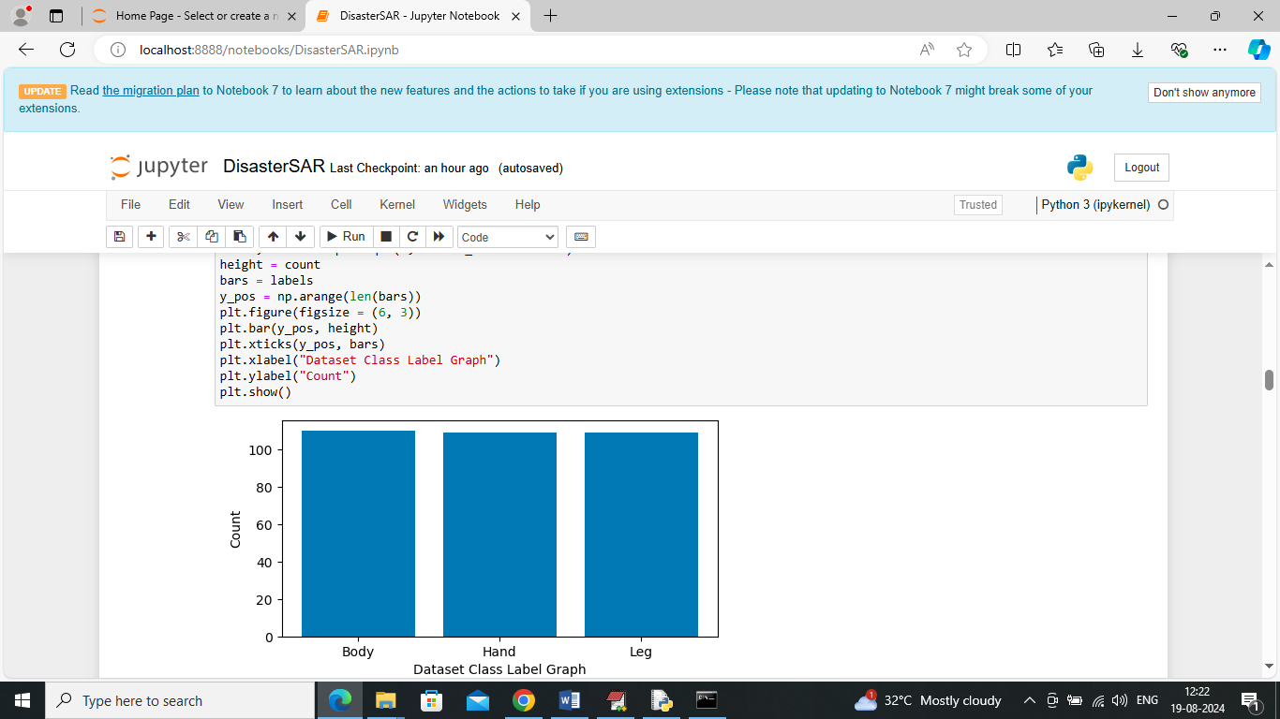
In above screen visualizing graph of different class labels where x-axis represents class label name and y-axis represents number of images available in that class
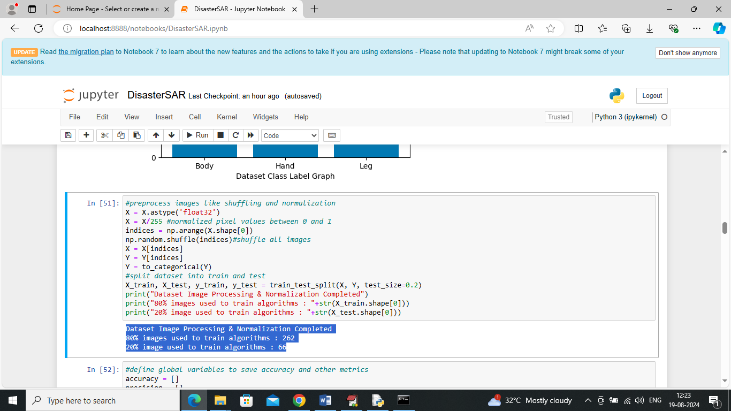
In above screen applying various pre-processing techniques such as shuffling, normalizing and splitting dataset into train and test where application using 80% dataset size for training and 20% for testing. In blue colour output can see train and test size
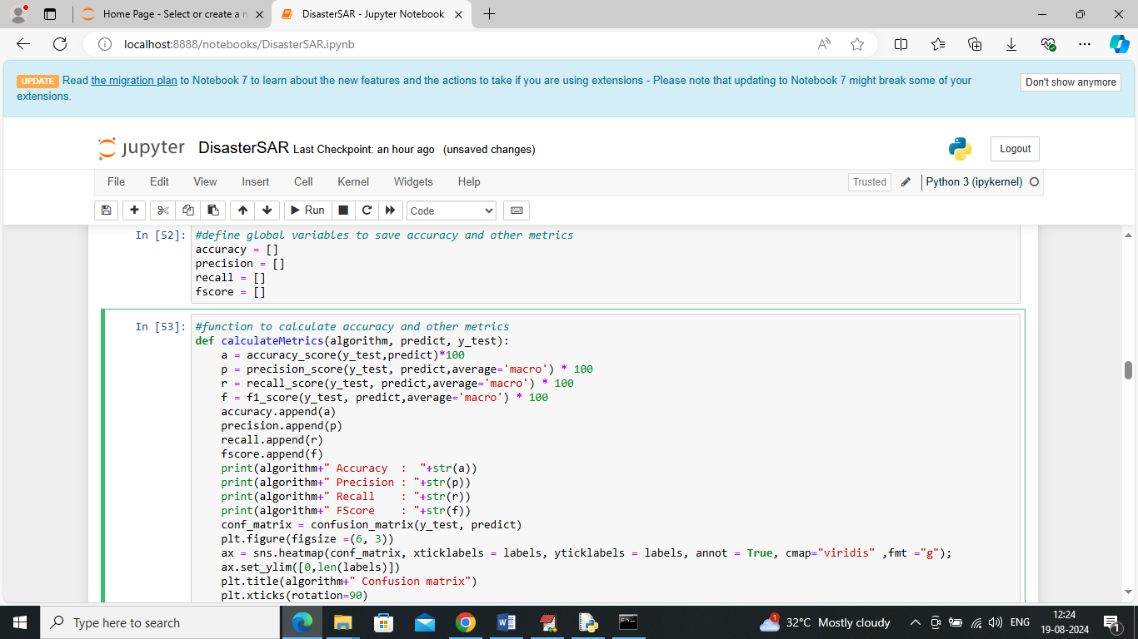
In above screen defining function to calculate accuracy and other metrics
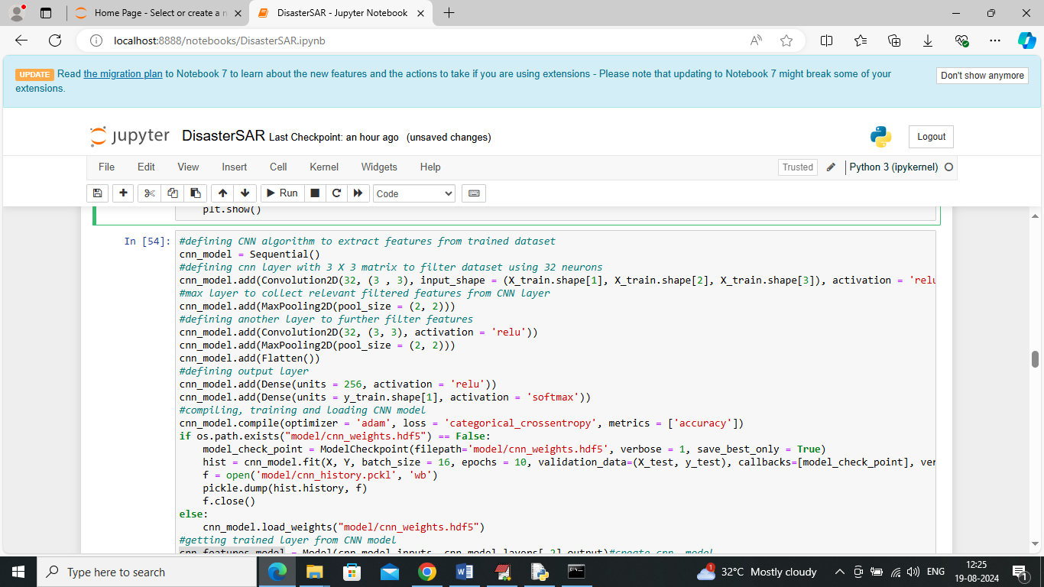
In above screen defining CNN algorithm architecture to train on processed features and after training will use below code to extract features from trained CNN model
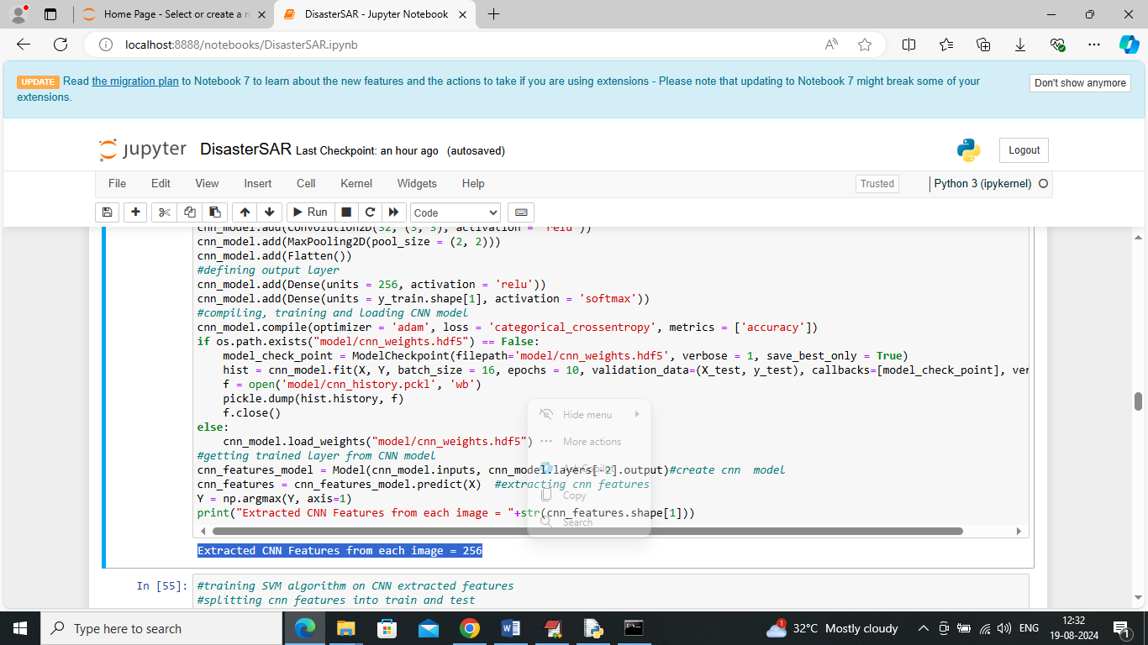
In above screen in last 4 lines you can see we are applying CNN model to extract features from X images and in blue colour out can see CNN extracted 256 features from each image from total 3072 features
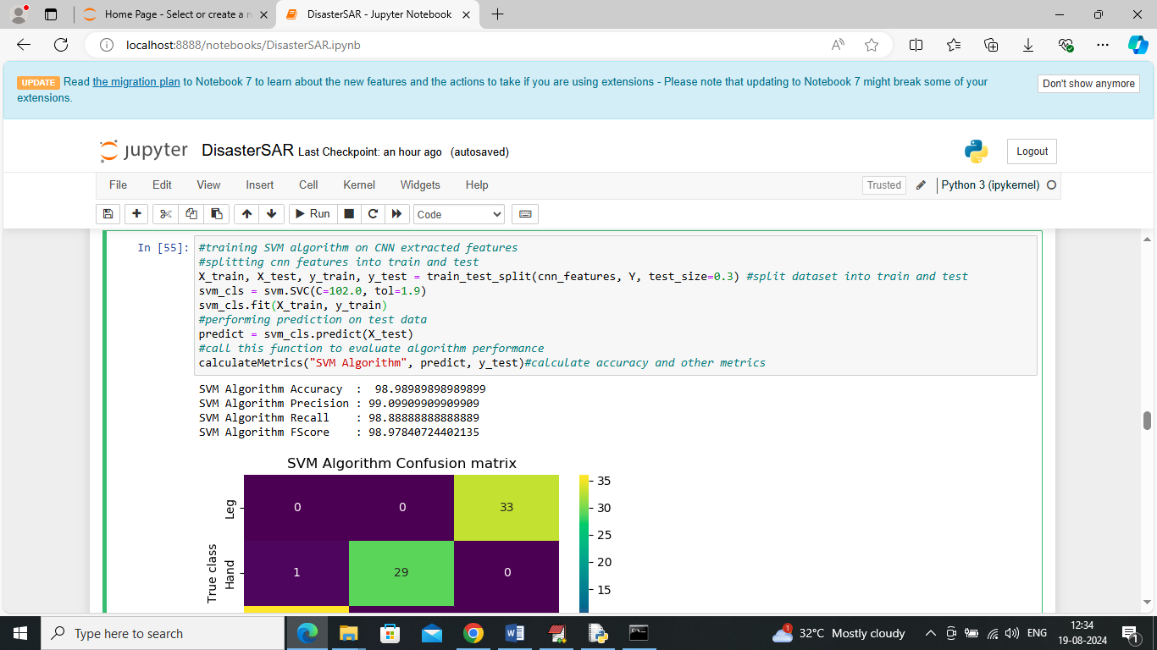
In above screen SVM algorithm getting trained on CNN extracted features and then trained model applied on test image to calculate prediction accuracy. In above screen SVM got 98% accuracy and can see other metrics like precision, recall and FSCORE. Below is the predicted confusion matrix for SVM
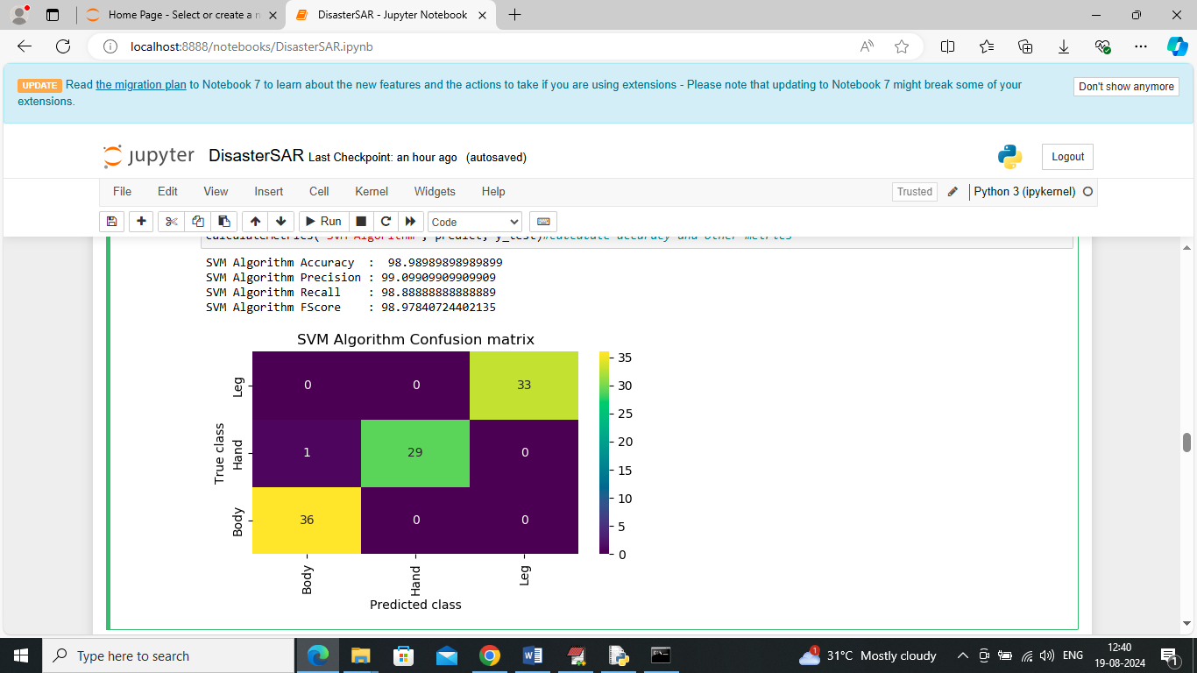
In above SVM confusion matrix graph x-axis represents Predicted Labels and y-axis represents True Labels and then all different colour boxes in diagnol represents correct prediction count and all remaining blue boxes represents incorrect prediction count which are very few
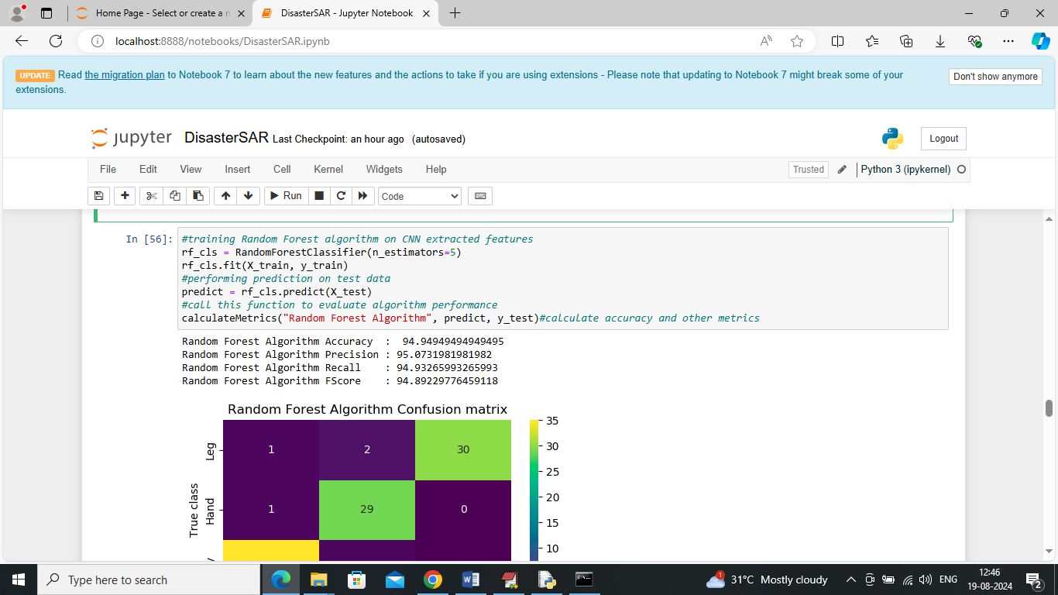
In above screen training Random Forest algorithm and it got 94% accuracy
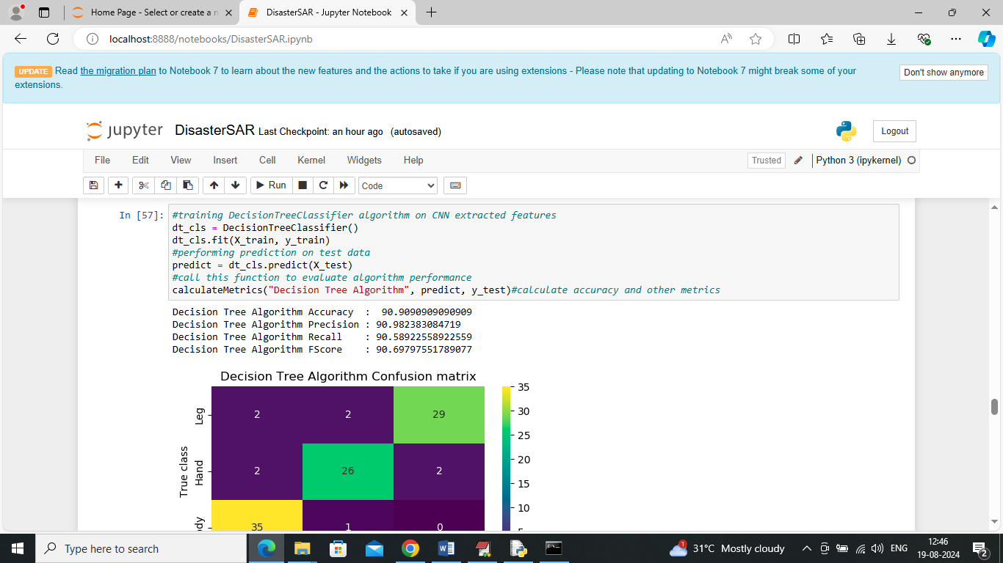
In above screen training Decision Tree algorithm and it got 90% accuracy and can see other metrics also
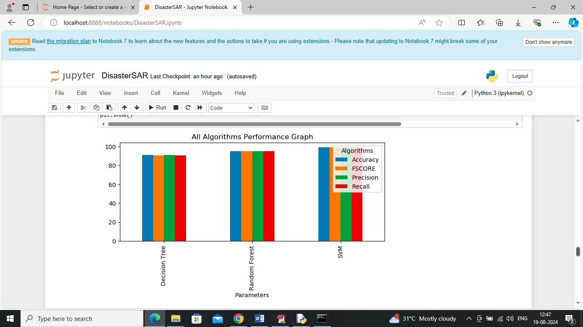
In above screen visualizing all algorithm performance where x-axis represents algorithm names and y-axis represents accuracy and other metrics in different colour bars and in all algorithms SVM got high accuracy. Each algorithm will be tested and trained on Random train and test split so all algorithm performance will vary for each run.
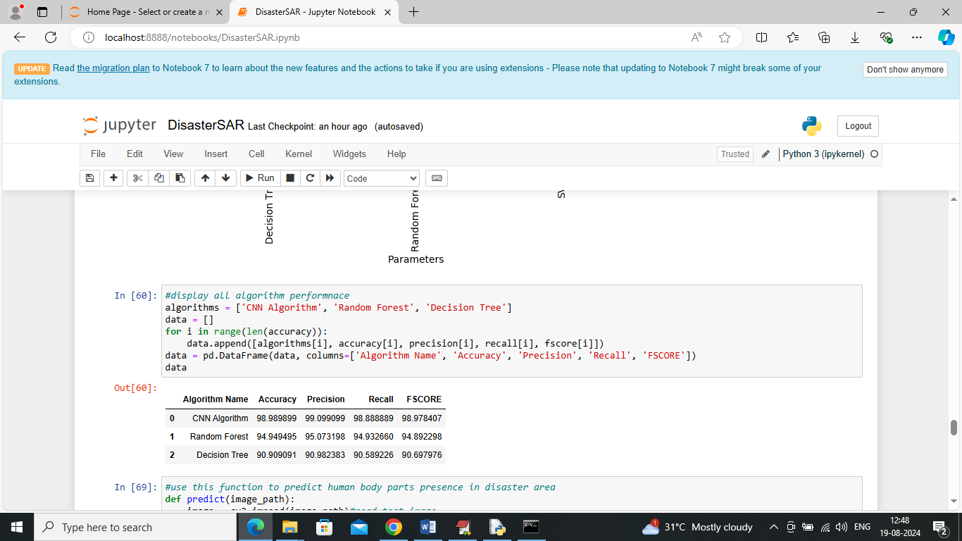
In above screen displaying all algorithm performance in tabular format
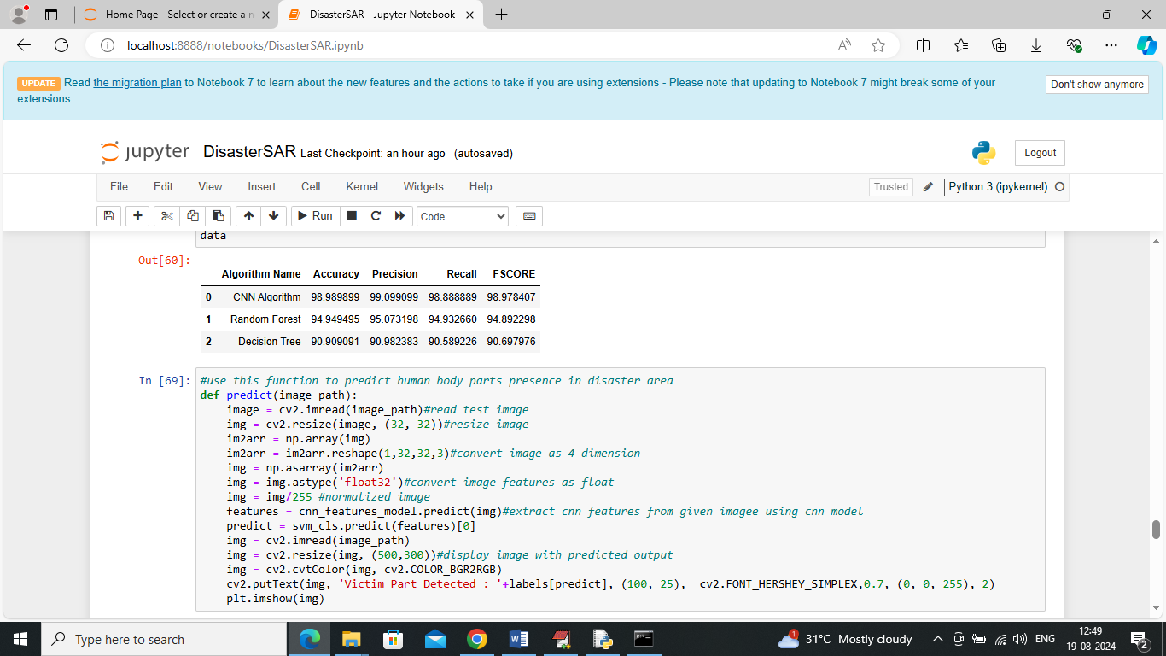
In above screen defining predict function which will take test image path and then read image, resize image, apply CNN to extract features and then apply SVM on extracted features to predict presence of human body part at disaster image
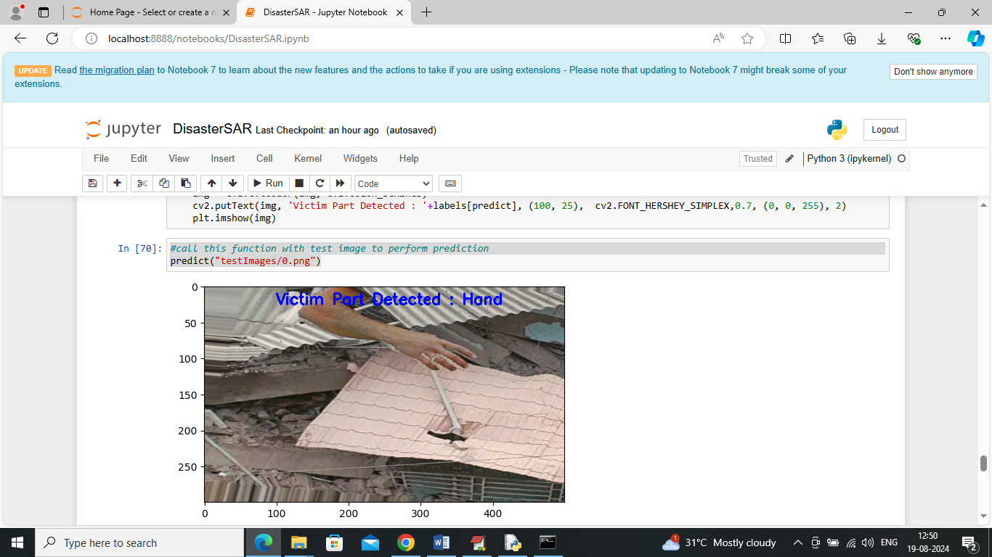
In above screen calling predict function with test image path and then ‘Hand’ part is detected
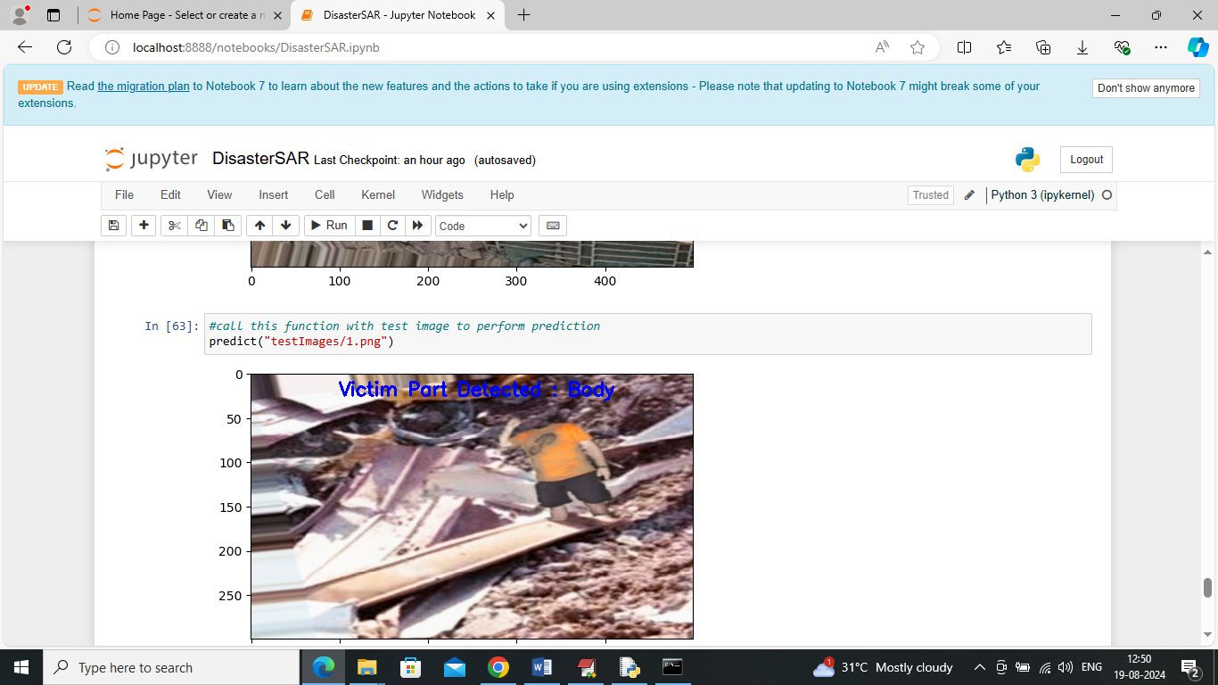
In above screen victim body is detected
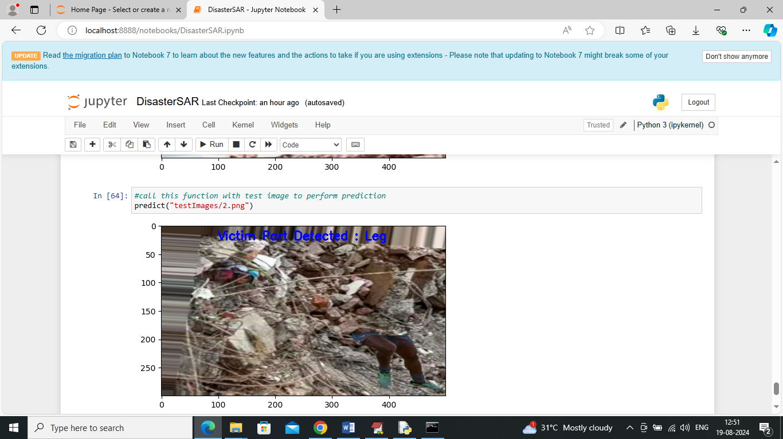
In above screen victim Leg is detected and similarly you can call predict function with different image paths to predict human body. All testing images are available inside ‘test Images’ folder.

