Crash Causal Factors Program (CCFP)
IT Solution
Business Requirements Document

September 2025

Draft / Deliberational / Pre-Decisional
For Internal Use Only / Not for Distribution

complet





Table of Contents
Document Purpose and Structure 1
Background 4
Program Overview 4
CCFP IT Solution 5
Assumptions/Constraints 6
Design Requirements 6
General Requirements 7
Data Collection Requirements 8
CCFP Incident Data 8
Inspection Data 9
Post-Crash Investigation Data 9
Reconstructionist Data 10
PCR Data 10
Additional Crash Data 10
BTS Data 11
CCFP Data Lake Integration and Storage Requirements 11
Data Management, Analysis, and Sharing 12
Analyze and Share Data; View and Download Results 12
Manage Data (Interface) 14
Manage Administrative Functions (Interface) 14
Appendix A: Acronyms and Abbreviations 16
Appendix B: Glossary of Key Terms 18
Appendix C: CCFP IT Solution Diagrams 21
Appendix D: External Data Sources for CCFP IT Solution 24
Appendix E: ELD Requirements 26

Document Purpose and Structure
This document outlines the background, assumptions/constraints, and business requirements for the Information Technology (IT) solution in support of the Federal Motor Carrier Safety Administration’s (FMCSA) Crash Causal Factors Program (CCFP). A summary of each section of the document is provided below.
- Background: Provides an overview of FMCSA’s CCFP program and explains why the Agency needs a CCFP IT Solution to advance program efforts.
- Assumptions/Constraints: Outlines assumptions and constraints associated with the development of the CCFP IT Solution.
- Design Requirements: Summarizes high-level design requirements in alignment with federal standards and best practices for the CCFP IT Solution.
- General Requirements: Provides high-level general requirements for the CCFP IT Solution.
- Data Collection Requirements: Outlines requirements related to data collection for the CCFP IT Solution.
- Data Management, Analysis, and Sharing Requirements: Provides requirements related to data management, analysis, and sharing. Includes user roles and access levels.
- Appendix A: Provides a list of acronyms and abbreviations used in this document and their corresponding definitions.
- Appendix B: Lists key terms used in this document and their corresponding definitions.
- Appendix C: Includes diagrams that demonstrate data collection and data management, analysis, and sharing requirements.
- Appendix D: Lists external data sources owned by FMCSA and other entities for incorporating into the CCFP IT Solution.
- Appendix E: Outlines specific requirements for integrating Electronic Logging Device (ELD) data into the CCFP IT solution.
Note: links to the appendices are provided where relevant throughout the document.

Background

Program Overview
FMCSA’s CCFP is a detailed crash data collection, analysis, and research effort intended to:
- Identify the key factors that contribute to crashes involving commercial motor vehicles (CMVs);
- Inform countermeasures to prevent these crashes; and
- Establish a foundation for continued data collection, sharing, and analysis.
Through a series of robust studies, the CCFP pursues a nuanced understanding of crashes involving CMVs so that policymakers, law enforcement agencies, regulators, and other interested parties can implement effective crash prevention strategies and programs.
The CCFP’s multi-year, multi-phase approach will target unique vehicle types and/or crash severities for each causal factors study. Phase 1 focuses on fatal crashes involving heavy-duty trucks (Class 7/8 trucks) and will leverage existing State jurisdiction crash data collection processes to streamline data collection efforts. Future phases will target other vehicle types and crash severities, continuing to identify existing data collection resources and leveraging them to the extent possible. The data collection process established in Phase 1 will serve as a foundation for subsequent phases. Figure 1 outlines the planned studies for each phase along with estimated timeframes where available. In addition to producing datasets and analytical reports, the CCFP will establish a foundation for continued data collection, analysis, and research that FMCSA and States can routinely use to optimize their CMV safety activities.
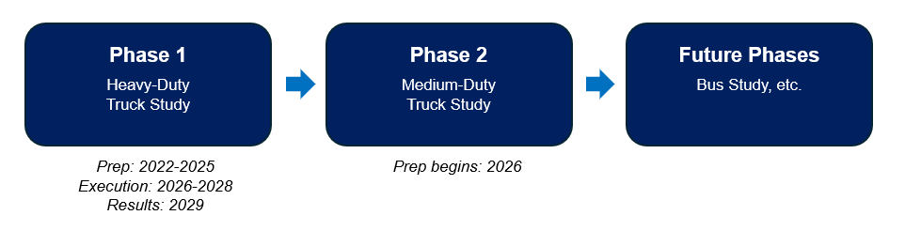
Figure 1. CCFP Planned Studies by Phase
Authorized by Congress, the CCFP is part of the U.S. DOT and FMCSA’s heightened effort to address the rising number of fatal crashes and pursue a long-term goal of zero roadway fatalities.

CCFP IT Solution
To advance the CCFP’s goals, FMCSA needs a CCFP IT Solution that supports a multi-phase, multi-year data collection, analysis, and research effort. FMCSA requires a solution that:
- Is scalable so it can grow and adapt to evolving business needs and research findings over time, such as new data attributes, users, participating States, and future phases of this program.
- Minimizes the data-sharing burden to States by adapting to State systems, thereby allowing States to send their data to the CCFP without requiring significant changes to systems or data formats.
- Facilitates dynamic data collection by securely ingesting, integrating, and sharing a variety of data attributes from many sources, including State jurisdictions, FMCSA systems, and other systems owned by other entities.
- Provides analytical functionality and tools to help FMCSA, States, and other stakeholders identify crash causal factors and conduct ad-hoc analyses and in-depth studies.
The sections that follow outline in detail the business requirements for the CCFP IT Solution.

Assumptions/Constraints
- An agile approach will be used throughout development to provide continuous communication and collaboration between the product owner and stakeholders. This approach will ensure that the final product aligns closely with user needs and expectations.
- The CCFP Project Team will participate in all user acceptance testing during sprint development. Detailed requirements for the CCFP IT Solution may need to be adjusted based on feedback received during user acceptance testing.
- A Product Roadmap will be provided to the entire CCFP Project Team and FMCSA Leadership to align everyone’s vision and direction for the CCFP IT Solution. This roadmap will include details on the product features and documentation deliverables, and a high-level timeline, including sprint and testing schedules.
- Development, functional testing, and data validation requirements for the participating States who will be sharing data with the CCFP IT Solution will be minimal.
- Approved data-sharing agreements must be in place before States begin using the CCFP IT Solution. FMCSA IT and the Privacy Office will work with the States to establish data-sharing agreements.

Design Requirements
The design of the CCFP IT Solution should follow the federal standards for websites along with DOT best practices, including:
- Section 508 Compliance: Comply with Section 508 of the Rehabilitation Act, which requires federal agencies to ensure their electronic and information technology is accessible to people with disabilities.
- Design Standards: Follow the finalized federal website standards which include a federal government banner for the website, a descriptive HTML page title and meta page description for accessibility and searchability.
- Domain: Comply with the DOTGOV Online Trust in Government Act by only using .gov or .mil domains for official communications, information, and services. View additional detail in this memorandum.
- Paperwork Reduction: Comply with the Paperwork Reduction Act, which requires that information collected from the public should minimize burden and maximize public utility. OMB approval must be received before collecting information via the CCFP IT Solution and the OMB control number must be displayed on the solution.
- Plain Writing: Follow the Plain Language Writing Act, which requires federal agencies to use clear communication that the public can understand and use.
- Privacy and Identity Management: Follow the Privacy Act, which requires federal agencies to publish documentation explaining how records about individuals are collected, maintained, used, and disseminated by the federal government. This documentation includes a Privacy Threshold Analysis, Privacy Impact Assessment, and System of Records Notice.
- Records Management: Follow National Archives and Records Administration (NARA) guidance on creating, managing, and disposing of federal records. Records management resources are available here.
- Open Government/Data: Publish information in ways that make it easy to find, access, share, distribute, and re-purpose; structure content and tag with standard metadata. Make open data, content, and application programming interfaces (APIs) the new default and make existing high-value data and content available through APIs where needed.
- Search: Ensure CCFP IT Solution includes a search function which allows users to easily search content. Provide ability to search across internal and external FMCSA systems/ databases, including legacy systems. Content should also be optimized for the search function.
- Mobile/Device Agnostic: CCFP IT Solution should be mobile responsive and device agnostic.
- Information Quality: Maximize the quality, objectivity, utility, and integrity of information and services provided to the public and make information and services available on a timely basis.
- Copyright: If private sector information is used or duplicated in the CCFP IT Solution, protect the property rights of the source. (These protections apply to any material posted to federal public websites, such as documents, graphics, or audio files.)

General Requirements
FMCSA needs a scalable CCFP IT Solution to support a multi-phase, multi-year data collection, analysis, and research effort. The solution must be able to dynamically collect various data attributes from multiple sources; integrate and match data from new and existing sources and store it in a CCFP Data Lake; and provide the environment and tools to analyze and share the data. The solution should be informed by the following general requirements.
- Scalability: Able to grow and adapt to business and program needs over time, such as increasing users, new participating States, new data attributes and sources, new/enhanced functionality, and future phases of this program such as the Medium-Duty Truck Study and Bus Study.
- Adaptability to State Systems: Able to allow States to share their data with CCFP without requiring significant changes to their systems or data formats.
- Dynamic Data Collection: Able to accept via manual entry or automation (e.g., webservice), integrate, and share different types of data (e.g., data elements, documents, videos, images, etc.) from multiple existing and new sources, such as FMCSA systems, State systems, National Highway Traffic Safety Administration (NHTSA) systems, and other non-FMCSA systems such as the Commercial Driver’s License Information System (CDLIS), National Oceanic and Atmospheric Administration (NOAA) datasets, and the Federal Highway Administration’s (FHWA) Highway Performance Monitoring System (HPMS). A list of the data sources for integration into the CCFP IT Solution is available in Appendix D. Specific requirements for integrating ELD data into the solution are outlined in Appendix E.
- Reliability and Performance: Able to handle at least 1,000 concurrent users without negatively impacting performance or response time. Must be available 24/7 except for scheduled maintenance and updates.
- Supportability and Maintainability: Must be easy for developers to maintain, fix, and update to keep service running smoothly. This ensures the CCFP IT Solution will stay reliable, adaptable, and cost-effective through its lifecycle.
- Agile Development: Must support iterative and incremental development and testing. Have minimal bugs that will be addressed quickly through the development process.
- System Design Documentation: Provide supporting documentation to assist users. This will include a data dictionary, a data coding manual, and user guide to support the CCFP Data Coding and Entry Training for CMV Data Analysts along with other necessary documentation for system operations and maintenance (e.g., interface control documentation, technical specifications).
- Training: Integrate CCFP Project Team Training Lead and other team members into development meetings and user acceptance testing. Provide training sessions with CCFP Project Team on the CCFP IT Solution once development is completed. Sessions should cover core tasks all users must perform, specific tasks by user role, and system policies.

Data Collection Requirements
The CCFP IT Solution must be able to collect different data attributes from various systems and users related to qualifying crashes. Each existing data collection process has its own submission timeframe. The goal is to leverage these existing processes and collect this data in the CCFP Data Lake as soon as it becomes available, so that the CCFP IT Solution and FMCSA can begin to assemble “complete” crashes and analyze crash causal factors.

For Phase 1 of the CCFP IT Solution, a qualifying crash is a crash involving at least one fatality and at least one heavy-duty truck (e.g., Class 7/8). An in-scope crash is a qualifying crash within a participating State jurisdiction. In addition, the CCFP IT Solution should be able to accept out-of-scope crashes to support analysis efforts. Out-of-scope crashes include:

- Qualifying crashes in State jurisdictions that are not participating in the study.

- Non-qualifying heavy-duty truck crashes (i.e., serious injury crashes) from any State that conducted an advanced investigation for those crashes.

The CCFP project will not collect all CCFP required data for the out-of-scope crashes listed above; these crashes will be used to supplement analysis and provide a baseline for comparison.

CCFP Incident Data
Initial Incident Form: New electronic form to be developed as part of the CCFP IT Solution. The Motor Carrier Safety Assistance Program (MCSAP) CMV Inspector will complete the form within 24-48 hours after a qualifying crash occurs. Once the form is completed and saved in the CCFP IT Solution, the U.S. DOT Numbers in the form will need to be validated against SafeSpect. This form will contain critical information to create the initial record for the crash, such as crash date and time, location, persons involved (e.g., drivers, motor carrier(s), and witnesses), and a short synopsis of the event. The form will need to be configurable to changing program and business needs (e.g., additional data attributes identified during the study, future phases of program). It will also need to be generated and stored in the CCFP Data Lake, and routed to the Bureau of Transportation Statistics’ (BTS) secure database, discussed in more detail later in this document. These requirements will be finalized during the Phase 2 Discovery Phase (Appendix C, Diagram 1).

Specific requirements for the new Initial Incident Form and ability to collect additional data for a crash are summarized below by corresponding user group and access requirements.

User Requirements | Users | Access Required
Create, update, save and delete electronic Initial Incident Form. | MCSAP CMV Inspector | Create, Read, Update, Delete*  *Will require additional business rules to determine the specific collection/analysis phase after which the form cannot be deleted.
View and update Initial Incident Form. | CMV Data Analyst  CCFP Project Team  BTS CIPSEA Agent | Read, Update  Read
Enter and update additional data elements related to a crash. | CMV Data Analyst  CCFP Project Team | Read, Update

Inspection Data
Post-Crash Inspection: Existing inspection performed by the MCSAP CMV Inspector. Recorded on driver/vehicle examination reports to document violations and defects discovered at the time of the inspection. These inspections assist in identifying where regulatory non-compliance by a driver may have contributed to crash causation and identify whether vehicle defects existed prior to or resulted from a crash. The MCSAP CMV Inspector collects post-crash inspection data via SafeSpect/approved commercial off-the-shelf software and uploads it to FMCSA within 7 days of the inspection. This data must be included in the CCFP Data Lake (Appendix C, Diagram 1).

Post-Crash Investigation Data
Post-Crash Investigation: A more thorough investigation of the crash, typically performed by a law enforcement officer. It involves the collection of additional data elements beyond what is collected as part of a standard Police Crash Report (PCR) but is not as expansive as a crash reconstruction. The new Post-Crash Investigation Form includes the post-crash investigation data elements for this study. The State CMV Data Analyst could enter this data manually into the CCFP Data Lake or there could be a mechanism to automate the data entry into the CCFP Data Lake. (Appendix C, Diagram 1).

Reconstructionist Data
Crash Reconstruction: A crash reconstruction involves all the components of a crash investigation, plus additional data collection and analysis that “utilizes principles of physics and empirical data to analyze the physical, electronic, video, audio, and testimonial evidence from a crash to determine how and why the crash occurred” (SAE International). Crash reconstructions are typically completed by specially trained law enforcement officers or contracted third parties. It is expected that findings from this analysis will be available between 90-120 days of the crash. The additional analysis or reconstruction reports are typically in a narrative form that must be read and interpreted for manual entry for connection to the appropriate research question.
The State CMV Data Analyst could enter this data manually into the CCFP Data Lake or this data could be sent automatically to the CCFP Data Lake where the technology is available (Appendix C, Diagram 1).

PCR Data
The PCR is a form for collecting data at the scene of a motor vehicle traffic crash. PCRs are typically completed by local/county/State law enforcement personnel and undergo quality control before being uploaded to the State’s own crash repository. The CCFP IT Solution must be able to collect PCR data from each participating State without asking them to make significant changes to their standard PCR submission process. The CCFP IT Solution should be adaptable to each State’s existing procedures. The CCFP IT Solution will need to be able to collect and store all categories of data listed on a State’s PCR. Standard categories based on the Model Minimum Uniform Crash Criteria (MMUCC) include crash, dynamic data elements, fatal section, large vehicles and hazardous materials, non-motorist section, person, roadway, and vehicle. In addition, once the PCR is integrated into the CCFP IT Solution, the driver information in the PCR should be validated against CDLIS. Example approaches for collecting PCR data are provided below.
- FMCSA Crash Data: The PCR is uploaded to the State crash repository and the MCSAP Analyst uploads a subset of that PCR data to FMCSA’s SafeSpect Crash Reporting Module within 45 days of the crash and then it becomes available in the Motor Carrier Management Information System (MCMIS). This data must be integrated into the CCFP Data Lake (Appendix C, Diagram 1).
- Direct Connection to State Crash Repository: Each State maintains their own crash repository with PCR data. The CCFP Project Team will explore the feasibility of establishing a direct connection between State crash repositories and the CCFP Data Lake via a CCFP webservice or other electronic data-sharing methods. This direct connection would integrate the PCR into the CCFP Data Lake (Appendix C, Diagram 1).

Additional Crash Data
During the study, some States may not submit all the required data. The State CMV Data Analyst will be responsible for collecting the missing data and entering it into the CCFP Data Lake (Appendix C, Diagram 1). To support the CMV Data Analyst an interface for manual entry must be developed. This interface must be configurable to support changing program and business needs (e.g., additional data attributes identified during the study, future phases of the program).

BTS Data
As part of the new CCFP process, BTS Confidential Information Protection and Statistical Efficiency Act (CIPSEA) Agents will conduct follow-up interviews with involved drivers, carriers, and witnesses after receiving notification that a new Initial Incident Form has been submitted for an in-scope crash. BTS is subject to CIPSEA which ensures the protection and security of respondent data. CIPSEA ensures that any identifying, sensitive, or proprietary information that BTS collects is not released to unauthorized persons, organizations, or associations.
FMCSA IT will coordinate with BTS to decide the best way to access BTS data. This method must comply with the BTS’ Confidentiality Policy and CIPSEA requirements. Access options may include read-only access to BTS data, exportable summary data, data integration from BTS’ secure database into the CCFP Data Lake, or data integration from the CCFP Data Lake to BTS’ secure database. Access options may require a Memorandum of Understanding (MOU) with BTS, which would specify the data being shared (for example, summary data excluding driver PII), security protocols, and the access method (Appendix C, Diagram 1).

CCFP Data Lake Integration and Storage Requirements
The CCFP IT Solution must be able to integrate, map, aggregate, and store different data attributes from various systems and users related to qualifying crashes in the CCFP Data Lake. These data attributes may be sent automatically from a source system to the CCFP Data Lake or be entered manually via a CCFP interface into the CCFP Data Lake by the State CMV Data Analyst. The IT solution must be able to accommodate both automatic and manual entry workflows. Specific data integration and storage requirements are outlined below. See diagram 2 in Appendix C for an illustration.

- Ability for a MCSAP CMV Inspector or State designated user to generate and save an electronic Initial Incident Form as soon as possible after the crash occurs (within 24-48 hours). Once saved in the CCFP Data Lake, the CCFP IT Solution should immediately notify the State CMV Data Analyst and BTS CIPSEA Agent that a new Initial Incident Form is available to review so they can begin collecting additional data related to the crash. Note: in-scope crashes would be routed to both the State CMV Data Analyst and BTS CIPSEA Agent. Out-of-scope crashes would only be routed to the State CMV Data Analyst.
- Ability to create and assign a unique CCFP identifier for a crash associated with the Initial Incident Form. The CCFP identifier must contain a data field to enable the distinction between in-scope crashes and out-of-scope crashes that are being collected as supplemental data.
- Ability to integrate into the CCFP Data Lake data related to qualifying and in-scope crashes as it is received from participating systems.
- Ability to generate a summary of data attributes selected in specific PCR sections and prompt the State CMV Data Analyst (who will be coordinating with the State) to select the top three primary contributing factors for that crash based on the summary. The specific PCR sections that should be included in the summary are:
  - Contributing Circumstances for Roadways, Vehicles, and Non-Motorists
  - Driver Actions at the Time of Crash
  - Driver Conditions at the Time of Crash
  - Driver and Non-Motorists Distracted By
  - Non-Motorist Actions at the Time of Crash
- Ability to aggregate data attributes pertaining to a single qualifying or in-scope crash and identify “complete” crash records. The ability to manage the data attributes that constitute a “complete” crash record is part of the CCFP Project Team Administrator Role which is described in Manage Administrative Functions (Interface).
- Ability to implement quality control business rules to check for missing data, data entry errors (e.g., format is incorrect for data type), etc.
- Ability to perform compliance checks against other authoritative systems (e.g., CDLIS).
- Ability to define and filter by qualifying, in-scope, and out-of-scope crashes.
- Ability to identify qualifying crashes and in-scope crashes that do not have a corresponding Initial Incident Form. This form is essential because it alerts the CMV Data Analyst to new crashes that need complete records and triggers the CIPSEA interview process. Flagging qualifying and in-scope crashes that are missing the form will allow for timely follow-up with each State to ensure the form is completed and no applicable crash is excluded from the study.
- Automatic edit tracking log that indicates when records are updated and by whom.

Data Management, Analysis, and Sharing
The CCFP IT Solution must include an analysis environment and a web-based application for authorized users to access and use the data in the CCFP Data Lake. The CCFP Project Team, CCFP Database Administrator, and State CMV Data Analysts will need to be able to conduct data analysis and reporting; manage the data in the CCFP Data Lake; manage administrative functions for the analysis environment and the web-based application. Other FMCSA users, NHTSA users, State users, and BTS users will need the ability to view and download reports. The public will need access to summarized, de-identified data once each study is published. Specific requirements for each data use category are summarized below by corresponding user group and access level required. The data management functionality must be complete by September 30, 2025; analysis and data sharing capabilities can be delivered after September 30, but before the pilot study begins in January of 2026.

Analyze and Share Data; View and Download Results
To support analysis, data-sharing, and download capabilities, the CCFP IT Solution must include an analysis environment, database, and analysis and data visualization tools.
Data access levels available to each user group will be managed via user roles and permissions in the Data Management Interface described in Manage Administrative Functions (Interface). The access model used for the FMCSA’s Drug and Alcohol Clearinghouse (DACH) could be used. See diagram 2 in Appendix C for an illustration.
User requirements and access levels for analysis and data-sharing and view and download capabilities are provided in the tables below.
Analyzing and Sharing Data
User Requirements | Users | Access Required
Manage the mapping and analysis of data attributes coming from external systems to CCFP data attributes. | CCFP Database Administrator (FMCSA CTO Resource) | Create, Read, Update, Delete
Analyze CCFP data stored in the Data Lake/analysis environment to assist with analysis of crash causal factors. | CCFP Project Team | Create, Read, Update, Delete
Run queries and create dashboards, visualizations, reports, and tables for data-sharing. | CCFP Project Team | Create, Read, Update, Delete
Share dashboards, reports, and tables. | CCFP Project Team | Create, Read, Update, Delete
Note: Further coordination and discussion with BTS is needed to determine access requirements for BTS data.
Viewing and Downloading Data
User Requirements | Users | Access Required
View and download dashboards, reports, and tables. | Federal Users* (PII)  State Users** (No PII)  Public Users (No PII, Summary De-Identified Data Only) | Read  Read  Read
*Example Federal Users: CCFP Project Team (includes designated FMCSA CIPSEA Agent), CCFP Database Administrator, CCFP Data Scientist, FMCSA HQ Users, FMCSA Enforcement, NHTSA Users, BTS CIPSEA Agents
**Example State Users: MCSAP CMV Inspector, State CMV Data Analyst, State Enforcement Users State Crash Reconstructionist/Post-Crash Investigator

Manage Data (Interface)
To support the following user requirements, the CCFP IT Solution must include an interface for data management. See diagram 2 in Appendix C for an illustration.
User Requirements | Users | Access Required
View raw data from all data sources. | CCFP Database Administrator (FMCSA CTO Resource) CCFP Project Team | Read
View all aggregated data associated with a crash. | CCFP Database Administrator (FMCSA CTO Resource)  CCFP Project Team  State CMV Data Analyst | Read
View data shared by BTS. | CCFP Database Administrator (FMCSA CTO Resource)  CCFP Project Team | Read
Review and edit data attributes as part of QC process. | CCFP Project Team  State CMV Data Analyst | Read, Update
View and edit a crash record’s “complete/incomplete” status. | CCFP Project Team  State CMV Data Analyst | Read, Update
View, unlock, and edit a complete crash record. | CCFP Project Team  State CMV Data Analyst | Read, Update

Manage Administrative Functions (Interface)
To support the following user requirements, the CCFP IT Solution must include an interface for administrative functions. See diagram 2 in Appendix C for illustration.
User Requirements | Users | Access Required
Manage users, groups, roles, interface, and data access permissions. | CCFP Project Team (Administrator Role) | Create, Read, Update, Delete
Define and manage study parameters (e.g., qualifying, in-scope and out-of-scope crash settings, study duration). Example crash settings include:  - CMV type: Heavy-duty truck, medium-duty truck, bus, etc.  - Crash type: Fatal, severe injury convenience sample  - Crash location: State, county  - Study duration: Starting/ending date | CCFP Project Team (Administrator Role) | Create, Read, Update, Delete
Manage data attribute settings, such as:  - Required vs. not required attributes  - Read-only vs. editable attributes  - Future attributes to be collected in forthcoming phases | CCFP Project Team (Administrator Role) | Read, Update
Identify data elements and develop business rules that represent a “complete” crash. | CCFP Project Team (Administrator Role) | Create, Read, Update, Delete

Appendix A: Acronyms and Abbreviations
The table below provides a list of acronyms and abbreviations used in this document and their corresponding definitions.
Term | Definition
ACE | Activity Center for Enforcement
AAMVA | American Association of Motor Vehicle Administrators
API | Application Programming Interfaces
BTS | Bureau of Transportation Statistics
CCFP | Crash Causal Factors Program
CDL | Commercial Driver’s License
CDLIS | Commercial Driver’s License Information System
CIPSEA | Confidential Information Protection and Statistical Efficiency Act
CMV | Commercial Motor Vehicle
CVSA | Commercial Vehicle Safety Alliance
CVSP | Commercial Vehicle Safety Plan
DACH | Drug and Alcohol Clearinghouse
DIR | Driver Information Resource
DSMS | Driver Safety Measurement System
ELD | Electronic Logging Device
eRODS | Electronic Record of Duty Status
FARS | Fatality Analysis Reporting System
FHWA | Federal Highway Administration
FMCSA | Federal Motor Carrier Safety Administration
FOIA | Freedom of Information Act
FY | Fiscal Year
GVWR | Gross Vehicle Weight Rating
HPMS | Highway Performance Monitoring System
HRRR Database | High-Resolution Rapid Refresh Database
IT | Information Technology
MCMIS | Motor Carrier Management Information System
MCSAP | Motor Carrier Safety Assistance Program
MIRE | Model Inventory of Roadway Elements
MMUCC | Model Minimum Uniform Crash Criteria
MOU | Memorandum of Understanding
NARA | National Archives and Records Administration
NCSA | National Center for Statistics and Analysis
NHTSA | National Highway Traffic Safety Administration
NOAA | National Oceanic and Atmospheric Administration
OMB | Office of Management and Budget
PCR | Police Crash Report
PRA | Paperwork Reduction Act
PU | Power Unit
SMS | Safety Measurement System
TPR | Training Provider Registry
U.S. DOT | United States Department of Transportation
VMT | Vehicle Miles Traveled

Appendix B: Glossary of Key Terms
The table below provides a list of key terms used in this document and their corresponding definitions.
Term | Definition
BTS CIPSEA Agent | Agent responsible for conducting interviews with the driver and witnesses to be completed within 24-48 hours after a crash. Interviews will be limited to in-scope crashes. Initial Incident Forms will be sent to agents to trigger the interview process.
CCFP Data Lake | Centralized repository designed to ingest, store, process, and secure large volumes of structured, semi-structured, and unstructured CCFP data. Will include CCFP database and data integration functionality.
CCFP IT Solution | To support the CCFP’s goals, FMCSA needs a CCFP IT Solution that:  - Is scalable so it can grow and adapt to evolving business needs and research findings over time, such as new data attributes, users, participating States, and future phases of this program.  - Minimizes the data-sharing burden to States by adapting to State systems, thereby allowing States to send their data to the CCFP without requiring significant changes to systems or data formats.  - Facilitates dynamic data collection by securely ingesting, integrating, and sharing a variety of data attributes from many sources, including State jurisdictions, FMCSA systems, and other systems owned by other entities.  - Provides analytical functionality and tools to help FMCSA, States, and other stakeholders identify crash causal factors and conduct ad-hoc analyses and in-depth studies.
CCFP Project Team | Includes FMCSA staff, the U.S. DOT Volpe Center support team as determined by the CCFP FMCSA Project Lead.
Crash Reconstruction | Includes all the components of a crash investigation, plus additional data collection and analysis that “utilizes principles of physics and empirical data to analyze the physical, electronic, video, audio, and testimonial evidence from a crash to determine how and why the crash occurred” (SAE International).
Crash Reconstructionist | Specially trained law enforcement officer or contracted party who completes a crash reconstruction, which is defined in the entry above.
FARS Analyst | State role responsible for collecting, translating, and transmitting their State’s data into National Center for Statistics and Analysis’ (NCSA) standard format and uploading data into FARS within 90 days after a crash.
FMCSA CIPSEA Agent | Member of the FMCSA CCFP Project Team who is granted access to view protected data in BTS’ system.
Heavy-Duty Truck | Heavy-duty trucks, or Class 7/8 trucks, have a gross vehicle weight rating (GVWR) of 26,001 pounds or more. Examples of heavy-duty trucks include truck-tractor semi-trailers, furniture trucks, garbage trucks, and cement trucks.
Initial Incident Form | New electronic form to be developed. Will be completed by the MCSAP CMV Inspector within 24-48 hours after a crash and generated and saved in the CCFP Data Lake. After the form is saved, the State CMV Data Analyst and BTS CIPSEA Agent will automatically be notified that a new Initial Incident Form is available for review and they can begin collecting additional data on the crash.
In-Scope Crash | A qualifying crash within a participating State jurisdiction.
MCSAP CMV Inspector | Federal inspector, certified by the Commercial Vehicle Safety Alliance (CVSA), who is responsible for the crash inspection response and for completing the new electronic Initial Incident Form within 24-48 hours of the crash.
Medium-Duty Truck | Medium-duty trucks, or Class 3-6 trucks, have a GVWR of 10,001-26,000 pounds. Examples of medium-duty trucks include bucket trucks, box trucks, city delivery vans, and full-size pickup trucks.
MMUCC | The Model Minimum Uniform Crash Criteria, also known as MMUCC, is a voluntary guideline that represents a minimum, standardized set of data variables to describe motor vehicle traffic crashes, which could be used to identify traffic safety problems and design countermeasures to improve traffic safety nationally and in each State.
Out-of-Scope Crash | A qualifying crash in a State jurisdiction that is not participating in the study.  OR  A non-qualifying heavy-duty truck crash (i.e., serious injury crash) from any State that conducted an advanced investigation for those crashes.
PCR | A form for collecting data at the scene of a motor vehicle traffic crash. Police crash reports, or PCRs, are typically completed by local/county/State law enforcement personnel and undergo quality control before being uploaded to a central crash report database.
Post-Crash Inspection | Existing inspection performed by the MCSAP CMV Inspector. Recorded on driver/vehicle examination reports to document violations and defects discovered at the time of the inspection. These inspections assist in identifying where regulatory non-compliance by a driver may have contributed to crash causation and identify whether vehicle defects existed prior to or resulted from a crash.
Post-Crash Investigation | More thorough investigation of a crash, involving the collection of additional data elements beyond what is collected as part of a standard PCR but not as expansive as a crash reconstruction.
Post-Crash Investigator | Law enforcement officer who performs a post-crash investigation which is defined in the entry above.
Qualifying Crash | For Phase 1, the Heavy-Duty Truck Study, a crash involving at least one fatality and at least one heavy-duty truck (Class 7/8).
State CMV Data Analyst | New State role to support data collection and reporting. Responsibilities include coordinating data collection, maintaining quality control, interpreting information in reports, and submitting data to FMCSA in a standard format; interpreting and analyzing crash causal factors data to help the State improve Commercial Vehicle Safety Plan (CVSP) preparation and target crash reduction activities.

Appendix C: CCFP IT Solution Diagrams
Diagram Key
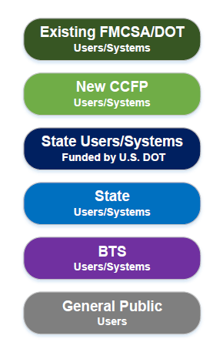

Diagram 1: Data Collection
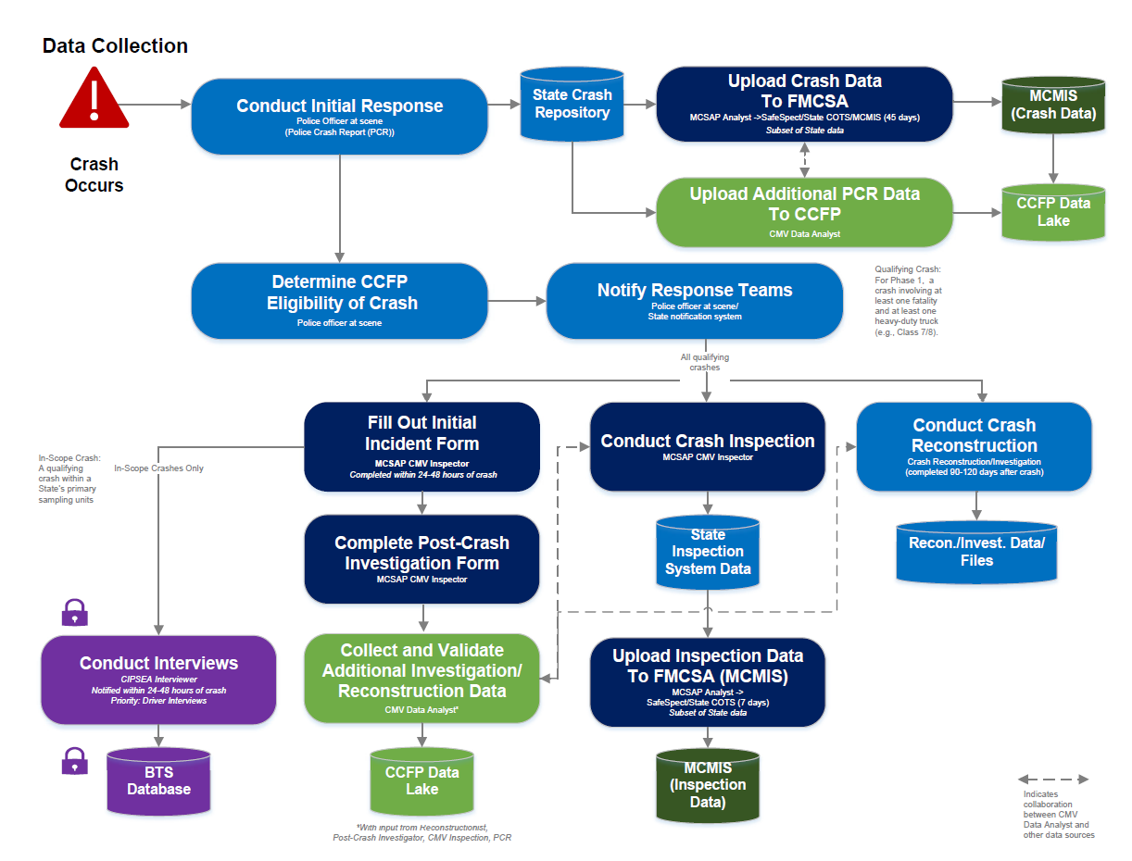

Diagram 2: Data Integration, Analysis and Management, and Sharing
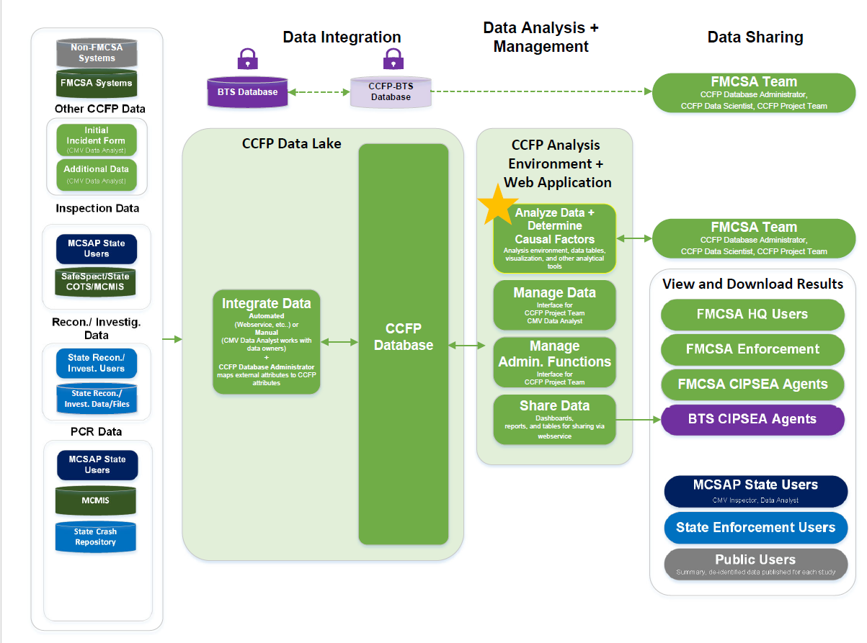

Appendix D: External Data Sources for CCFP IT Solution
Connecting to external data sources is an essential requirement for the CCFP IT Solution. It will enable State CMV Data Analysts and the CCFP Project Team to go beyond the inspection, investigation, and PCR data and gain additional insight on the contributing factors involved in each crash. For instance, FMCSA’s Training Provider Registry (TPR) contains driver records for Agency-mandated training. Integrating TPR into the CCFP IT Solution could help explain why a pattern of driver safety issues documented on a PCR is occurring.
The tables below list external data sources owned by FMCSA and other entities for incorporating into the CCFP IT Solution.
FMCSA-Owned Data Sources
Data Source | Relevant Data for CCFP
Activity Center for Enforcement (ACE) | Investigation reports; carrier files
DataQs | Requests for data reviews, results of those reviews, including Crash Preventability determinations
Driver Information Resource (DIR) | Driver inspection history, crash history, DACH information
Drug and Alcohol Clearinghouse (DACH) | CDL driver drug and alcohol violations; current carrier queries
Driver Safety Measurement System (DSMS) | Internal enforcement tool; driver inspection results, investigation results, and crash history; DSMS percentiles that reflect a driver’s safety performance relative to other drivers
Electronic Logging Device (ELD)/Electronic Record of Duty Status (eRODS) | Record of driving time, hours of service, engine hours, ignition status, location and miles driven
Safety Measurement System (SMS) | Carrier exposure data (VMT per average PU), inspection results, investigation results, and crash history; SMS percentiles that reflect a carrier’s safety performance relative to other carriers
Training Provider Registry (TPR) | Driver training records for FMCSA-mandated entry-level driver training

Data Sources Owned by Other Entities
Data Source | Owner | Relevant Data for CCFP
CCFP BTS Secure Database | BTS | Aggregated, anonymized data from confidential interviews of drivers, carriers, and witnesses involved in a qualifying crash.
Commercial Driver’s License Information System (CDLIS) | AAMVA or Soon to Be FMCSA | CDL records, driver status and history
Highway Performance Monitoring System (HPMS)/Model Inventory of Roadway Elements (MIRE) | FHWA | Official federal government source of data on the extent, conditions, performance, use, and operating characteristics of all public roads/highways
Google Maps/Earth | Google | Location information; aerial views
NHTSA Recalls Database | NHTSA | Recall data for vehicle parts and accessories from the original equipment manufacturer
High-Resolution Rapid Refresh (HRRR) Database | NOAA | Real-time weather data including solar radiation (Watts/m2), relative humidity (%), wind speed (miles per hour), air temperature (°Fahrenheit or °F), precipitation (amount of rainfall in “inches”), and visibility (miles).

Appendix E: ELD Requirements
During roadside inspections and post-crash inspections, drivers must transfer hours of service data via an ELD output file to eRODs. This data can be transferred electronically via a telematics ELD (web service or email) or via a local ELD (USD or Bluetooth). Currently, the MCSAP CMV Inspector verifies the submission of the ELD output file at roadside in eRODs and saves the file locally for their records. If a driver is unable to transfer a file post-crash, the MCSAP CMV Inspector will work with the motor carrier to obtain the ELD output file.
For the purposes of the Heavy-Duty Truck Study, drivers/motor carriers will enter a unique CCFP code as an Output File Comment when submitting the file. Example format for the code could be “CCFP-State-Post-Crash-Inspection-Code.”
The requirements listed below will enable the integration of ELD data into the CCFP IT Solution.
- Ability to allow the MCSAP CMV Inspector and analysts on the CCFP Project Team to upload ELD output files to the associated crash record in the CCFP IT Solution. Upload functionality should be compatible with the CSV format of ELD output files.
- Ability to extract data from ELD output file so the data can be analyzed in the CCFP IT Solution.

Phase 2 and subsequent phases will be dependent on administrative priorities and future funding.
For more on BTS and CIPSEA, see BTS’ Confidentiality Policy: https://www.bts.gov/confidentiality

