**CURRICULUM DESIGN**

This application will help the institutions / universities to design their course curriculum with required subject wise Credits.

**SUPER ADMIN LOGIN**

1. **CRUD Operations** for the following
2. **Program**: (Under Graduate / Post Graduate etc.) **COMPLETED**
3. **Course**: (Ex: B.Tech. / B.A./B.Com. Etc.) **COMPLETED**
   * 1. Course Short Code (Ex: B.Tech.)
     2. Course Name (Ex: Bachelor of Technology)
     3. Minimum Credits (Ex: 150)
     4. Maximum Credits (Ex: 180)
4. **Subject Category**: (Ex: Basic Science / Humanities etc.) **COMPLETED**
5. **Subject**: (Ex: Physics / Chemistry etc.) **COMPLETED**
6. **Semester**: (I, II, III, IV etc.) **COMPLETED**
7. Facility to **link / de-link** the following
   1. **Subject** to **Subject Category COMPLETED BUT the process of linking is properly provided.**

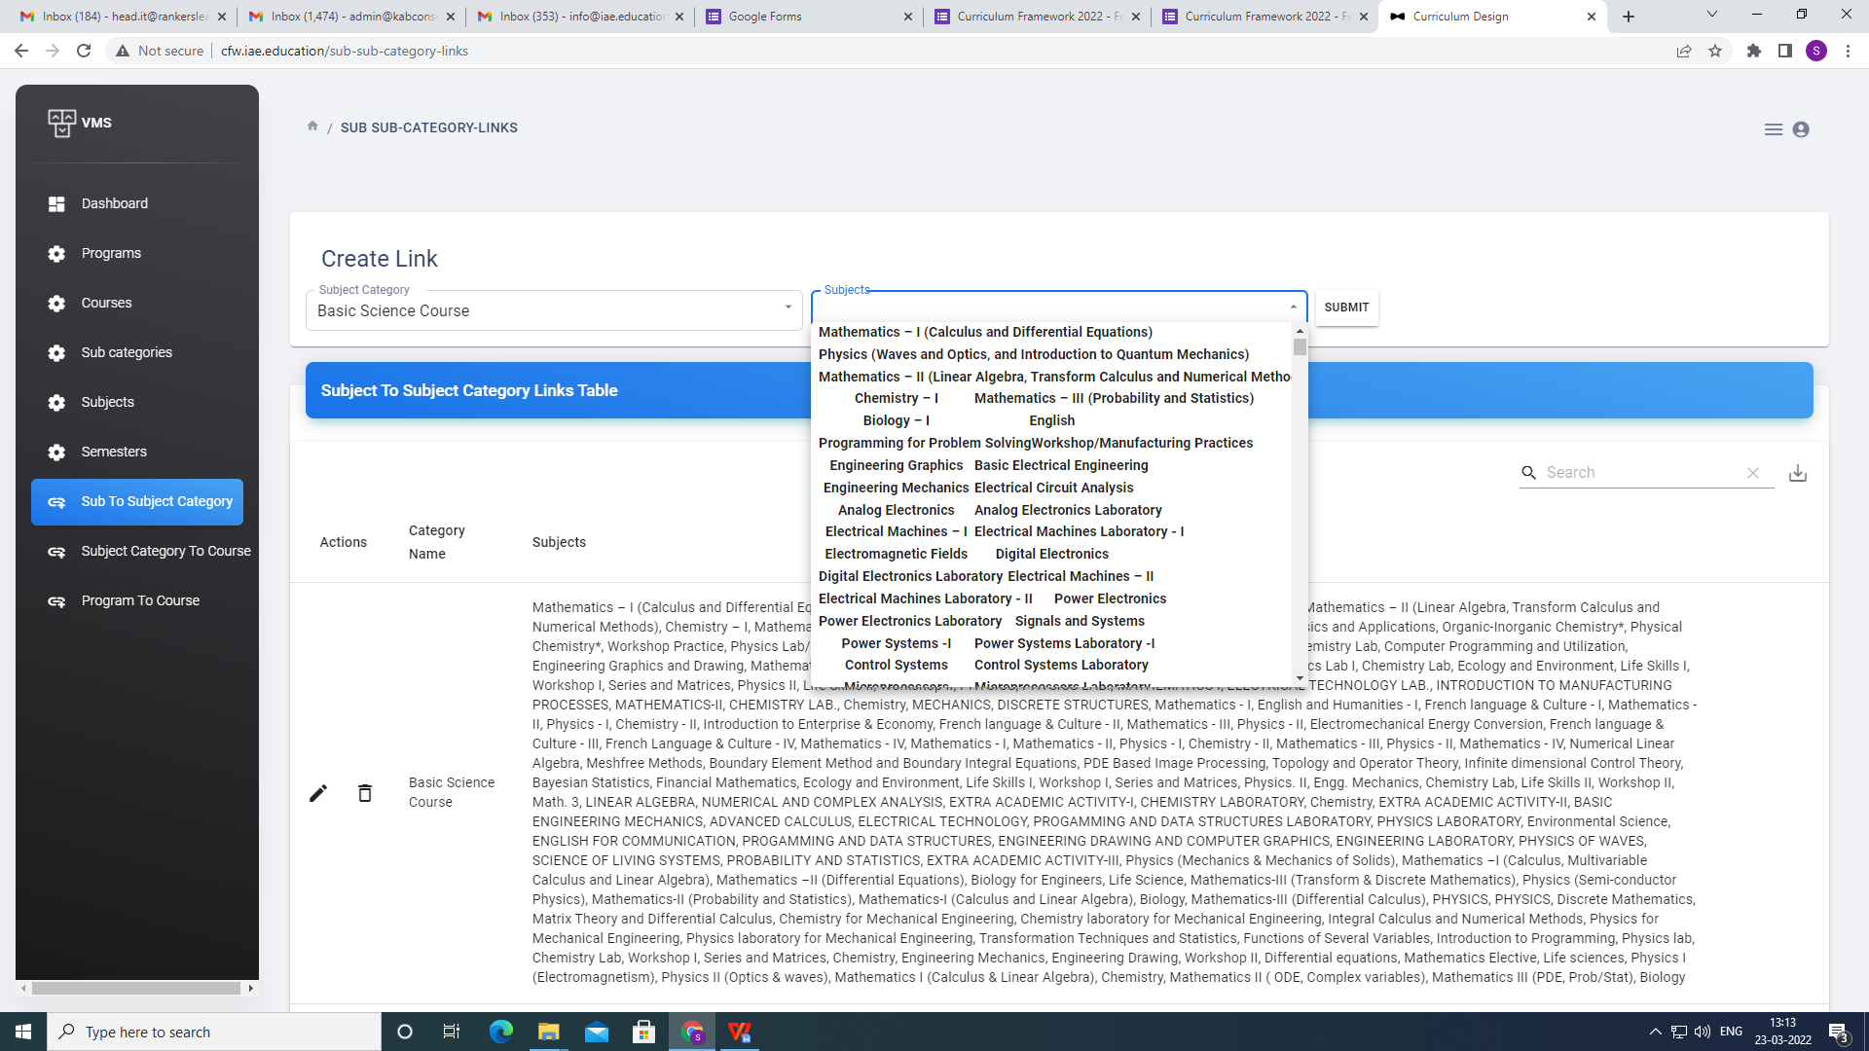

* 1. **Subject Category** to **Course COMPLETED BUT the process of linking is properly provided.**
  2. **Course** to **Program COMPLETED BUT the process of linking is properly provided.**

1. **Search** Facility for all the screens in the application **COMPLETED**
2. Need **Data Export** to Excel facility for all tables in the application **PENDING** - Only 5 records are exporting to excel or pdf.
3. **Filter / Sort** Facility to all the tables in the application **PENDING** - sort not working properly (ex: subjects)
4. **Reports**
   1. Registered Institutions List with a search (all columns) facility. **PENDING**

|  |  |  |  |  |  |  |  |  |
| --- | --- | --- | --- | --- | --- | --- | --- | --- |
| **Sl.No.** | **Date of Registration** | **Name of the Institution** | **Username (Email ID)** | **Address** | **Name of the Contact Person** | **Contact Person’s Mobile Number** | **Contact Person’s Email ID** | **Actions** |
|  |  |  |  |  |  |  |  | Change / Reset Password  Resend Verification E-mail  Activate/De-Activate Account  Edit Profile |

Show Number of Records

* 1. Institution wise courses and their curriculum designs **PENDING**

Note: All the above fields will be used in institution login to design the curriculum and assign the credits to the selected subjects.

**INSTITUTION:**

1. **Institution Registration Form:**
   1. Name of the Institution:
   2. Institution Email ID (Username): (Send account activation mail for verification)
   3. Create Password:
   4. Confirm Password:
   5. Address for Correspondence:
   6. Name of the Contact Person:
   7. Contact Person’s Mobile No.: (Send OTP for verification here only, resend facility after 5mins)
   8. Contact Person’s Email ID:
   9. Terms & Conditions check box
   10. Submit Button

**PENDING** - Registration form showed the message email already registered with another institution and then it showed the below screen. (Working fine)

Email used to register is [‘head.it@rankerslearning.com’](mailto:‘head.it@rankerslearning.com’)

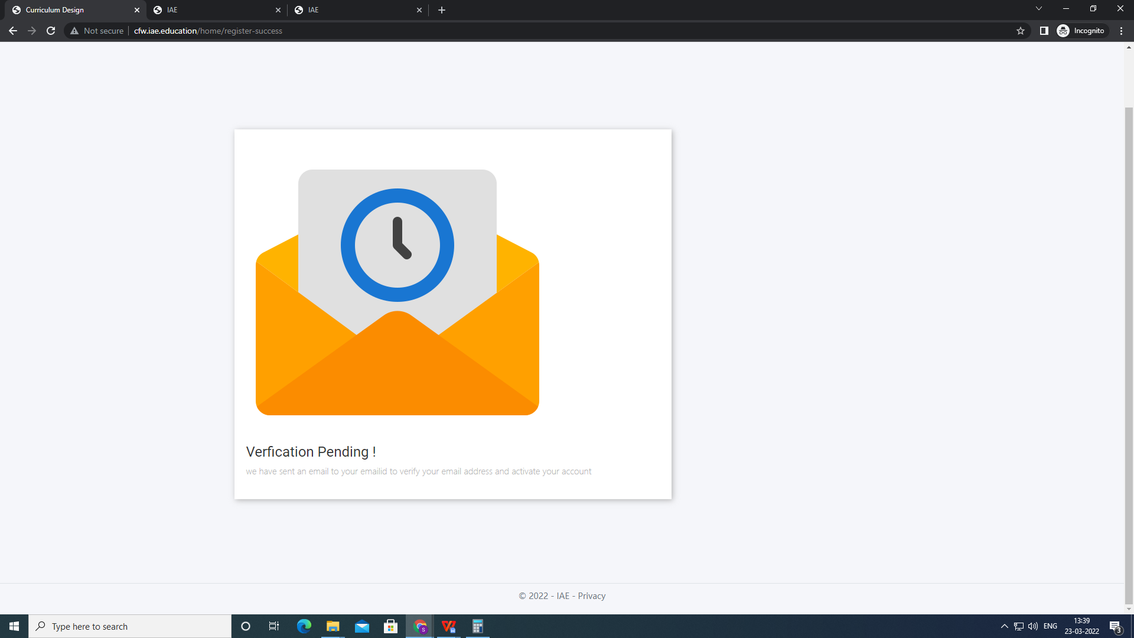

**INSTITUTION LOGIN:**

**Screen 1:**

1. Upon selection of a Program>Course: it should show the Subject Categories with a selection (or add button - Ex: left to right) box and text box to enter the weightage (%), Total % to be displayed by calculating the entered weightages, after submission with a Save button, it should go to another page (Screen 2).

**PENDING** -

1. Show the Given Percentage Total below the percentage column (Done)
2. Write the column names (Subject/Course Category, Weightage in %, Credits as per given Weightage) (Done)
3. Display the ‘Course Name’ and ‘Branch Name’ on the Top (B.Tech. - Mechanical Engineering) below the lable ‘Curriculum Design’ (Done)
4. Subject category column width can be increased to avoid two lines. (Done)

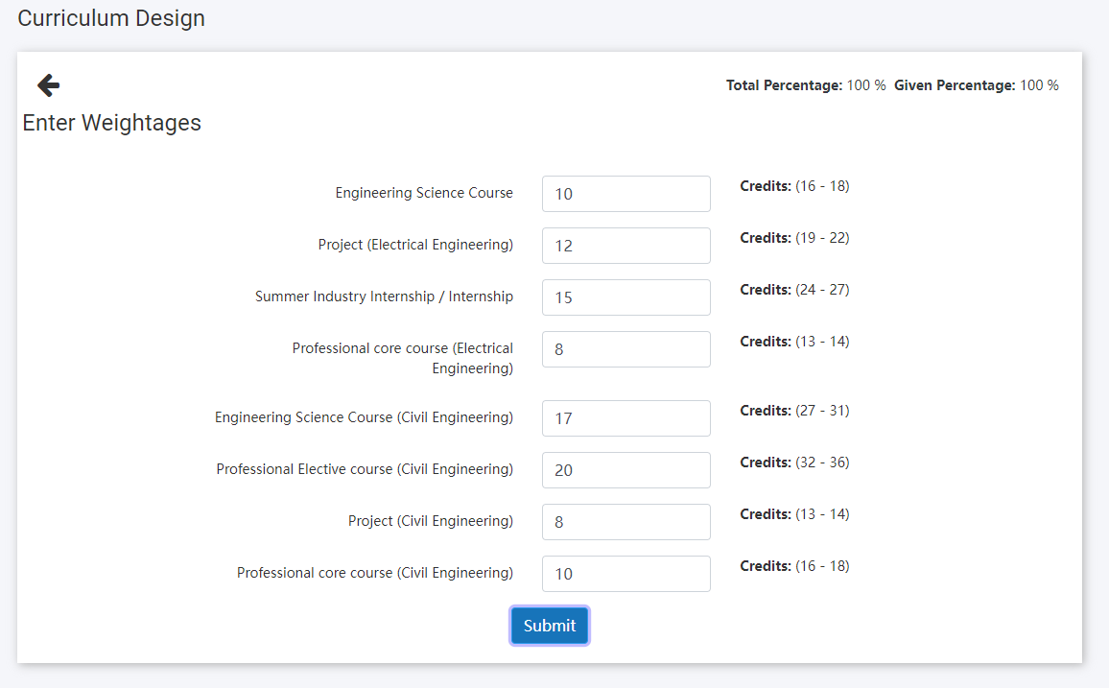

**Screen 2:**

1. Display the Program, Course, Minimum Credits, Maximum Credits and Credits Assigned (this will be displayed by calculating the credits as mentioned below). **COMPLETD but the display of the above things to be highlighted.** (Done)
2. Display the Subject categories, if we click on a category, the list of subjects should be displayed with the following columns with a check box to select and text boxes to enter the details, these columns should be enabled for the selected subjects only. **COMPLETED**
   1. Lecture Hours per Week
   2. Tutorial Hours per Week
   3. Practical / Lab Hours per Week
   4. Credits (=a+b+(c X .5))
   5. Select Semester (Drop down)

Example:

**Subject Category: Basic Sciences**

|  |  |  |  |  |  |
| --- | --- | --- | --- | --- | --- |
| **Subject** | **Lecture Hours per Week** | **Tutorial Hours per Week** | **Practicals/ Lab Hours per Week** | **Credits** | **Select Semister** |
| Physics | 1 | 1 | 3 | 3.5 | I |
| Chemistry | 1 | 1 | 2 | 3 | II |

1. There must be two Special Columns called Electives, Open Electives (Ex: Elective-I, Elective-II, Open Elective-I, Open Elective-II etc.) **PENDING**
2. These elective / open elective subjects are common for all subject categories and showing in all the subject categories but unique, for example if Elective-I is selected in Subject Category 1, then it should not be shown in another subject categories drop down. **PENDING**
3. It must be implemented similarly for all the subject categories. **PENDING**
4. Total Credits must be calculated immediately as and when we enter the values in the text boxes and displayed on top as mentioned in point no.I. **COMPLETED**
5. There must be a Save button to save this and a Reset Button to clear all with an alert message in popup. **PENDING - RESET BUTTON**
6. A facility must be there to export to as excel and pdf. **PENDING**
7. Print facility to the final saved curriculum design. **PENDING** (Done)
8. Reports: Created courses and their curriculum designs **PENDING - Show the Reports as a Report not as form.** (Done)
9. Update profile for institutions and super admin **PENDING**
10. Change password for institutions and super **PENDING**
11. Forgot password for Institutions **PENDING** (Done)
12. About, Contact Us, Terms & Conditions, Disclaimer Pages. **PENDING**
13. Add individual update in add subjects page
14. Add individual update in add credits page. (Done)
15. **I will add the points later if I miss any thing.**