1. Introduction
The purpose of this project is to analyse customer behaviour and churn patterns within a telecommunications company. Customer churn refers to customers discontinuing their service subscription, which directly impacts company revenue and long-term growth.
The analysis uses the Telco Customer Churn dataset, which contains customer demographic information, service subscriptions, account details, billing information, and churn status. The dataset provides valuable insights into factors that may influence customer retention and customer attrition.
The objectives of this analysis are to:
• Understand customer demographics and subscription characteristics.
• Analyse customer churn distribution and identify high-risk customer segments.
• Investigate the relationship between service usage, contract types, billing methods, and churn.
• Examine financial factors such as monthly and total charges.
• Identify key drivers associated with customer churn.
• Generate actionable business recommendations to improve customer retention and reduce churn.
The analysis will be conducted using Python, Pandas, Matplotlib, and Seaborn through exploratory data analysis (EDA), statistical summaries, and data visualization techniques.
2. Dataset Overview
The analysis was conducted using the Telco Customer Churn dataset containing customer subscription and service information from a telecommunications provider.
The dataset contains 7,043 customer records and 21 attributes describing customer demographics, account information, subscribed services, billing characteristics, and churn status.
Key Variables
Customer Information:
- Gender
- Senior Citizen Status
- Partner Status
- Dependents Status
Service Information:
- Phone Service
- Multiple Lines
- Internet Service
- Online Security
- Online Backup
- Device Protection
- Technical Support
- Streaming TV
- Streaming Movies
Account Information:
- Tenure
- Contract Type
- Paperless Billing
- Payment Method
Financial Information:
- Monthly Charges
- Total Charges
Target Variable:
- Churn (Yes/No)
The dataset contains a mixture of categorical and numerical variables. Of the 21 attributes, The dataset contains 3 numerical variables (tenure, Monthly Charges, Total Charges after conversion) and 18 categorical variables.
. The target variable, Churn, indicates whether a customer has discontinued the service.
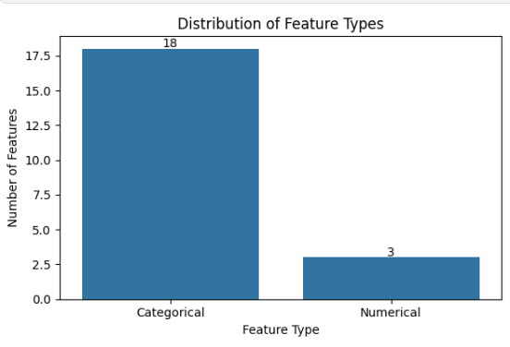
Figure 1: Distribution of feature types in the Telco Customer Churn dataset. The dataset contains a larger number of categorical variables than numerical variables, indicating that customer characteristics, service subscriptions, and billing preferences form the majority of available information.
3. Data Quality Assessment
A data quality assessment was performed to evaluate the structure, completeness, and consistency of the dataset containing 7,043 records and 21 features.
Missing Values
No missing values were found in any of the columns, indicating complete data across all features.
Duplicate Records
There are no duplicate rows, confirming that each entry in the dataset is unique.
Data Types
The dataset contains a mix of categorical (object), integer, and float variables. However, the Total Charges column is stored as an object type instead of a numerical type, indicating a formatting issue.
Total Charges Quality Check
The TotalCharges column contains 11 blank values, which are not counted as missing in the standard summary. This column requires cleaning and conversion to a numeric format before further analysis.

Unique Values
Most categorical variables have low cardinality (2–4 unique values), while numerical features like Monthly Charges (1585 unique values) and Total Charges (6531 unique values) show higher variability.
Numerical Summary
- Senior Citizen: Binary feature with low proportion of senior customers
- Tenure: Ranges from 0 to 72 months
- Monthly Charges: Varies between 18.25 and 118.75
Overall, the dataset is clean with only minor issues in the Total Charges column that need preprocessing.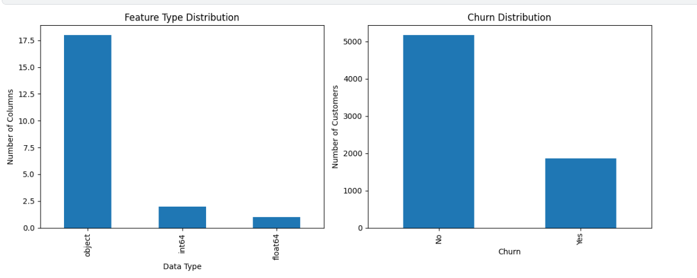Figure2: The visualization shows the distribution of data types and the churn class balance. It confirms that the dataset mainly contains categorical features with a few numerical ones. The churn plot highlights the proportion of retained vs. churned customers, helping understand class distribution for modeling.
4. Customer Demographics Analysis
This section explores the basic demographic profile of the telecom customers to understand the composition of the user base in terms of gender, age group (senior citizen status), family status, and customer usage patterns (tenure and monthly charges).
Gender Distribution
The dataset contains a nearly equal distribution of male and female customers. Males account for 50.48% (3555 customers), while females represent 49.52% (3488 customers). This indicates that the customer base is well balanced in terms of gender, with no significant bias toward either group.
Senior Citizen Distribution
Most customers are non-senior citizens. Around 83.79% (5901 customers) are younger than senior age, while only 16.21% (1142 customers) are senior citizens. This shows that the service is primarily used by a younger population segment.
Partner Status
The distribution of customers with and without partners is relatively balanced. 51.70% (3641 customers) do not have a partner, while 48.30% (3402 customers) have a partner. This suggests that the service is used by both single and partnered individuals almost equally.
Dependents Status
A large proportion of customers do not have dependents. About 70.04% (4933 customers) have no dependents, whereas only 29.96% (2110 customers) have dependents. This indicates that the majority of customers are independent users without family responsibilities.
Tenure Analysis
The average customer tenure is approximately 32.37 months, with a standard deviation of 24.56 months, showing a wide variation in customer loyalty. The minimum tenure is 0 months, while the maximum is 72 months. This suggests that the customer base includes both new users and long-term loyal customers.
Monthly Charges Analysis
The average monthly charge is 64.76, with a standard deviation of 30.09. Charges range from 18.25 to 118.75, indicating a broad pricing distribution. The median value (70.35) is slightly higher than the mean, suggesting a moderate skew toward lower-paying customers.
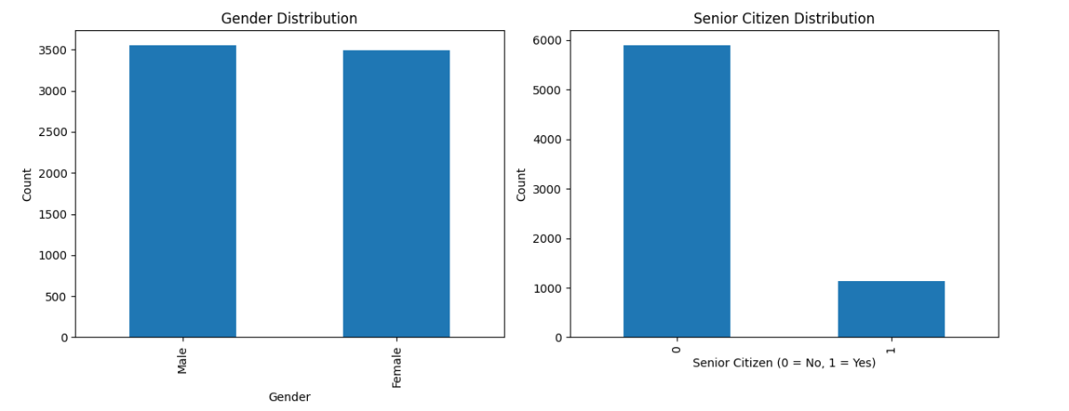
Figure 4.1:This figure shows the distribution of customers based on gender and senior citizen status. The gender distribution is almost balanced, with a nearly equal proportion of male and female customers. However, the senior citizen distribution is highly skewed toward non-senior customers, indicating that the majority of users belong to a younger age group.
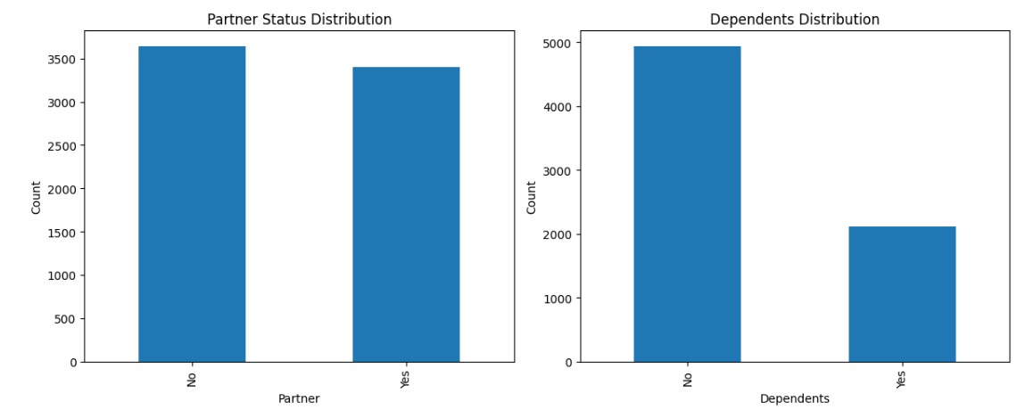
Figure 4.2: This figure illustrates the distribution of customers based on partner status and dependents. It shows that a slightly higher proportion of customers do not have a partner, while a significant majority do not have dependents. This suggests that most customers are independent users without family responsibilities.
5. Service Subscription Analysis
This section analyses the adoption of different telecom services by customers, including phone service, internet service, and additional value-added services such as online security, tech support, and streaming services.
Phone Service Usage
The majority of customers use phone services, with 90.32% (6361 customers) subscribed to phone service, while only 9.68% (682 customers) do not use it. This shows that phone connectivity is a core service for most customers.
Internet Service Usage
Internet service usage is distributed across three categories. The most commonly used service is Fiber optic (43.96%), followed by DSL (34.37%), while 21.67% of customers do not use internet services at all. This indicates strong adoption of high-speed internet services, especially fiber optic connections.
Online Security
Online security services are not widely adopted. Around 49.67% of customers do not use online security, while 28.67% have subscribed, and 21.67% do not use internet services. This suggests that security features are underutilized compared to basic connectivity services.
Tech Support
A similar trend is observed in tech support usage. Nearly 49.31% of customers do not use tech support, while 29.02% have subscribed, and 21.67% have no internet service. This indicates moderate adoption of customer support-related services.
Streaming Services Usage
Streaming services show a more balanced distribution. For Streaming TV, 38.44% of customers use the service, while 39.90% do not. Similarly, for Streaming Movies, 38.79% are users compared to 39.54% non-users. Around 21.67% of customers do not have internet service, limiting access to streaming features.
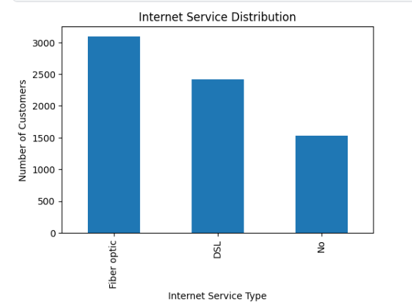
Figure 5.1: This figure shows the distribution of customers based on their internet service type. It indicates that fiber optic is the most commonly used service, followed by DSL, while a smaller proportion of customers do not use internet services. This highlights that most customers are connected through internet services, with fiber optic being the dominant choice.
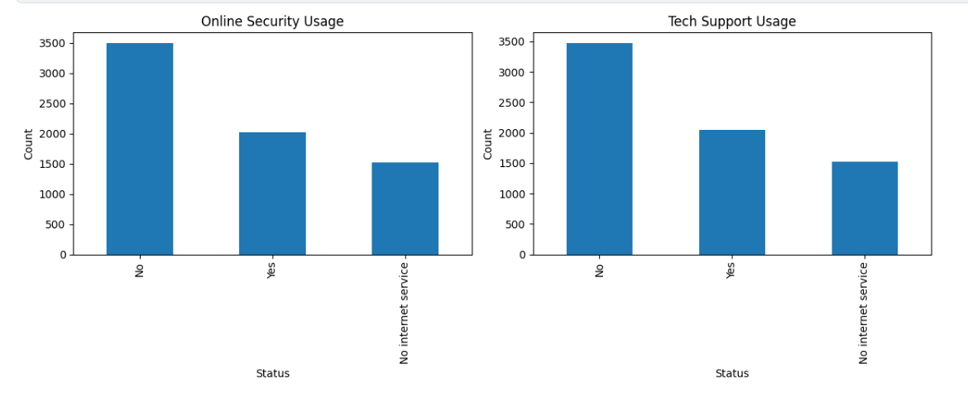
Figure 5.2: This figure presents the adoption of online security and tech support services among customers. It shows that a significant portion of customers do not use these value-added services, while only a smaller group has subscribed to them. This suggests that advanced protection and support services are underutilized compared to basic internet services.
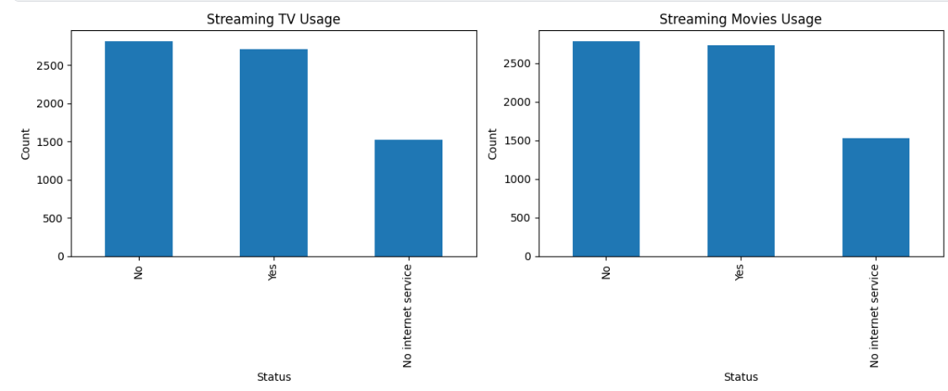
Figure 5.3: This figure illustrates customer usage of streaming services, including TV and movies. The distribution shows a relatively balanced split between users and non-users, while a portion of customers does not have internet service access. This indicates moderate adoption of entertainment-related services among internet users.
6. Contract & Billing Analysis
Contract & Billing Analysis
This section analyses customer contract preferences, billing methods, payment behavior, and spending patterns to understand how customers engage financially with the telecom service.
Contract Type Distribution
The majority of customers prefer month-to-month contracts (55.02%), while two-year contracts account for 24.07% and one-year contracts account for 20.91%. This indicates that most customers are not committed to long-term contracts, which may increase churn risk.
Paperless Billing
A significant portion of customers (59.22%) use paperless billing, while 40.78% still prefer traditional billing methods. This shows a moderate adoption of digital billing systems.
Payment Methods
The most commonly used payment method is electronic check (33.58%), followed by mailed check (22.89%), bank transfer (21.92%), and credit card (21.61%). This indicates that customers are fairly distributed across different payment methods, with a slight preference for electronic checks.
Monthly Charges
The average monthly charge is 64.76, with values ranging from 18.25 to 118.75. This shows a wide variation in customer spending levels.
Total Charges
The average total charge is 2283.30, with a median of 1397.48, indicating that a large number of customers are relatively new or mid-tenure users, while some long-term customers significantly increase total revenue values.
Contract-wise Spending Behavior
Customers on two-year contracts contribute the highest total charges (3728.93 on average), followed by one-year contracts (3034.68), while month-to-month customers contribute the least (1369.25). This clearly shows that long-term contracts generate higher customer lifetime value.
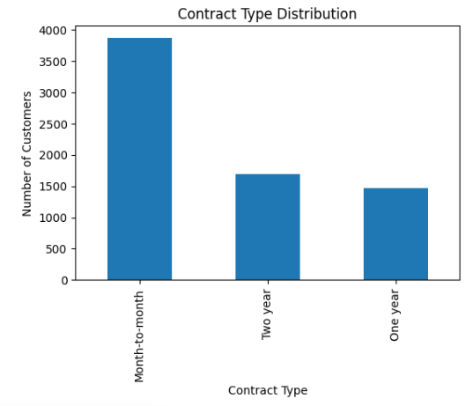
Figure 6.1: This figure shows that most customers prefer month-to-month contracts, while fewer customers are enrolled in one-year and two-year contracts. This indicates a high level of contract flexibility among customers, which may contribute to higher churn risk.
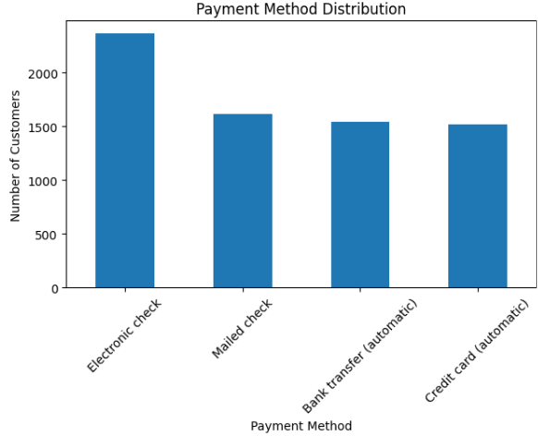
Figure 6.2: This figure illustrates the distribution of payment methods used by customers. Electronic check is the most commonly used method, while other methods such as credit card, bank transfer, and mailed check are used more evenly. This shows diverse payment preferences among customers.
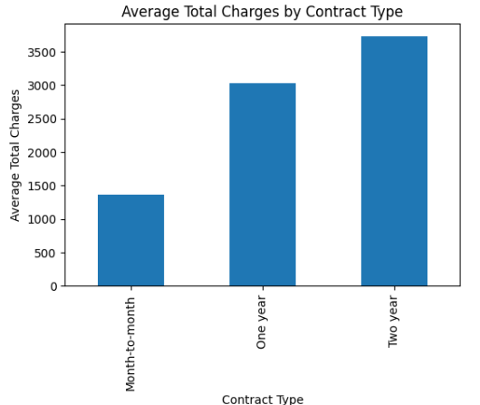
Figure 6.3: This figure compares average total charges across contract types. Customers with two-year contracts generate the highest total charges, followed by one-year contracts, while month-to-month customers contribute the least. This highlights the importance of long-term contracts in increasing customer lifetime value.
7. Churn Analysis
Churn Analysis
This section analyzes customer churn behavior to understand the proportion of customers leaving the telecom service and the key factors influencing churn.
Overall Churn Rate
The dataset shows that 73.46% (5174 customers) did not churn, while 26.54% (1869 customers) left the service. This indicates that approximately 1 in 4 customers is churning, which represents a significant retention challenge for the company.
Churn by Contract Type
Contract type has a strong impact on churn behavior. Customers with month-to-month contracts show the highest churn rate (42.71%), while one-year (11.27%) and two-year contracts (2.83%) show significantly lower churn rates. This clearly indicates that longer contracts improve customer retention and reduce churn risk.
Churn by Payment Method
Customers using electronic checks have the highest churn rate (45.29%), which is significantly higher than other payment methods. In contrast, customers using credit card (15.24%) and bank transfer (16.71%) show much lower churn rates. This suggests that electronic check users are more likely to discontinue the service.
Churn by Internet Service Type
Customers with fiber optic internet show the highest churn rate (41.89%), followed by DSL users (18.96%), while customers with no internet service have the lowest churn rate (7.40%). This indicates that fiber optic customers may have higher expectations or dissatisfaction levels.
Tenure and Churn Relationship
Customers who churned have a significantly lower average tenure (17.98 months) compared to non-churning customers (37.57 months). This shows that new customers are more likely to leave, while long-term customers tend to stay.
Monthly Charges and Churn
Churned customers have a higher average monthly charge (74.44) compared to non-churned customers (61.26). This suggests that higher pricing may contribute to customer churn, especially for price-sensitive users.
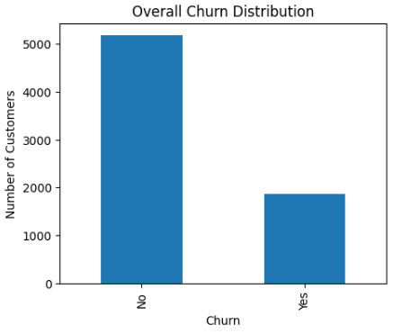
Figure 7.1: Overall Churn Distribution
This figure shows the proportion of customers who churned versus those who remained. It indicates that approximately one-fourth of customers have churned, highlighting a moderate but significant customer attrition rate.
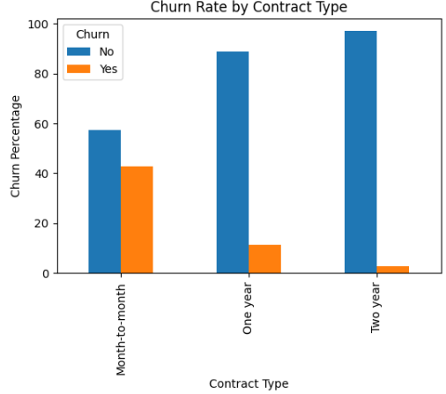
Figure 7.2: Churn Rate by Contract Type
This figure illustrates that customers with month-to-month contracts have the highest churn rate, while long-term contracts (one-year and two-year) significantly reduce churn. This highlights contract duration as a key factor in customer retention.
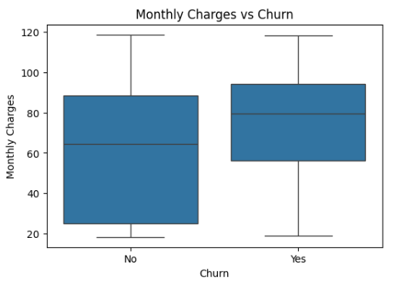
Figure 7.3: Monthly Charges vs Churn
This figure compares monthly charges between churned and non-churned customers. It shows that churned customers generally pay higher monthly charges, suggesting that higher pricing may increase the likelihood of churn.
8. Financial Analysis
Financial Analysis
This section analyses customer revenue patterns using monthly charges and total charges to understand customer value, revenue distribution, and the financial impact of churn.
Overall Revenue Overview
The average monthly charge across all customers is 64.76, while the average total charge is 2283.30. The wide range in total charges (from 18.80 to 8684.80) indicates significant variation in customer lifetime value.
Revenue by Churn Status
Customers who did not churn generate higher total revenue (2555.34 average) compared to churned customers (1531.79 average). However, churned customers pay higher monthly charges (74.44 vs 61.26), suggesting that higher pricing may contribute to customer loss before long-term value is achieved.
Median values confirm this trend, showing that churned customers contribute significantly less lifetime revenue (703.55 vs 1683.60).
Revenue by Contract Type
Contract type strongly impacts revenue generation. Customers with two-year contracts generate the highest total revenue (3728.93 average), followed by one-year contracts (3034.68), while month-to-month customers contribute the least (1369.25). This clearly shows that long-term contracts are more financially valuable.
Customer Value Segmentation
Customers are almost evenly split into high-value (49.92%) and low-value (50.08%) segments based on total charges. However, high-value customers contribute significantly more revenue, with an average total charge of 4059.43, compared to 507.17 for low-value customers.
Revenue Impact of Churn
The total estimated revenue loss from churned customers is 2,862,926.90, which represents a major financial impact. This highlights churn as a critical business issue affecting profitability and long-term revenue stability.
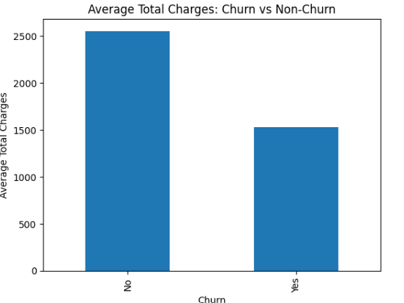
Figure 8.1: Revenue Comparison Between Churn and Non-Churn Customers
This figure shows that non-churned customers generate significantly higher total revenue compared to churned customers. This highlights the importance of customer retention in maximizing long-term revenue.
9. Feature Relationship Analysis
Feature Relationship Analysis
This section explores relationships between key variables to understand what factors influence customer churn, spending behavior, and contract preferences.
Churn vs Monthly Charges & Total Charges
Customers who churn have higher average monthly charges (74.44) compared to non-churned customers (61.26). However, they generate lower total revenue (1531.79 vs 2555.34), indicating that customers tend to leave earlier before generating long-term value.
Churn vs Tenure
Tenure shows a strong relationship with churn. Customers who churn have significantly lower average tenure (17.98 months) compared to those who stay (37.57 months). This confirms that early-stage customers are more likely to leave the service.
Contract Type Relationships
Contract type strongly influences customer behavior:
- Month-to-month customers have very low tenure (18.03 months) and highest churn risk (42.71%).
- One-year and two-year contracts show much higher tenure (42.04 and 56.73 months) and significantly lower churn rates.
This shows that longer contracts improve retention and customer stability.
Internet Service Impact
Internet service type is a major driver of churn:
- Fiber optic users have the highest churn rate (41.89%) and highest monthly charges (91.50).
- DSL users show moderate churn (18.96%).
- Customers with no internet service have the lowest churn (7.40%).
This suggests that high-cost fiber optic customers are more likely to leave.
Payment Method Impact
Payment method is strongly related to churn:
- Electronic check users have the highest churn rate (45.29%).
- Credit card and bank transfer users have much lower churn rates (~15–17%).
This indicates that electronic check users represent a high-risk churn group.
Correlation Analysis
- Tenure and Total Charges have a strong positive correlation (0.83), meaning long-term customers generate higher revenue.
- Monthly Charges and Total Charges are moderately correlated (0.65).
- Tenure and Monthly Charges have weak correlation (0.24), indicating pricing does not strongly affect customer duration directly.
Gender vs Churn
Gender has minimal impact on churn, as both male and female customers show almost identical churn rates (~26%). This suggests that gender is not a significant predictor of churn.
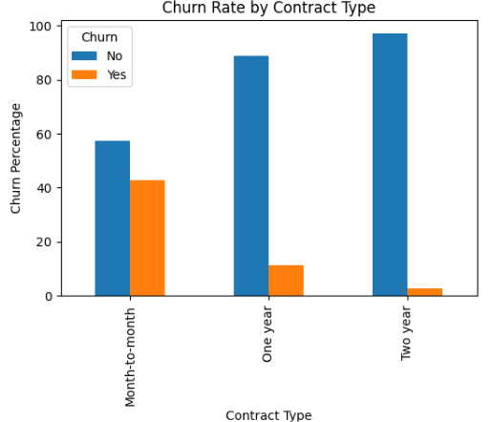
Figure 9.1: Churn Rate by Contract Type
This figure shows that customers with month-to-month contracts have the highest churn rate, while long-term contracts significantly reduce churn. This highlights contract duration as a key factor in customer retention.
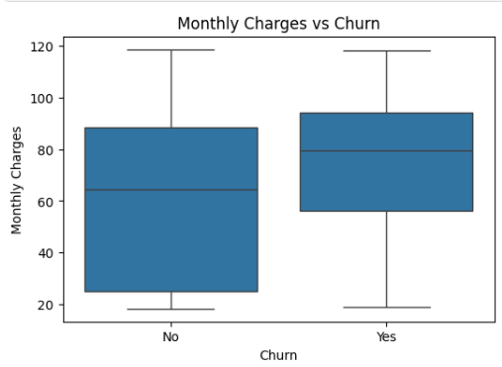
Figure 9.2: Monthly Charges vs Churn
This figure compares monthly charges between churned and non-churned customers. It shows that churned customers generally pay higher monthly charges, suggesting pricing may influence churn behaviour.
10. Key Findings
The analysis of the Telco Customer Churn dataset reveals several important insights regarding customer behavior, service usage, and churn patterns. Overall, the churn rate is 26.54%, indicating that approximately one in four customers leaves the service.
Customer tenure is one of the strongest indicators of churn, with churned customers having significantly lower tenure compared to retained customers. This shows that early-stage customers are more likely to discontinue the service.
Contract type plays a critical role in customer retention. Month-to-month customers show the highest churn rate, while one-year and two-year contracts significantly reduce churn. This highlights the importance of long-term commitments in improving customer loyalty.
Financial factors also influence churn behavior. Customers who churn tend to have higher monthly charges but lower total charges, indicating early exit before long-term value is generated. Additionally, fiber optic users and electronic check payment users show higher churn rates compared to other groups.
Demographic features such as gender have minimal impact on churn, suggesting that behavioral and service-related factors are more important than personal attributes.
Overall, churn is driven primarily by contract type, tenure, pricing, internet service type, and payment method.
11. Recommendations
Based on the analysis, several actionable recommendations can be made to reduce customer churn and improve retention:
- Promote Long-Term Contracts
Customers on month-to-month plans are most likely to churn. Offering discounts or incentives for one-year and two-year contracts can significantly improve retention.
- Improve Pricing Strategy
Since higher monthly charges are associated with churn, the company should evaluate pricing competitiveness, especially for fibre optic users.
- Target High-Risk Customers Early
New customers with low tenure are more likely to churn. Implement onboarding programs, welcome offers, and early engagement strategies to retain them.
- Improve Fiber Optic Customer Experience
Fiber optic users show high churn rates, indicating possible dissatisfaction. Service quality improvements or targeted support should be considered.
- Encourage Stable Payment Methods
Customers using electronic checks show higher churn. Promoting automatic payments like credit cards or bank transfers may improve retention.
- Enhance Customer Engagement
Increase usage of value-added services (online security, tech support) to improve customer stickiness.
12. Conclusion
This project analysed customer churn behaviour using the Telco Customer Churn dataset to identify key drivers of customer retention and attrition.
The analysis revealed that churn is primarily influenced by contract type, tenure, service type, payment method, and pricing structure. Customers with short-term contracts, high monthly charges, and electronic payment methods are more likely to churn.
On the other hand, long-term contracts and higher tenure significantly reduce churn probability and increase customer lifetime value.
The findings from this study provide actionable insights for telecom companies to improve retention strategies, optimize pricing, and enhance customer experience.
Overall, data-driven decision-making can significantly reduce churn and improve long-term profitability.

