Urban Green Cover Assessment - Model Output
This document contains the output screenshots generated during the Urban Green Cover Assessment project, including dataset overview, CNN architecture, training results, accuracy/loss curves, confusion matrices, MobileNetV2 transfer learning results, and final model comparison.

1. Class Distribution
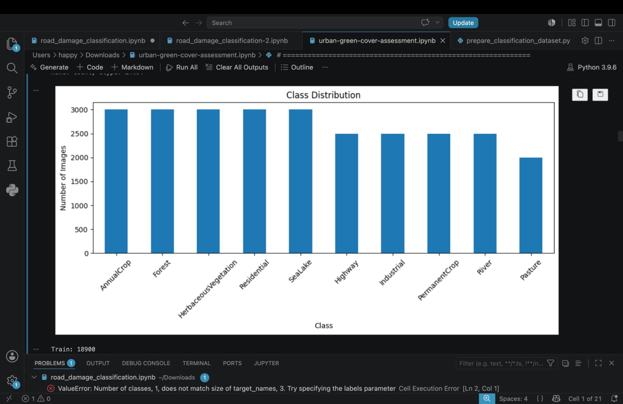

2. Dataset Information and Custom CNN Architecture
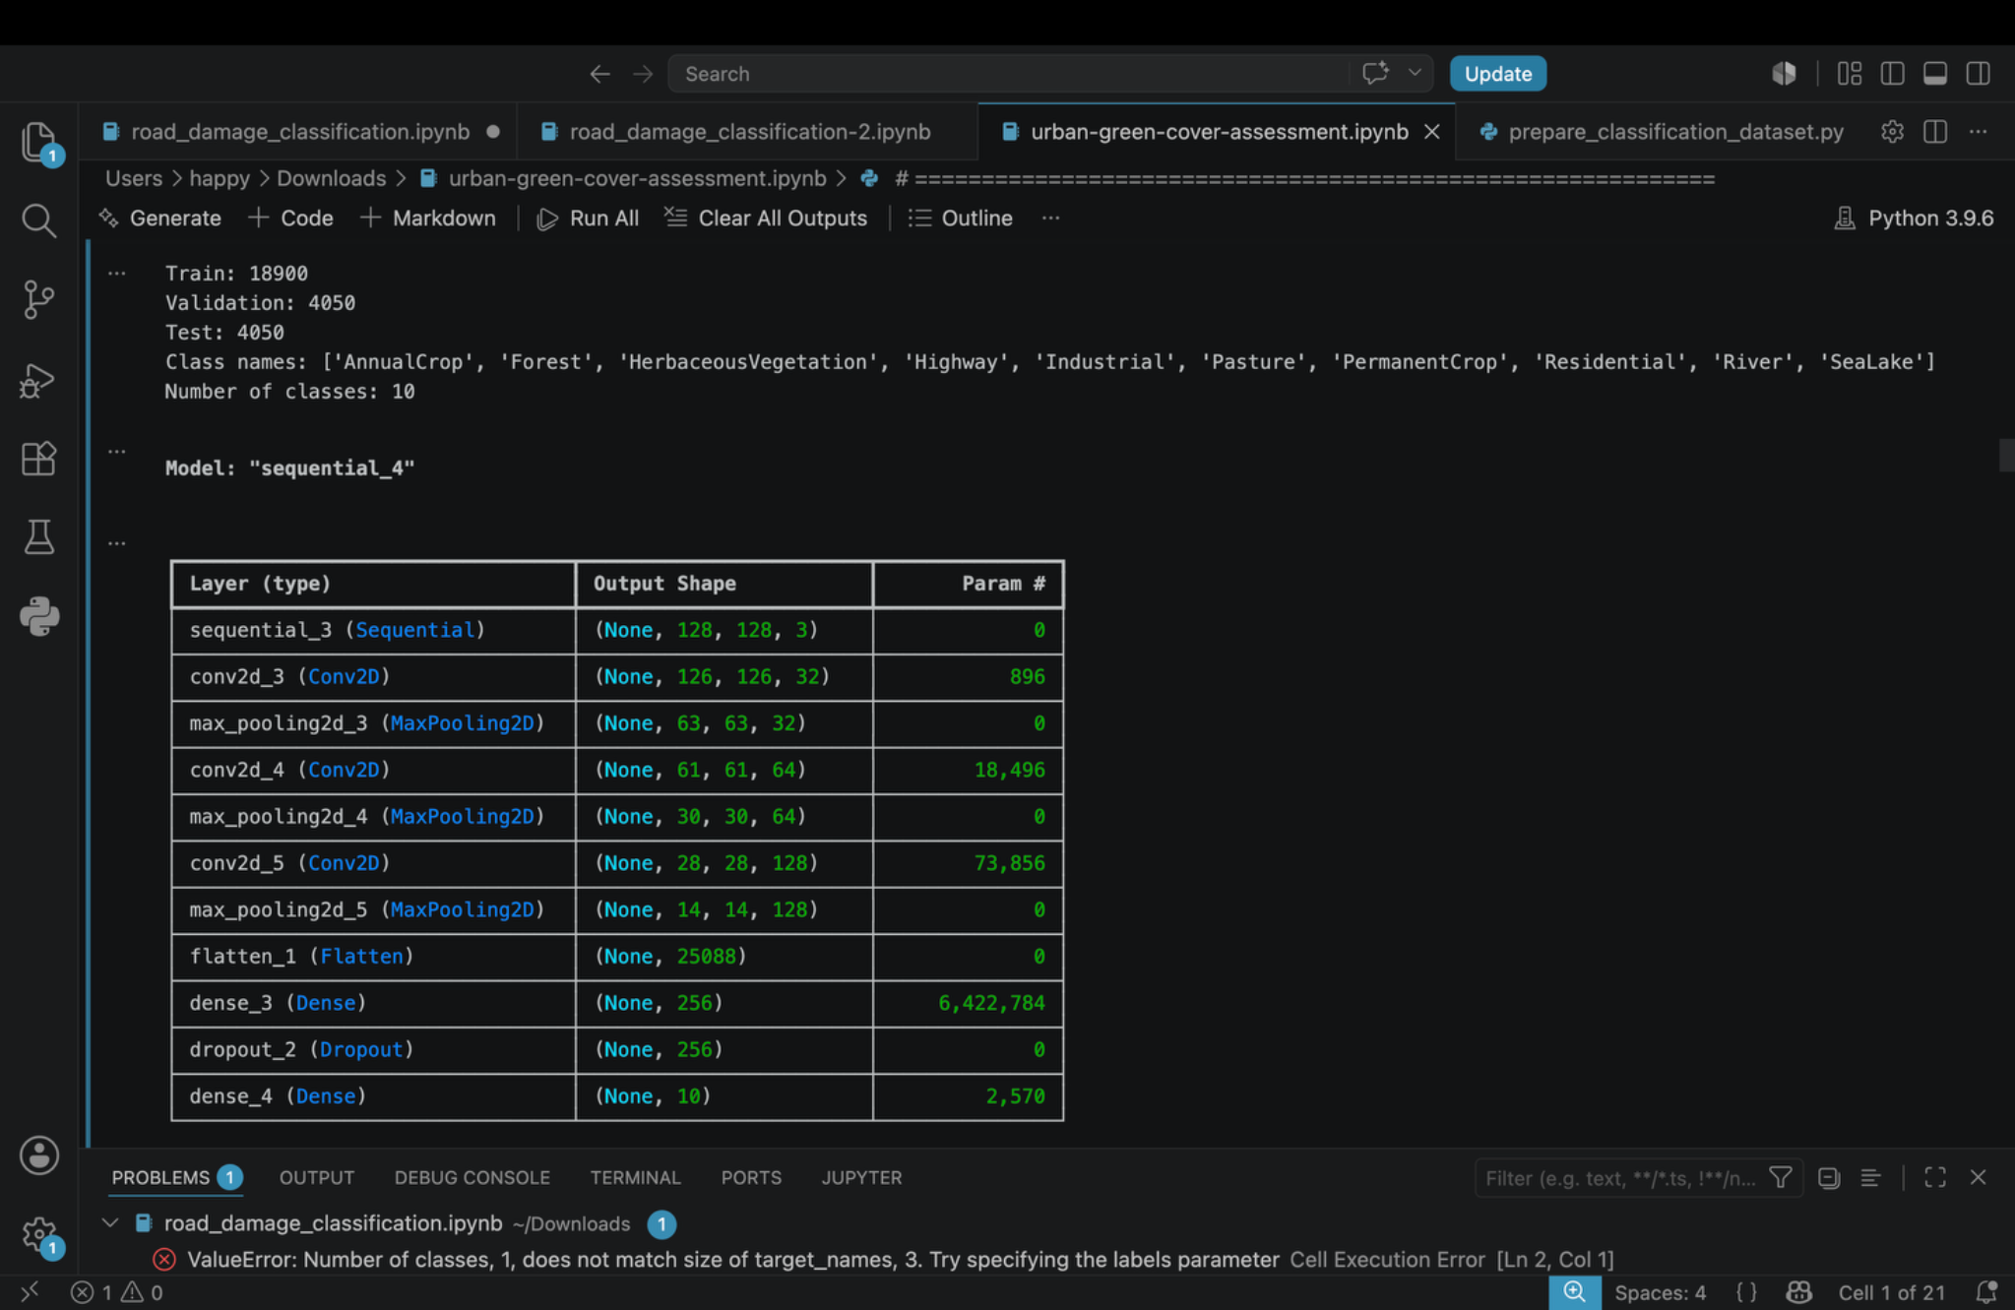

3. Custom CNN Training Progress
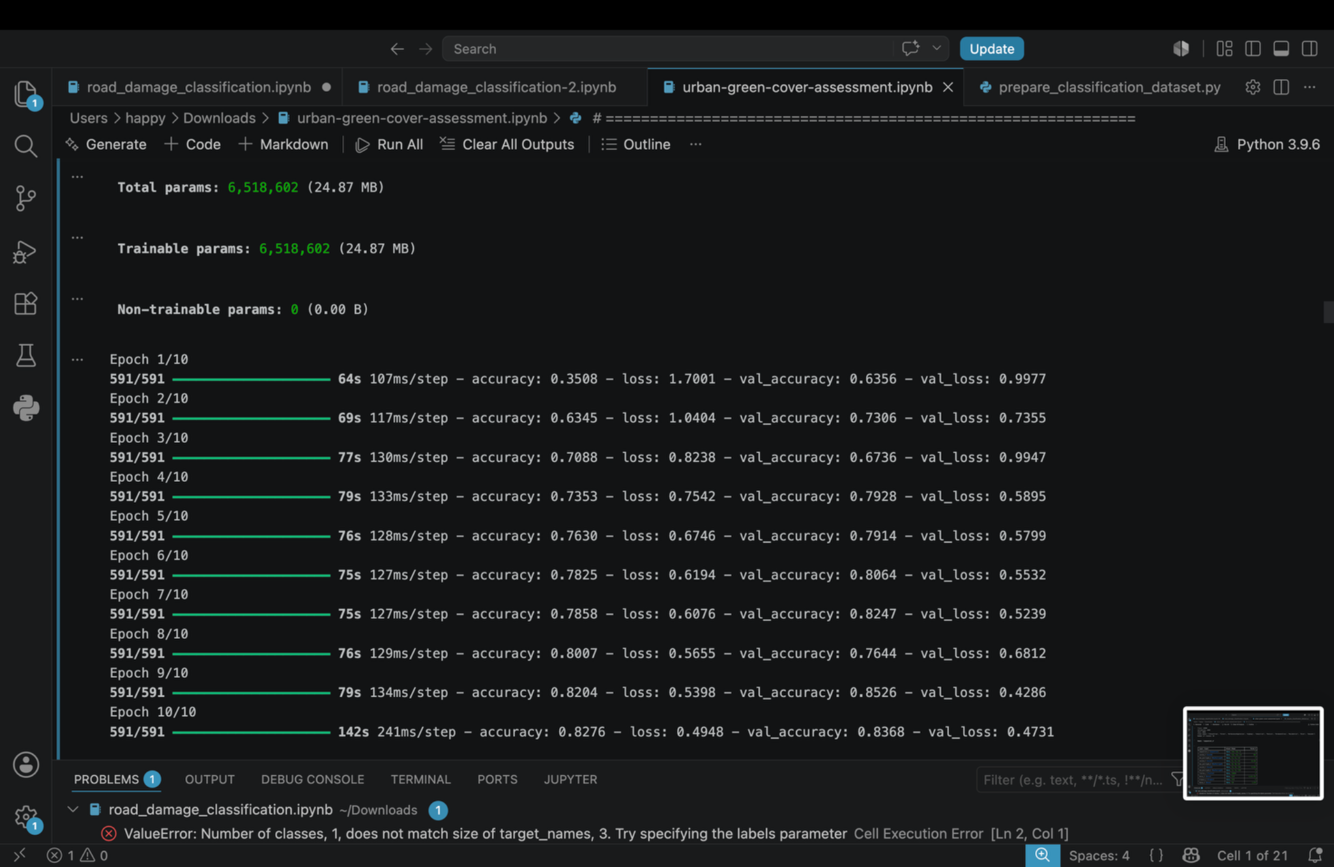

4. Custom CNN Accuracy Curve
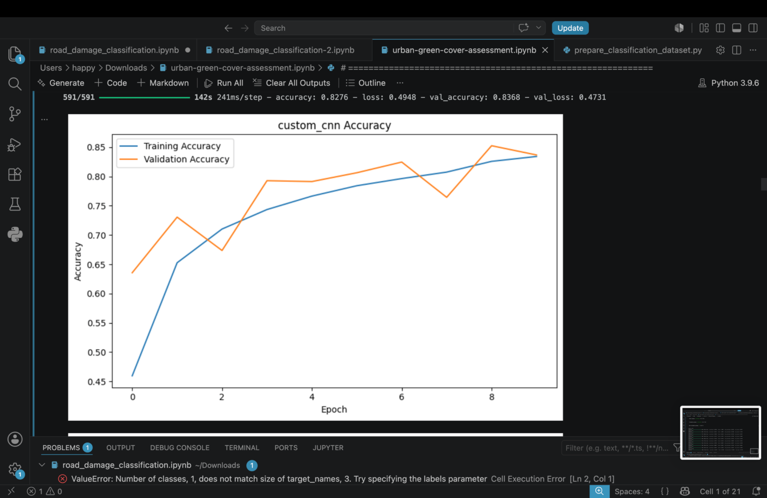

5. Custom CNN Loss Curve
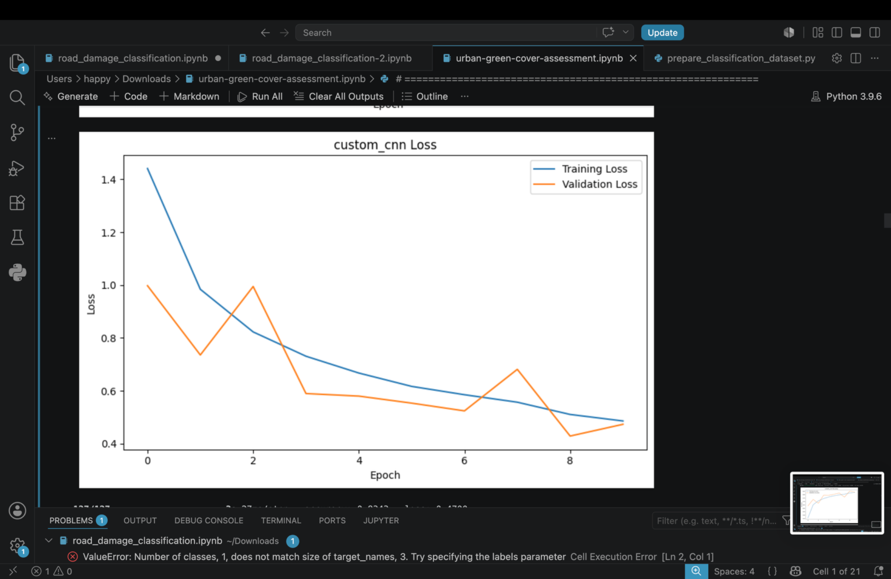

6. Custom CNN Test Accuracy
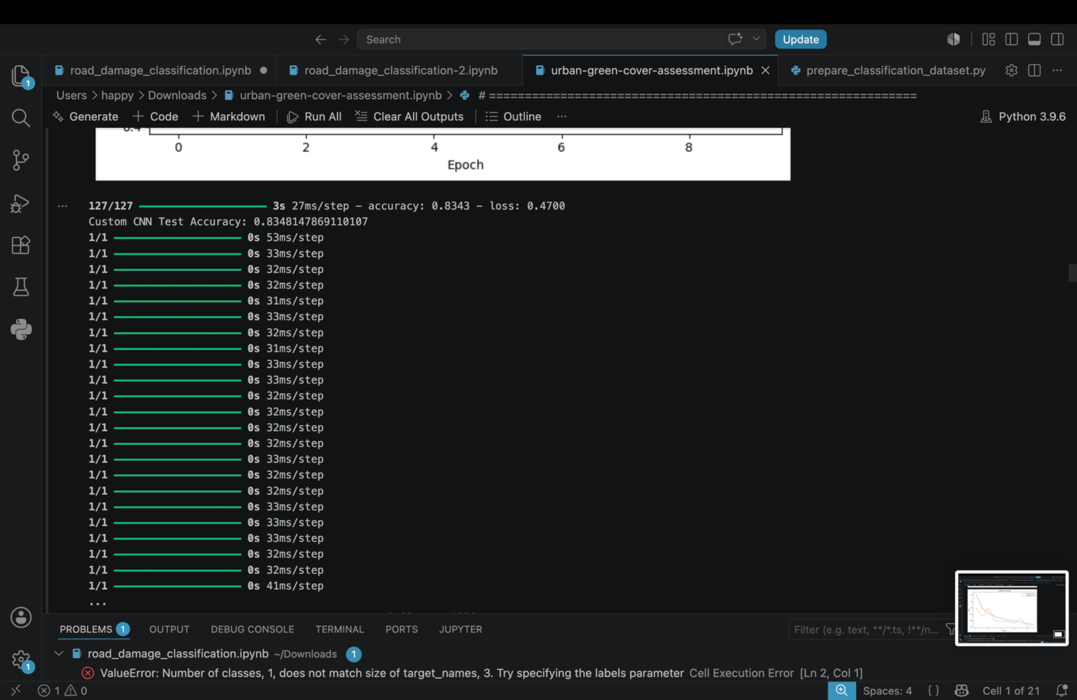

7. Custom CNN Classification Report and Confusion Matrix
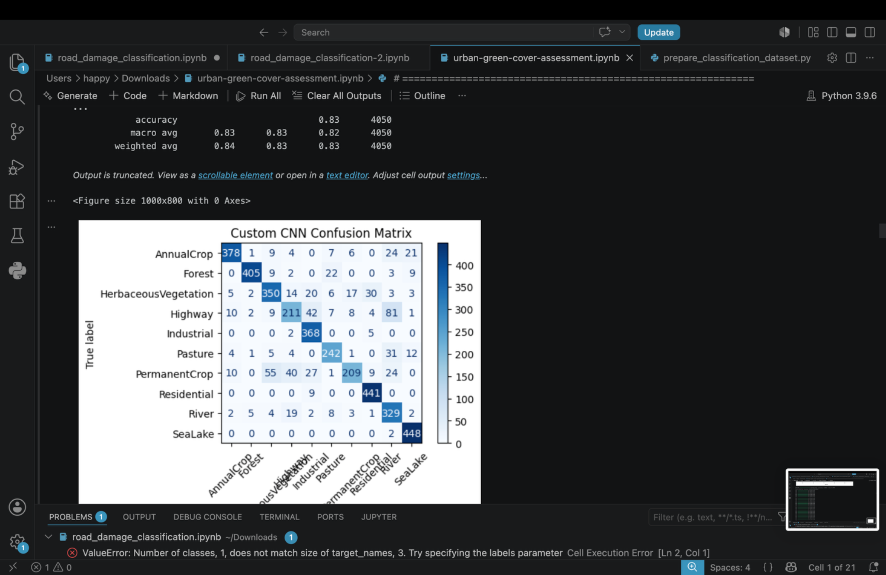

8. Custom CNN Confusion Matrix
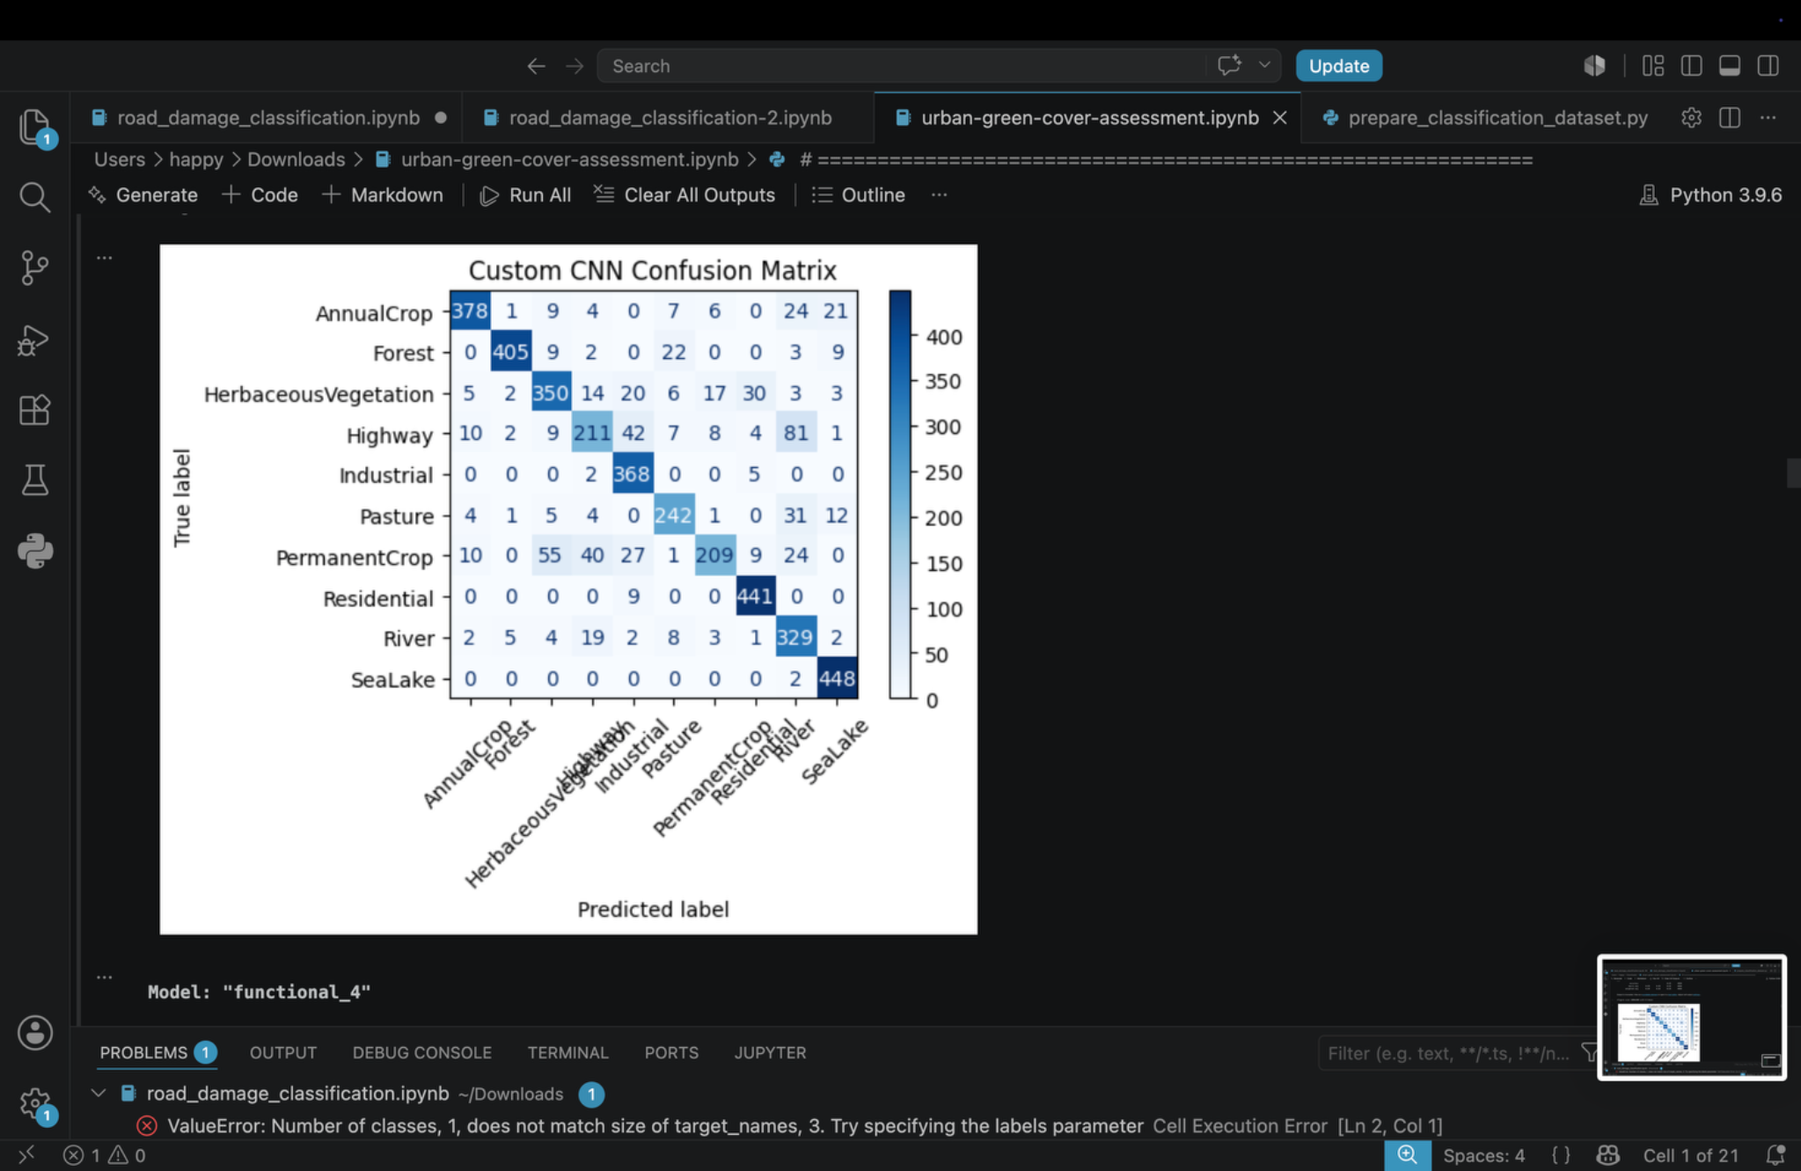

9. MobileNetV2 Architecture
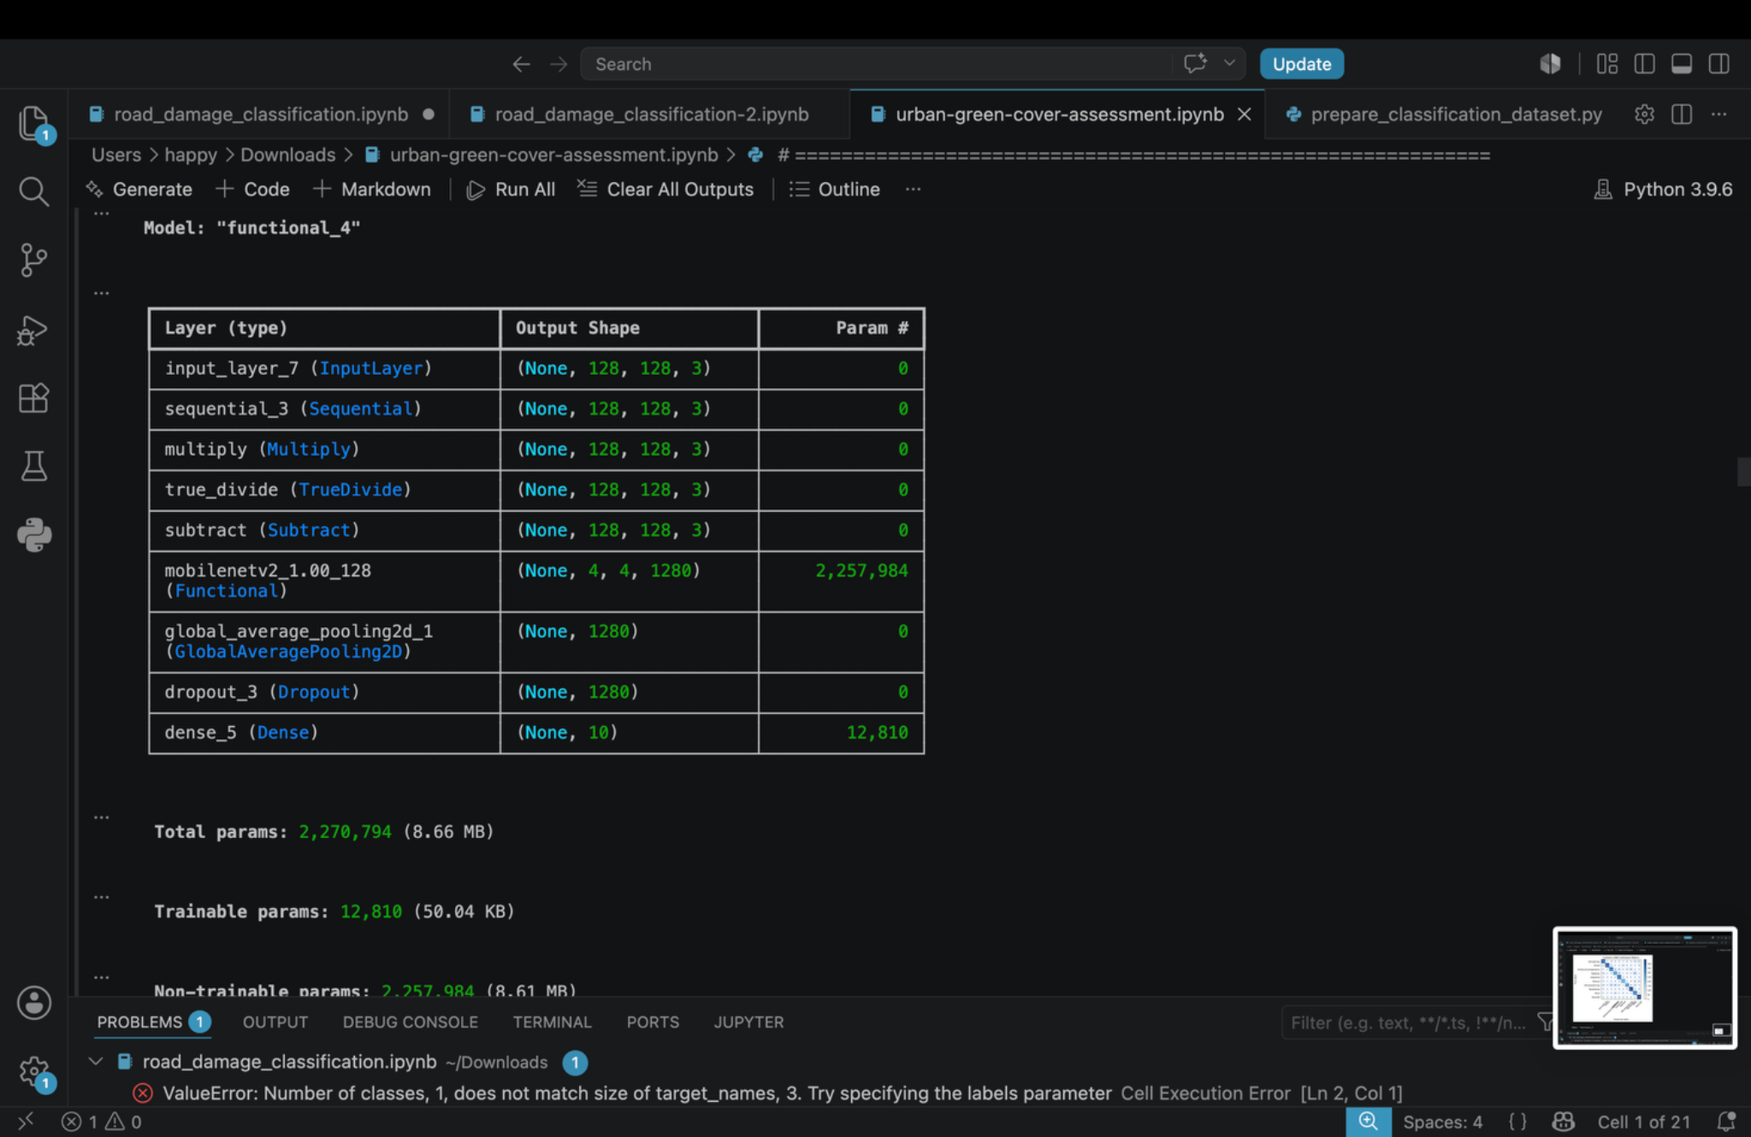

10. MobileNetV2 Training Progress
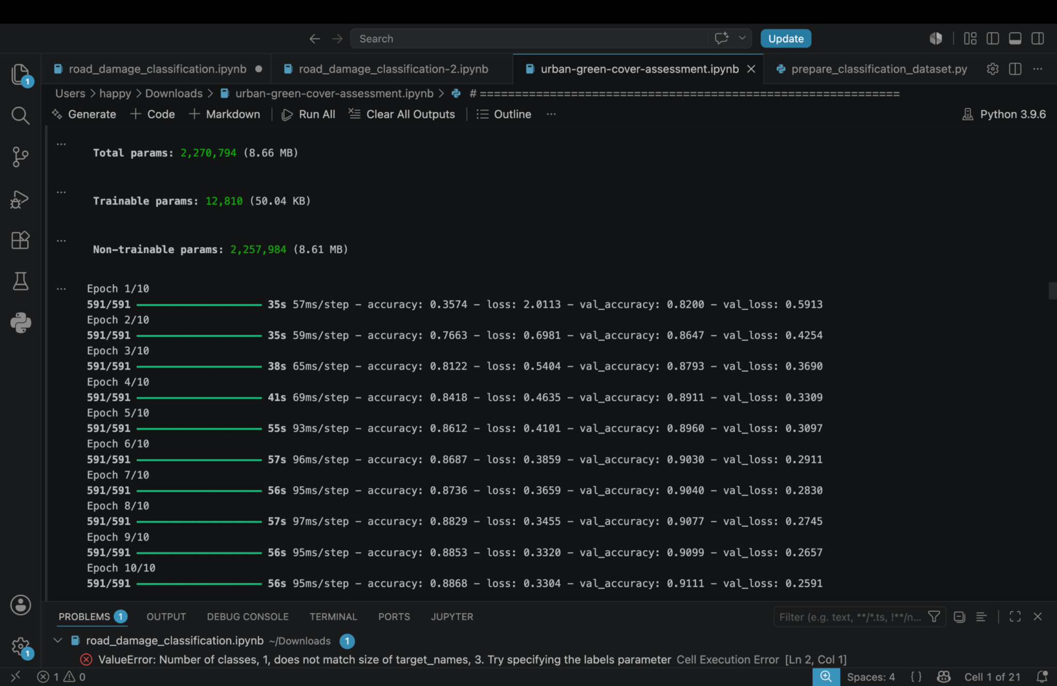

11. MobileNetV2 Accuracy Curve
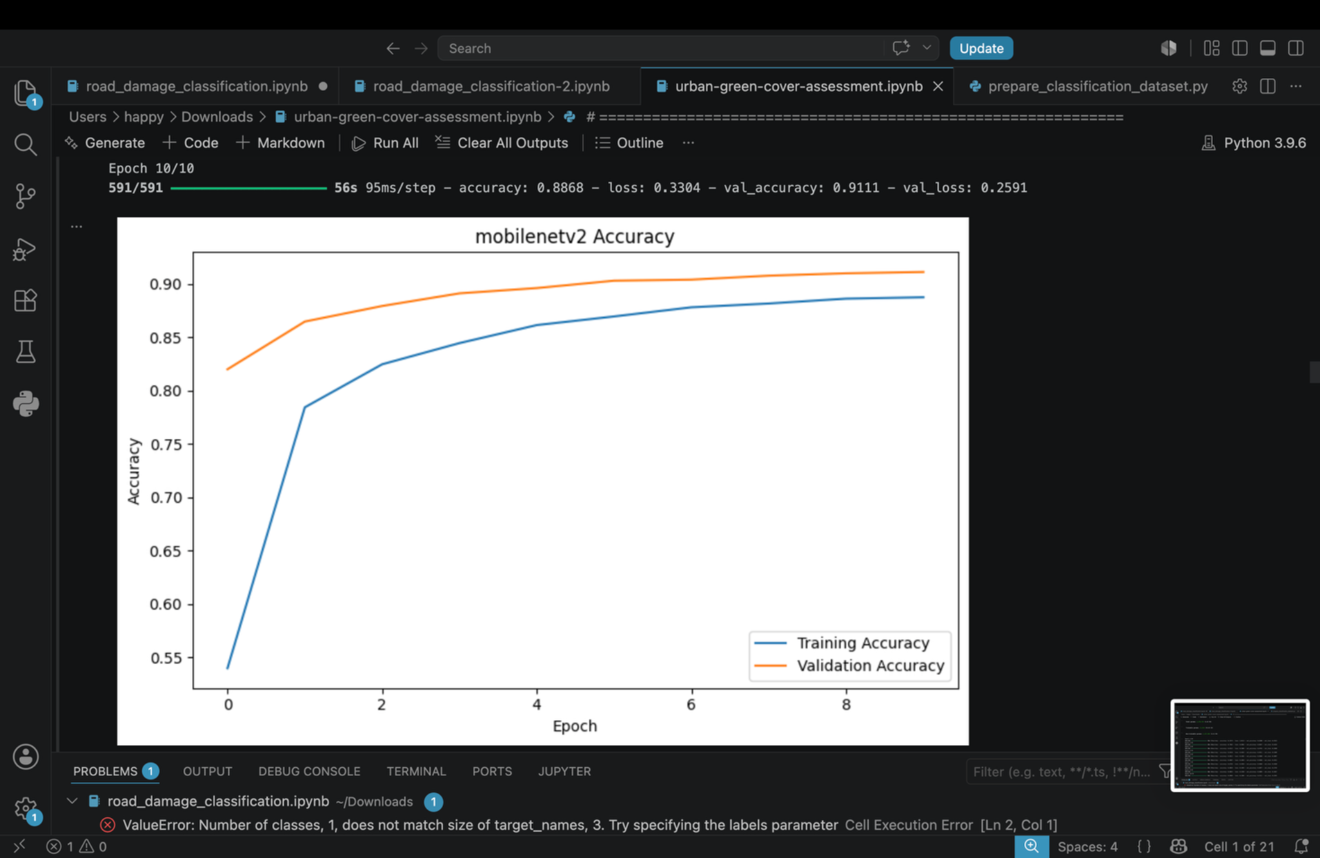

12. MobileNetV2 Loss Curve
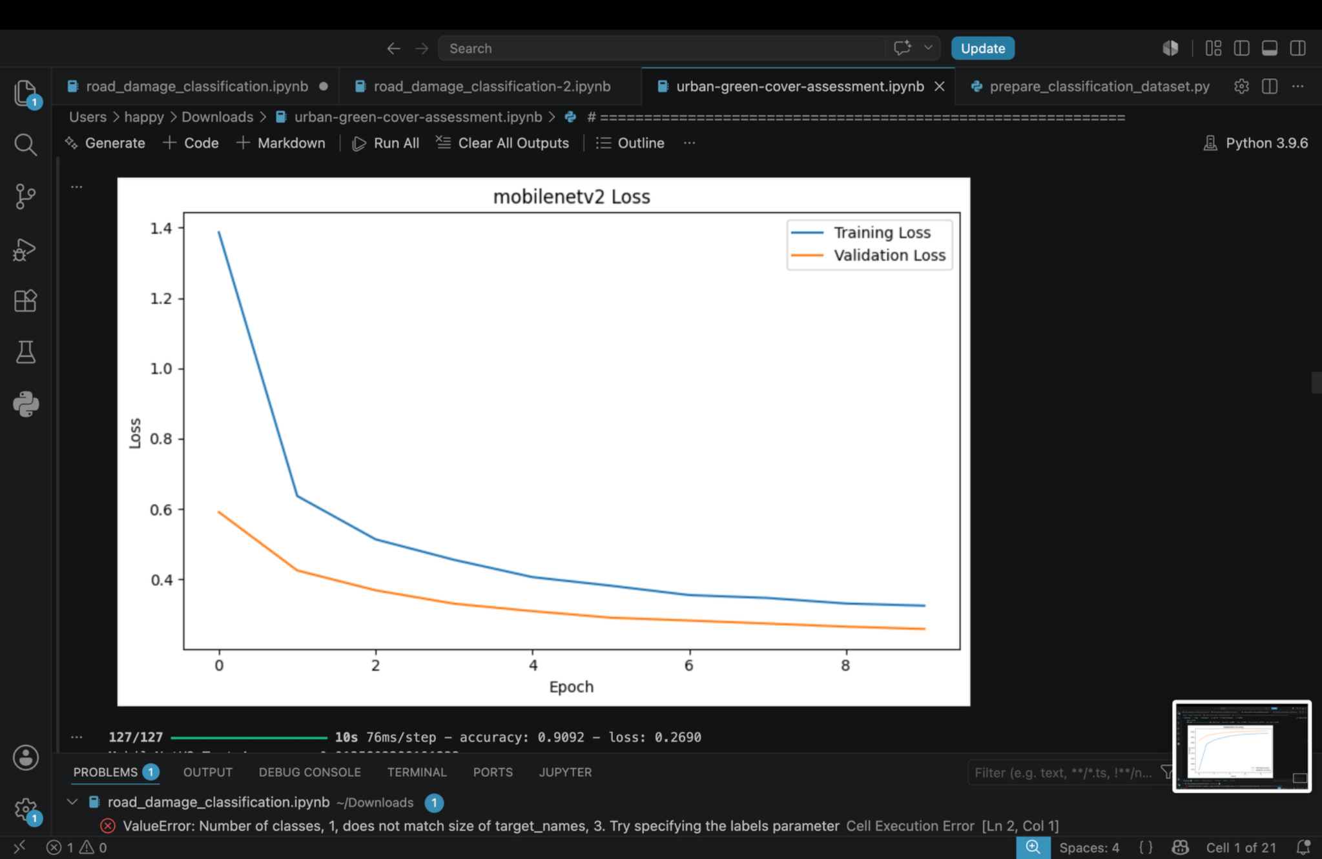

13. MobileNetV2 Test Accuracy
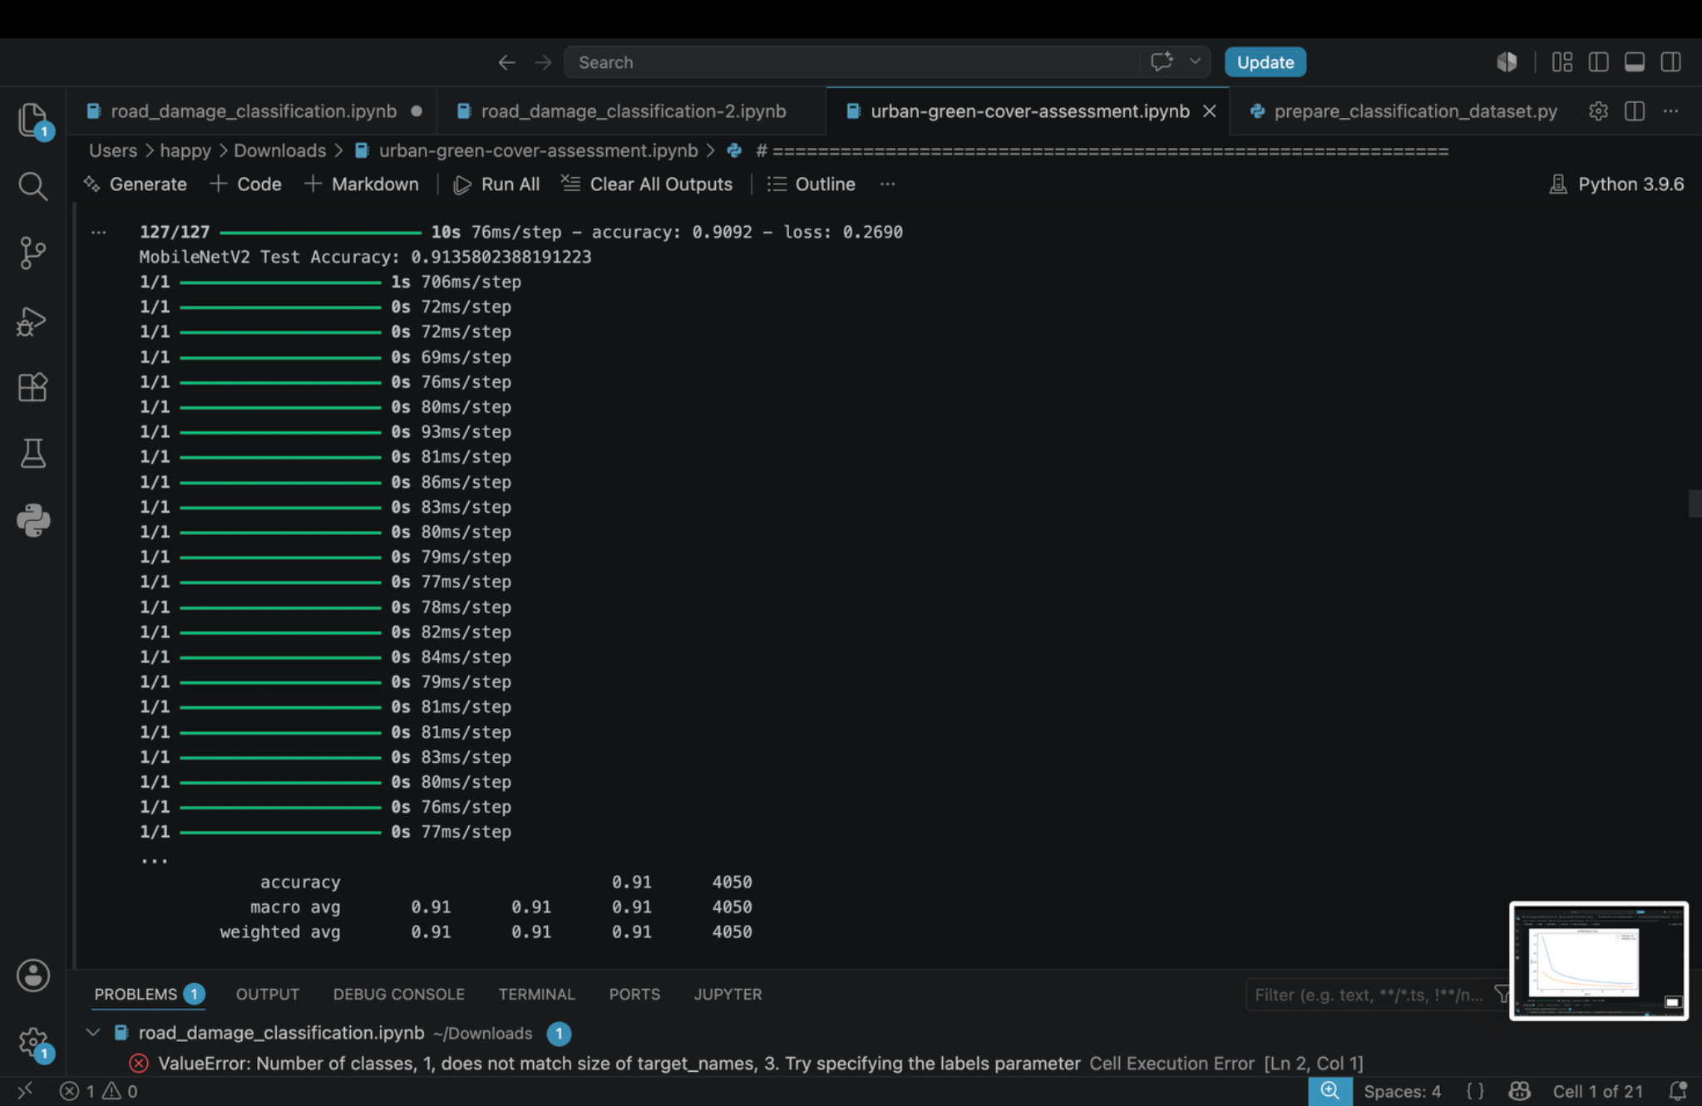

14. MobileNetV2 Classification Report and Confusion Matrix
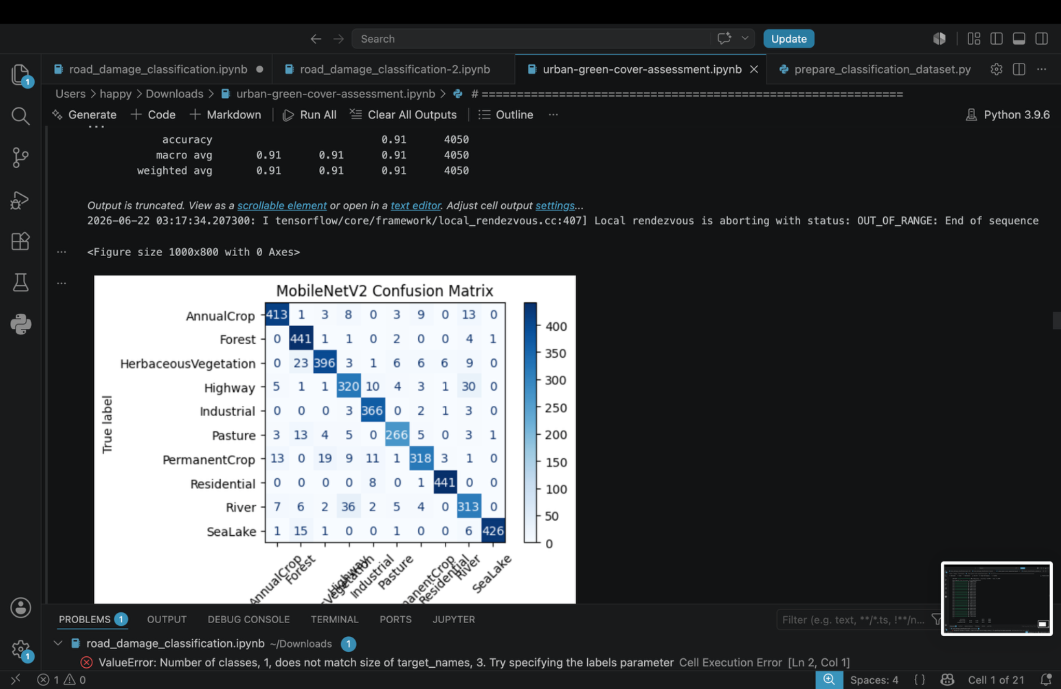

15. MobileNetV2 Confusion Matrix
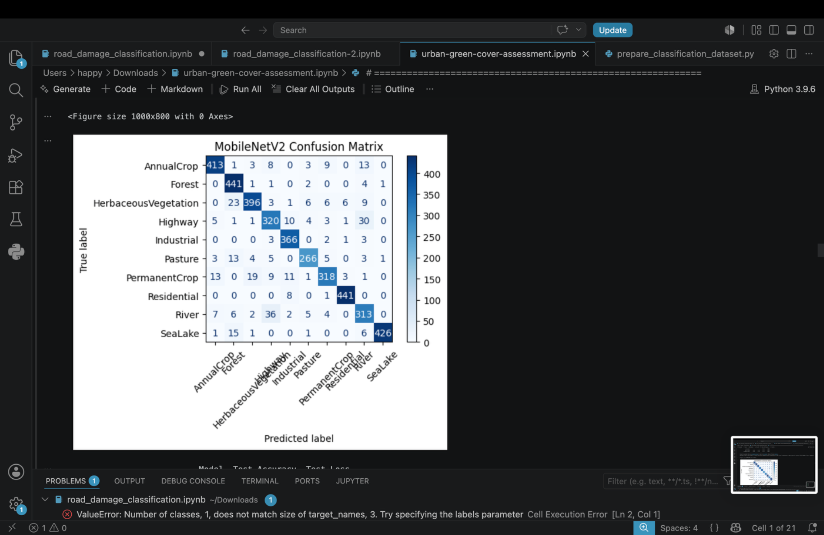

16. Final Model Accuracy Comparison
