DATABASE SESSION-3 ASSIGNMENT SOLUTION:

1. Given a table Sales with:
  - SaleDate
  - Region
  - Amount
  - ProductID
- Calculate a running total of sales amount per region ordered by date.
- Running total of quantity per product: Return all rows with the running total
QUERY:
SELECT sale_date, sale_reg, sale_amt, fk_sale_prod,
SUM(sale_amt) OVER (
PARTITION BY sale_reg
ORDER BY sale_date
ROWS BETWEEN UNBOUNDED PRECEDING AND CURRENT ROW )
AS running_total_amount_region,
SUM(sale_amt) OVER (
PARTITION BY fk_sale_prod
ORDER BY sale_date
ROWS BETWEEN UNBOUNDED PRECEDING AND CURRENT ROW )
AS running_total_amount_product
FROM sale
ORDER BY sale_date, sale_reg;
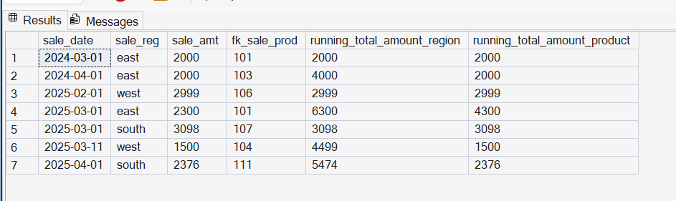

2. Using a table Employees with:
  - EmployeeName
  - Department
  - Salary
- Show each employee’s salary along with the average salary of their department
QUERY:
SELECT employee_name, dept,salary, AVG(salary)
OVER (PARTITION BY dept) AS dept_avg_salary
FROM employees;
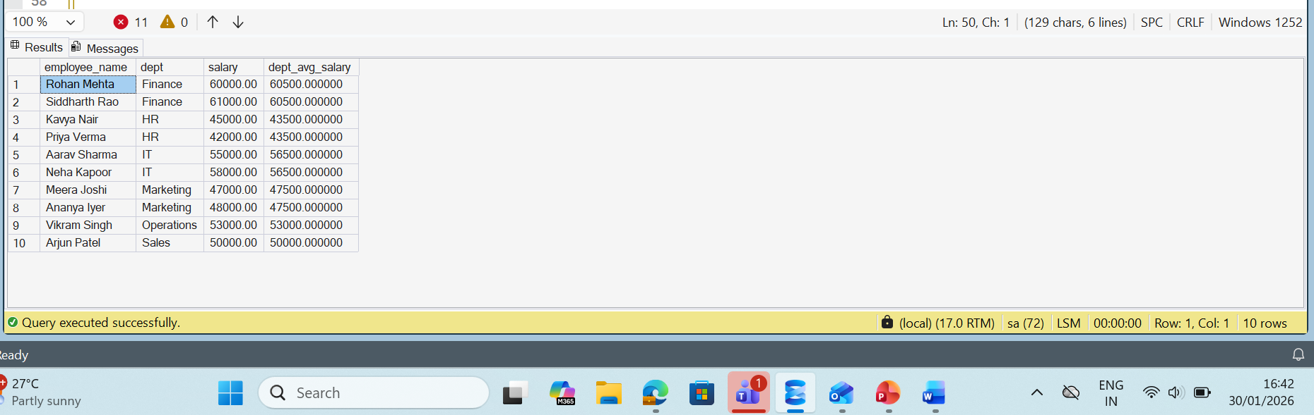

3. From a table Students with:
  - StudentName
  - Class
  - Score
- Rank students within each class based on score, with the highest score ranked first.

Query:
SELECT stud_name,class,score,
RANK() OVER (PARTITION BY class ORDER BY score DESC) AS rank_in_class
FROM students;
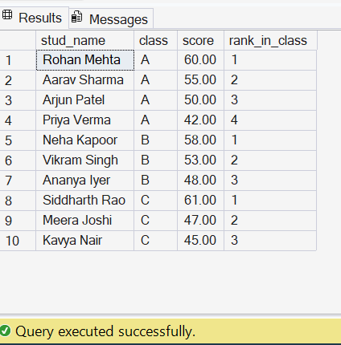

MERGE:
1. Products
  - ProductID
  - ProductName
  - Price
- Products_Staging
  - ProductID
  - ProductName
  - Price
- Write a MERGE statement that:
  - Updates ProductName and Price if ProductID already exists in Products
  - Inserts the record if ProductID does not exist in Products

QUERY:
MERGE INTO products AS target
USING products_staging AS source
ON target.pk_prod_id = source.pk_prod_id
WHEN MATCHED THEN
UPDATE SET target.prod_name = source.prod_name,
target.Price = source.Price
WHEN NOT MATCHED BY TARGET THEN
INSERT (pk_prod_id, prod_name, price)
VALUES (source.pk_prod_id, source.prod_name, source.price);
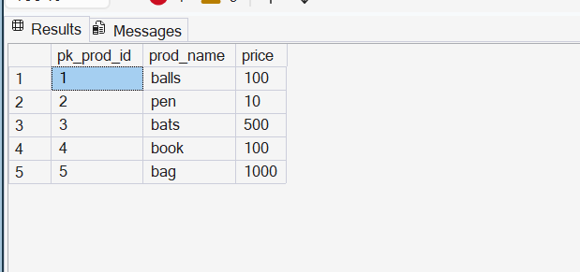

2. Customers
  - CustomerID
  - CustomerName
  - IsActive
- Customers_Staging
  - CustomerID
  - CustomerName
- Write a MERGE statement that:
  - Updates CustomerName for existing customers
  - Inserts new customers
  - Marks customers as inactive (IsActive = 0) if they no longer exist in the staging table
QUERY:
MERGE INTO custs AS target
USING custs_staging AS source
ON target.pk_cust_id = source.pk_cust_id
WHEN MATCHED THEN
UPDATE SET target.cust_name = source.cust_name, target.IsActive = 1
WHEN NOT MATCHED BY TARGET THEN
INSERT (pk_cust_id,cust_name, isActive)
VALUES (source.pk_cust_id, source.cust_name, 1)
WHEN NOT MATCHED BY SOURCE THEN
UPDATE SET target.IsActive = 0;

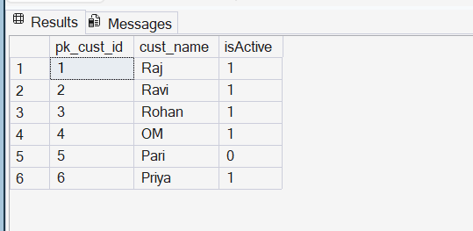

3. EmployeeSalary
  - EmployeeID
  - Salary
- EmployeeSalary_Staging
  - EmployeeID
  - Salary
- Write a MERGE statement that:
  - Updates salary only if the new salary is higher
  - Inserts new employees if they do not exist

QUERY:
MERGE emps AS Target
USING emps_staging AS Source
ON (Target.pk_empID = Source.pk_empID)
WHEN MATCHED AND Source.salary > Target.salary THEN
UPDATE SET Target.salary = Source.salary
WHEN NOT MATCHED BY TARGET THEN
INSERT (pk_empID, salary)
VALUES (Source.pk_empID, Source.salary);
