GIT EXERCISE
Team members: Ravi Vadher, Abhishek Gujarati, Harsh, Parth Maha, Het Patel

Merge Conflict Screenshot:
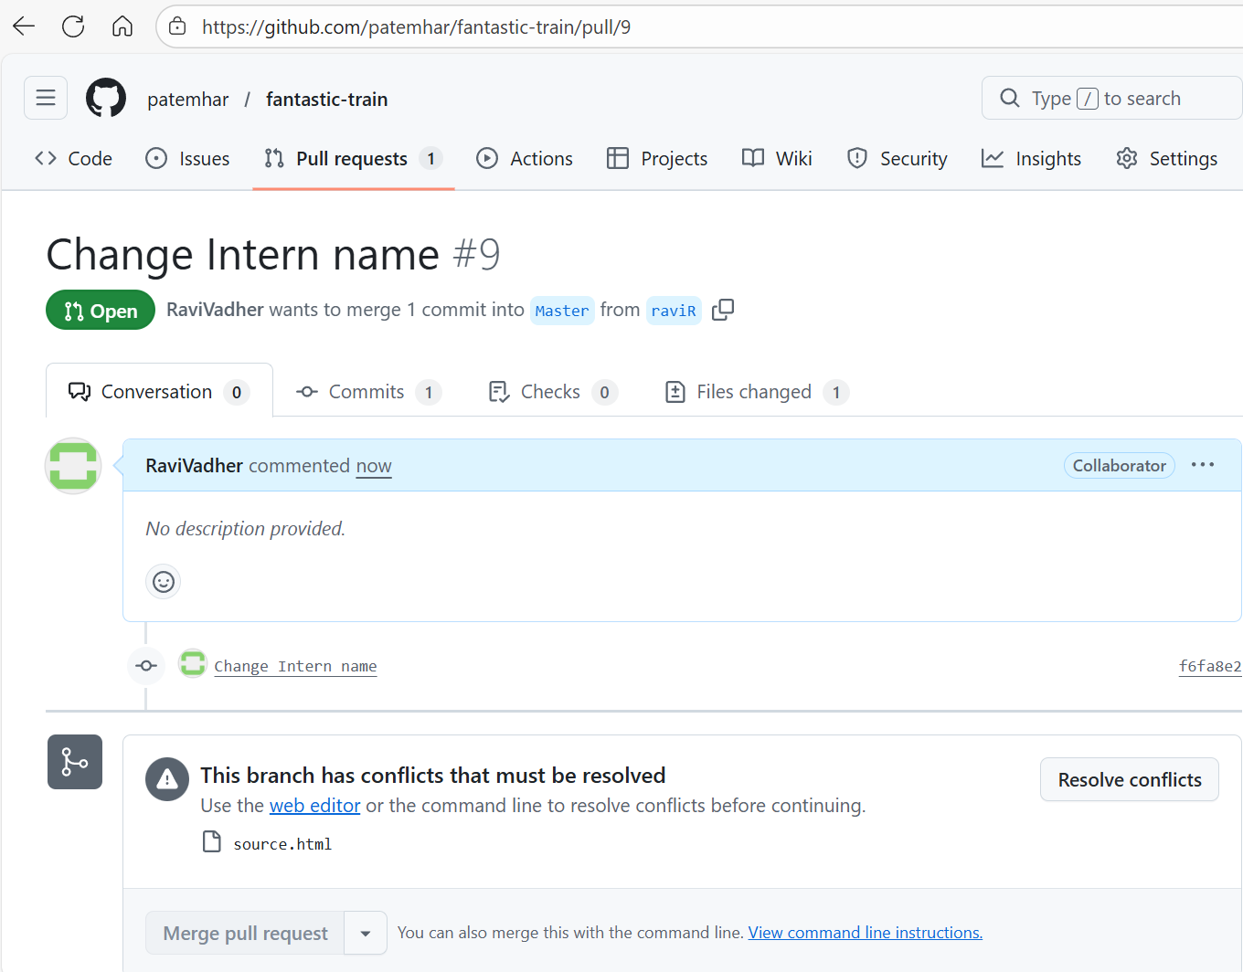

Here conflict has occurred because I change specific code from branch raviR and also change that code from Master.
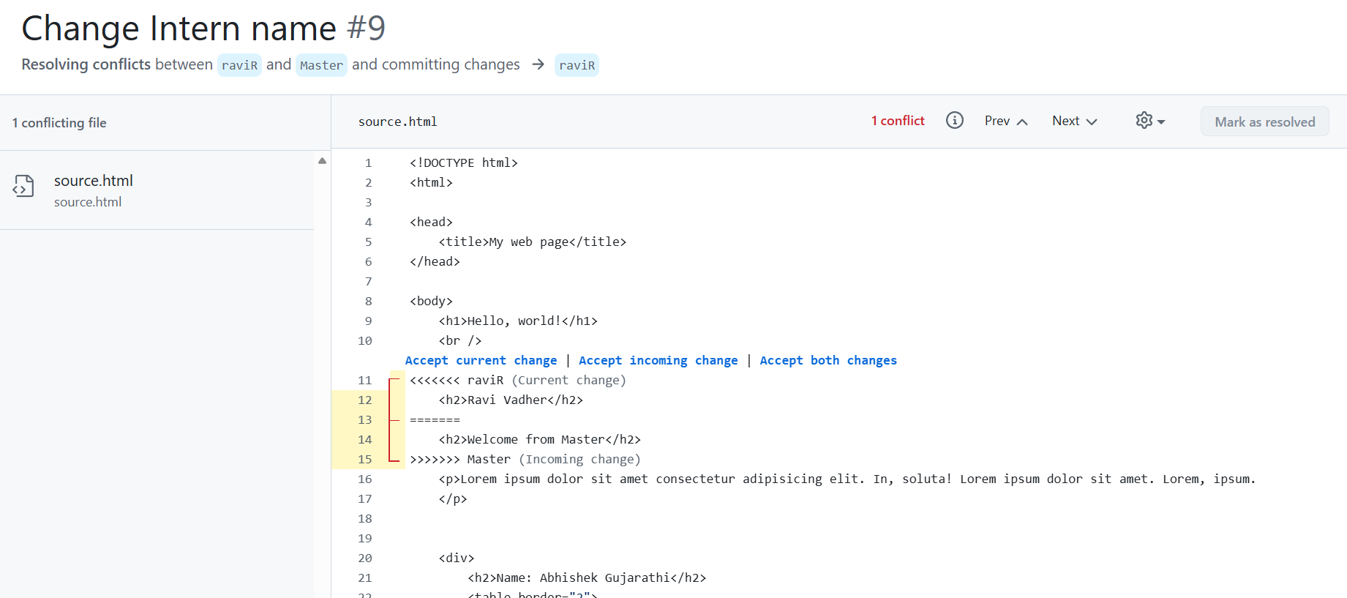

Conflict Resolve Screenshot:
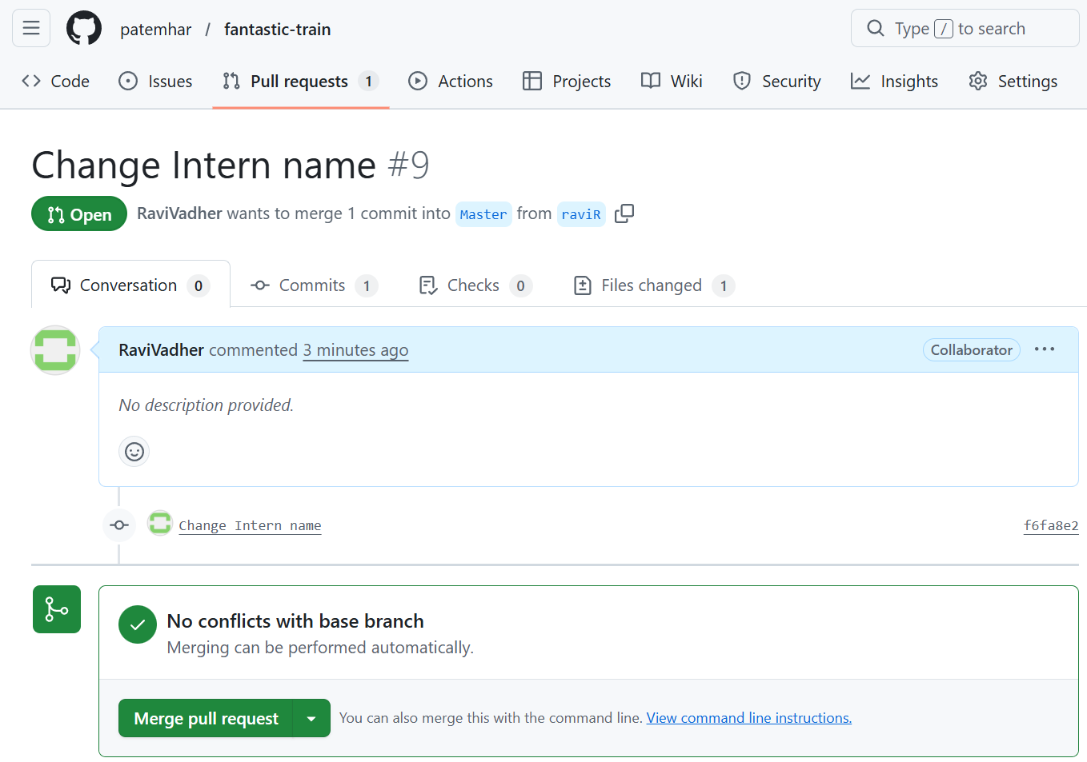
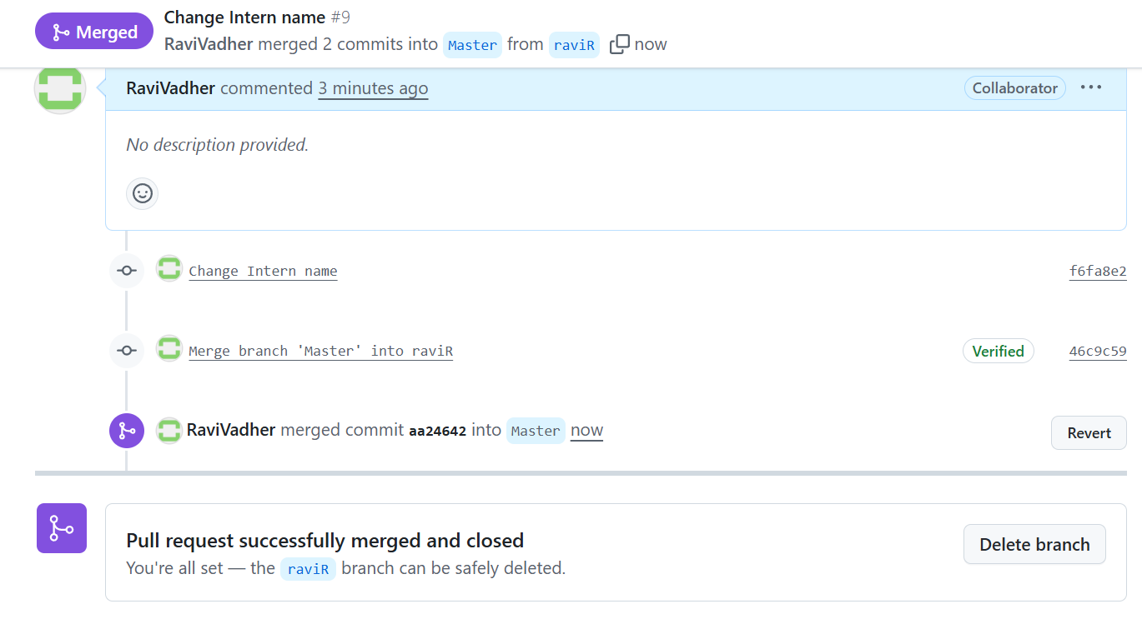

Steps For Resolve Conflict:
-checkout my PR branch raviR
-after identify conflict file using git status command
-open vs code and resolve manually. Change source.html as Master branch code.
-Then push again. Conflict resolved.

· Additional tasks:
o How to delete a branch?
Answer: We can delete branch in two ways. One from directly in GitHub and second is using command git branch -d branch name.
o What needs to be done when remote repository declines push?
Answer: When remote repository declines push we need to run command git pull origin branch-name.
o What is git stash and the need for it?
Answer: git stash is basically used for temporarily saves uncommitted changes. Stash is needed when we need to switch branch and we don’t want to commit unfinished task.
o What is .gitignore?
Answer: .gitignore is file extension that tells git which files/folder to ignore.
o Why do we need .gitignore?
Answer: .gitignore to avoid pushing unnecessary file and protect sensitive files.
o Git alias what, why?
Answer: Git alias is shortcut command and it is used to makes commands shorter.
o What is the difference between a git merge and a git rebase?
Answer: Git merge Git Rebase
-it create merge commit -it rewrites commit history
-it is safe for shared branches - it is not safe for shared branches

o What is the difference between clone with SSH and HTTP/S.
Answer:
SSH HTTPS
-uses SSH keys -uses username and tokens
-No password every time -token is required every time.
-more secure -security is lesser then SSH

o What are ssh keys?
Answer: SSH keys are a pair of keys used for secure authentication and authorization. There are two keys : public key and privet key
o How to configure ssh keys in git account.
Answer: To configure SSH keys in GitHub first need to generate an SSH key using ssh-keygen. Then copy the public key and add it to the GitHub account under settings – SSH keys.
o Benefits of cloning with SSH.
Answer: Benefits of cloning with SSH are :
It is more secure, faster authentication and No password required.
o What is rebase? Difference between merge and rebase.
Answer: Git rebase moves commits on top of another branch. Merge keeps history and rebase rewrites history. Rebase is used to keep commit history clean.

o What is forking? Demonstrate by creating a fork.
Answer: Forking means creating copy of someone’s repo in own GitHub account.
Example: for today’s exercise in our team one person create repo and I can copy of him repo in my GitHub account. Using fork button, we can see on GitHub
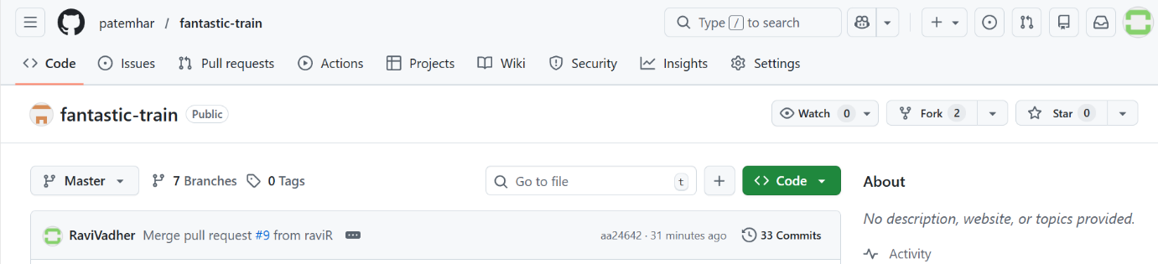

o What is a force push, when should it be used and why would you need to?
Answer: Force push overwrites remote history.it is used after rebase and fixing wrong commits. We should avoid it on shared branches.

