Code Quality Tools Practices:
SonarQube:
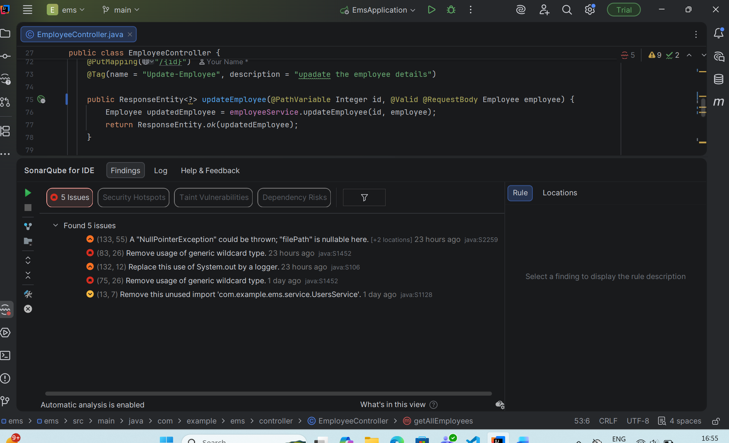

There are five issues are found on EmployeeController.java. I solved all the issues one by one as per it’s impact on maintainability.

- Issue-2: Remove usage of generic wildcard type.
This issue has occurred because I give generic return type to function but function always return the Employee type object.
Example:
public ResponseEntity<Employee> updateEmployee(@PathVariable Integer id, @Valid @RequestBody Employee employee) {
Employee updatedEmployee = employeeService.updateEmployee(id, employee);
return ResponseEntity.ok(updatedEmployee);
}

- Issue-4: Remove usage of generic wildcard type.
This issue is also same as Issue-2.
Example:
public ResponseEntity<Employee> updateEmployeeDepartment(
@PathVariable Integer id,
@Valid @RequestBody EmployeeDepartmentUpdateDTO updates) {
Employee updatedEmployee = employeeService.updateEmployeeDepartment(id, updates);
return ResponseEntity.ok(updatedEmployee);
}
- Issue-3: Replace this use of System.out by a logger.
This issue has occurred because of during writing code for debugging I write
“ System.out.println(files);” but after I forget to remove it. Currently solution is I not need that line so I can remove it. If any crucial insights then I should used logging instead of the standard outputs (e.g., System.out, System.err).

- Issue-5: Remove this unused import 'com.example.ems.service.UsersService'.
This issue has occurred because by mistake I import UsersService in Emloyee Controller but never used it. Simply remove import from codebase.

After Resolving Some of Issues:
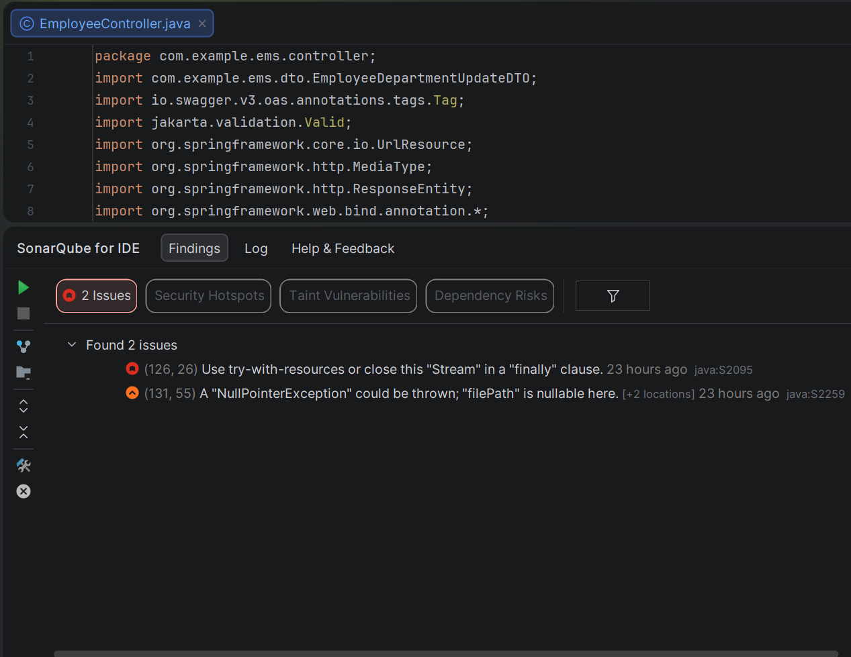
2. Snyk:
In project Employee Management System when I scan through Snyk I found two main dependency vulnerability issues in
1. spring-security-crypto
2. springdoc-openapi-starter-webmvc-ui
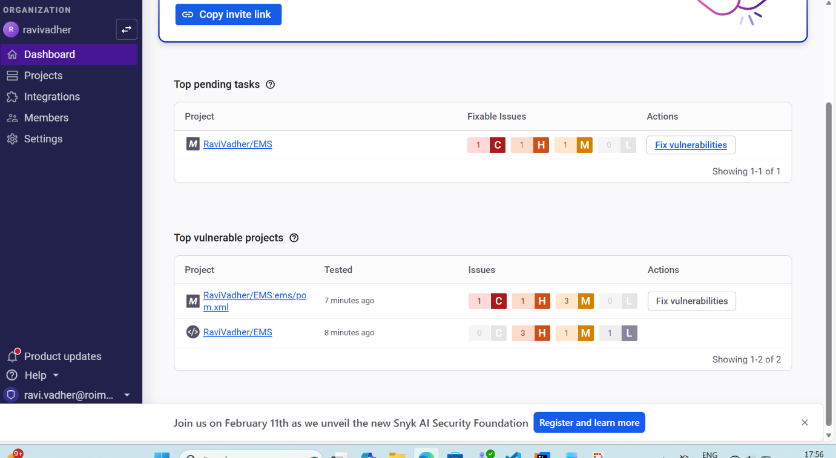

After click on Fix vulnerabilities it will automated generate pull request.
Vulnerability resolve after upgrading.
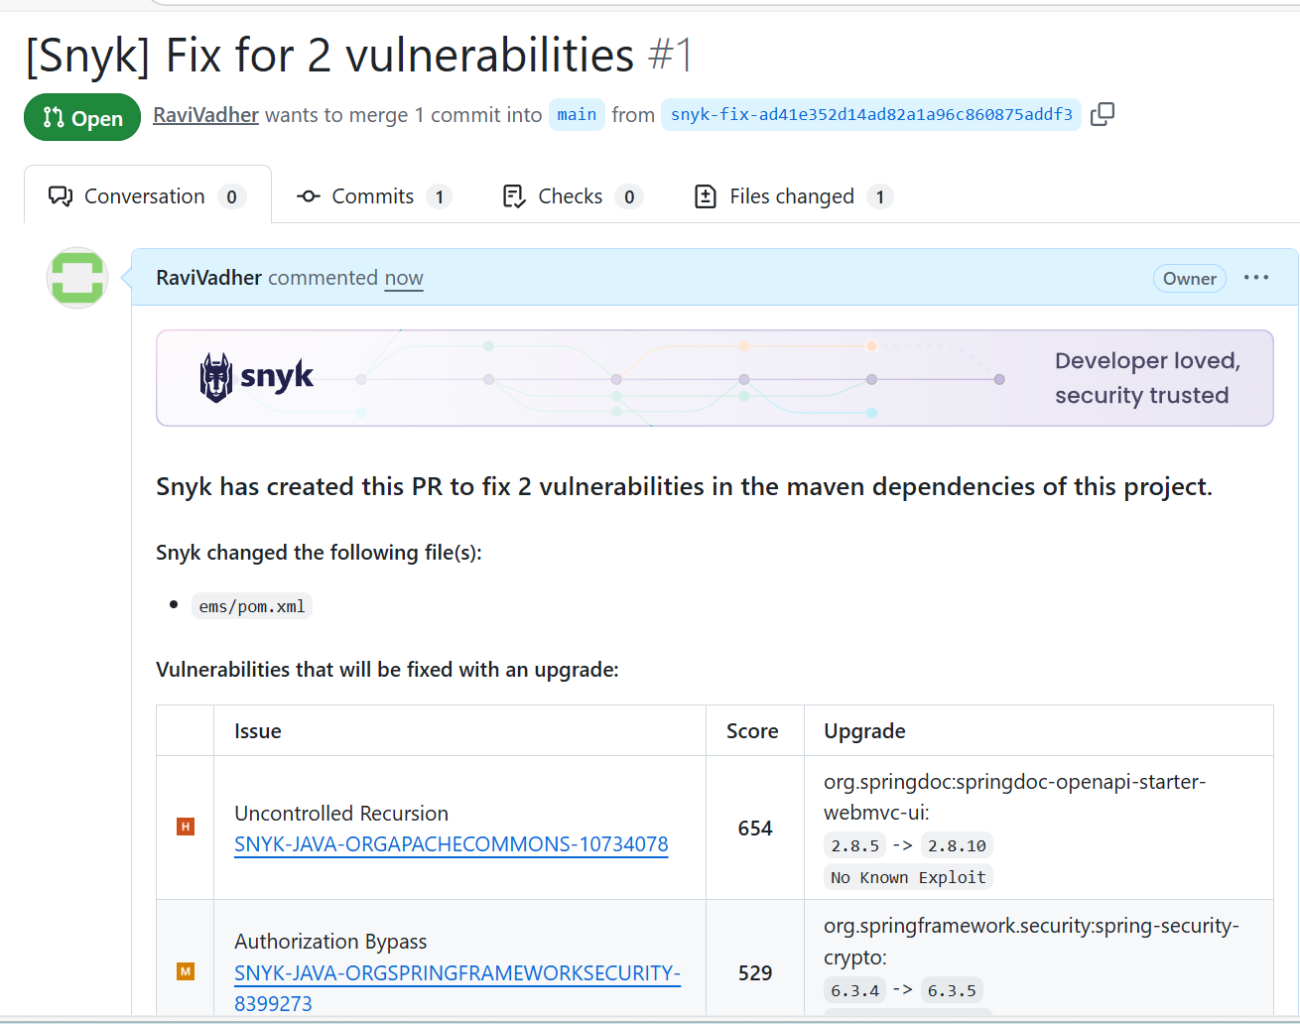
After fixes:
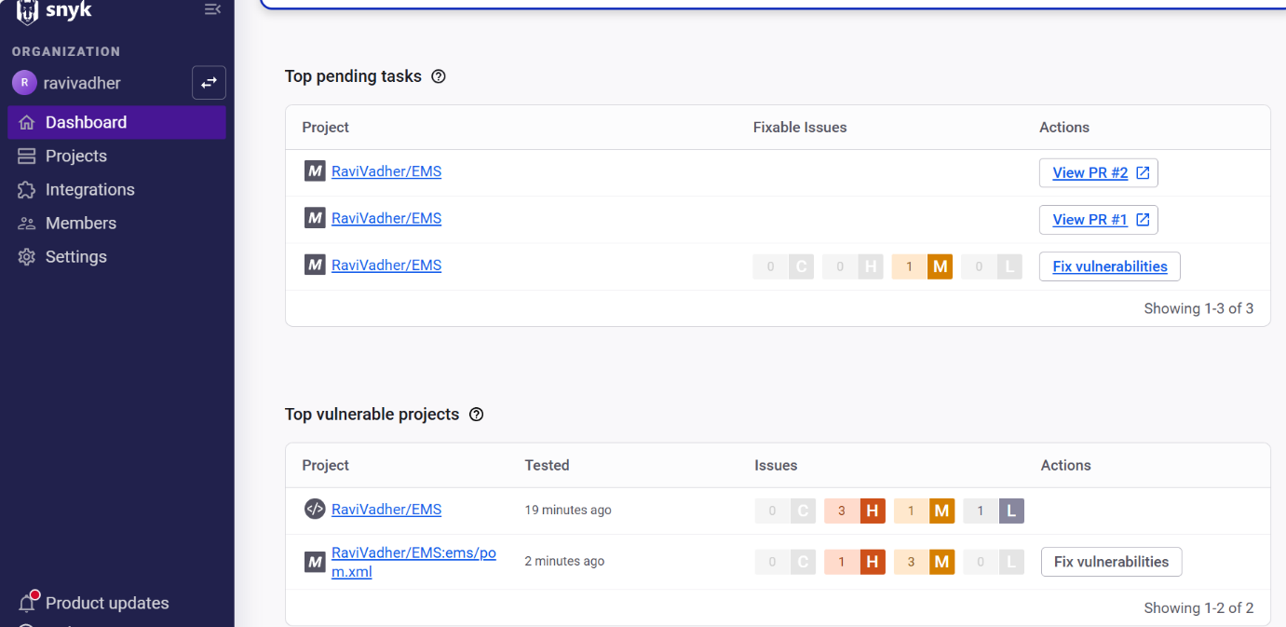

SonarQube Vs Synk:

SonarQube | Synk
More focus on code quality and maintainability | Heavily focused on security
It performs static analysis, code duplication detection and code coverage | It perform static analysis of dependencies and their vulnerabilities
It requires dedicated server setup and maintenance | It provide cloud based service

