Assignment-1
- a. Write a function to return the number of leaves to be added if an employee joins anytime during the year, considering 1 day leave per month.

CREATE FUNCTION dbo.fn_calculate_remainingLeaves(@joining_date Date)
RETURNS INT
AS
BEGIN
DECLARE @Leaves INT
SET @Leaves = 12- MONTH(@joining_date) +1;
RETURN @Leaves;
END;

b.Write a stored procedure such that as soon as a new Employee is added, his leave balance is added in Leave Balance table. Use the function created in previous step.
CREATE PROCEDURE dbo.sp_initialize_leaves (@emp_id INT, @joining_date DATE)
AS
BEGIN
DECLARE @total_allowed INT
DECLARE @year INT =YEAR(@joining_date);
SET @total_allowed = dbo.fn_calculate_remainingLeaves(@joining_date)
INSERT INTO leave_balances (fk_balance_emp, fk_balance_type,Year,leave_taken,total_allowed)
SELECT @emp_id, lt.pk_types_id, @year, 0, @total_allowed
FROM leave_types lt;
END;

C. Create a stored procedure to cancel a Leave Request, update the leave balance of cancelled leave. and Rollback if any step fails.

CREATE TRIGGER trg_restore_balance_leavecancelON leave_applications
AFTER UPDATE
AS
BEGIN
UPDATE lb
SET lb.leave_taken = lb.leave_taken - 1
FROM leave_balances lb
JOIN deleted d
ON lb.fk_balance_emp = d.fk_app_emp
AND lb.fk_balance_type = d.fk_app_type
AND lb.Year = YEAR(d.leave_date)
JOIN inserted i
ON i.pk_app_id = d.pk_app_id
WHERE d.Status = 'Approved'
AND i.Status = 'Rejected' AND lb.leave_taken > 0;
END;

d. Create a view to see the approved leave details for next 1 month for all employees
CREATE VIEW v_leave_report AS
SELECT e.emp_name ,la.leave_date as Date,la.approvedby
FROM leave_applications la
JOIN employees e
ON la.fk_app_emp = e.pk_emp_id
WHERE la.leave_date BETWEEN CAST(GETDATE() AS DATE) AND DATEADD(MONTH, 1, CAST(GETDATE() AS DATE))
AND la.Status = 'Approved';

SELECT * from v_leave_report;

VIEW DIAGRAM
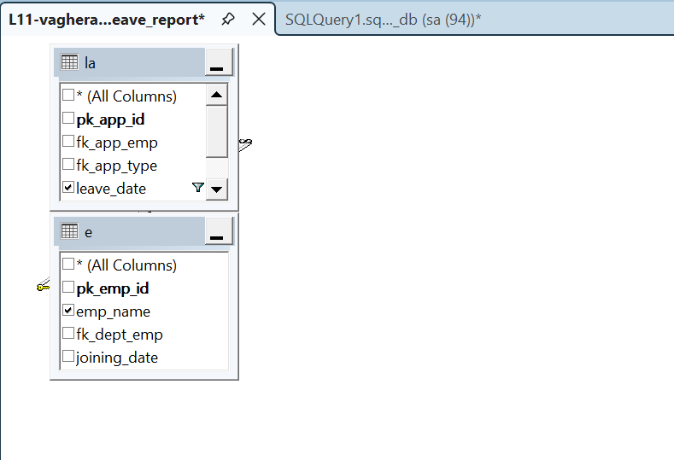

e. Create a view to have Department-wise, employee-wise total number of all leaves.
CREATE VIEW v_dept_emp_leaves AS
SELECT e.emp_name, d.dept_name,
count(l.pk_app_id) as total_leveas
FROM employees e
JOIN departments d ON e.fk_dept_emp = d.pk_dept_id
LEFT JOIN leave_applications l ON l.fk_app_emp =e.pk_emp_id
AND l.Status='Approved'
group by d.dept_name,e.emp_name;

SELECT * from v_dept_emp_leaves;

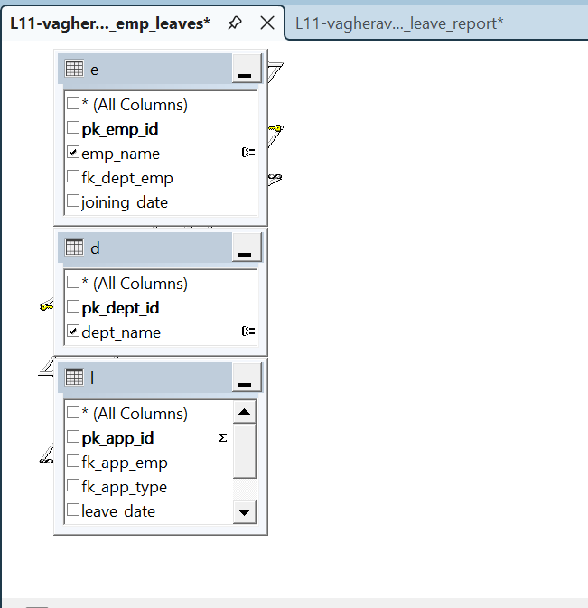

f. Write a trigger such that when a new Leave Type is added, its related Leave details and balance are added as well
CREATE TRIGGER trg_newtype_leave
ON leave_types
AFTER INSERT
AS BEGIN INSERT INTO leave_balances
(fk_balance_emp,fk_balance_type,YEAR,leave_taken,total_allowed)
SELECT e.pk_emp_id, i.pk_types_id, YEAR(GETDATE()),0,i.total_allowed
from employees e
JOIN inserted i ON 1=1;
END;

g. Write a trigger such that as soon as a Leave Request is approved, the remaining balance should get updated.
CREATE TRIGGER trg_update_balance_on_leave_approval
ON leave_applications
AFTER INSERT, UPDATE
AS
BEGIN
UPDATE lb
SET lb.leave_taken = lb.leave_taken + 1
FROM leave_balances lb
JOIN inserted i
ON lb.fk_balance_emp = i.fk_app_emp
AND lb.fk_balance_type = i.fk_app_type
AND lb.Year = YEAR(i.leave_date)
WHERE i.Status = 'Approved';
END;

Assignment-2
a. Create a stored procedure which runs at the start of every year. For all active employees, For all leave types, Add yearly quota from Leave Type table into Leave Balance(If balance record exists → update, If not → insert) Example: Leave Type can be: Earned Leave: 12, Casual Leave: 6, 10 Public Holidays
CREATE PROCEDURE sp_add_yearly_leave
@Year INT AS
BEGIN
UPDATE lb
SET lb.total_allowed = lb.total_allowed + lt.total
FROM leave_balances lb
JOIN leave_types lt
ON lt.pk_types_id = lb.fk_balance_type
WHERE lb.Year = @Year;

INSERT INTO leave_balances
(fk_balance_emp, fk_balance_type, Year, leave_taken, total_allowed)
SELECT e.pk_emp_id, lt.pk_types_id,@Year, 0, lt.total
FROM employees e
CROSS JOIN leave_types lt
WHERE NOT EXISTS (
SELECT 1
FROM leave_balances lb
WHERE lb.fk_balance_emp = e.pk_emp_id
AND lb.fk_balance_type = lt.pk_types_id
AND lb.Year = @Year
);
END;

b. Create a stored procedure which accepts LeaveId, ApprovedBy, ApprovalStatus and Updates Leave Request status of employee based on approval status
CREATE PROCEDURE sp_update_leave_status
@LeaveId INT,
@ApprovedBy NVARCHAR(150),
@ApprovalStatus NVARCHAR(20)
AS
BEGIN
UPDATE leave_applications
SET
Status = @ApprovalStatus,
approvedby = @ApprovedBy
WHERE pk_app_id = @LeaveId;
END;

- Create a trigger that ensures before adding a new leave if Remaining balance > Requested leave days else Raise a proper error message.

CREATE TRIGGER trg_check_leavebalance_before_insert
ON leave_applications
INSTEAD OF INSERT
AS
BEGIN
-- Check if any inserted leave has insufficient balance
IF EXISTS (
SELECT 1 FROM inserted i
JOIN leave_balances lb
ON lb.fk_balance_emp = i.fk_app_emp
AND lb.fk_balance_type = i.fk_app_type
AND lb.Year = YEAR(i.leave_date)
WHERE (lb.total_allowed - lb.leave_taken) < 1
)

BEGIN
RAISERROR (
'Leave request cannot be submitted. Not sufficent leave balance.',
16, 1
);
RETURN;
END;

