Ensure you have OPENWEBUI compatible Fast API Endpoint:
from fastapi import APIRouter, HTTPException, BackgroundTasks
from openwebui.models import ChatCompletionRequest, Query
from openwebui.routers.rag import agentic_rag_endpoint
import time, traceback

router = APIRouter()

@router.get("/models")
async def list_models():
now = int(time.time())
return {"object": "list", "data": [{"id": "contextual-rag", "object": "model", "created": now}]}

@router.post("/chat/completions")
async def chat_completions(request: ChatCompletionRequest):
try:
user_msg = next((m for m in reversed(request.messages) if m.role == "user"), None)
if not user_msg:
raise HTTPException(status_code=400, detail="No user message found")

query = Query(query=user_msg.content, evaluate=False)
response = await agentic_rag_endpoint(query, BackgroundTasks())

return {
"id": f"chatcmpl-{response.query_id}",
"object": "chat.completion",
"created": int(time.time()),
"model": request.model or "contextual-rag",
"choices": [{"index": 0, "message": {"role": "assistant", "content": response.response}}],
"usage": {
"prompt_tokens": len(user_msg.content.split()),
"completion_tokens": len(response.response.split()),
"total_tokens": len(user_msg.content.split()) + len(response.response.split())
}
}
except Exception as e:
print(f"Chat Completion Error: {e}\n{traceback.format_exc()}")
raise HTTPException(status_code=500, detail="Chat completion failed")

Fast api main.py
from fastapi import FastAPI
from fastapi.middleware.cors import CORSMiddleware

from openwebui.routers import health, rag, openai_api, evaluation

app = FastAPI(
title="Contextual RAG ChatBot API",
description="Enhanced RAG API with modular routers",
version="2.2.0"
)

# CORS
app.add_middleware(
CORSMiddleware,
allow_origins=["*"],
allow_credentials=True,
allow_methods=["*"],
allow_headers=["*"],
)

# Register routers
app.include_router(health.router, prefix="/health", tags=["health"])
app.include_router(rag.router, tags=["rag"])
app.include_router(openai_api.router, prefix="/v1", tags=["openai"])
app.include_router(evaluation.router, prefix="/evaluate", tags=["evaluation"])

@app.get("/")
async def root():
return {"message": "Contextual RAG ChatBot API is running", "version": "2.2.0"}

if __name__ == "__main__":
import uvicorn
uvicorn.run(app, host="0.0.0.0", port=8000)

Open docker desktop and then open terminal

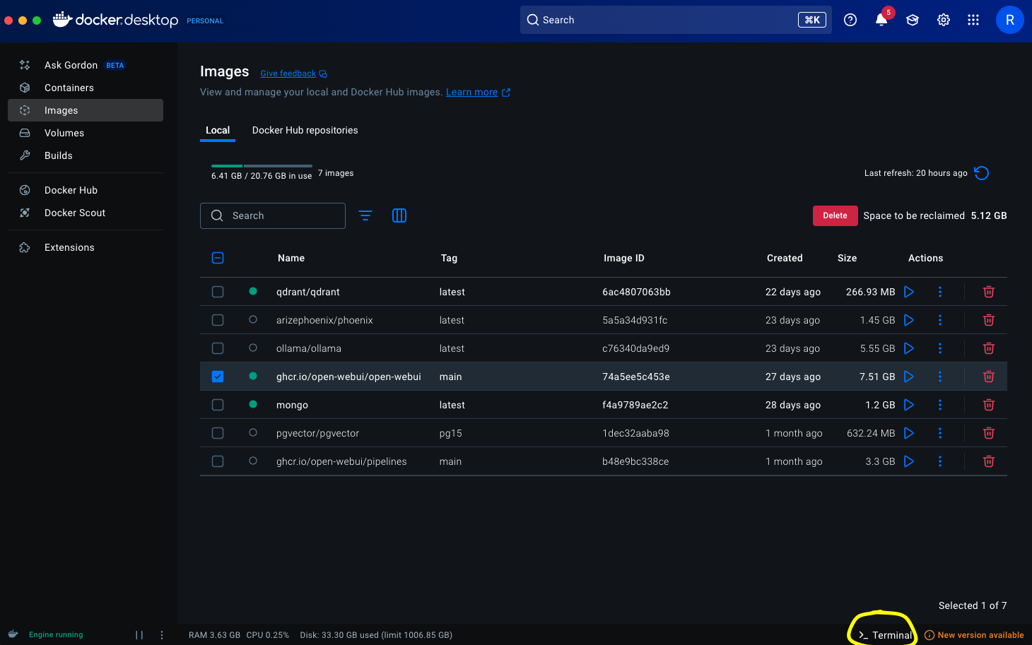

Run below command to create container

`
docker run -d \
-p 3000:8080 \
--add-host=host.docker.internal:host-gateway \
-e ENABLE_OPENAI_API=true \
-e OPENAI_API_BASE_URL=http://host.docker.internal:8000/v1 \
-e OPENAI_API_KEY=dummy-key \
-v open-webui:/app/backend/data \
--name open-webui \
--restart always \
ghcr.io/open-webui/open-webui:main
`
Here update
OPENAI_API_BASE_URL if your fastapi endpoint is not running on localhost
OPENAI_API_KEY set any sample key
Also stop and remove container if already exist with the same name
‘
docker stop open-webui && docker rm open-webui
`
Open the OpenWebUI running on
‘http://localhost:3000/’
Signup and Login if do not have account already

USER(RAVI VAISHNAV) → ADMIN PANEL → SETTINGS → CONNECTIONS →Click on +
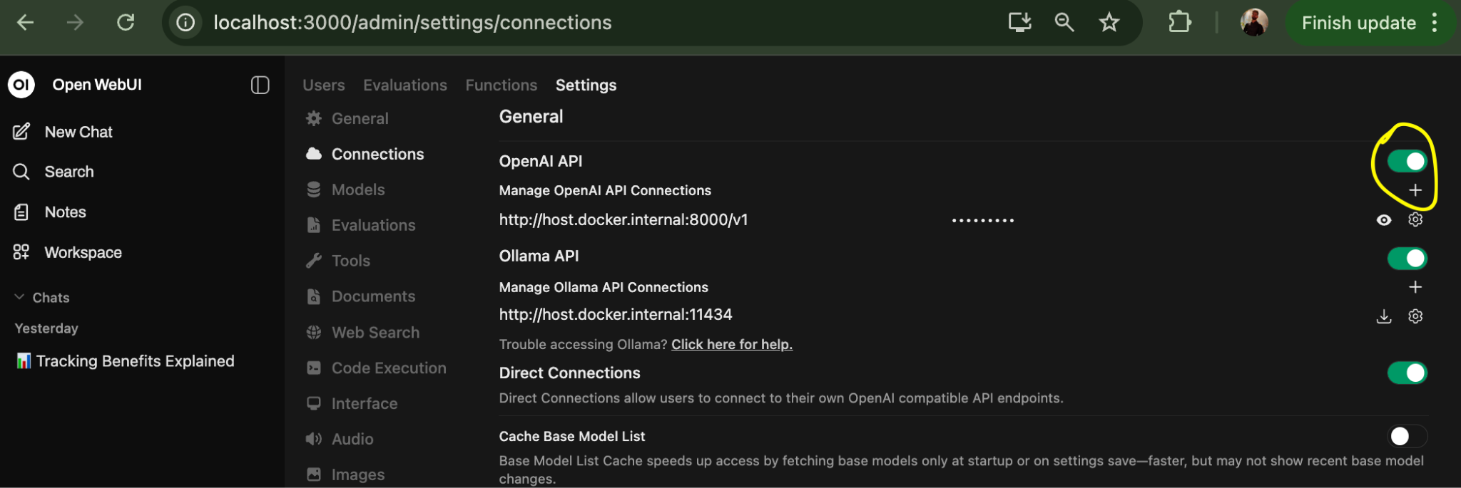

Then fill details like this

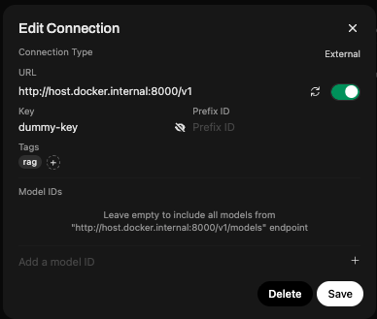

You will see the model in chat model selection


Note: Ensure your fastapi endpoint is running

