MintHRM
Human Resource Management Platform

Technical Architecture Document
AI-Assisted Self-Service Report Builder
Audience: Development team
Companion to: SRS v0.2
Version: 1.0 (Draft)
Confidential – Internal use only

Document Control
Field | Detail
Document title | Technical Architecture Document – AI-Assisted Report Builder
Audience | Development team (backend, frontend, DevOps)
Companion document | SRS v0.2 (functional specification)
Version | 1.0 (Draft)
Status | For development planning

Revision history
Version | Author | Summary
1.0 | Architecture | Initial technical architecture for development

Table of Contents

1. Introduction

1.1 Purpose
This document describes the technical architecture for the AI-Assisted Self-Service Report Builder, a new module of the MintHRM platform. It is intended for the development team and covers the technology stack, components and their responsibilities, build-time and run-time workflows, the data model, security architecture, the recommended project/folder structure, and deployment. It complements the SRS, which defines the functional requirements.

1.2 Architectural principles
- Semantic layer first: no component — human or AI — works against raw physical schema; everything goes through a governed metadata layer.
- Deterministic SQL: only the Query Engine generates SQL, always parameterized and tenant-scoped. The AI never emits SQL.
- AI sees metadata only: the AI receives field names, types and specs — never employee records (PII).
- Spec is the source of truth: a report is its definition (data spec + presentation spec); SQL is a compiled, reproducible artifact.
- Separation of concerns: authoring, querying, rendering, scheduling and AI are independent modules behind clear interfaces.

2. Architecture Overview
The system is a multi-tenant web application layered over the existing PostgreSQL datamart. The browser hosts two single-page applications (Builder and Viewer). A FastAPI backend exposes the REST API and contains the core modules. A separate metadata database stores the semantic layer, report definitions, versions and audit data. Reporting queries run against a read-only replica of the datamart. Redis backs caching and the Celery worker that handles scheduled runs and asynchronous exports. The AI provider is reached only through the AI Adapter and only ever receives metadata.
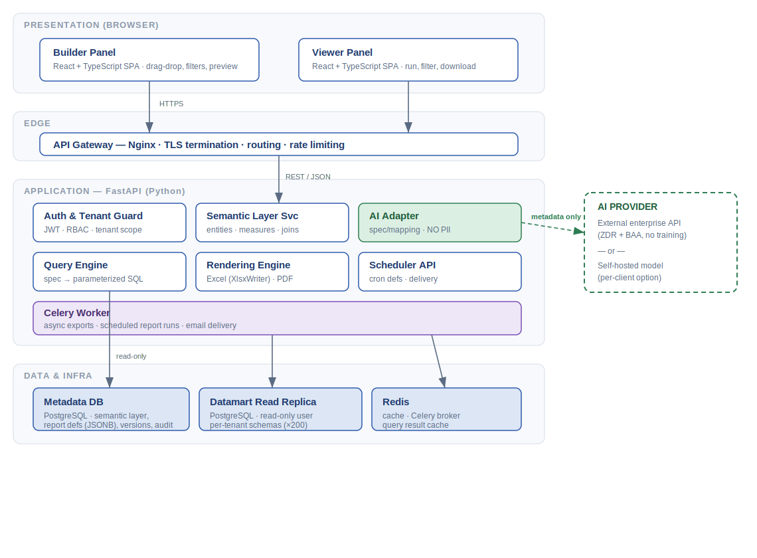
Figure 1 — System architecture (component and data-flow overview)
Request style: synchronous REST/JSON for interactive operations (build, preview, run-on-demand); asynchronous jobs via Celery for scheduled reports and large exports.

3. Technology Stack
Versions below reflect current stable releases as of 2026; pin the latest stable/LTS at project initialisation.

3.1 Frontend
Concern | Choice | Notes
Language / framework | React 19 + TypeScript | Type safety mirrors backend spec models.
Build tooling | Vite (Node.js 24 LTS) | Fast dev server and builds.
Drag & drop | dnd-kit | Field selector and column reordering.
Server state | TanStack Query | API data fetching/caching.
Client state | Zustand (or Redux Toolkit) | Builder working state.
UI components | Radix UI / shadcn (or MUI) | Accessible primitives, theming.
Charts (optional) | Recharts | If basic visual summaries are added later.

3.2 Backend
Concern | Choice | Notes
Language | Python 3.13 | Stable, strong data tooling.
Web framework | FastAPI + Pydantic v2 | Typed, async, auto OpenAPI docs.
Server | Uvicorn behind Gunicorn | ASGI workers.
SQL building | SQLAlchemy Core | Parameterized, programmatic SQL (not ORM, not raw strings).
DB driver | psycopg 3 | PostgreSQL access; separate read-only pool for the replica.
Excel parsing | pandas + openpyxl | Header + type inference; data rows stripped before AI.
Excel rendering | XlsxWriter | Branded, formatted .xlsx output.
PDF rendering | WeasyPrint (HTML/CSS → PDF) | ReportLab as alternative for pixel-level layouts.
Auth | OAuth2 / JWT (Authlib / python-jose) | RBAC + per-tenant claims.
Migrations | Alembic | Schema versioning for the metadata DB.

3.3 AI, async & infrastructure
Concern | Choice | Notes
AI (default) | External enterprise API (Anthropic) under ZDR + BAA | No training on data; metadata-only payloads.
AI (optional) | Self-hosted open-weight model (vLLM + Llama/Mistral) | For strict data-residency clients.
Async / scheduling | Celery + Celery Beat | Scheduled report runs, async exports, email delivery.
Cache / broker | Redis | Result cache and Celery broker/backend.
Metadata DB | PostgreSQL 16/17 | Semantic layer, report defs, versions, audit.
Reporting source | Datamart read replica (PostgreSQL 18) | Existing store; read-only user.
Reverse proxy | Nginx | TLS termination, routing, rate limiting.
Containerisation | Docker + docker-compose; Kubernetes (prod, optional) | Reproducible environments.
Observability | structlog + Prometheus/Grafana + Sentry + OpenTelemetry | Logs, metrics, tracing, errors.
CI/CD & tests | GitHub Actions; pytest, Vitest, Playwright | Automated build/test/deploy.

4. Component Responsibilities

4.1 Frontend — Builder & Viewer SPAs
The Builder provides the authoring experience: field selector, filter panel, chat assistant, Excel upload, branding controls and live preview. The Viewer lists published reports, applies runtime filters and triggers downloads. Both are tenant-aware and role-aware; they never construct SQL and never assume cross-tenant access.

4.2 API & Auth / Tenant Guard
FastAPI routers expose the REST endpoints. The Auth layer verifies JWTs, enforces RBAC, and resolves the caller’s tenant. The Tenant Guard injects the tenant context that every downstream service and the Query Engine are bound to; tenant scope is enforced server-side, not by the UI.

4.3 Semantic Layer Service
Owns the metadata catalogue per tenant: entities (Employee, Department, Leave, etc.), dimensions, measures, and predefined joins. It is built by auto-introspecting the datamart schema and then enriched manually. Both the AI Adapter and the Query Engine resolve business names through this service.

4.4 AI Adapter
A provider-agnostic interface for the AI assistant’s three tasks (Excel mapping, natural-language request, adjustment chat). It assembles metadata-only payloads (headers, inferred types, semantic field names, current spec), calls the configured provider, and returns a structured specification or mapping suggestion. It enforces the rule that no PII and no SQL crosses this boundary.

4.5 Query Engine
The only component that produces and runs SQL. It compiles a data spec plus runtime filter parameters into parameterized, tenant-scoped SQL using SQLAlchemy Core, applies a row limit and statement timeout, executes on the read replica, and returns rows. Guards prevent cross-tenant references and any non-read operation.

4.6 Rendering Engine
Applies the presentation spec to query results to produce branded Excel (XlsxWriter) and PDF (WeasyPrint) outputs, including header/footer/logo, column formats and conditional formatting. Used both for on-demand downloads and for scheduled deliveries.

4.7 Scheduler & Celery Worker
Celery Beat triggers scheduled report definitions; the worker runs the report through the Query and Rendering engines and delivers the output (e.g. email). The same worker handles large/async exports so the API stays responsive. All runs are written to the audit log.

5. Workflows

5.1 Build-time
Creating or editing a template. Chat and Excel are interleavable input modes in a single session; the AI returns a specification that the user confirms; the finalised template is saved as an immutable version snapshot.
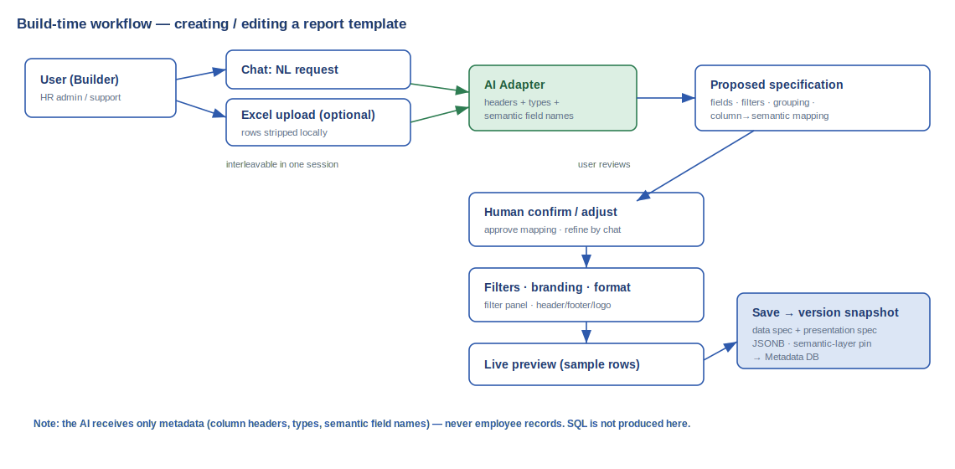
Figure 2 — Build-time workflow

5.2 Run-time
Running and exporting a published report. No AI participates; real data is processed only by the Query and Rendering engines, and the action is audited.
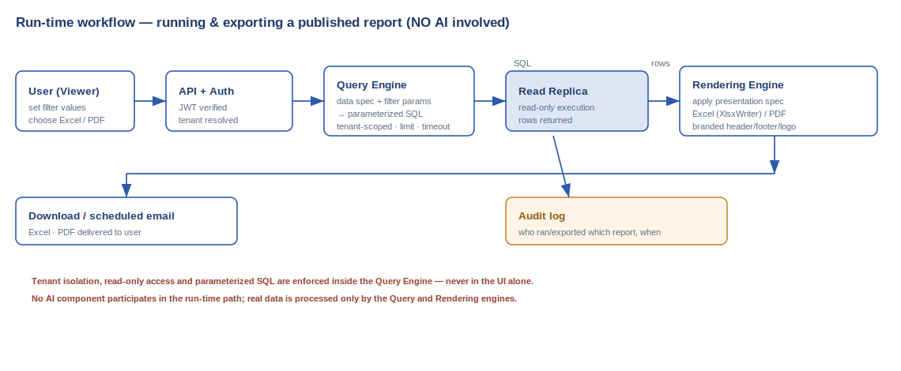
Figure 3 — Run-time workflow

6. Data Model (Metadata Database)
The application owns a dedicated PostgreSQL metadata database, separate from the datamart. Report definitions and the semantic layer are stored here; JSONB is used for the flexible spec structures. Core tables:
Table | Key columns | Purpose
tenants | id, name, status | Registered client organisations.
users | id, tenant_id, role, ... | Accounts and RBAC role per tenant.
semantic_models | id, tenant_id, version, catalog (JSONB) | Versioned semantic layer (entities, dimensions, measures, joins, physical mapping).
report_templates | id, tenant_id, name, current_published_version_id, created_by | Logical report; points to its published version.
report_template_versions | id, template_id, version_no, data_spec (JSONB), presentation_spec (JSONB), semantic_version_ref, status (draft/published), created_by, created_at | Immutable version snapshots; pinned to a semantic-layer version.
report_schedules | id, template_id, cron, recipients, format, enabled | Scheduled delivery configuration.
ai_sessions | id, template_id, messages (JSONB), created_by | Build-time chat history (not used at run-time).
audit_log | id, tenant_id, user_id, action, target_type, target_id, detail (JSONB), created_at | Immutable record of template changes and report runs/exports.
sql_cache (optional) | version_id, sql_text, semantic_version_ref | Cached compiled SQL; always reproducible from the spec.
Note: the SQL is never the source of truth. sql_cache is a performance optimisation only — if it is missing or stale it is regenerated from the data spec and the pinned semantic version.

7. Security Architecture
Security is layered (defense in depth). The two most important controls for this product are tenant isolation (enforced in the Query Engine) and the AI/PII boundary (enforced in the AI Adapter).
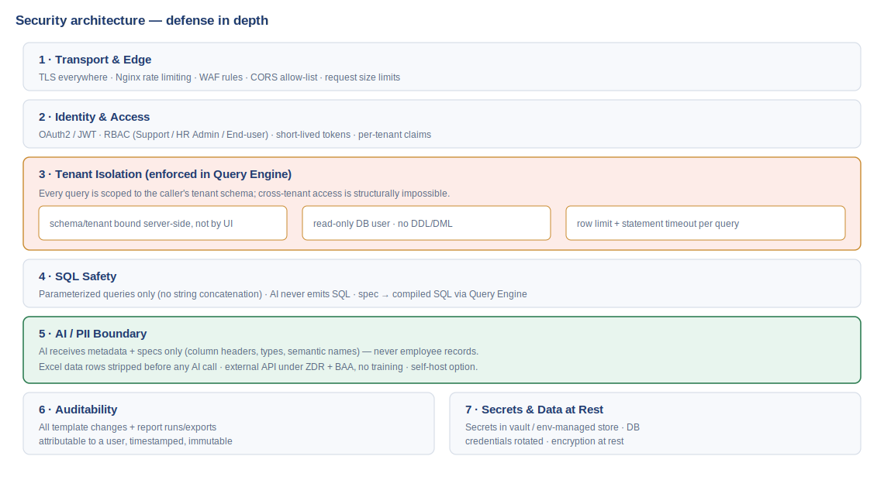
Figure 4 — Security architecture (defense in depth)

7.1 Tenant isolation
Every query is bound to the caller’s tenant schema server-side. A read-only database user with no DDL/DML rights is used for reporting. Each query carries a row limit and a statement timeout. Because scoping happens in the Query Engine, a compromised or buggy UI cannot reach another tenant’s data.

7.2 SQL safety
All SQL is built with parameterized queries through SQLAlchemy Core; user/filter values are bound parameters, never concatenated. The AI never produces SQL, removing the largest injection risk vector.

7.3 AI / PII boundary
The AI Adapter transmits only metadata and specifications. Uploaded Excel files have their data rows stripped locally before any AI call, and types are inferred with pandas rather than by the AI. The default external provider operates under a Zero Data Retention agreement and a Business Associate Agreement, with no training on customer data; a self-hosted model is available for clients whose contracts require it.

7.4 Identity, secrets & audit
Access uses OAuth2/JWT with short-lived tokens and RBAC. Secrets and DB credentials are held in a managed secret store and rotated. Data is encrypted in transit (TLS) and at rest. All template changes and report executions are written to an immutable, user-attributable audit log.

8. Recommended Project Structure
A monorepo with clearly separated backend, frontend and infrastructure. The backend layering keeps the deterministic Query Engine and the AI Adapter isolated from each other and from the HTTP layer.

8.1 Backend
backend/
├─ app/
│ ├─ main.py # FastAPI entrypoint
│ ├─ core/ # cross-cutting concerns
│ │ ├─ config.py # settings (env-driven)
│ │ ├─ security.py # JWT, RBAC dependencies
│ │ ├─ tenancy.py # tenant resolution & scope
│ │ └─ logging.py # structured logging setup
│ ├─ api/ # HTTP layer (routers only)
│ │ ├─ deps.py
│ │ └─ v1/
│ │ ├─ templates.py # CRUD + versioning
│ │ ├─ reports.py # run / preview
│ │ ├─ semantic.py # semantic layer admin
│ │ ├─ ai.py # chat / mapping endpoints
│ │ ├─ exports.py # excel / pdf
│ │ └─ schedules.py
│ ├─ domain/ # pure models (no I/O)
│ │ ├─ report_spec.py # data + presentation spec
│ │ ├─ semantic.py # entity / dimension / measure
│ │ └─ enums.py
│ ├─ services/ # use-case orchestration
│ │ ├─ template_service.py # version lifecycle
│ │ ├─ semantic_service.py
│ │ ├─ ai_service.py
│ │ └─ audit_service.py
│ ├─ query_engine/ # spec -> safe SQL (deterministic)
│ │ ├─ compiler.py
│ │ ├─ sql_builder.py # SQLAlchemy Core, parameterized
│ │ ├─ filters.py
│ │ └─ guards.py # tenant scope, limit, timeout
│ ├─ rendering/ # exports
│ │ ├─ excel_renderer.py
│ │ ├─ pdf_renderer.py
│ │ └─ templates/ # HTML/PDF branding templates
│ ├─ ai/ # provider adapters
│ │ ├─ base.py # AIProvider interface
│ │ ├─ anthropic_provider.py
│ │ ├─ selfhosted_provider.py
│ │ └─ prompts/ # metadata-only prompt templates
│ ├─ ingestion/ # excel upload
│ │ └─ excel_parser.py # headers + types; rows stripped
│ ├─ repositories/ # metadata DB access
│ │ ├─ template_repo.py
│ │ ├─ semantic_repo.py
│ │ └─ audit_repo.py
│ ├─ db/
│ │ ├─ metadata.py # app metadata DB session
│ │ └─ datamart.py # read-only replica pool
│ └─ workers/ # celery
│ ├─ celery_app.py
│ ├─ tasks.py # scheduled runs, async export
│ └─ beat_schedule.py
├─ migrations/ # alembic
├─ tests/
├─ pyproject.toml
└─ Dockerfile

8.2 Frontend
frontend/
├─ src/
│ ├─ app/ # routing, providers
│ ├─ features/
│ │ ├─ builder/ # report builder
│ │ │ ├─ FieldSelector.tsx
│ │ │ ├─ FilterPanel.tsx
│ │ │ ├─ ChatAssistant.tsx
│ │ │ ├─ ExcelUpload.tsx
│ │ │ └─ PreviewPane.tsx
│ │ ├─ viewer/ # run + download
│ │ └─ templates/ # list + versions
│ ├─ api/ # typed API client
│ ├─ components/ # shared UI
│ ├─ hooks/
│ ├─ store/ # client state
│ └─ types/ # TS types mirroring specs
├─ package.json
└─ Dockerfile

8.3 Infrastructure & docs
infra/
├─ docker-compose.yml # dev: api, worker, redis, db, nginx
├─ nginx/ # reverse proxy config
└─ k8s/ # prod manifests (optional)
docs/
├─ SRS.md
└─ architecture.md
README.md

9. Deployment & Operations
- Environments: local (docker-compose), staging, production. Identical container images promoted across environments.
- Services: API (Uvicorn/Gunicorn), Celery worker, Celery Beat, Redis, metadata PostgreSQL, Nginx; the datamart read replica is provisioned by the DB team.
- Scaling: API and worker scale horizontally; reporting load is isolated on the replica so it never affects the production primary.
- Observability: structured logs, Prometheus metrics + Grafana dashboards, Sentry for errors, OpenTelemetry traces across API → query → render.
- CI/CD: GitHub Actions runs lint, tests (pytest/Vitest/Playwright) and builds images on every merge; deploys are gated by passing checks.

10. Key Technical Decisions
# | Decision | Rationale
D1 | Semantic layer as the foundation | Reliable AI suggestions and safe queries across 200 varied schemas; no direct raw-schema access.
D2 | AI produces structured specs, never SQL | Eliminates SQL-injection and cross-tenant risk from AI output.
D3 | AI receives metadata only, never PII | Privacy guarantee independent of provider choice.
D4 | Report definition is source of truth; SQL is compiled | Prevents spec/SQL drift; enables safe regeneration and versioning.
D5 | SQLAlchemy Core for parameterized SQL | Programmatic, safe SQL without an ORM’s overhead or raw strings.
D6 | Reporting on a read replica with read-only user | Protects production; structurally blocks writes.
D7 | Version-on-publish, autosave drafts | Clean version history with full rollback.
D8 | Celery + Redis for async/scheduled work | Keeps the API responsive; supports scheduled delivery.
D9 | Provider-agnostic AI adapter | Switch between external (ZDR+BAA) and self-hosted per client without touching core logic.

11. Open Items for Development Kick-off
- Confirm metadata DB as a separate instance vs a separate database on existing infrastructure.
- Confirm AI provider for the default deployment and initiate ZDR + BAA contracting.
- Decide UI component library (Radix/shadcn vs MUI) and state library (Zustand vs Redux Toolkit).
- Confirm replica provisioning and the read-only DB user with the database team.
- Agree the semantic-layer introspection + enrichment process and ownership.

