**Analysis on A Pizza Store**

1. 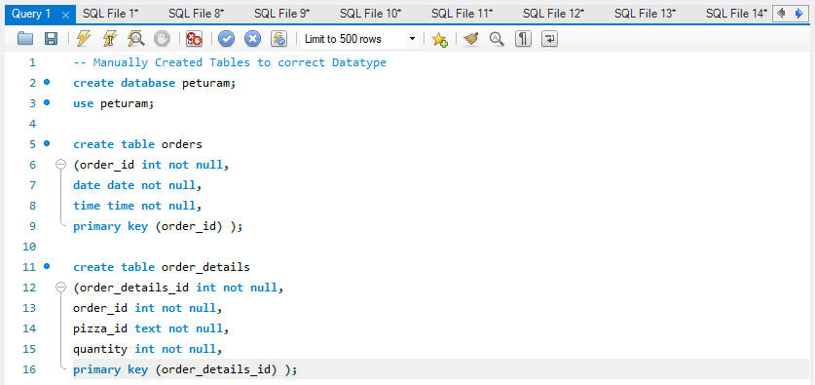Created Database with name **Peturam**, Imported CSV files and created some tables Manually to correct Datatype.
2. There are total Four Tables Orders, Order Details, Pizzas, Pizzas Types.
3. 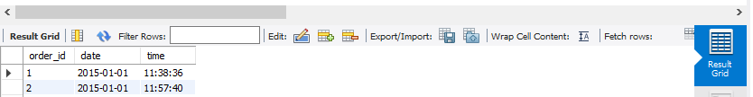Orders Table
4. 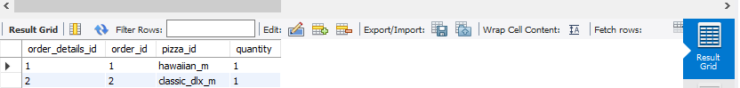Order Details Table
5. 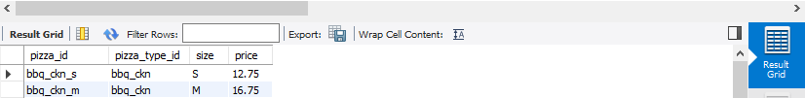Pizzas Tables
6. 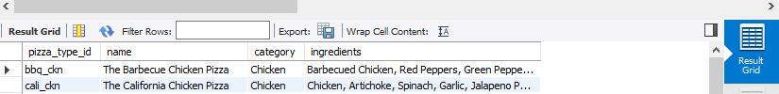Pizza Types Table

**Analyzed and Extracted Useful Data**

1. 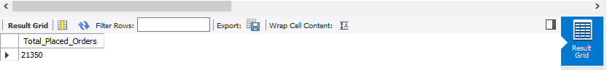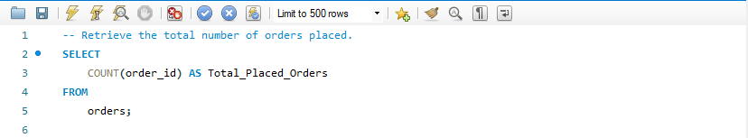Retrieve the total number of orders placed.
2. 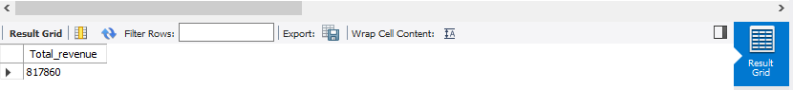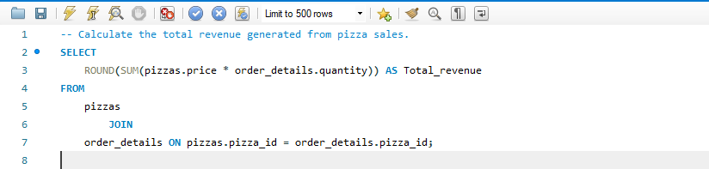Calculate the total revenue generated from pizza sales.
3. 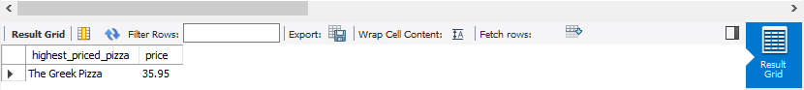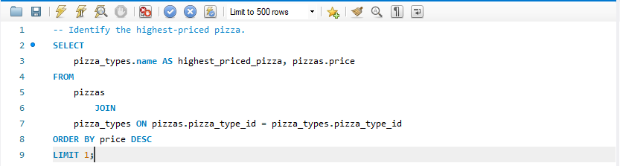Identify the highest-priced pizza.
4. 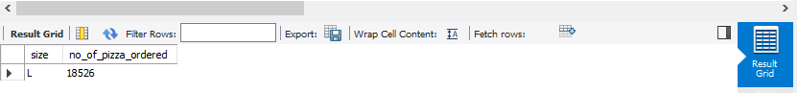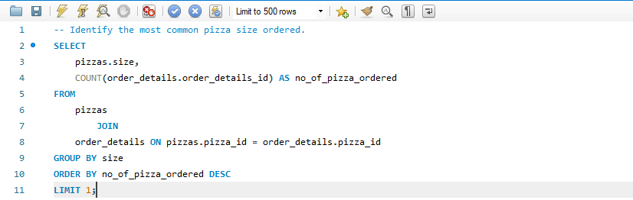Identify the most common pizza size ordered.
5. 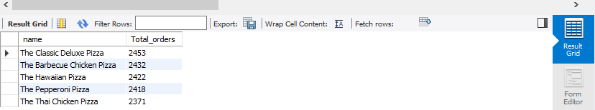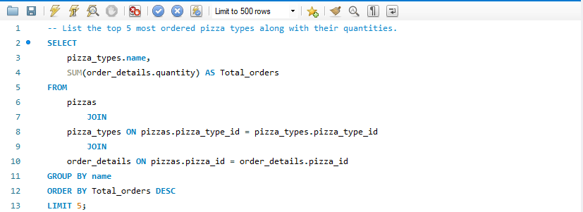List the top 5 most ordered pizza types along with their quantities.
6. 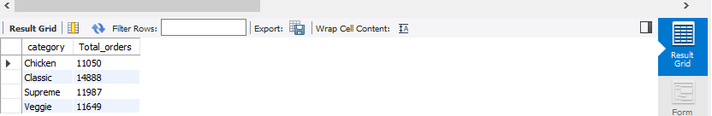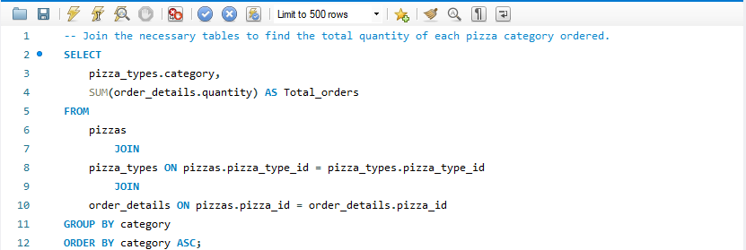Join the necessary tables to find the total quantity of each pizza category ordered.
7. 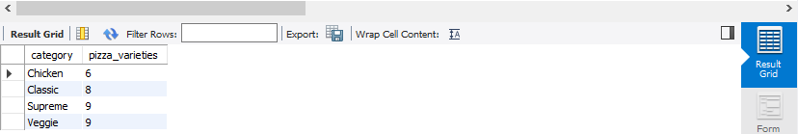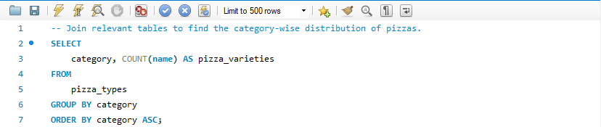Join relevant tables to find the category-wise distribution of pizzas.
8. 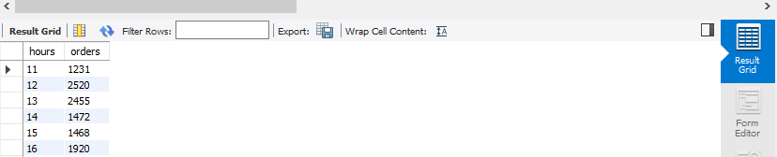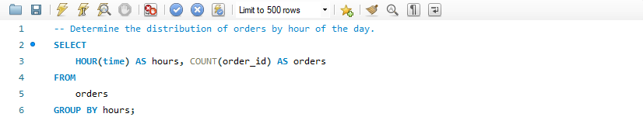Determine the distribution of orders by hour of the day.
9. 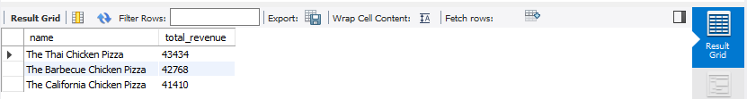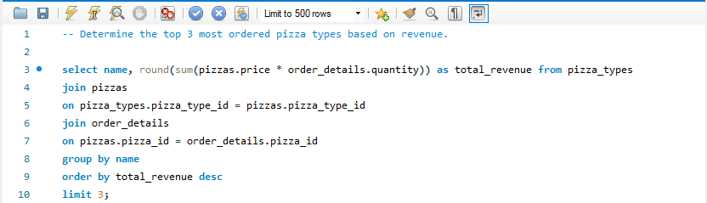Determine the top 3 most ordered pizza types based on revenue.
10. 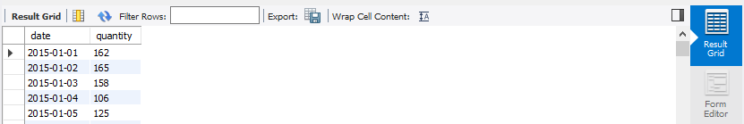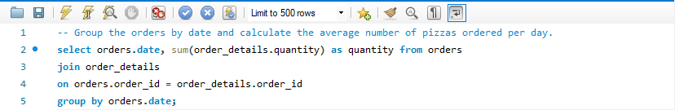Group the orders by date and calculate the average number of pizzas ordered per day.
11. 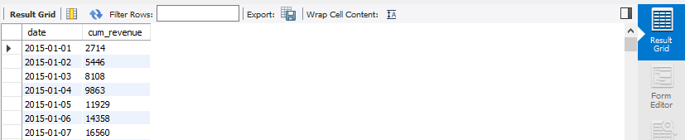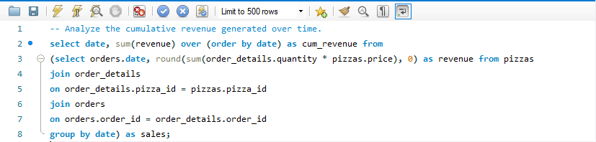Analyze the cumulative revenue generated over time.