**CHAPTER 1**

**INTRODUCTION**

**1.1 Motivation**

The distribution section in the laboratories needs to be continuously monitored by a lab incharge during issue and return of components . In certain cases where the lab incharge is not present, the students have to wait to get the components. Further the manual issue may involve erroneous distribution of components.

**1.2 Objective of the project**

In order to ease the above process and ensure better maintenance of the lab which would further relieve the error prone manual issue of components, there is a need for an automatic component dispenser which is required to -

* Read the table number through RFID and authorize.
* Indicate the box which contains the requested component.
* Store the information about the components issued and returned.
* Collect the damaged IC information.

**1.3 Organization of the report**

The report is divided into 6 chapters. Chapter 1 contains motivation and objective of the project. Chapter 2 presents literature review about the project. Block diagram in Chapter 3 briefs about the implementation. Chapter 4 contains description of individual blocks and the design. In Chapter 5, flowchart of the project is described along with software details. Chapter 6 draws conclusion on the result, followed by the future work possible in this direction.

**CHAPTER 2**

**LITERATURE REVIEW**

This chapter provides details about the existing technologies similar to Automatic Component Dispenser. The related works are based on the field of embedded technology.

**2.1 Automatic pill dispenser**

In this automated system, the pills are placed manually on a circular base containing blades that rotate about a central axis as shown in Figure 2.1. The dispenser will be controlled by a microprocessor that interfaces with an LED display, as well as an alphanumeric keypad will be utilized as a source for inputting of the data, and selecting from preprogrammed menu items [1].

Major Objectives of the system are -

1. To construct a device that is relatively small and lightweight.
2. To develop the software in such a way that patients receive their medication reliably and safely as prescribed by their physicians.
3. To use as much off the shelf technology, as well as harvest parts from other systems to keep costs low.

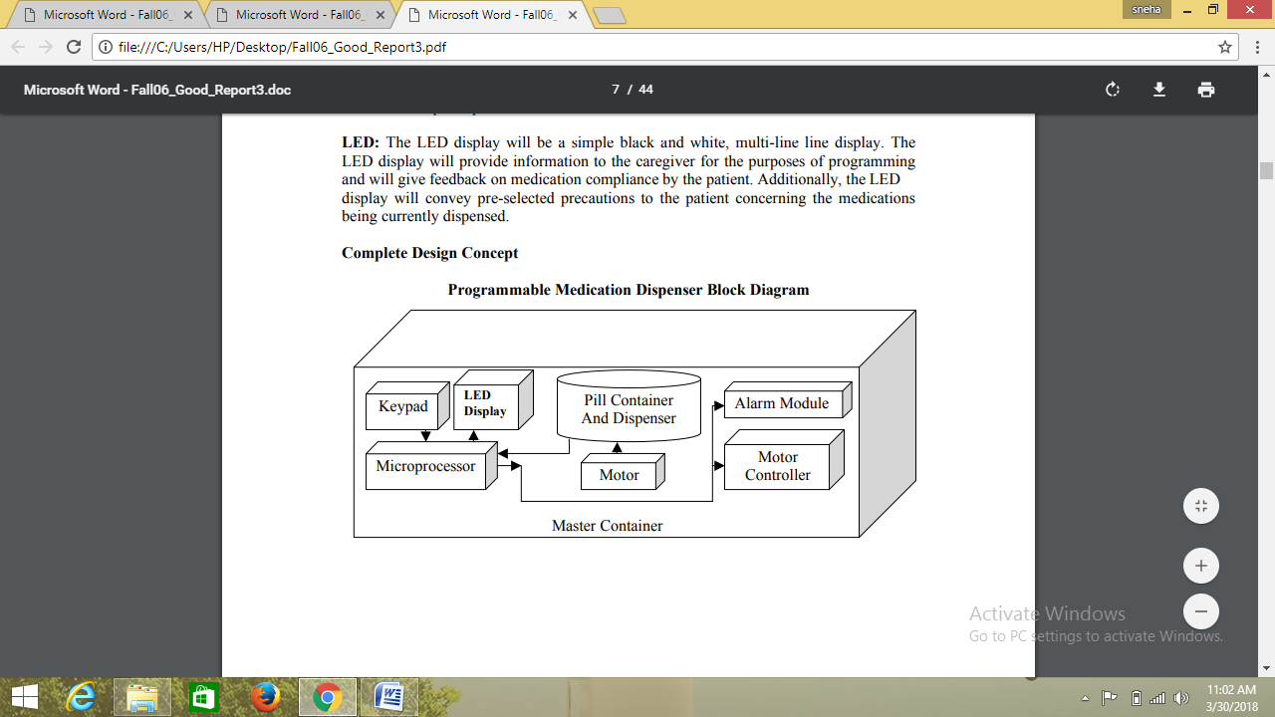

**Figure 2.1 :Block diagram of programmable medication dispenser**

**2.2 Automatic Ration Distribution Using GSM and RFID**

The automated system shown in Figure 2.2 is a novel approach in public distribution system (PDS) for more efficient, accurate, and automated technique of ration distribution. The present ration distribution system has drawbacks such as inaccurate quantity of goods, low processing speed, large waiting time and material thefts in ration shops. The proposed automatic ration shop for public distribution system described in paper [2] is based on Radio Frequency Identification (RFID) technology that replaces manual work and conventional ration cards.

Customer’s database will be stored in microcontroller which is provided by the Government Authority. When the customer scans the tag to RFID reader, microcontroller checks the customer’s details to distribute materials from the ration shop. After successful verification, the customer needs to enter the type of material as well as the quantity of material through keypad. After delivering proper materials to the customer, the microcontroller sends information to the customer as well as PDS authorities using Global System for Mobile (GSM) technology.

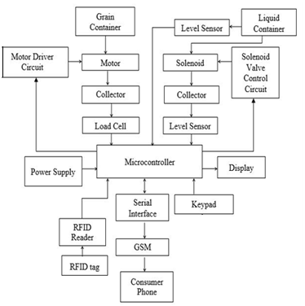

**Figure 2.2 :Block diagram of Automatic ration dispenser**

**CHAPTER 3**

**BLOCK DIAGRAM**

Chapter 3 contains block diagram and it briefs about the components used in the system. The components used in the system are Microcontroller, Keypad, LCD Display, RFID Reader, Stepper motor, Motor driver. Block diagram of the proposed system is shown in Figure 3.1.

Power supply



Keypad

LCD DISPLAY

EEPROM

RFID Tag

8051

Based

Microcontroller

Motor Driver

Motorized

Components

Box

RFID Reader

**Figure 3.1 :Block Diagram of Automatic Component Dispenser**

**Description:**

**Power supply:** An SMPS rated 12V, 2A is used to provide power to the microcontroller board. The regulator IC's present in the board provide ripple free regulated 12V, 5V output to motor driver, motors, RFID module, microcontroller, LCD and IR sensor.

**Keypad:** Keypads are found on alphanumeric keyboards and on other devices such as calculators, push-button telephones, combination locks which require mainly numeric input. In this project, keypad is being used to input the request by the student.

**Microcontroller:** Microcontroller is the heart of the system. It interfaces with keypad, LCD, RFID module, IR sensor and motor drivers. It also interfaces with EEPROM to store the data.

**RFID Module:** RFID reader modules are also called as interrogators. They convert radio waves returned from the RFID tag into a form that can be passed on to microcontroller, which can make use of it. Here, RFID module is being used to authorize the table number.

**EEPROM:** EEPROM is a type of non-volatile memory used in computers and other electronic devices to store relatively small amounts of data but allowing individual bytes to be erased and reprogrammed simultaneously. In the proposed system, EEPROM is used to store details of the components present in the component box.

**Display:** Various display devices such as seven segment display, LCD display and LED display can be interfaced with microcontroller to read the output directly. In this project, LCD display is used to show details about the components.

**Motor Driver:** The motor driver receives signals from the microcontroller and transmits the relative signals to the motors. It has two voltage pins, one of which is used to draw current for the working of the driver and the other is used to apply voltage to the motors. L293D is used to drive the stepper motor.

**Stepper motor:** A stepper motor is a [brushless DC electric motor](https://en.wikipedia.org/wiki/Brushless_DC_electric_motor) that divides a full rotation into a number of equal steps. The motor's position can then be commanded to move and hold at one of these steps without any [position sensor](https://en.wikipedia.org/wiki/Rotary_encoder) for [feedback](https://en.wikipedia.org/wiki/Feedback) .

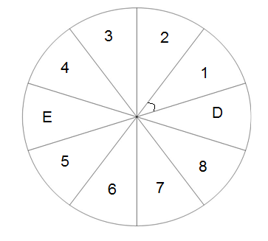**Motorized Component Box:** A circular rotating box consisting of ten partitions as shown in Figure 3.2 is used. The circular base is enclosed by a rectangular box which has a window over it for component access by the student .





**Figure 3.2 :Design of Automatic Component Dispenser**

Out of ten compartments, eight compartments consist of components to be accessed. One being empty, the other compartment is for collecting the damaged components. The empty compartment ensures that no component can be issued or received without access.

**IR Sensor:** An [infrared sensor](https://www.elprocus.com/ir-remote-control-basics-operation-application/) is an electronic device that emits infrared radiations in order to sense some aspects of the surroundings. In the proposed system, IR Sensor is used to calibrate the position of empty compartment by detecting the black paint on the circular base.

**CHAPTER 4**

**HARDWARE DESCRIPTION**

Chapter 4 contains the technical details of the components used.

**4.1 Power supply:**

An SMPS rated 12V, 2A is used to provide power to the microcontroller board. The regulator IC's present in the board provide ripple free regulated 12V, 5V output to motor driver, motors, RFID module, microcontroller, LCD and IR sensor. AC power adapter is used to power up the stepper motor.

**Features**

* Voltage rating- 12V
* Current rating- 2A
* Short circuit protection
* Over voltage and over current protection

**Working:**

AC power adapter consists of step down transformer, bridge rectifier, smoothening filter and a regulator. Transformers convert AC electricity from one voltage to another with little loss of power. A Bridge Rectifier converts the AC to pulsating DC. Smoothing is performed by a large value electrolyte capacitor connected across the DC supply to act as a reservoir, supplying current to the output when the varying DC voltage from the rectifier is falling. Voltage regulator ICs regulates the input dc voltage to 12V.

**4.2 Keypad**

 4×4 matrix keypad as shown in Figure 4.1, consists of 4 rows and 4 columns. The first 4 pins are connected to the column as INPUT and other 4 pins are connected to the row as OUTPUT. This 16-button keypad described in [4] provides a useful human interface component for microcontroller projects.

**Features**

* Ultra-thin design.
* Adhesive backing.
* Excellent price/performance ratio.
* 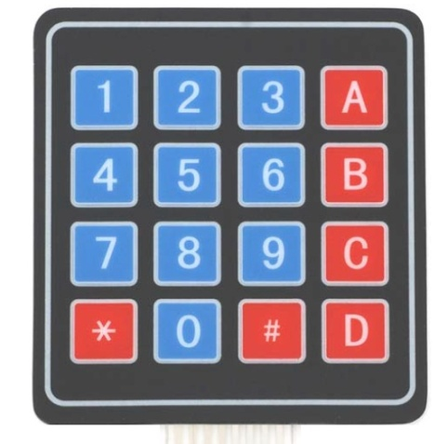Easy interface to any microcontroller

**Figure 4.1: Keypad**

**Key Specifications**

* Maximum Rating: 24 VDC, 30 mA.
* Interface: 8-pin access to 4x4 matrix
* Operating temperature: 32 to 122 °F (0 to 50°C)
* Dimensions:
  + - Keypad, 2.7 x 3.0 in (6.9 x 7.6 cm)
    - Cable: 0.78 x 3.5 in (2.0 x 8.8 cm)

**Working**

Matrix keypads use a combination of four rows and four columns to provide button states to the host device, typically a microcontroller. Underneath each key is a pushbutton, with one end connected to one row, and the other end connected to one column. These connections are shown in Figure 4.2.

For the microcontroller to determine which button is pressed, it first needs to pull each of the four columns (pins 1-4) either low or high one at a time, and then poll the states of the four rows (pins 5-8). Depending on the states of the columns, the microcontroller decides which button is being pressed.

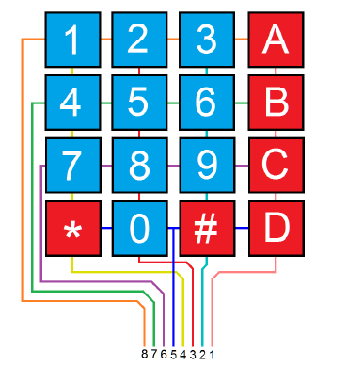

**Figure 4.2 : Structure of keypad.**

**4.3 Microcontroller**

Microcontroller is the heart of the proposed system. It interfaces with keypad, LCD, RFID module, motor drivers, IR Sensor and EEPROM. In the proposed system 8051 based NUVOTON W78E052D microcontroller, shown in Figure 4.3 is used. It is an 8-bit microcontroller which can accommodate a wider frequency range with low power consumption. It consists of hardware watchdog timer and a serial port. These peripherals are supported by 8 sources 4-level interrupt capability. To facilitate programming and verification, the Flash EPROM inside the W78E052D series allows the program memory to be programmed and read electronically. Once the code is confirmed, the user can protect the code for security [10].

**Features of** **W78E052D microcontroller**

* + - Fully static design 8-bit CMOS microcontroller
    - Pin and Instruction-sets compatible with MCS-51
    - 256 bytes of on-chip scratchpad RAM
    - 8K bytes electrically erasable/programmable Flash EPROM
    - Four 8-bit bi-directional ports
    - One extra 4-bit bit-addressable I/O port
    - Three 16-bit timer/counters

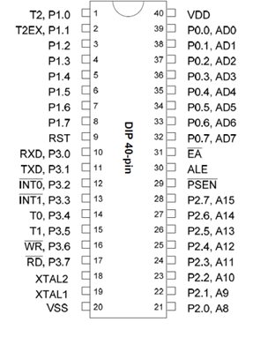

**Figure 4.3 : Nuvoton Microcontroller**

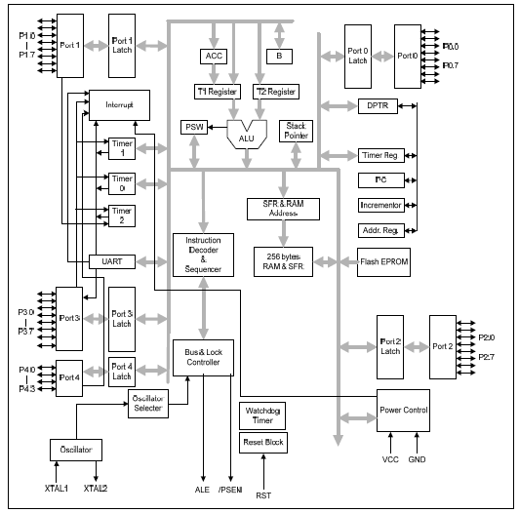

**Figure 4.4 : Block diagram of W78E052D microcontroller**

**Functional description**

The W78E052D series architecture shown in Figure 4.4 consists of a core controller surrounded by various registers, five general purpose I/O ports, 8K flash EPROM, 2K FLASH EPROM for ISP function, 256 bytes of RAM, three timer/counters, and a serial port. The processor supports 111 different op-codes and references both a 64K program address space and a 64K data storage space [10].

**I/O Ports**

The W78E052D series has four 8-bit ports and one extra 4-bit port. Port 0 can be used as an Address/Data bus when external program is running or external memory/device is accessed by MOVC or MOVX instruction. In these cases, it has strong pull-ups and pull-downs, and does not need any external pull-ups. Otherwise it can be used as a general I/O port with open-drain circuit. Port 2 is used chiefly as the upper 8-bits of the Address bus when port 0 is used as an address /data bus. It also has strong pull-ups and pull-downs when it serves as an address bus. Port 1 and Port 3 act as I/O ports with alternate functions. Port4 is only available on PLCC/PQFP/LQFP package type. Another bit-addressable bidirectional I/O port is P4. It serves as a general purpose I/O port similar to Port1 and Port3. P4.3 and P4.2 are alternative function pins. It can be used as general I/O port or external interrupt input sources (INT2/INT3).

**Architecture**

The W78E052D series are based on the standard 8052 device. It is built around an 8-bit ALU that uses internal registers for temporary storage and control of the peripheral devices. It can execute the standard 8052 instruction set.

**Scratch-pad RAM**

The W78E052D series has 256 byte on-chip scratch-pad RAM. This can be used by the user for temporary storage during program execution. A certain section of this RAM is bit addressable, and can be directly addressed for this purpose.

**ALU**

ALU is the heart of W78E052D series. It is responsible for arithmetic and logical functions. It is also used in decision making, in case of jump instructions, and is also used in calculating jump addresses. The user cannot directly use the ALU, but the Instruction Decoder reads the op-code, decodes it, and sequences the data through the ALU and its associated registers to generate the required result. The ALU mainly uses the ACC which is a special function register (SFR) on the chip. Another SFR, namely B register is also used for multiply and Divide instructions. The ALU generates several status signals which are stored in the Program Status Word register (PSW) [10].

**4.4 RFID Module**

**RFID Reader**

EM-18 Radio Frequency Identification Device ([RFID](https://electrosome.com/rfid-radio-frequency-identification/)) reader shown in Figure 4.5 is one of the commonly used wireless communication device.

**Features:**

* Operating frequency is 125 KHz.
* Low power consumption.
* Provides both UART and TTL output formats.
* 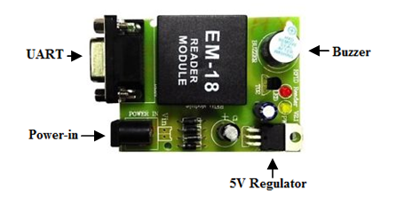It can be directly interfaced with microcontrollers using UART and with PC using an RS232 converter.

**Figure 4.5 : RFID Reader Module**

**RFID Tag (Card)**

RFID tag shown in Figure 4.6 stores unique digital identity codes that can be scanned from a distance. It also captures the signals and sends them to the reader [5].

**Features:**

* The tag is passive.
* 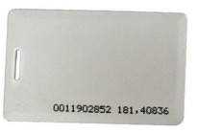 The tag has 12 byte unique ID.

**Figure 4.6 : RFID Tag**

**Functional description**

The proposed system uses RFID tag to authorize the table. The students of the respective table need to swipe the card. The module radiates 125 KHz through its coils. When a 125 KHz passive RFID tag is brought into this field it gets energized from the field as shown in Figure 4.7. The passive RFID tag gets enough power for its working from the field generated by the reader. By changing the modulation current through the coils, tag will send back the information contained in the factory programmed memory array. The output consists of 12 character ASCII data, where first 10 bits will be the tag number and last 2 bits will be the XOR result of the tag number which can be used for error correction .

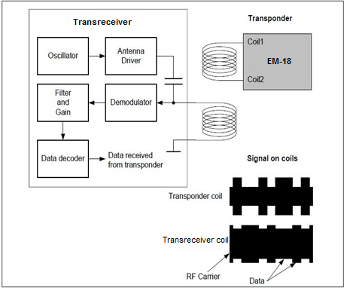

**Figure 4.7 : Working of RFID reader module when the RFID tag is swiped**

**4.5 Display**

LCD (Liquid Crystal Display) screen is an electronic display module and finds a wide range of applications. A 20x4 LCD display is very basic module and is very commonly used in various devices and circuits. These modules are preferred over seven segments and other multi segment LEDs because they are economical, easily programmable and have no limitation of displaying special and even custom characters and animations.

A 20x4 LCD shown in Figure 4.8 can display 20 characters per line an there are 4 such lines. In this LCD each character is displayed in 5x7 pixel matrix. This LCD has two registers, namely, Command and Data.

The command register stores the command instructions given to the LCD. A command is an instruction given to LCD to do a predefined task like initializing it, clearing its screen, setting the cursor position, controlling display etc. The data register stores the data to be displayed on the LCD. The data is the ASCII value of the character to be displayed on the LCD.

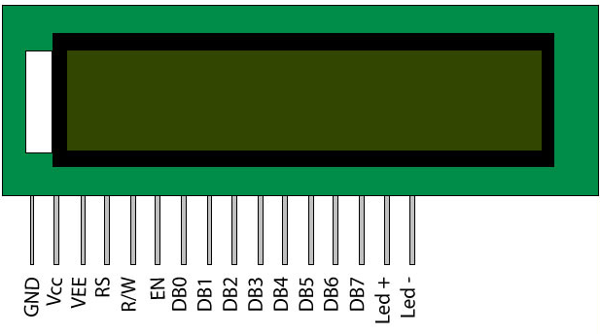

**Figure 4.8 Pin diagram of LCD**

LCD accepts two types of signals, one is data, and another is control. These signals are recognized by the LCD module from the status of the RS pin. Data can also be read from the LCD display, by pulling the R/W pin high. As soon as the EN pin is pulsed, LCD display reads data at the falling edge of the pulse and executes it, same for the case of transmission. LCD display takes a time of 39-43µS to place a character or execute a command. Except for clearing display and to seek cursor to home position it takes 1.53ms to 1.64ms. Any attempt to send the data before this interval may lead to failure to read data or execution of the current data in some devices. Some devices compensate the speed by storing the incoming data to some temporary registers.

LCD displays have two RAMs, naming DDRAM and CGRAM. DDRAM registers in which position which character in the ASCII chart would be displayed. Each byte of DDRAM represents each unique position on the LCD display. The LCD controller reads the information from the DDRAM and displays it on the LCD screen. CGRAM allows user to define their custom characters. For that purpose, address space for first 16 ASCII characters are reserved for users. After CGRAM has been setup to display characters, user can easily display their custom characters on the LCD screen [4].

**4.6 Stepper Motor**

Stepper motor shown in Figure 4.9, is a DC motor that moves in discrete steps. It has multiple coils that are organized in groups called "phases". By energizing each phase in sequence, the motor will rotate one step at a time.

**Features**

* Step angle- 1.8o
* Type - Bi-polar
* 200 steps-per-revolution
* Supply Voltage-12V
* Maximum continuous power- 5W

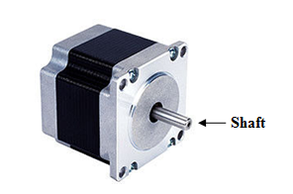

**Figure 4.9 : Stepper motor**

**Functional description**

A **bipolar stepper motor** has one winding per stator phase. A two phase bipolar stepper motor will have 4 leads as shown in Figure 4.10. A bipolar stepper motor does not have a common lead like a uni-polar stepper motor. Hence, there is no natural reversal of [current](https://www.electrical4u.com/electric-current-and-theory-of-electricity/) direction through the winding. A bipolar stepper motor has easy wiring arrangement but its operation is little complex. In order to drive a bipolar stepper, [IC](https://www.electrical4u.com/integrated-circuits-types-of-ic/) with an internal H bridge circuit is needed. This is because, in order to reverse the polarity of stator poles, the current needs to be reversed. This can only be done through a H bridge [9].

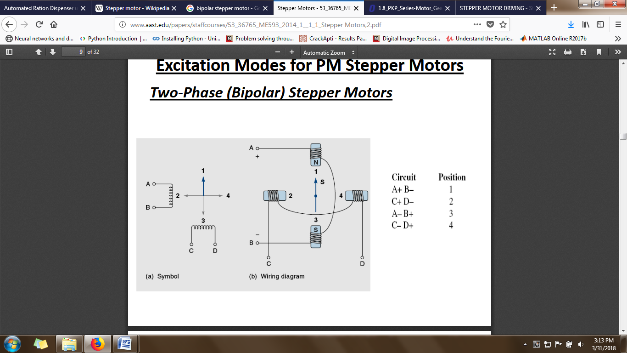

**Figure 4.10: Working of bipolar stepper motor**

**4.7 L298 Motor Driver**

The L298, as shown in Figure 4.11 is an integrated monolithic circuit in a 15-lead Multi-watt and PowerSO20 package. It is a high voltage, high current dual full-bridge driver designed to accept standard TTL logic levels and drive inductive loads such as relays, solenoids, DC and stepper motors. Two enable inputs are provided to enable or disable the device independently of the input signals. The emitters of the lower transistors of each bridge are connected together and the corresponding external terminal can be used for the connection of an external sensing resistor. An additional supply input is provided so that the logic works at a lower voltage.

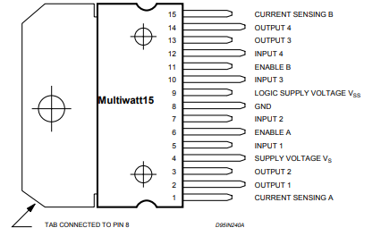

**Figure 4.11 : Pin connections of L298.**

**4.8 EEPROM**

The AT24C04 provides 4096 bits of serial electrically erasable and programmable read-only memory (EEPROM) organized as 512 words of 8 bits each. The device is optimized for use in many automotive applications where low-power and low-voltage operations are essential.

**Pin Configuration**

**Figure 4.12 : Pin diagram of EEPROM**

The pin description of AT24C04 is shown in Figure 4.12 and is as follows;

**A0-A2** –Address inputs

**SDA (Serial data) -** The SDA pin is bidirectional for serial data transfer. This pin is open-drain and may be wire-ORed with any number of other open-drain or open-collector devices.

**SCL (Serial clock input)** - The SCL input is used to positive edge clock data into each EEPROM device and negative edge clock data out of each device.

**WP** –Write Protect

**NC** –No connect

**Features**

* Internally Organized 512 x 8 (4K)
* Two-wire Serial Interface
* Bi-directional Data Transfer Protocol
* 100 kHz (2.7V) and 400 kHz (5V) Compatibility
* Endurance: 1 Million Write Cycles
* Data Retention: 100 Years

**Functional description:**

I2C is a master- slave protocol that includes the data along with clock pulse. Typically, the master device switches the clock line, SCL. This line orders the data timing which transfers on to the I2C bus. Unless the clock is operated, no data will be transferred. All slaves are controlled by the same clock, SCL. I2C protocol works as a master device and regulates EEPROM and it works as a slave.

Interfacing operation of I2C Bus-EEPROM with [8051 microcontroller involves](https://www.elprocus.com/pin-diagram-of-8051-microcontroller/) sending a signal like WRITE, followed by data and address bus. In this operation, EEPROM is used to store the data. In microcontroller, two numbers of EEPROM lines are regulated by I2C supported drivers (pull-up). The SCL and SDA are connected to the I2C based serial EEPROM IC [7].

**4.9. IR Sensor**

Active infrared sensors as shown in Figure 4.13 consist of two elements: infrared source and infrared detector. Infrared sources include an LED or infrared laser diode. Infrared detectors include photodiodes or phototransistors. The energy emitted by the infrared source is reflected by an object and falls on the infrared detector [8].

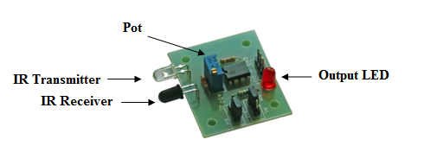

**Figure 4.13: IR sensor**

**Functional Description**

It is universal that black color absorbs the entire radiation incident on it and white color reflects the entire radiation incident on it. The IR led and the photodiode are placed side by side. When the IR transmitter emits infrared radiation, since there is no direct line of contact between the transmitter and receiver, the emitted radiation must reflect back to the photodiode after hitting any object. The surface of the object can be divided into two types: reflective surface and non-reflective surface.

If the surface of the object is reflective in nature i.e. it is white or other light color, most of the radiation incident on it will get reflected back and reaches the photodiode. Depending on the intensity of the radiation reflected back, current flows in the photodiode.

If the surface of the object is non-reflective in nature i.e. it is black or other dark color as shown in Figure 4.14, it absorbs almost all the radiation incident on it. As there is no reflected radiation, there is no radiation incident on the photodiode and the resistance of the photodiode remains higher allowing no current to flow.

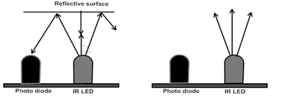

**Figure 4.14 : Working of IR sensor**

**CHAPTER 5**

**SOFTWARE DESCRIPTION**

This chapter illustrates the software used in the system and the flowchart which demonstrates the working and overall functionality of the system.

**5.1 KEIL uVISION IDE**

Keil uvision IDE is a popular embedded software development IDE which is widely used to program the 8051/8052 architecture. It is quite popular in the academic as well as engineering community. Keil uVision IDE is a proprietary IDE developed by [Keil Inc](https://en.wikipedia.org/wiki/Keil_(company)) .

## Keil uvision C compiler (C51 C Compiler)

The Keil C51 C Compiler for the 8051 microcontroller is the most popular 8051 C compiler. The C51 Compiler translates C source files into re locatable object modules which contain full symbolic information for debugging with the µVision debugger or an in-circuit emulator. In addition to the object file, the compiler generates a listing file which may optionally include symbol table and cross reference information.

Keil uvision C compiler is used to compile the code in the proposed system.

**Features**

* Nine basic data types, including 32-bit IEEE floating-point,
* Flexible variable allocation with bitdata, bdata, idata, xdata, and pdata memory types,
* Interrupt functions may be written in C,
* Full use of the 8051 register banks,
* Complete symbol and type information for source-level debugging
* Bit-addressable data objects,
* Built-in interface for the [RTX51 Real-Time Kernel](http://www.keil.com/rtx51/),

**5.2 NUVOTON ISP- ICP UTILITY**

The Nuvoton W78E052D controller is available with UART boot-loader and can be directly programmed from the serial port. Nuvoton ISP-ICP Utility software is used to program the target microcontroller.

In the proposed system, Nuvoton ISP-ICP Utility software shown in Figure 5.1 is used to flash the hex files.

When the Nuvoton ISP-ICP Utility software is opened, the following steps are performed

1. ISP by COM port option is selected for flashing the .hex file through COM port.
2. COM port is selected from the drop down and the device manager is checked for com port number.
3. The required controller is chosen. In this case, it is W78E052D.
4. The .hex file is browsed and selected by clicking on Load File as shown in Figure 5.2
5. Update chip option is clicked to flash the .hex file as shown in Figure 5.3

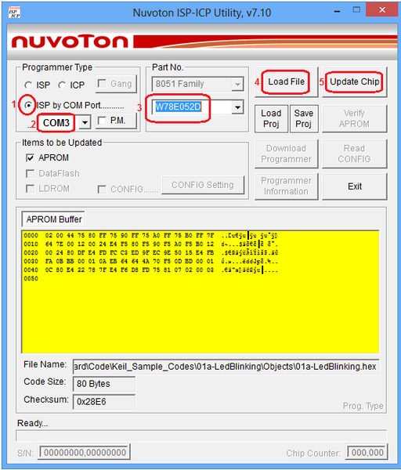

**Figure 5.1: Nuvoton ISP-ICP Utility**

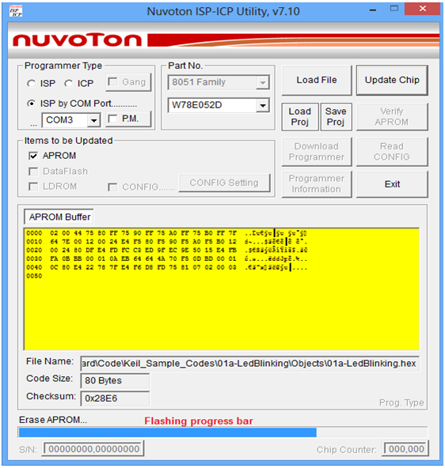

**Figure 5.2 : Flashing status in blue color progress bar**

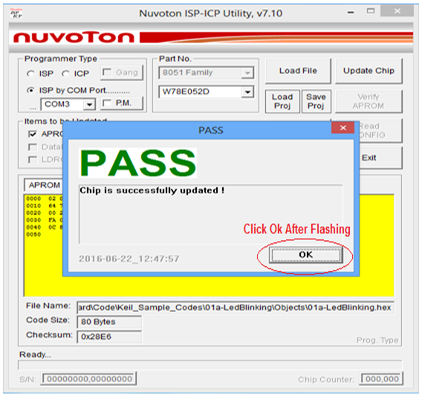

**Figure 5.3: Successful flashing of hex file**

**5.3 FLOWCHART:**

The flowchart of the system is shown in Figure.5.4.



**Figure 5.4 : Flowchart of Automatic component dispenser**

**5.3.1 Circuit Diagram**

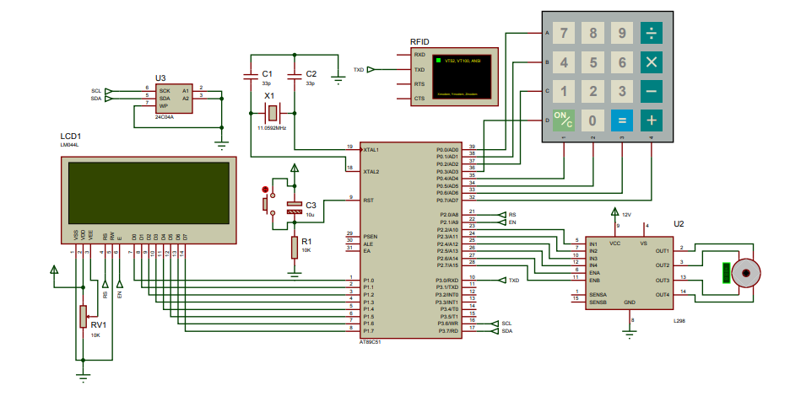

**Figure 5.5: Circuit Diagram**

**5.3.2 Hardware connections**

Figure 5.5 shows the circuit diagram of Automatic Component Dispenser. The circuit connections are as follows :

LCD

* Data Port --- Port1
* RS---P2.0
* EN---P2.1
* --- GND

Keypad --- Port 0

I2C

* + SCL --- P3.6
  + SDA --- P3.7

L298 motor driver

* ENA --- P2.6
* ENB --- P2.7
* IN1 --- P2.2
* IN2 --- P2.3
* IN3 --- P2.4
* IN4 --- P2.5

RFID Reader

* TXD --- P3.0

IR Sensor

* VOUT --- P3.5

**5.3.3 Implementation:**

1. The student from a particular table with the respective RFID tag is read by the RFID reader and is authorized to access the components upon student’s requirement.
2. LCD displays the menu and allows the student to select the component of the requirement.
3. The student selects issue option and requests the desired components through the keypad. The data about the issue of the components is stored in the EEPROM.
4. On request through keypad, the microcontroller drives the stepper motor so that the students can take the components from the respective compartment.
5. While returning, again the student has to use the RFID tag to select the return option. On selecting, he/she can return the components serially and the data in the EEPROM is updated.
6. The information about components issued and returned that are stored in the EEPROM can be accessed by lab incharge.

**CHAPTER 6**

**RESULTS AND CONCLUSION**

**6.1. RESULTS**

The proposed system is designed with a circular box containing ten compartments as shown in Figure 6.1 and Figure 6.2.

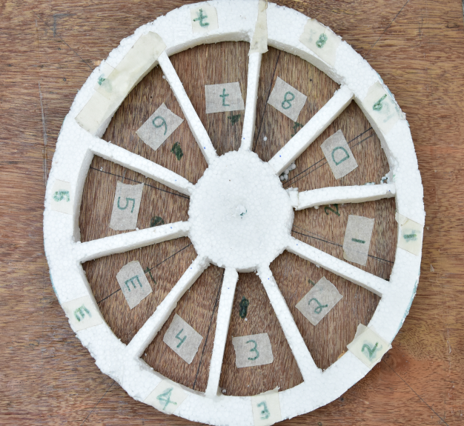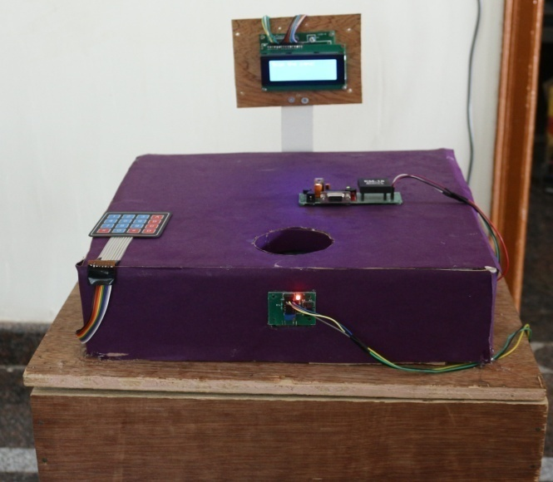

**Figure 6.1: Front view of the system Figure 6.2: Top view of the circular base**

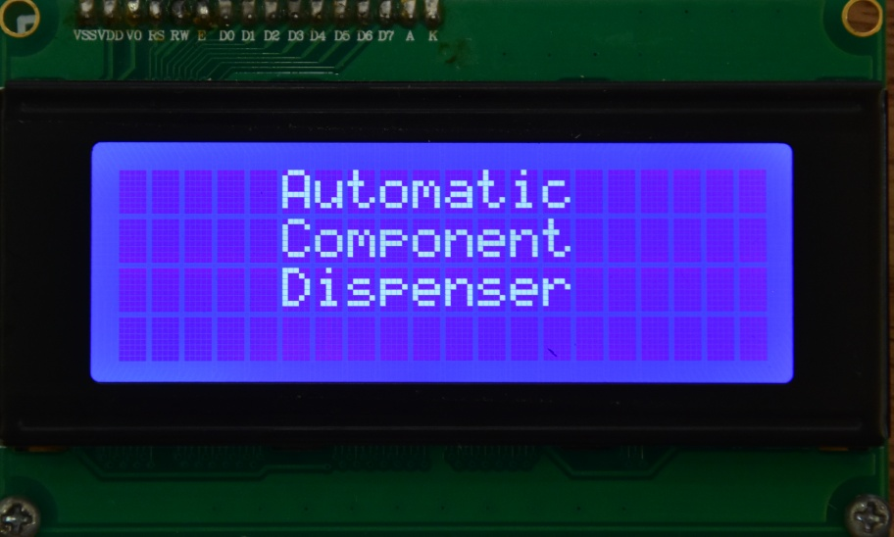

**Figure 6.3: Startup display**

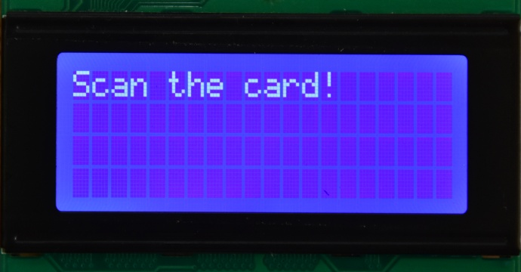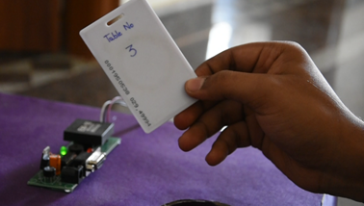

**Figure 6.4: Scanning the card**

Initially, the user of the respective table needs to scan the RFID card. The RFID reader beeps as soon as the card is detected. The microcontroller checks the authenticity of the card and grants the respective privilege. RFID card of Table number 3 is scanned as shown in the Figure 6.4.

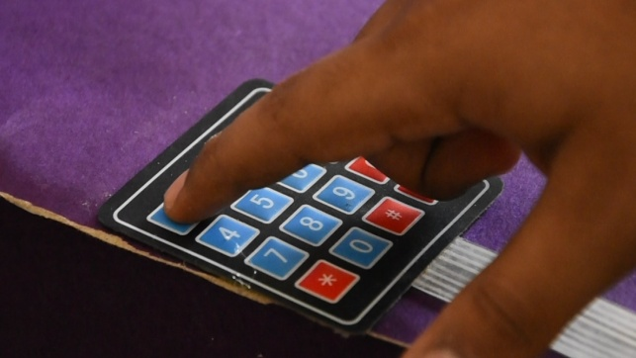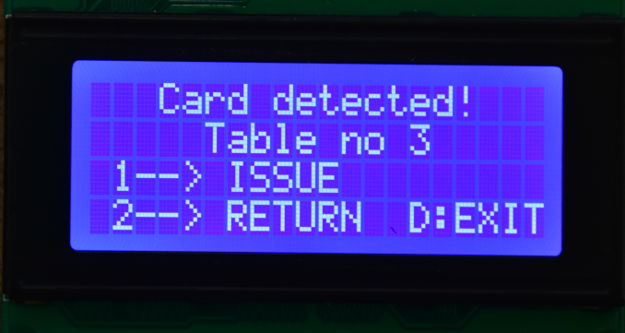

**Figure 6.5: Selecting the issue option**

With reference to Figure 6.5, menu is displayed so that the user can select either issue or return based on requirement. The user presses key '1' for opting issue option. Menu for the issue option is displayed as shown in Figure 6.6. The user can select the required component from the component list through keypad.

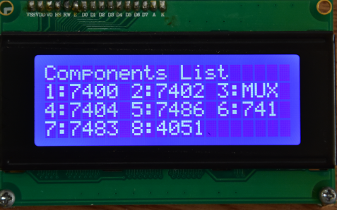

**Figure 6.6: Displaying menu during issue**

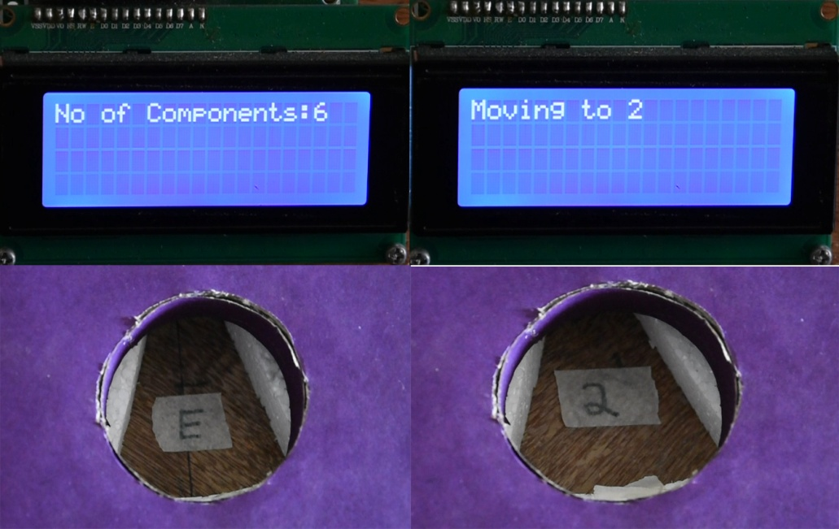

**Figure 6.7: Getting required components**

The user can also enter the number of components required, through keypad. After the entry, the circular base which will be pointing to the empty position moves to the box containing the requested component as shown in Figure 6.7. The user needs to follow the same steps while returning the components.

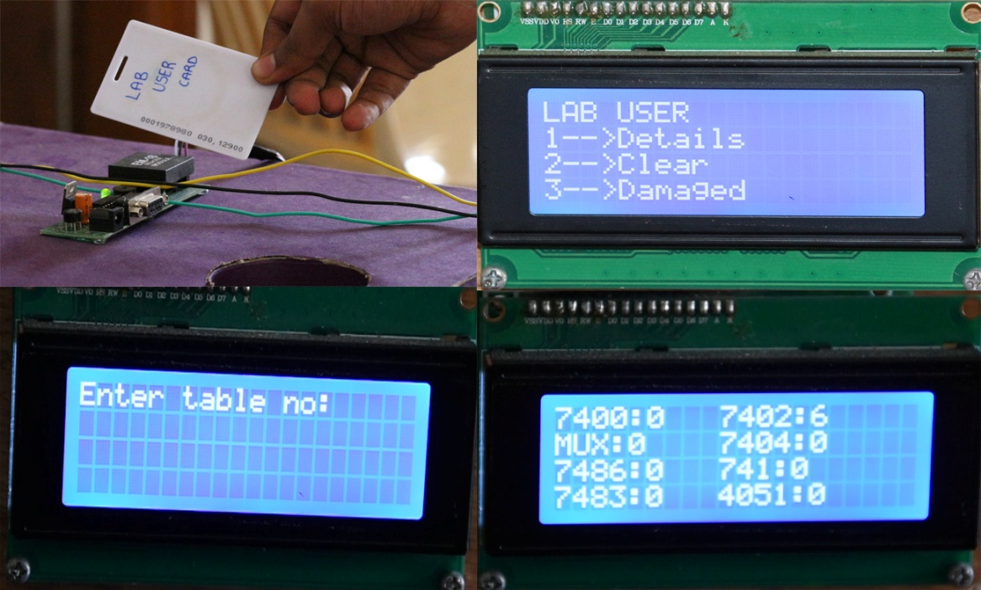

**Figure 6.8: Lab user interface**

The lab user has a separate card which can be used to get the details of the components taken by the students by scanning his 'Lab User Card' as shown in Figure 6.8.. He can also view the list of damaged components and clear the data stored in the EEPROM.

**6.2. CONCLUSION**

With the available facilities and infrastructure provided, the project was successfully completed well within the stipulated time. It was demonstrated in the lab up to nine components in each compartment.

Automatic Component Dispenser effectively reduces the manual error prone distribution. Even in the absence of lab in charge, students can easily draw the components. The ICs that are issued, returned and damaged are electrically stored and hence doesn’t require the need of paper and pen, thereby making it eco friendly.

**Future Enhancements:**

* Computer interface can be built replacing the LCD.
* CCTV can be used to monitor the component transaction.
* ID cards can be used in place of RFID for authorization.

**ACTION PLAN**

|  |  |  |  |  |  |  |  |  |
| --- | --- | --- | --- | --- | --- | --- | --- | --- |
|  | 2017 | | | | 2018 | | | |
| Activity | Aug | Sep | Oct | Nov | Jan | Feb | Mar | April |
| Problem definition |  |  |  |  |  |  |  |  |
| Literature Review |  |  |  |  |  |  |  |  |
| Design |  |  |  |  |  |  |  |  |
| Documentation for phase I |  |  |  |  |  |  |  |  |
| Implementation |  |  |  |  |  |  |  |  |
| Testing |  |  |  |  |  |  |  |  |
| Evaluation of results |  |  |  |  |  |  |  |  |
| Documentation for phase II |  |  |  |  |  |  |  |  |
| Report writing |  |  |  |  |  |  |  |  |

**REFERENCES**

1. B. Bowers, M. Preston, “Automatic Pill Dispenser”, EEL 4914 Senior Design, University of Florida, Fall 2006.
2. Vinayak T. Shelar, Mahadev S. Patil, RFID and GSM based Automatic Rationing System, vol. 4, issue 6, June 2015.
3. Janice Gillispie Mazidi, Muhammad Ali Mazidi, and Rolin D. McKinlay, "The 8051 Microcontroller and Embedded Systems, Using Assembly and C", Pearson, 2nd Edition, 2008.
4. Kenneth Ayala, "The 8051 Microcontroller", Cengage Learning, 3rd Edition, 2004.
5. https://www.elprocus.com/peripherals-interfacing-to-the-microcontroller-8051-in-electronics.
6. https://circuitdigest.com/microcontroller-projects/rfid-interfacing-with-8051.
7. https://www.engineersgarage.com/8051-microcontroller.
8. http://www.ti.com/lit/an/slva704/slva704.pdf
9. https://embetronicx.com/tutorials/microcontrollers/8051/ir-sensor-interfacing-with-8051.
10. http://solarbotics.net/library/pdflib/pdf/motorbas.pdf.
11. http://www.keil.com/dd/docs/datashts/nuvoton/w78e054d_w78e052d.pdf.

**APPENDIX**

**Datasheets:**

* http://ww1.microchip.com/downloads/en/DeviceDoc/doc0180.pdf
* https://www.sparkfun.com/datasheets/Robotics/L298_H_Bridge.pdf
* http://www.circuitstoday.com/interfacing-rfid-module-to-8051
* https://www.winstar.com.tw/products/character-lcd-display-module/20x4-lcd-display.html
* http://www.keil.com/dd/docs/datashts/nuvoton/w78e054d_w78e052d_w78e051d.pdf