Ex.No:
Date: TOUCH SENSOR WITH LED AND BUZZER

Aim:
To create a touch-sensitive system using an Arduino that activates both an LED and a buzzer simultaneously when the touch sensor is triggered, while providing real-time feedback on the sensor's status through the Serial Monitor.
Components Required:
- Touch Sensor
- Arduino Nano
- Jumper Wires
- USB Cable
- LED
- Buzzer

Algorithm:
Step 1: Setup the circuit by connecting Vcc pin of touch sensor into 5V pin on arduino nano,
Signal output pin of touch sensor to digital pin D2 on arduino nano and GND pin of
Touch sensor to GND pin on arduino nano using female-female jumper wires.
Step 2: Insert the buzzer and LED into the bread board. Connect the positive leg of the
Buzzer to pin D4 and the negative leg to GND. Connect the positive leg of the LED
to pin D3 and the negative leg to GND of arduino nano using male-female jumper
wires.
Step 3: Open Arduino IDE and write the code
- Declare pin 2 as the input pin for the touch sensor.
- Declare pin 4 and pin 3 as the output pin for buzzer and LED
- Initialize the serial communication at a baud rate of 9600.
- Inside the loop, If the touch sensor is touched print "sensor touched" to the Serial Monitor and turn on the buzzer and LED by setting their output pins to HIGH.
- If the touch sensor is not touched print "sensor not touched" to the Serial Monitor and turn off the buzzer and LED by setting their output pins to LOW
Step 4: Go to tools → Board →Arduino AVR Board → Arduino Nano.
Step 5:Go to tools → Processor → ATMega328p (Old Bootloader).
Step 6:Connect Arduino Nano with computer using USB cable.
Step 7: Go to tools →port → suitable port
Step 8: Compile and upload the code.

Arduino Interfacing:
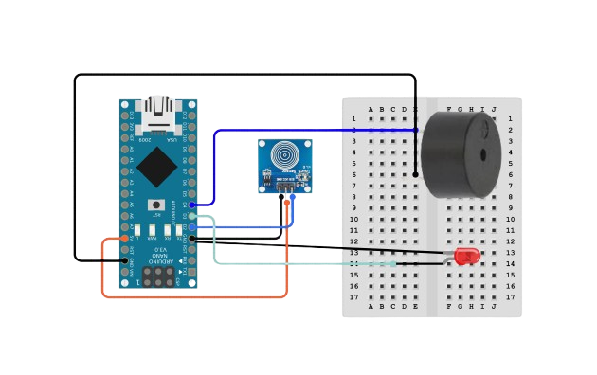

Sketch:
int touchpin=2;
int buzzer = 4;
int led=3;
int val;
void setup() {
Serial.begin(9600);
pinMode(touchpin, INPUT);
pinMode(buzzer, OUTPUT);
pinMode(led, OUTPUT);
}
void loop() {
val = digitalRead(touchpin);
if(val == HIGH) {
Serial.println("sensor touched");
digitalWrite(buzzer, HIGH);
digitalWrite(led,HIGH);
delay(1000);
}
else {
Serial.println("sensor not touched");
digitalWrite(buzzer,LOW);
digitalWrite(led,LOW);
delay(1000);
}
}

Output:
sensor not touched
sensor touched
sensor touched
sensor not touched
sensor touched

Result:
The Arduino sketch successfully executed, detecting touch inputs from the sensor and controlling the LED and buzzer together. The Serial Monitor displayed whether the sensor was touched or not.

