|  |  |
| --- | --- |
| **Ex.No:**  **Date:** | **DC Motor-Revolution** |

**Aim:**

To control the direction and speed and direction of a DC Motor using Arduino.

**Components Required:**

* Arduino Nano
* DC Motor
* Bread Board
* Jumper Wires
* L298N Motor Driver Module
* USB cable

**Algorithm:**

**Step 1:** setup a connection and connect IN-1 of L298N motor driver to arduino pin D8 using M→F jumper wire. IN-2 of L1298N motor to arduino pin D9 using m→F jumper wire, PWN of LS9B motor to arduino pin D2 using M→F jumper wires and connect the 5v and GND of the arduino to the vcc and GND of the motor driver respectively using male to female jumper wires

**Step 2:**   open arduino IDE and write code for controlling the direction and speed of a DC motor using arduino Nano.

**Step 3:** Go to tools →port→ select suitable port.

**Step 4:** Then check for procession and then select ATMega328 (old Bootloader)

**Step 5:** compile the code.

**Step 6:** connect arduino nano with computer using USB cable and upload code to

arduino

**Arduino Interfacing:**

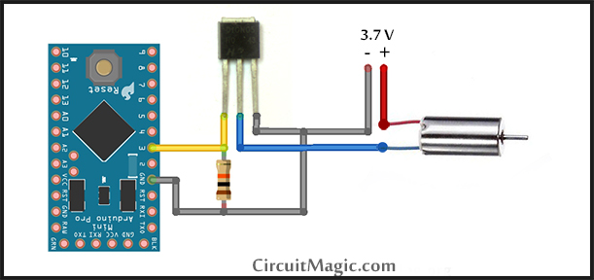

**Sketch:**

Const int pwn =2;

Const int IN-1=8;

Const int IN-2 = 9;

Void setup(){

Pinmode(pwn,OUTPUT);

Pinmode(IN-1,OUTPUT);

Pinmode(IN-2,OUTPUT);

Serial.begin(9600);

}

Void loop(){

Serial.println(‘Clockwis Reading’);

Serial Write(IN-1,HIGH);

Serial Write(IN-2,LOW);

analog Write(pwn.255);

delay(3000);

digital Wirte(IN-1,HIGH);

digital Wirte(IN-2,HIGH);

delay(3000);

Serial.println(‘Anticlockwis Reading’);

digital Wirte(IN-1,LOW);

digital Wirte(IN-2,HIGH);

delay(3000);

digital Wirte(IN-1,HIGH);

digital Wirte(IN-2,HIGH);

delay(1000);

}

**Output:**

**Clockwise Reading**

**Anticlockwise Reading**

**Clockwise Reading**

**Anticlockwise Reading**

**Result:**

Thus the above program has been executed and verified successfully.