|  |  |
| --- | --- |
| **Ex.No:**  **Date:** | **Indective Proximity Sensor** |

**Aim:**

To integrate Arduino with Indective Proximity sensor for metal detection

**Components Required:**

* Inductive Proximity sensor
* Arduino Nano
* LED
* Jumper Wires
* USB Cable
* Bread board

**Algorithm:**

**Step 1:**Setup a connection and connect the signal pin of inductive proximity sensor to the analog input pin A2 on Arduino and Ground pin of the sensor to the GND pin on Arduino nano using male-female jumper wires.

**Step 2:** Insert the LED into the bread board. Connect the positive leg of the LED

to pin D4 and the negative leg to GND of arduino nano using male-female jumper

wires.

**Step 3:** Open Arduino IDE and write the code

* Set up the Arduino IDE and connect the Arduino Nano to the computer.
* Define the pin connected to the inductive proximity sensor (int sensor = A2;).
* In the setup() function:
* Initialize the pin mode for the inductive proximity sensor as INPUT.
* Initialize the serial communication with a baud rate of 9600.
* In the loop() function:
* Read the sensor output using digitalRead(sensor).
* If the sensor detects metal, the output will be HIGH (1); otherwise, it will be LOW (0).
* Print the sensor value to the serial monitor.
* Repeat the process in an infinite loop.

**Step 4:** Go to tools 🡪 Board 🡪Arduino AVR Board 🡪 Arduino Nano.

**Step 5:** Go to tools 🡪 Processor 🡪 ATMega328p (Old Bootloader).

**Step 6:** Connect Arduino Nano with computer using USB cable.

**Step 7:** Go to tools 🡪port 🡪 suitable port

**Step 8:** Compile and upload the code.

**Arduino Interfacing:**

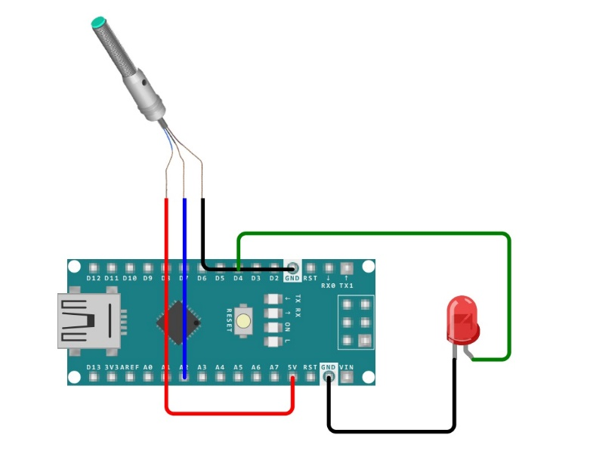

**Sketch:**

const int inductiveSensorPin = A2;

const int ledPin =4 ;

void setup() {

pinMode(inductiveSensorPin, INPUT);

pinMode(ledPin, OUTPUT);

digitalWrite(ledPin, LOW);

Serial.begin(9600);

}

void loop() {

int metalDetected = digitalRead(inductiveSensorPin);

if (metalDetected == HIGH) {

digitalWrite(ledPin, HIGH);

Serial.println("No Metal detected!");

} else {

digitalWrite(ledPin, LOW); // Turn off the LED

Serial.println("Metal detected");

}

delay(2000); // Add a delay to prevent rapid LED flashing

}

**Output:**

No Metal Detected

Metal Detected

No Metal Detected

Metal Detected

Metal Detected

Metal Detected

**Result:**

The Indective Proximity sensor is successfully integrate with the Arduino Nano, and the Indective Proximity sensor state is successfully being monitored and displayed on the serial monitor.