**Trainee Diary Online System**

Trainee Diary is an online system that helps trainees with tasks, projects, and meetings during their internship period. The Trainee begins by logging in to the system using their valid email with password. The validity is verified here. If a password is forgotten, it is possible to enter the system by Make sure to renew the password and have a backup plan in case you forget it. On September 25th, the trainee is required to communicate via email regarding a project status. when the trainee can click delete button. The column that matches will be removed. and as well when the click the edit button, a new form will open as edit details form. There are parameters like Title, Type, Date & Time and Description. There, the above mentioned three categories are used as the type. It is possible to provide a brief description for the description. The Add Details button is located at the bottom of the To-Do list for trainees to see. When the trainee clicks on that button. If you add details, a new form will be opened. It is likewise Resembles the add details form. The To-Do List was updated with the added and edited details data. The trainee can also see the search function at the top of the To-Do list. Furthermore, a detailed report can be generated for each and every trainee. Who uses this system.

**Functional Requirements**

**User Authentication:**

The system must allow trainees to register and log in using a valid email and password. Passwords must be securely stored and encrypted in the database.

**Task and Project Management:**

Trainees should be able to add, edit, and delete tasks and project details, including Title, Type, Date & Time, and Description.

**Email Correspondence:**

The system should enable trainees to schedule and manage email correspondences, such as sending project status emails on specific dates. Implement email templates or integration for sending project status emails.

**Search Functionality:**

Provide a search feature to enable trainees to quickly find and filter tasks or projects based on keywords, dates, or categories. Ensure the search results are presented in an organized and user-friendly manner.

**Reporting:**

Implement a reporting system that allows trainees to generate detailed reports for their tasks and projects. Reports should include information such as completed tasks, pending tasks, project progress, and more.

**Non-Functional Requirements:**

Usability:

User-Friendly Interface: The system should have an intuitive and user-friendly interface, ensuring that trainees can easily navigate and use the application without extensive training.

Performance: Response Time-The system should provide quick response times, with pages and actions loading within a reasonable timeframe.

Scalability: It should be designed to handle a potentially large number of users and data without significant performance degradation.

Reliability: The system should have a high level of uptime and availability, with minimal scheduled downtime for maintenance.

Data Integrity: Ensure data integrity, with reliable storage and retrieval of data, preventing data corruption or loss.

Security: Data Security: Implement robust data encryption and access control mechanisms to protect user data from unauthorized access or data breaches.

**Methodology**

The method used to build the system is called the system development life cycle (SDLC). Included in the SDLC process are project identification and selection. Implement a user authentication system that allows learners to log in using their legitimate email address and password. Provide users with password recovery capabilities in case they lose their credentials. When taking Project and Tasks Management, there are Make an area where trainees may oversee their assignments, meetings, and projects while doing their internship. Give trainees the option to add and modify project data including the description, date and time, type, and title. Make it possible to remove particular entries as needed .and aswell , Provide Specifics Functionality. Make the To-Do list's bottom contain a "Add Details" button. Click to launch a new form where learners can enter more information on a task or project. their is an Email Correspondence is specifically sector in here. Search Functionality, Include a search function at the top of the To-Do list. Reporting, Develop a reporting feature that can generate detailed reports for each trainee who uses the system. Create an intuitive and user-friendly interface with clear buttons for adding, editing, deleting, and searching tasks and projects in here. Security, Prioritize security measures to protect user information and prevent unauthorized access.

**Sequence Diagram:** 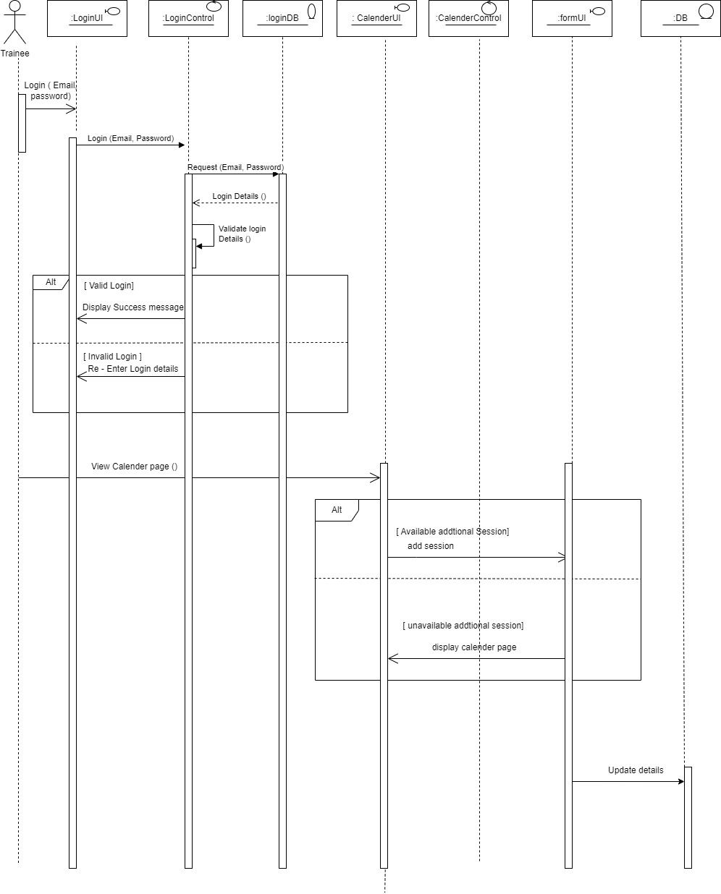

**Activity Diagram**

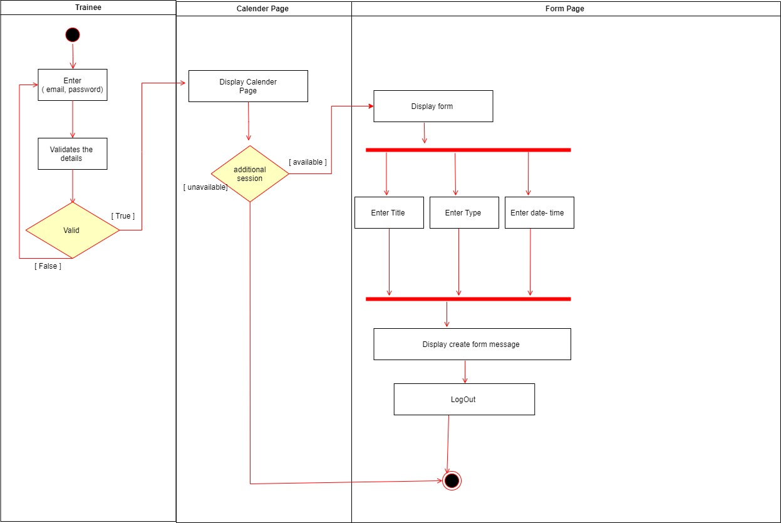

**Use Case Diagram**

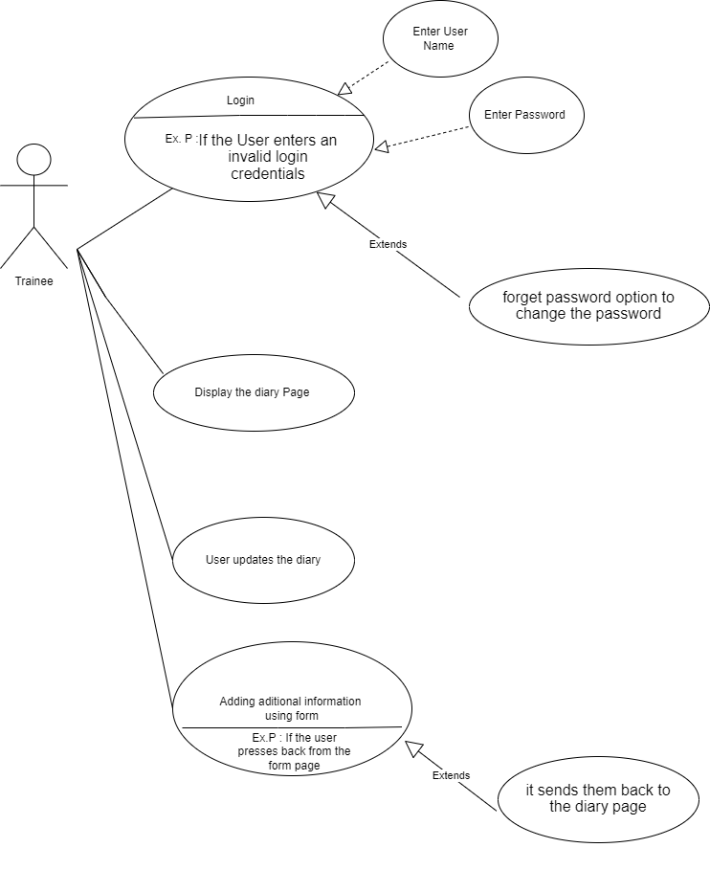

**User Interfaces**

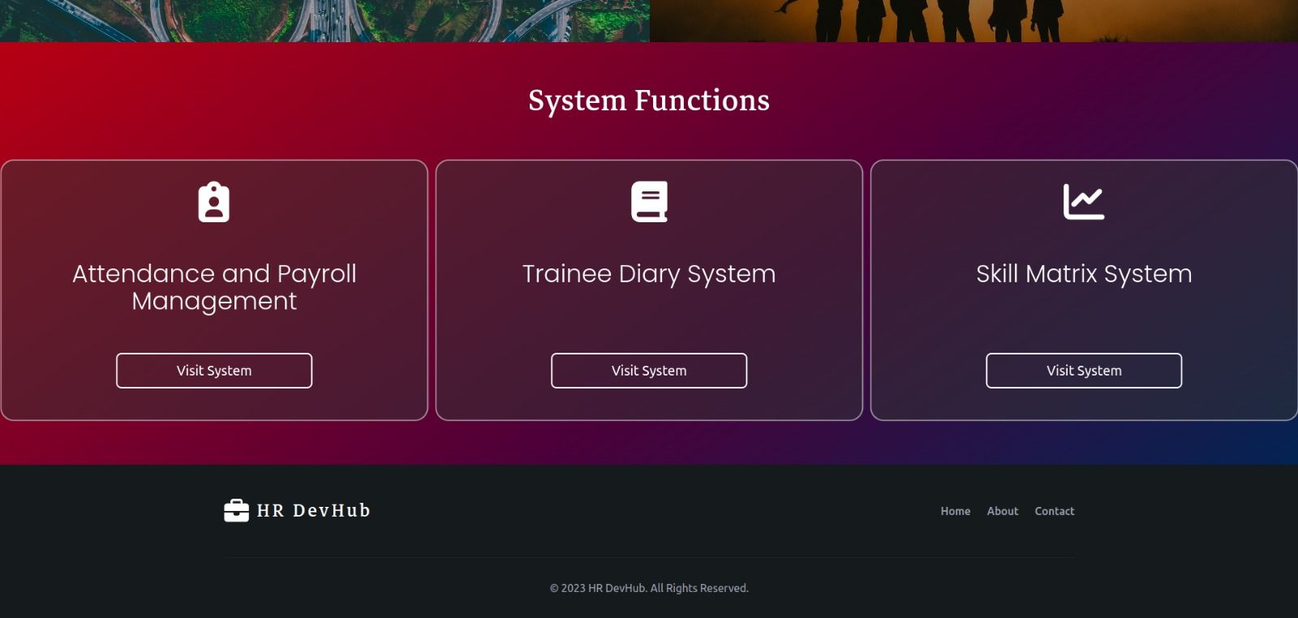

**Trainee Login Page.**

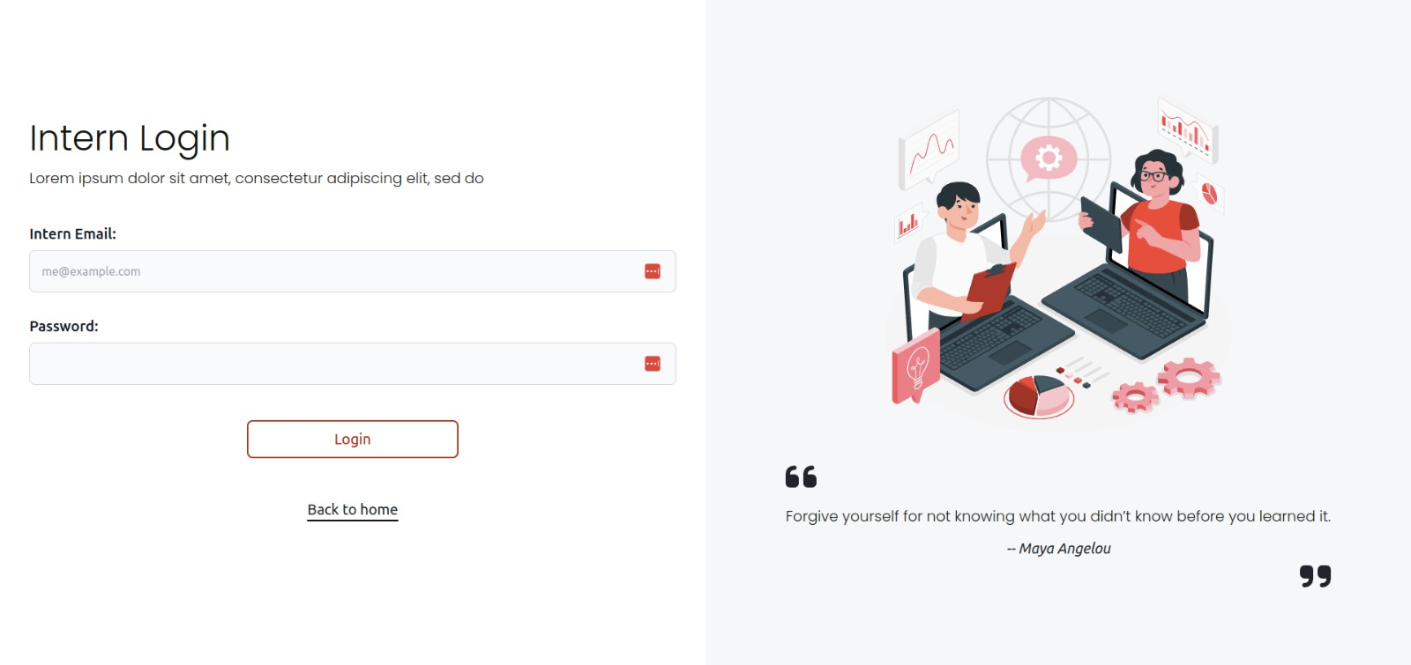

**Dash Board**

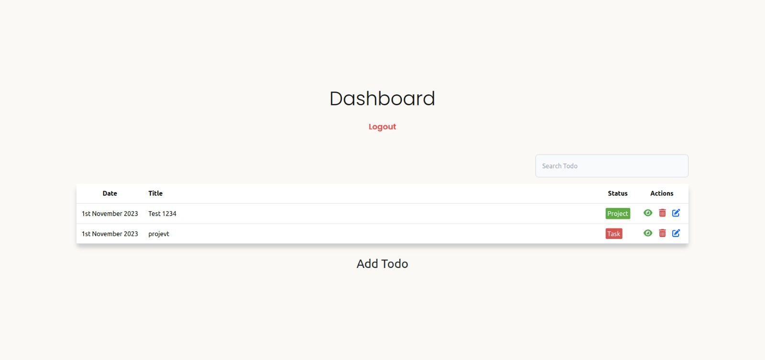

**Edit - Details Form Page**

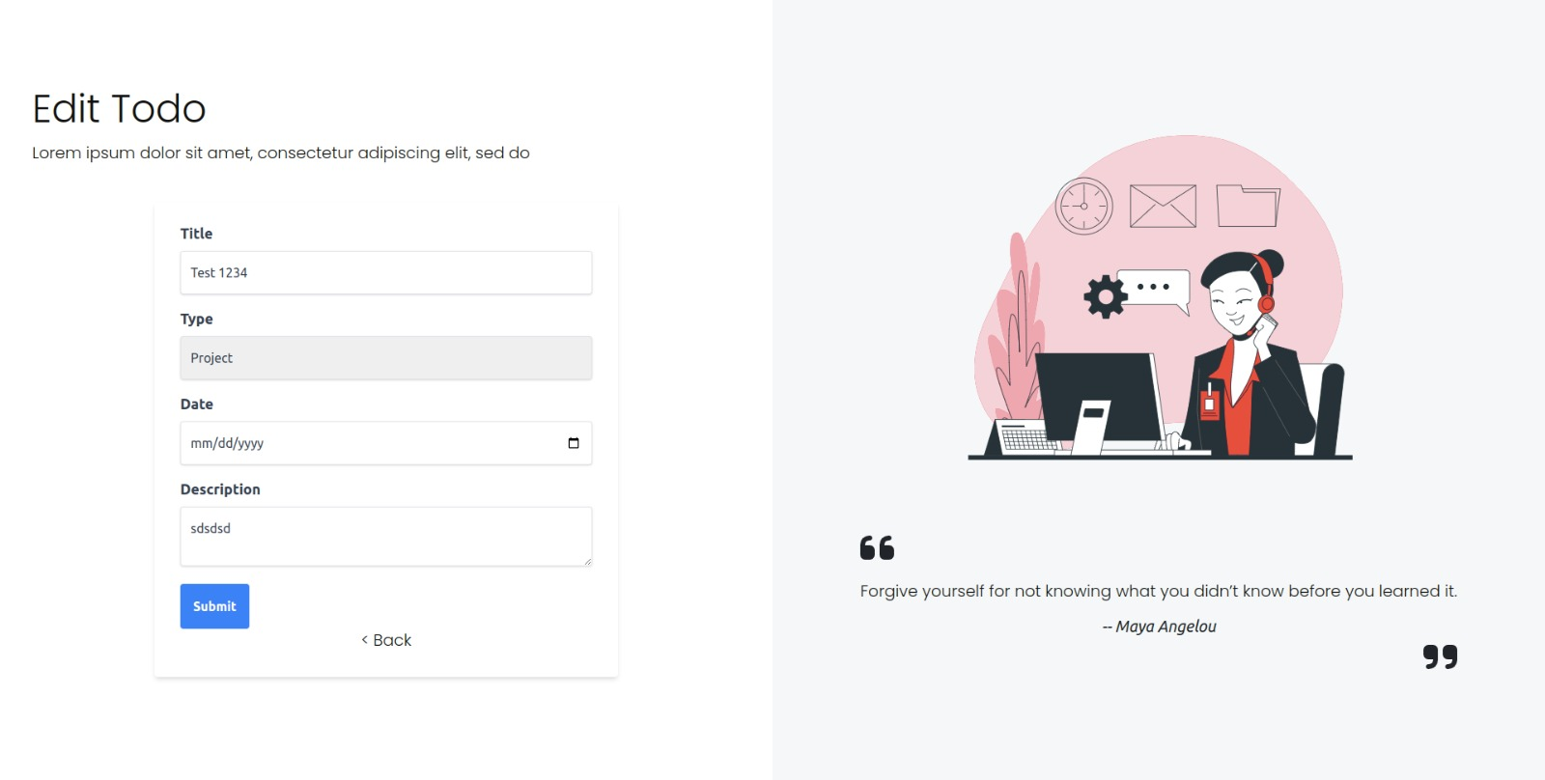

**View Details Form Page**

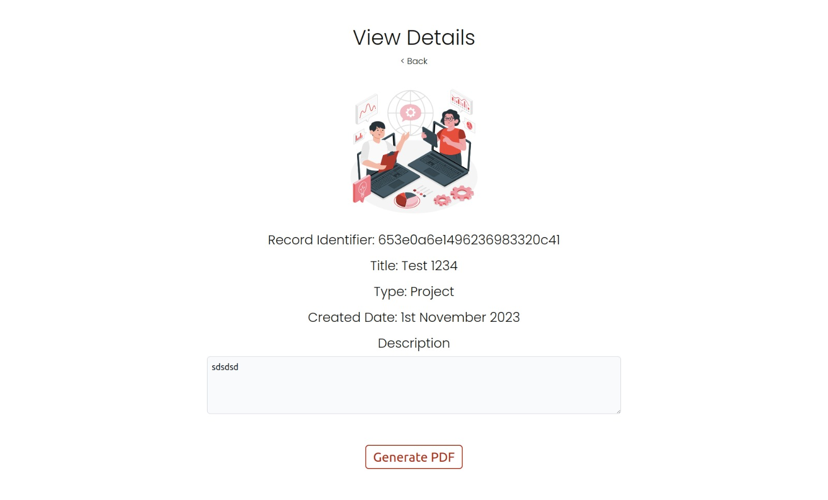

**Implementation**

**Tools used for the development**

|  |  |
| --- | --- |
| **Software** | **Usage** |
| Visual Studio Code | For coding environment |
| Mongo DB | For database management |
| Google Chrome | For the display web page |
| Adobe Photoshop CC/Adobe Illustrator | For the image and logo creation |
| React (java Script library) | For Develop the Frontend |
| Node.js Platform | For Develop the Backend  (server environment) |

The system has developed as MERN Stack Architecture following are the screenshots of the related coding.

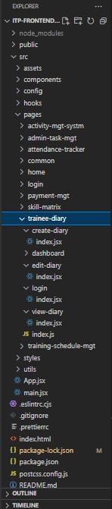

­­

**Code of Login Page**

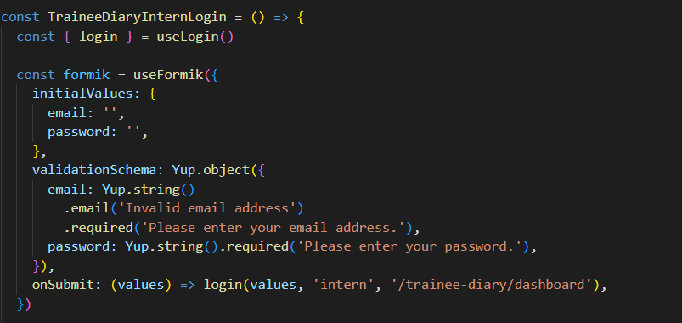

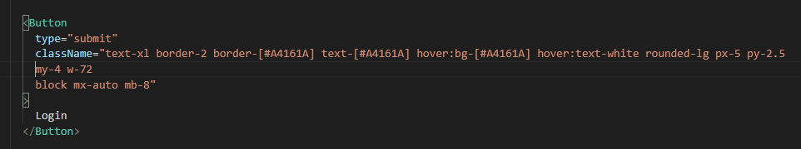

**Code of Dashboard**

**(From index. Jsx)**

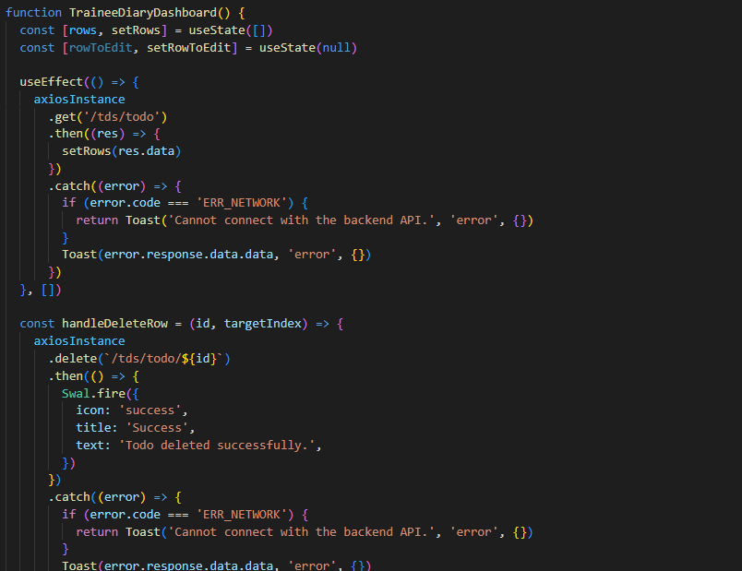

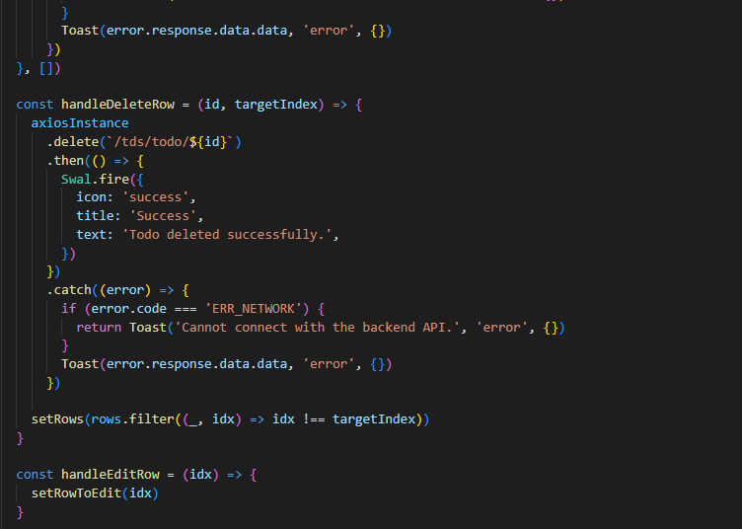



**(from table. jsx)**

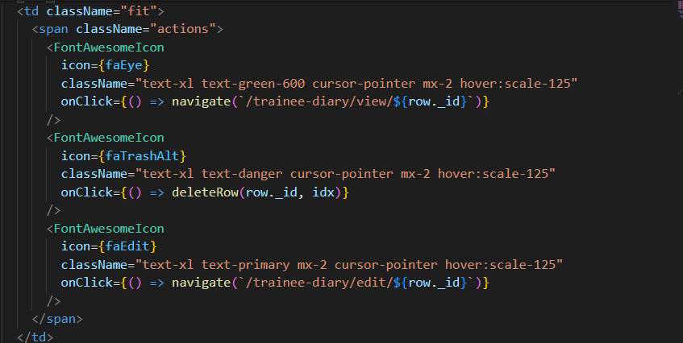

**Code of Edit Diary**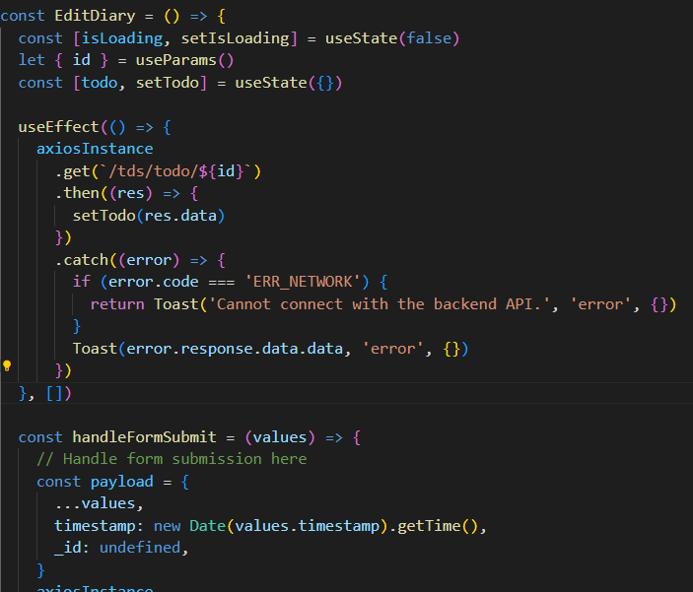

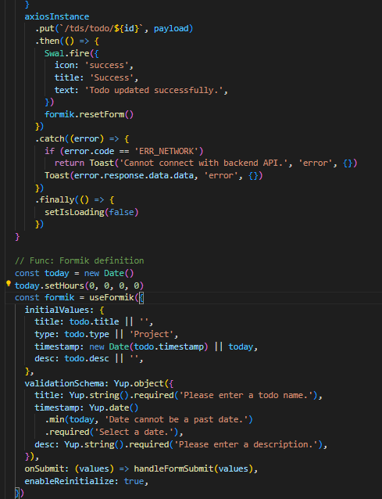

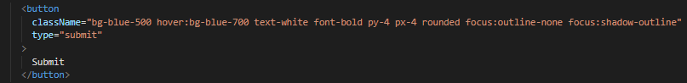

**Code of View Diary**

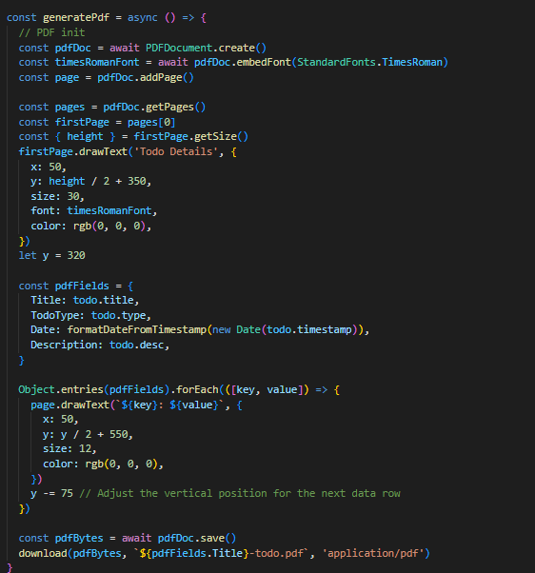

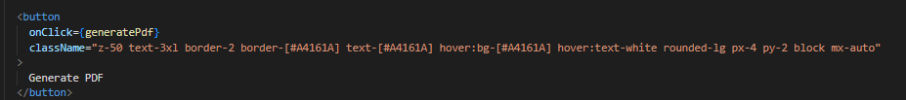

**Code of Create Diary**

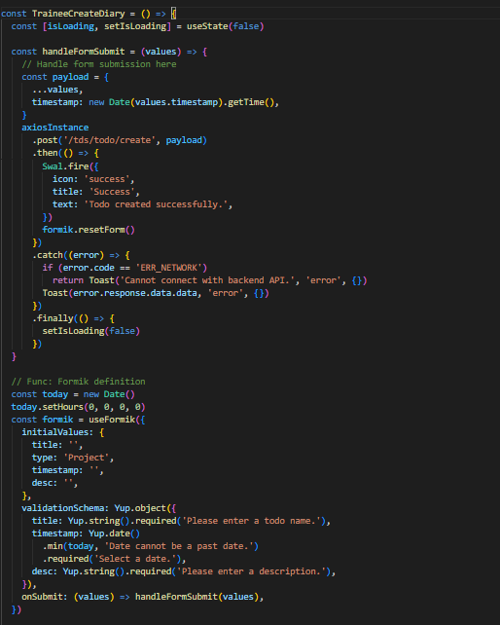

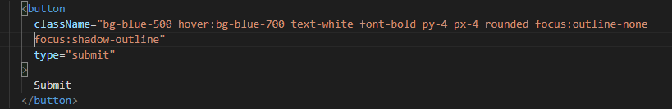

**Testing**

**Testing Function:** Delete To-Do data

**Test Case Design By :** IT21806636

**Test Priority (High/Medium/Low):** High

**Pre-Conditions (If there are any):** Trainee must have log into system

**Test Steps:**

1.click delete button on To-Do table

2.selected row has been Deleted

|  |  |  |  |  |  |
| --- | --- | --- | --- | --- | --- |
| Test ID | Test Inputs | Expected  Output | Actual Output | Result  (Pass/Fail) | Description |
|  | Click the “Delete” button in a To-Do table | Selected row has been deleted and a column in the table appears to be missing. | A column in the table appears to be missing. | Pass | Trainee delete row details.  Comments:  Trainee has been successfully deleted from the database |

**Testing Function:** Update To-Do data

**Test Case Design By :** IT21806636

**Test Priority (High/Medium/Low):** High

**Pre-Conditions (If there are any):** Trainee must have log into system

**Test Steps:**

1.click Edit button on To-Do table

2.Open edit details form Page

|  |  |  |  |  |  |
| --- | --- | --- | --- | --- | --- |
| Test ID | Test Inputs | Expected  Output | Actual Output | Result  (Pass/Fail) | Description |
|  | Click the “Edit” button in a To-Do table | When the edit button is clicked, the edit details form opens and after filling the fields there, the dashboard opens after submitting and the data in the relevant column is updated. | When the edit button is clicked, the edit details form opens and after filling the fields there, the dashboard opens after submitting and the data in the relevant column is updated | Pass | Trainee update row details.  Comments:  Trainee has been successfully update from the database |

**Testing Function:** Add To-Do data

**Test Case Design By :** IT21806636

**Test Priority (High/Medium/Low):** High

**Pre-Conditions (If there are any):** Trainee must have log into system and retrieve details.

**Test Steps:**

1.click Add To Do button on bottom of the dashboard

2.Open edit details form Page

|  |  |  |  |  |  |
| --- | --- | --- | --- | --- | --- |
| Test ID | Test Inputs | Expected  Output | Actual Output | Result  (Pass/Fail) | Description |
|  | Click the “Add To Do” button in a To-Do table | When the “Add To Do “button is clicked, the View details page opens and after adding the new fields there, Trainee can click the “Generate PDf ”  button and download it. | When the “Add To Do” button is clicked, the view details Page opens and after filling the fields there, download the pfd. | Pass | Trainee added details and successfully download PDF  Comments:  Trainee has been successfully add data from the database |

**Testing Function:**  Search data

**Test Case Design By:** IT21806636

**Test Priority (High/Medium/Low):** High

**Pre-Conditions (If there are any):** Trainee must have log into system and retrieve details.

**Test Steps:**

1.View dashboard

2.search by titles in the table

|  |  |  |  |  |  |
| --- | --- | --- | --- | --- | --- |
| Test ID | Test Inputs | Expected  Output | Actual Output | Result  (Pass/Fail) | Description |
|  | titles | Search any title columns Data. | Search any title data and, given that searched data | Pass | Trainee can search  Data from the table.  Comments:  Sorted data has been displayed. |

Admin Search Request

|  |  |
| --- | --- |
| **Test Case ID:** Trainee | **Test Design By:** De Silwa |
| **Test Title:** Trainee search request record | **Test Designed Date:** 2023.10.29 |
| **Test priority:** High | **Test Executed By:** De Silwa |
| **Module name:** Search request | **Test Executed Date**: 2023.10.30 |
| **Description:** Enter any title name to get details | |
| **Precondition**: should be login as admin | |
| **Dependencies:** | |
| **Test Steps:**   * Login to the system by entering correct login credentials * Navigate to the dashboard * Enter “Title Name” on the search bar * Display the request records in the table which is similar to the entered keyword | |

|  |  |  |  |  |  |
| --- | --- | --- | --- | --- | --- |
| **Test ID** | **Test Inputs** | **Expected outputs** | **Actual output** | **Result** | **Comments** |
| Admin | Project Mass | Display all the request records where name is equal to Project Mass in the table. | Display all the request records where name is equal to Project Mass in the table. | Pass | Output is coming as expected |
| Admin | Meeting Mass | No search result | No search result | Pass | Output is coming as expected |