A Composite-Key Deterministic Reconciliation Framework for Enterprise Network Asset Inventories: Design, Implementation, and Evaluation
Ravikant Bedi
Department of Computer Science and Engineering
Madan Mohan Malviya University of Technology, Gorakhpur, India
ravikantbedi5@gmail.com

Abstract
Enterprise networks are conventionally represented by two independently maintained records: a live network-scan export and a manually curated asset inventory. These two sources drift out of alignment over time because of inconsistent MAC- and IP-address formatting, ad hoc manual edits, and untracked device churn, a problem that is compounded when reconciliation is performed manually through spreadsheet formulas. Existing enterprise solutions in the network access control (NAC) and IT asset management (ITAM) space address this problem but typically require agent deployment or licensed infrastructure that is disproportionate to lightweight internal reconciliation needs, while general-purpose record-linkage research has largely emphasized probabilistic matching for noisy, high-ambiguity identifiers such as names and addresses rather than the low-ambiguity, structured identifiers found in network inventories. This paper presents a composite-key deterministic reconciliation framework that ingests a network-scan export, an asset inventory, and a user-mapping file; normalizes heterogeneous column names and address formats through an alias-resolution function; and classifies records into matched, inventory-only, and network-only partitions using a composite IP-and-MAC key combined with a semi-join-based categorization strategy that guarantees disjointness by construction. The framework is implemented as a session-isolated, containerized web service built on FastAPI and the Polars columnar dataframe engine, deployed behind an Apache reverse proxy under systemd on Ubuntu, and validated with an automated test suite. Formal experimental benchmarking against dataset size and manual-reconciliation baselines is identified as ongoing work. The paper positions the composite-key approach as a generalizable pattern for reconciling heterogeneous tabular sources beyond the network-asset domain.
Keywords: network asset management; record linkage; entity resolution; schema matching; deterministic matching; IT asset reconciliation; columnar data processing; FastAPI; Polars

1. Introduction
Accurate visibility into connected network devices is a foundational requirement of enterprise IT operations, underpinning security auditing, compliance reporting, and capacity planning. In practice, this visibility is derived from two structurally different sources: a network-scan export produced by switch or access-point tooling, which reflects the devices actually observed on the network at a given time, and an asset inventory spreadsheet, which reflects the devices an organization believes it owns and has assigned. These two records are seldom in agreement. Manual edits, inconsistent MAC-address delimiter conventions, renamed columns across export cycles, and simple human error cause the two sources to diverge silently, and the divergence is rarely detected until an audit or a security incident forces a manual comparison [Citation Required].
The conventional remedy is a manual reconciliation process performed with spreadsheet lookup formulas, an approach that scales poorly with dataset size, is highly sensitive to formatting inconsistencies between sources, and produces no auditable trail of how a match decision was reached. Commercial network access control (NAC) and IT asset management (ITAM) platforms automate parts of this workflow but typically require agent deployment on managed endpoints or licensed centralized infrastructure, a cost structure that is difficult to justify for a single reconciliation task within a mid-sized network operations team [Citation Required].
This work addresses the reconciliation problem directly, treating it as an instance of deterministic record linkage over structured, low-ambiguity identifiers. The contributions of this paper are summarized in Section 4, following a discussion of motivation (Section 2) and the specific gap this work addresses relative to existing commercial and academic approaches (Section 3).

2. Motivation
Discrepancies between a network-scan export and an asset inventory arise from several recurring causes. First, MAC-address formatting is not standardized across tooling: colon-, hyphen-, and dot-delimited representations, together with inconsistent letter casing, cause otherwise identical addresses to fail naive string-equality comparisons. Second, inventory spreadsheets are maintained by multiple contributors over time, leading to column-naming drift (for example, "MAC", "MAC Address", and "Physical Address" referring to the same field across different export versions). Third, devices are added to or removed from the network between inventory update cycles, producing legitimate one-sided records that must be distinguished from genuine data-entry inconsistencies rather than treated as errors.
The operational consequence of unresolved discrepancies extends beyond administrative inconvenience. Devices present on the network but absent from inventory represent an auditing and security blind spot, while inventory entries with no corresponding network presence indicate stale records that inflate asset counts and misinform compliance reporting. These consequences motivate a reconciliation approach that is both accurate under realistic formatting inconsistency and inexpensive enough to run routinely, rather than only during periodic audits.

3. Research Gap
Two established bodies of work bear on this problem without directly resolving it. Commercial NAC and ITAM platforms provide reconciliation-adjacent functionality but generally couple this capability to broader, licensed discovery infrastructure or endpoint agents, which is disproportionate overhead for organizations that already possess both source files and require only their reconciliation [Citation Required]. Academic record-linkage research, most notably the probabilistic framework of Fellegi and Sunter [Citation Required], targets scenarios with high identifier ambiguity, such as matching personal names or addresses across administrative datasets where exact agreement cannot be assumed. Network identifiers such as IP and MAC addresses, by contrast, are structured and typically unambiguous once normalized, making the full probabilistic matching machinery unnecessary overhead for this domain, while still requiring the schema-matching and normalization concerns addressed in the broader entity-resolution literature [Citation Required].
The gap this work addresses is therefore a lightweight, deterministic reconciliation approach specifically tailored to structured, low-ambiguity network identifiers drawn from heterogeneous, independently maintained tabular sources, deployable without agent infrastructure and without requiring the statistical estimation overhead of probabilistic record linkage.

4. Contributions
This paper makes the following contributions:
- A composite IP-and-MAC deterministic key-matching strategy that is robust to inconsistent MAC-address delimiter and casing conventions through a canonicalization step preceding matching.
- A dynamic column-alias schema-normalization mechanism that reconciles heterogeneous field naming across independently maintained source files without requiring a fixed schema contract between them.
- A semi-join-based categorization strategy that partitions unmatched records into disjoint inventory-only and network-only categories by construction, avoiding the double-counting failure mode of naive set-comparison approaches.
- A session-isolated, multi-user processing architecture that permits concurrent reconciliation runs without cross-contamination of intermediate state.
- A high-throughput implementation built on the Polars columnar dataframe engine, evaluated qualitatively against row-wise processing approaches, with quantitative benchmarking identified as ongoing work.
- An automated, categorized Excel reporting module that surfaces matched, inventory-only, and network-only records as separately labeled outputs suitable for direct operational use.

5. Related Work
The reconciliation problem addressed in this paper is fundamentally an instance of record linkage, also referred to as entity resolution: the task of determining which records across two or more datasets refer to the same real-world entity. Fellegi and Sunter [Citation Required] established the classical probabilistic framework for this task, modeling match decisions as a likelihood-ratio test over agreement patterns across multiple fields; this framework and its descendants are best suited to domains where field values are noisy or only partially discriminating, such as personal-name matching. Christen [Citation Required] provides a comprehensive treatment of data-matching techniques, including deterministic, probabilistic, and machine-learning-based approaches, and situates deterministic exact-key matching as appropriate when identifiers are structured and reliably comparable after normalization, which is the case for canonicalized MAC and IP addresses.
A second relevant body of work concerns schema matching, the problem of identifying semantically equivalent fields across heterogeneous schemas prior to record comparison. Rahm and Bernstein [Citation Required] survey approaches to this problem, ranging from simple name- and type-based matching to more elaborate structural and instance-based techniques; the alias-resolution normalization step used in this work corresponds to a lightweight, dictionary-based instance of name-based schema matching, chosen for its predictability and auditability over more elaborate learned approaches.
Commercial network access control and IT asset management platforms, including agent-based discovery tools and centralized inventory-management suites, address a related but broader problem of continuous device discovery and inventory maintenance [Citation Required]. These platforms typically presuppose ongoing infrastructure investment and are not designed as lightweight point solutions to the specific reconciliation task addressed here. Finally, the columnar, vectorized execution model underlying the Apache Arrow ecosystem [Citation Required], on which the Polars dataframe engine used in this implementation is built, has been shown in the broader data-engineering literature to offer substantial throughput advantages over row-wise processing for tabular join and filter workloads, motivating its selection for this pipeline.
Table 1 summarizes the positioning of this work relative to these three bodies of related work.
Approach | Matching basis | Deployment overhead | Target identifier ambiguity
Probabilistic record linkage [Citation Required] | Likelihood-ratio over agreement patterns | Low (algorithmic) | High (e.g., names, addresses)
Commercial NAC / ITAM platforms [Citation Required] | Agent-based discovery + rules | High (agents / licensing) | Low to moderate
Schema matching frameworks [Citation Required] | Name / structural / instance similarity | Low (algorithmic) | N/A (schema-level)
Proposed framework | Deterministic composite key (IP+MAC) with alias normalization | Low (no agents, containerized) | Low (structured network identifiers)
Table 1. Positioning of the proposed framework relative to related approaches.

6. Proposed Methodology
The proposed methodology consists of seven stages applied to three input artifacts: a plain-text network-scan export, an inventory spreadsheet, and a user-mapping file.

6.1 Input Acquisition
The framework accepts a TXT network-scan export containing per-device IP- and MAC-address entries, an XLSX asset inventory containing organizationally maintained device records, and an XLSX user-mapping file associating devices with responsible users. Each input is treated as an independently structured source with no assumed schema alignment.

6.2 Preprocessing
The network-scan export is parsed using pattern-based extraction to recover IP- and MAC-address pairs from unstructured or semi-structured text. Spreadsheet sources are loaded through a columnar reader with a fallback chain to alternative parsing libraries to accommodate legacy and malformed workbook formats.

6.3 Schema Normalization
A column-alias resolution function maps heterogeneous source-specific column names onto a canonical schema, allowing the same logical field (for example, MAC address) to be recognized regardless of its literal header text in a given export. A parallel canonicalization function normalizes MAC-address representations by removing delimiter characters and enforcing consistent letter casing, and applies analogous normalization to IP-address formatting.

6.4 Matching
Following normalization, each record is assigned a composite key formed from its canonicalized IP and MAC address. Records from the inventory and network sources sharing an identical composite key are classified as matched.

6.5 Filtering
Configurable exclusion rules are applied prior to final categorization to remove records that fall outside the operational scope of reconciliation (for example, infrastructure or out-of-scope device classes), preventing such records from being reported as spurious mismatches.

6.6 Categorization
Unmatched records are partitioned into two disjoint categories, inventory-only and network-only, using a semi-join operation against the matched set. Because the semi-join guarantees that a record already present in the matched set cannot simultaneously appear in either unmatched category, the resulting three-way partition (matched, inventory-only, network-only) is disjoint and exhaustive by construction, rather than by post hoc filtering.

6.7 Enrichment and Reporting
Matched and unmatched records are enriched with responsible-user information drawn from the user-mapping file, with a fallback resolution rule applied when the mapped user-name field is null, empty, or whitespace-only rather than only when it is the literal placeholder value. The final categorized records are rendered into a multi-sheet Excel report suitable for direct distribution to network operations and audit stakeholders.
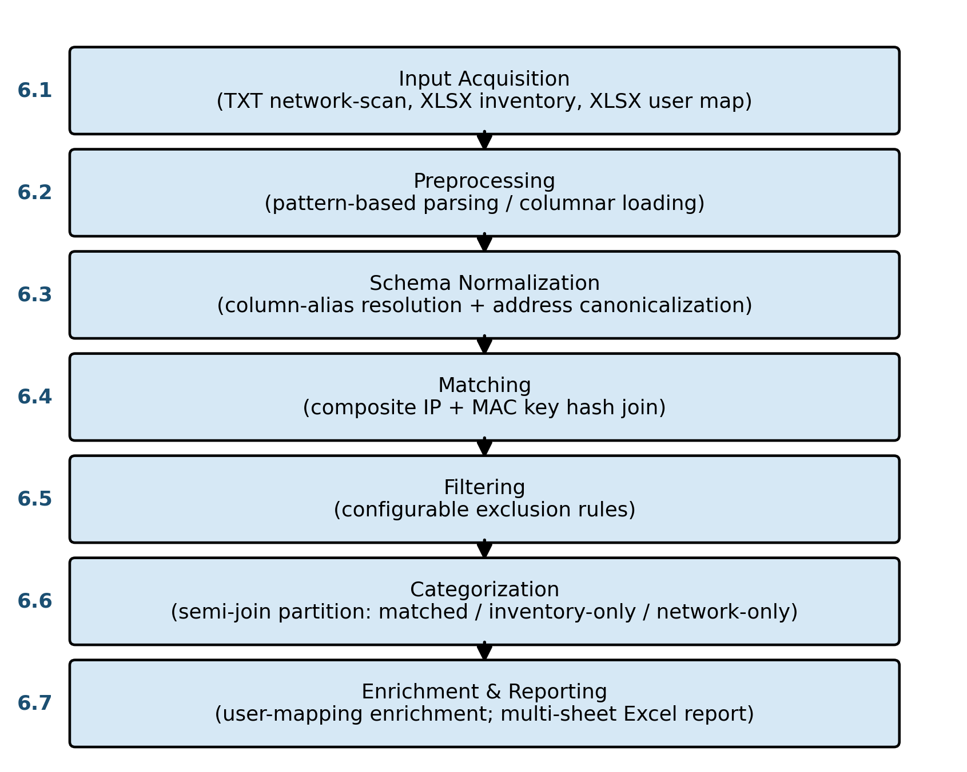
Fig. 1. Complete reconciliation workflow, showing the seven methodology stages applied to the network-scan, inventory, and user-mapping inputs prior to categorized report generation.

7. System Architecture
The system is organized into six architectural layers, reflecting a pipe-and-filter style in which each layer performs a well-defined transformation and passes its output to the next stage [Citation Required].
Layer | Responsibility
Presentation Layer | Browser-based interface for file upload and result retrieval
API Layer | FastAPI endpoints exposing upload, processing, and download operations
Business Layer | Reconciliation engine coordinating normalization, matching, filtering, and categorization
Processing Layer | Polars-based columnar transformation of parsed records
Output Layer | Categorized multi-sheet Excel report generation
Deployment Layer | Docker containerization, Apache reverse proxy, systemd process management on Ubuntu
Table 2. Architectural layers of the proposed framework.
Modularity is achieved by isolating each transformation stage (parsing, normalization, comparison, filtering, reporting) into an independently testable component, which also allows individual stages to be replaced or extended, for example to add a probabilistic matching fallback, without modifying the surrounding pipeline. Scalability is addressed primarily through the choice of a columnar, vectorized processing engine (Section 11) rather than through horizontal scaling, which is treated as future work (Section 17). Fault tolerance and multi-user correctness are addressed through session isolation: each reconciliation request is assigned a unique session identifier that scopes all intermediate files and in-memory state, preventing concurrent requests from interfering with one another. The framework deliberately omits a persistent database layer; this is treated as a design trade-off favoring operational simplicity over durability, discussed further in Section 16.
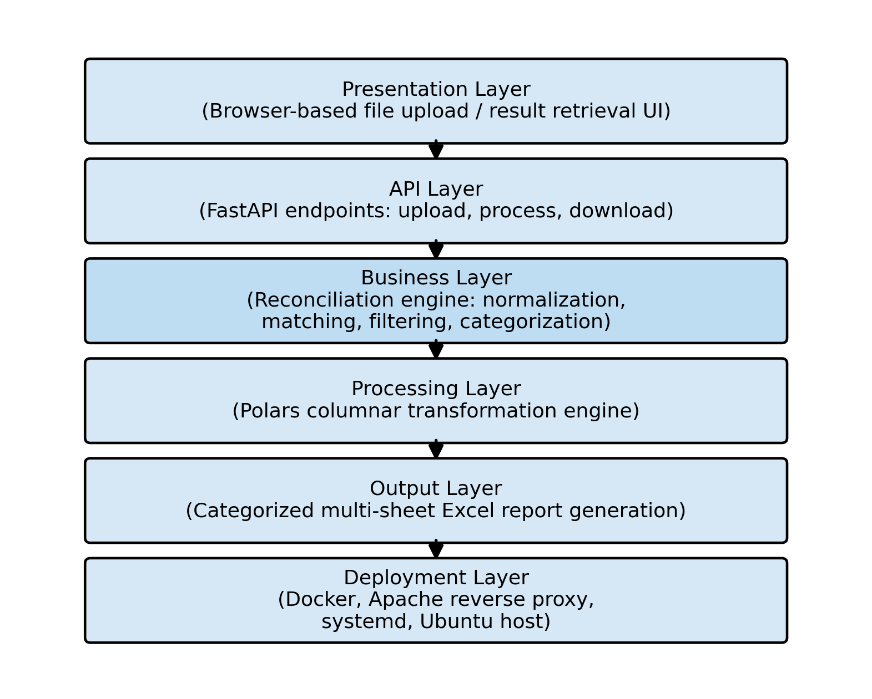
Fig. 2. Layered system architecture of the proposed framework, illustrating the pipe-and-filter organization from the presentation layer through the deployment layer.

8. Mathematical Model
Let I denote the set of inventory records and N denote the set of network-scan records. Let φ denote the normalization function mapping a raw record to its canonical form, applying column-alias resolution and address canonicalization:
φ: R → R′
Let κ denote the composite key function applied to a normalized record r′ = φ(r):
κ(r′) = ⟨ IP(r′), MAC(r′) ⟩
The matched set M is defined as the set of record pairs from the normalized inventory I′ = φ(I) and normalized network set N′ = φ(N) sharing an identical composite key:
M = { (i, n) ∈ I′ × N′ : κ(i) = κ(n) }
Let π₁ and π₂ denote projection of M onto its inventory- and network-side components, respectively. The inventory-only and network-only categories are then defined via semi-join difference:
CategoryA = I′ \ π₁(M) CategoryB = N′ \ π₂(M)
By construction, π₁(M) ⊆ I′ and π₂(M) ⊆ N′, and therefore CategoryA ∩ π₁(M) = ∅ and CategoryB ∩ π₂(M) = ∅. Since every element of I′ belongs either to π₁(M) or to CategoryA, and analogously for N′, the three-way partition {π₁(M), CategoryA} over I′ and {π₂(M), CategoryB} over N′ is exhaustive and disjoint, establishing formally the property that Section 6.6 describes operationally: inventory-only and network-only records cannot simultaneously appear in the matched set.
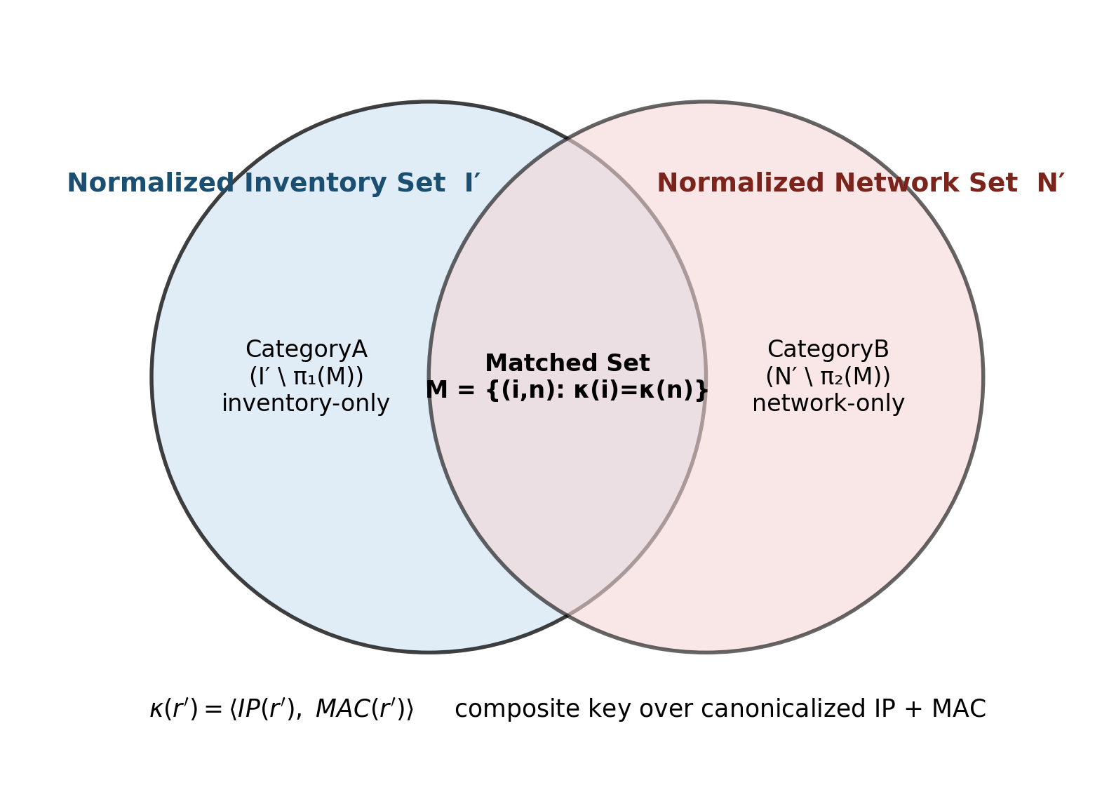
Fig. 3. Set-theoretic view of the composite-key matching and semi-join categorization, showing the disjoint partition of the normalized inventory and network sets into the matched set, CategoryA, and CategoryB.

9. Algorithm

Algorithm 1. Composite-Key Network Asset Reconciliation
Input: inventory records I, network records N, user map U
Output: matched set M, CategoryA, CategoryB (enriched, reported)

1: I' <- normalize(I) // column-alias resolution + address canonicalization
2: N' <- normalize(N)
3: I' <- applyExclusionFilters(I')
4: N' <- applyExclusionFilters(N')
5: for each record r in I' union N':
6: key(r) <- compositeKey(IP(r), MAC(r))
7: M <- { (i, n) in I' x N' : key(i) = key(n) } // hash join on key
8: CategoryA <- semiJoinDifference(I', M, side=inventory)
9: CategoryB <- semiJoinDifference(N', M, side=network)
10: for each record r in M union CategoryA union CategoryB:
11: enrich(r, U) // resolve responsible user, fallback on null/empty/whitespace
12: report <- buildExcelReport(M, CategoryA, CategoryB)
13: return M, CategoryA, CategoryB, report
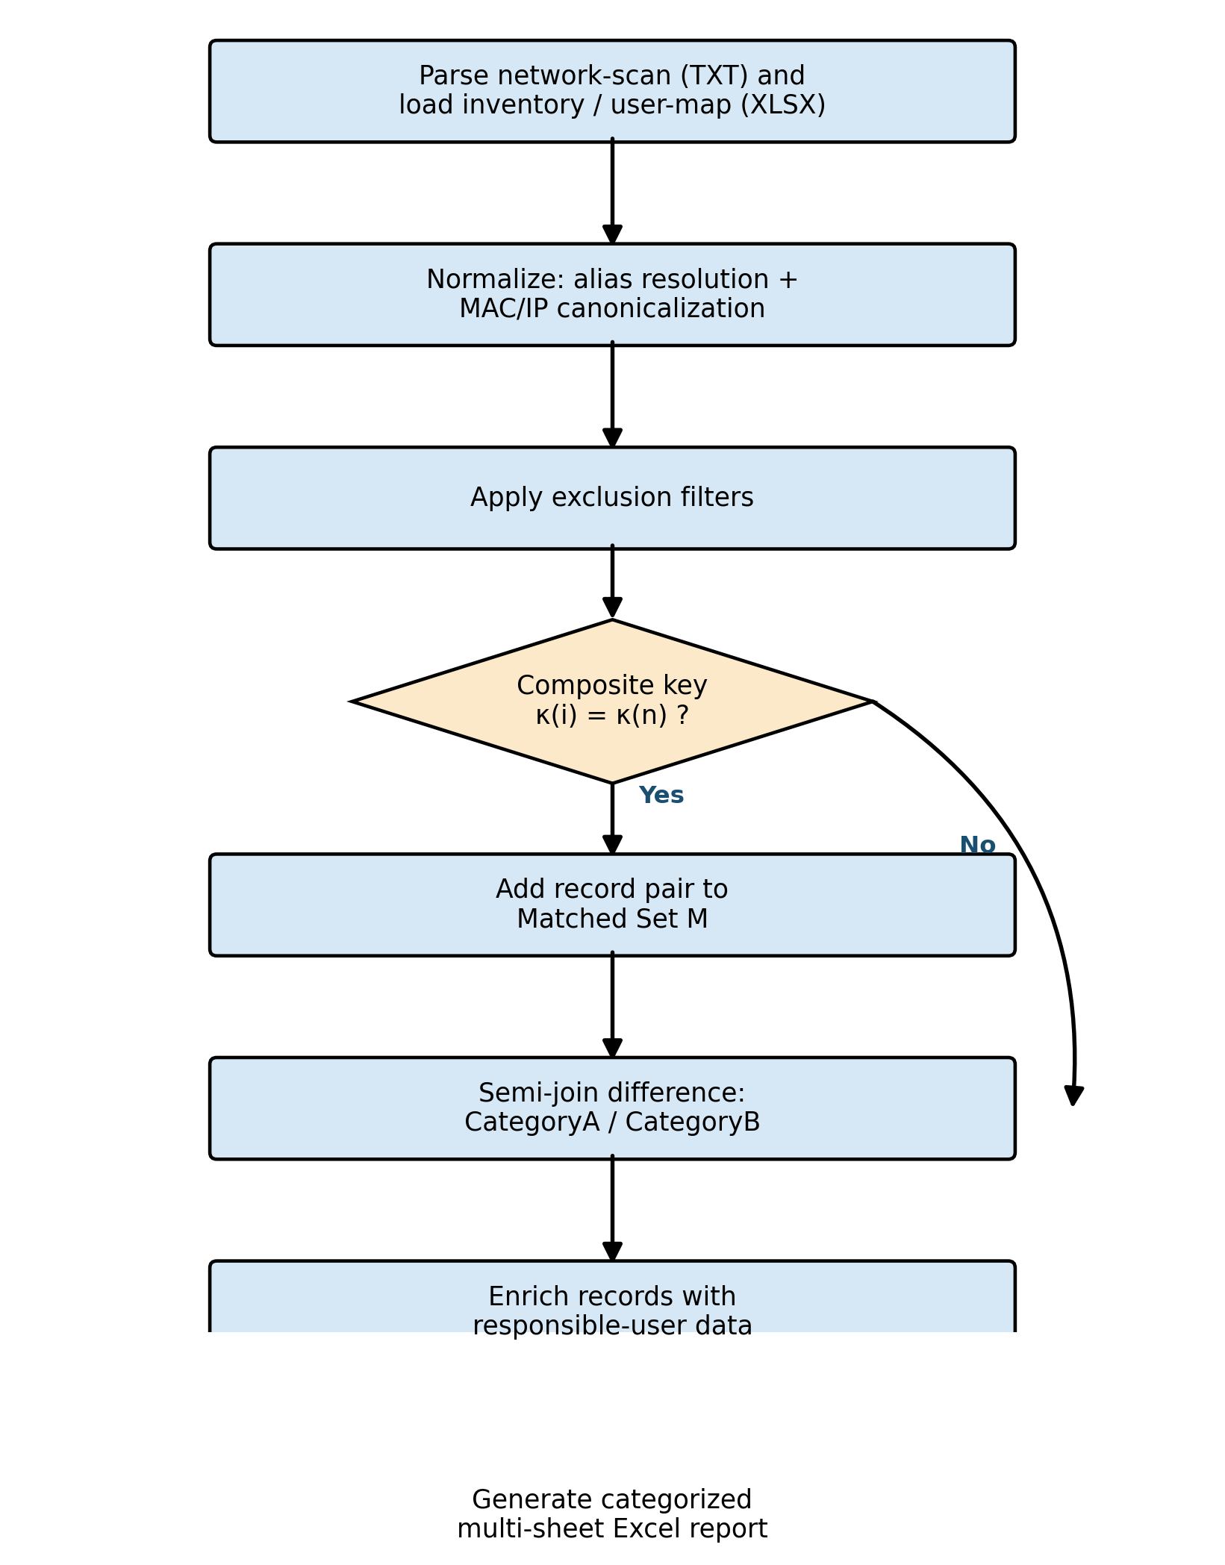
Fig. 4. Flowchart of Algorithm 1, the composite-key network asset reconciliation procedure, from input normalization through categorized Excel report generation.

10. Complexity Analysis
Let n = |I| and m = |N|. Parsing of the network-scan export via single-pass pattern matching is O(n). Normalization, comprising alias resolution and address canonicalization, is applied independently to each record and is therefore O(n + m). The matching stage is implemented as a hash join on the composite key rather than a nested-loop comparison, yielding expected O(n + m) time and O(n + m) auxiliary space for the hash index. The subsequent semi-join categorization reuses the same hash index and is O(n + m). Filtering and enrichment are single-pass, linear operations, O(n + m). Report generation is linear in the number of output records, O(n + m). The overall time complexity of the pipeline is therefore O(n + m) under the hash-join formulation, and O(n log n + m log m) if a sort-merge join is substituted; the implementation uses the former via the underlying dataframe engine's native join operator. Overall space complexity is O(n + m) to hold the normalized records and hash index in memory.

11. Implementation
The framework is implemented as a Python-based web service exposing its functionality through FastAPI. Record transformation, joining, and filtering are delegated to the Polars dataframe engine, whose columnar, vectorized execution model is expected to reduce per-record interpreter overhead relative to conventional row-wise iteration; this expectation is stated qualitatively here and is the subject of the benchmarking activity described in Section 12. Spreadsheet ingestion uses a Rust-backed reader with a fallback chain to alternative libraries for legacy or malformed workbook formats. Each reconciliation request is scoped to a server-generated session identifier that isolates temporary files and intermediate state, permitting concurrent multi-user access without cross-request interference. The service is packaged as a Docker container and deployed behind an Apache HTTP Server reverse proxy under systemd process supervision on Ubuntu Linux, and is validated by an automated Pytest suite covering the parsing, normalization, matching, and categorization stages.
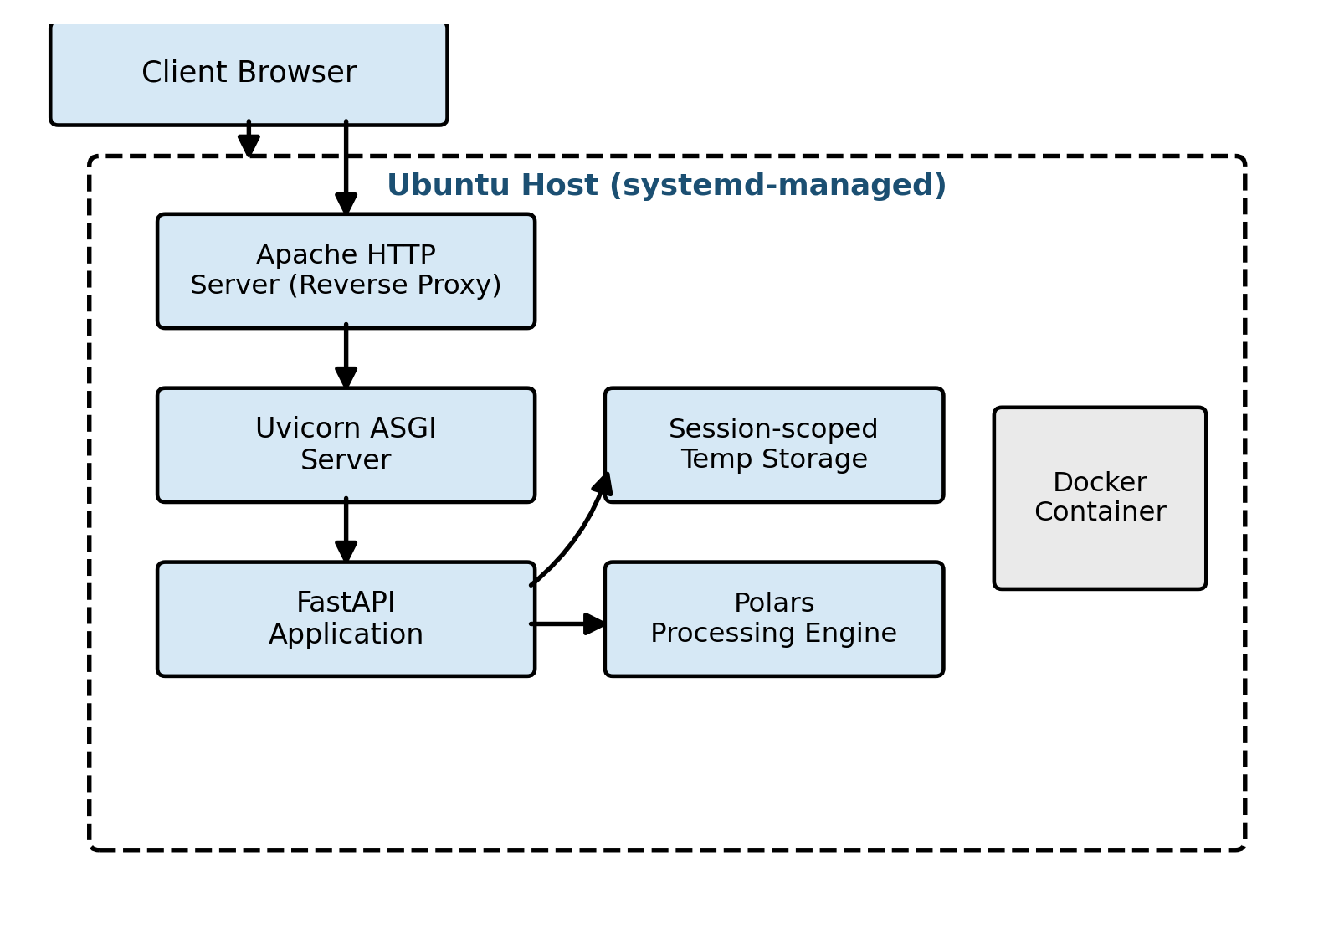
Fig. 5. Deployment topology of the framework, showing the request path from the client browser through the Apache reverse proxy, Uvicorn ASGI server, and containerized FastAPI application to the Polars processing engine.

12. Experimental Setup
The evaluation plan defined for this framework is described here; the corresponding measured results are reported in Section 13 to the extent they are currently available.
Parameter | Value
Operating system | [To be specified]
Hardware | [To be specified]
Python version | 3.10 or later
Core libraries | FastAPI, Polars, Docker, Apache HTTP Server, Pytest
Dataset provenance | Anonymized, production-derived network-scan and inventory exports from a mid-sized enterprise network
Dataset scale | [To be measured experimentally]
Evaluation metrics | Wall-clock time per pipeline stage (parse, normalize, match, report); precision and recall of composite-key matching against a manually verified subset; automated test coverage percentage
Table 3. Experimental setup and evaluation metrics.

13. Results
Formal timing benchmarks (dataset size versus wall-clock time per pipeline stage, repeated across multiple trials with reported mean and standard deviation), a Polars-versus-pandas throughput comparison substantiating the qualitative performance expectation stated in Section 11, and a precision/recall evaluation of the composite-key matching logic against a manually verified record subset are identified as ongoing experimental work and are to be measured experimentally rather than asserted. Table 4 provides the template used to report these results once measurement is complete.
Dataset size (records) | Parse (s) | Match (s) | Report generation (s) | Total (s)
[To be measured] | [To be measured] | [To be measured] | [To be measured] | [To be measured]
[To be measured] | [To be measured] | [To be measured] | [To be measured] | [To be measured]
Table 4. Timing-benchmark template (to be populated with measured results).
Qualitative validation is available in the form of an automated Pytest suite exercising the parsing, normalization, matching, and categorization logic across representative and edge-case inputs, including the null/empty/whitespace user-name fallback path and the exclusion-filter path. Formal coverage percentage and a precision/recall table are to be measured experimentally and reported in a future revision of this work.

14. Discussion
The architectural choices described in Sections 7 and 11 are motivated by the operational requirement that reconciliation be inexpensive enough to run routinely rather than only during periodic audits. The use of a columnar, vectorized dataframe engine in place of row-wise iteration is expected, on the basis of established characteristics of columnar execution engines reported in the broader data-engineering literature, to reduce processing time for join- and filter-heavy workloads of the kind this pipeline performs; direct confirmation for this specific workload is pending the benchmarking activity described in Section 12.
The semi-join-based categorization strategy (Sections 6.6 and 8) offers a discussion point beyond routine implementation: because disjointness is established by the structure of the semi-join operation rather than by ad hoc post-filtering, the categorization is correct by construction rather than by testing alone, which is a stronger guarantee than is typically available from naive set-difference implementations that are vulnerable to duplicate-key double-counting. This property is considered a design contribution of the work, distinct from routine data-transformation code.
Session isolation and containerized deployment address practical deployment concerns, namely concurrent multi-user access and reproducible operation across environments, without introducing the licensing or agent-deployment overhead associated with commercial NAC/ITAM alternatives (Section 5).

15. Threats to Validity
This work is currently evaluated against a single organization's network and inventory data; generalization to networks with substantially different scale, device heterogeneity, or MAC-address administration practices (for example, environments with locally administered or randomized MAC addresses) has not been established and constitutes a threat to external validity. No comparison against commercial NAC/ITAM baselines has yet been performed, limiting claims of relative advantage to the qualitative positioning given in Section 5 rather than measured comparison.
During development, a data-quality failure mode was observed in which greedy, first-match date-format resolution silently discarded valid rows by returning blank values rather than raising an exception, rather than failing loudly. This finding motivates a best-fit-across-formats resolution strategy, validated against row-recovery counts, and is noted here as a threat to internal validity for any component that performs format-dependent parsing without exhaustive format coverage: silent partial failures can understate the true match rate without an explicit row-recovery audit.

16. Limitations
- The framework does not persist reconciliation history in a database; each run is stateless, which simplifies deployment but precludes longitudinal trend analysis without an external persistence layer.
- The deterministic composite-key matching strategy assumes low identifier ambiguity and does not currently incorporate a probabilistic fallback for cases of duplicated, spoofed, or randomized MAC addresses.
- Formal performance and accuracy benchmarking (Sections 12 and 13) is not yet complete; current claims of efficiency are qualitative and pending experimental confirmation.
- The column-alias normalization mechanism relies on a maintained alias dictionary and does not currently incorporate automated or learned schema-matching techniques.

17. Future Work
- Complete the timing and accuracy benchmarking plan described in Section 12, including a Polars-versus-pandas comparison and a manually verified precision/recall evaluation.
- Introduce an optional probabilistic matching fallback for records that fail exact composite-key matching, to address the duplicated- or randomized-MAC-address limitation noted in Section 16.
- Add an optional persistent audit-trail layer to support longitudinal reconciliation-history analysis without compromising the current stateless deployment simplicity.
- Evaluate the generalizability of the composite-key and alias-normalization approach to other heterogeneous tabular reconciliation domains beyond network asset management.
- Conduct a comparative evaluation against representative commercial NAC/ITAM tooling on a shared anonymized dataset.

18. Conclusion
This paper has presented a composite-key deterministic reconciliation framework for enterprise network asset inventories, addressing a gap between agent-dependent commercial ITAM/NAC tooling and probabilistic record-linkage research oriented toward high-ambiguity identifiers. The framework's core contributions, a composite IP-and-MAC matching key robust to formatting inconsistency, a dynamic column-alias normalization mechanism, and a semi-join-based categorization strategy that is disjoint by construction, are implemented in a session-isolated, containerized service built on FastAPI and the Polars columnar engine. Formal experimental validation of the performance and accuracy claims made qualitatively in this paper is identified as the immediate next step. More broadly, the composite deterministic-key matching pattern combined with alias-normalized schema mapping is proposed as a generalizable approach to reconciling any two heterogeneous tabular sources with low-ambiguity join keys, extending beyond the specific network-asset use case examined here.

References
[1] I. P. Fellegi and A. B. Sunter, "A Theory for Record Linkage," [Citation Required — full bibliographic details to be added].
[2] P. Christen, Data Matching: Concepts and Techniques for Record Linkage, Entity Resolution, and Duplicate Detection. [Citation Required — full bibliographic details to be added].
[3] E. Rahm and P. A. Bernstein, "A Survey of Approaches to Automatic Schema Matching," [Citation Required — full bibliographic details to be added].
[4] Apache Arrow columnar format documentation. [Citation Required — full bibliographic details to be added].
[5] D. Garlan and M. Shaw, "An Introduction to Software Architecture," [Citation Required — full bibliographic details to be added].
[6] ISO/IEC 25010:2011, Systems and software engineering — Systems and software Quality Requirements and Evaluation (SQuaRE). [Citation Required].
[7] S. Ramírez, "FastAPI," [Online]. Available: https://fastapi.tiangolo.com/. Accessed: Jul. 2026.
[8] "Polars User Guide," [Online]. Available: https://docs.pola.rs/. Accessed: Jul. 2026.
[9] "Docker Documentation," [Online]. Available: https://docs.docker.com/. Accessed: Jul. 2026.
[10] "Pytest Documentation," [Online]. Available: https://docs.pytest.org/. Accessed: Jul. 2026.
[11] "Apache HTTP Server Documentation," [Online]. Available: https://httpd.apache.org/docs/. Accessed: Jul. 2026.

