Introduction

[Jenkins](https://jenkins.io/) is an open-source automation server that automates the repetitive technical tasks involved in the continuous integration and delivery of software. Jenkins is Java-based and can be installed from Ubuntu packages or by downloading and running its web application archive (WAR) file — a collection of files that make up a complete web application to run on a server.

In this tutorial, you will install Jenkins by adding its Debian package repository, and using that repository to install the package with apt.

Prerequisites

To follow this tutorial, you will need:

* One Ubuntu 18.04 server configured with a non-root sudo user and firewall by following the [Ubuntu 18.04 initial server setup guide](https://www.digitalocean.com/community/tutorials/initial-server-setup-with-ubuntu-18-04). We recommend starting with at least 1 GB of RAM. See [Choosing the Right Hardware for Masters](https://jenkins.io/doc/book/hardware-recommendations/) for guidance in planning the capacity of a production Jenkins installation.
* Java 8 installed, following our guidelines on [installing specific versions of OpenJDK on Ubuntu 18.04](https://www.digitalocean.com/community/tutorials/how-to-install-java-with-apt-on-ubuntu-18-04#installing-specific-versions-of-openjdk).

Step 1 — Installing Jenkins

The version of Jenkins included with the default Ubuntu packages is often behind the latest available version from the project itself. To take advantage of the latest fixes and features, you can use the project-maintained packages to install Jenkins.

First, add the repository key to the system:

* wget -q -O - https://pkg.jenkins.io/debian-stable/jenkins.io.key | sudo apt-key add -

Copy

When the key is added, the system will return OK. Next, append the Debian package repository address to the server’s sources.list:

* sudo sh -c 'echo deb http://pkg.jenkins.io/debian-stable binary/ > /etc/apt/sources.list.d/jenkins.list'

Copy

When both of these are in place, run update so that apt will use the new repository:

* sudo apt update

Copy

Finally, install Jenkins and its dependencies:

* sudo apt install jenkins

Copy

Now that Jenkins and its dependencies are in place, we’ll start the Jenkins server.

Step 2 — Starting Jenkins

Let’s start Jenkins using systemctl:

* sudo systemctl start jenkins

Copy

Since systemctl doesn’t display output, you can use its status command to verify that Jenkins started successfully:

* sudo systemctl status jenkins

Copy

If everything went well, the beginning of the output should show that the service is active and configured to start at boot:

Output

● jenkins.service - LSB: Start Jenkins at boot time

Loaded: loaded (/etc/init.d/jenkins; generated)

Active: active (exited) since Mon 2018-07-09 17:22:08 UTC; 6min ago

Docs: man:systemd-sysv-generator(8)

Tasks: 0 (limit: 1153)

CGroup: /system.slice/jenkins.service

Now that Jenkins is running, let’s adjust our firewall rules so that we can reach it from a web browser to complete the initial setup.

Step 3 — Opening the Firewall

By default, Jenkins runs on port 8080, so let’s open that port using ufw:

* sudo ufw allow 8080

Copy

Check ufw’s status to confirm the new rules:

* sudo ufw status

Copy

You will see that traffic is allowed to port 8080 from anywhere:

Output

Status: active

To Action From

-- ------ ----

OpenSSH ALLOW Anywhere

8080 ALLOW Anywhere

OpenSSH (v6) ALLOW Anywhere (v6)

8080 (v6) ALLOW Anywhere (v6)

**Note:** If the firewall is inactive, the following commands will allow OpenSSH and enable the firewall:

* sudo ufw allow OpenSSH
* sudo ufw enable

Copy

With Jenkins installed and our firewall configured, we can complete the initial setup.

Step 4 — Setting Up Jenkins

To set up your installation, visit Jenkins on its default port, 8080, using your server domain name or IP address: http://your_server_ip_or_domain:8080

You should see the **Unlock Jenkins** screen, which displays the location of the initial password:

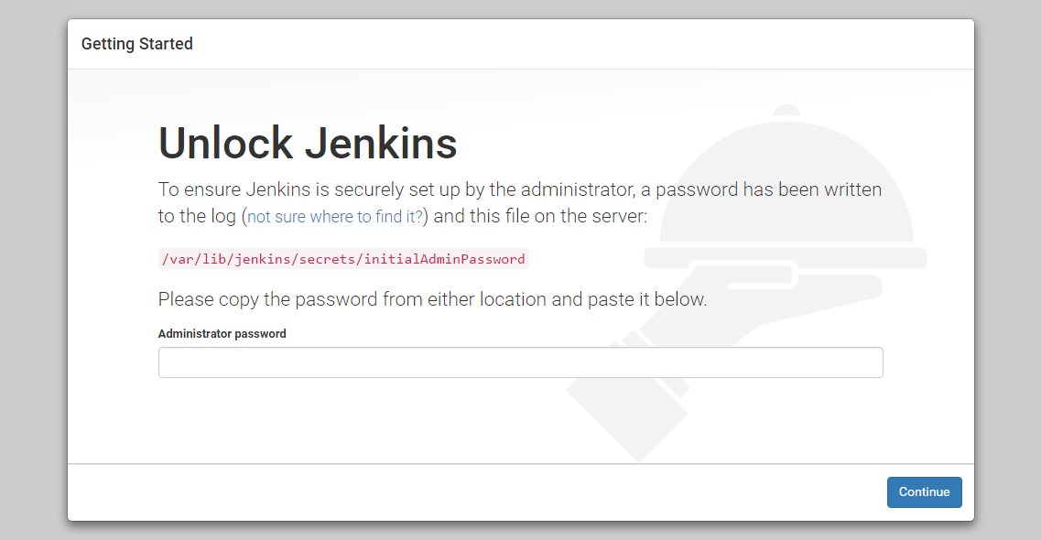

In the terminal window, use the cat command to display the password:

* sudo cat /var/lib/jenkins/secrets/initialAdminPassword

Copy

Copy the 32-character alphanumeric password from the terminal and paste it into the **Administrator password** field, then click **Continue**.

The next screen presents the option of installing suggested plugins or selecting specific plugins:

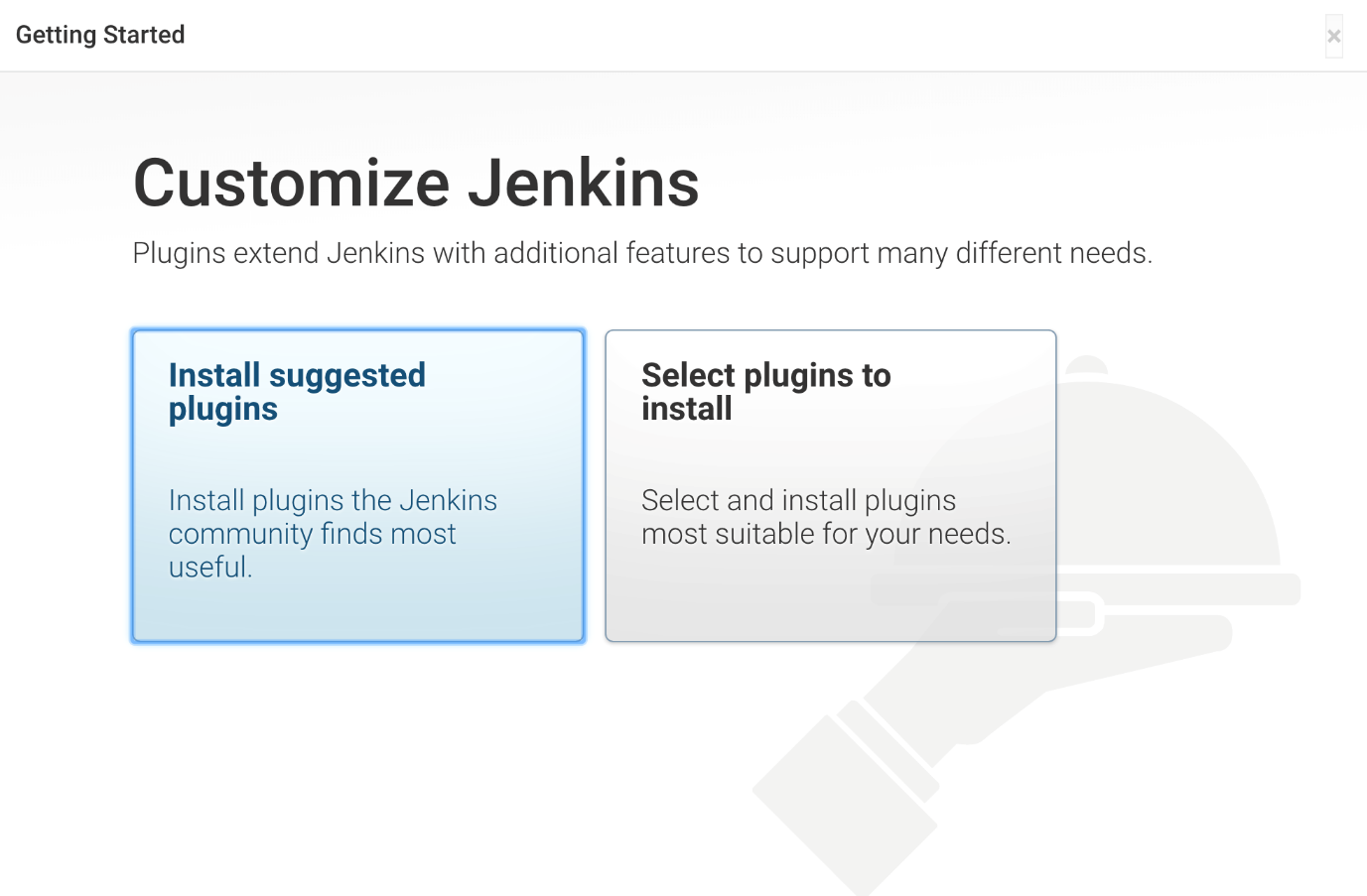

We’ll click the **Install suggested plugins** option, which will immediately begin the installation process:

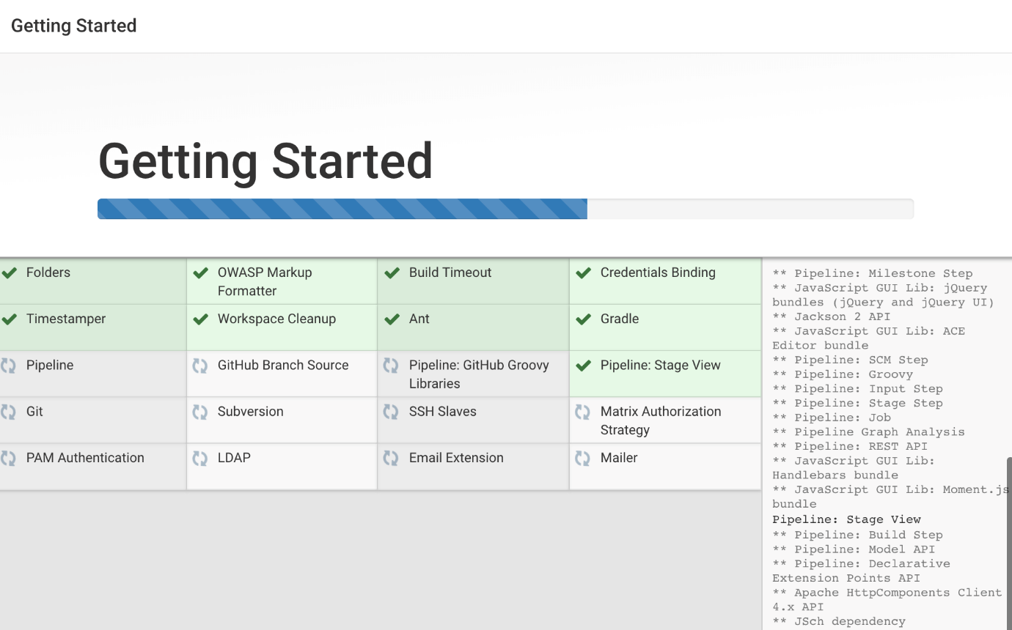

When the installation is complete, you will be prompted to set up the first administrative user. It’s possible to skip this step and continue as admin using the initial password we used above, but we’ll take a moment to create the user.

**Note:** The default Jenkins server is NOT encrypted, so the data submitted with this form is not protected. When you’re ready to use this installation, follow the guide [How to Configure Jenkins with SSL Using an Nginx Reverse Proxy on Ubuntu 18.04](https://www.digitalocean.com/community/tutorials/how-to-configure-jenkins-with-ssl-using-an-nginx-reverse-proxy-on-ubuntu-18-04). This will protect user credentials and information about builds that are transmitted via the web interface.

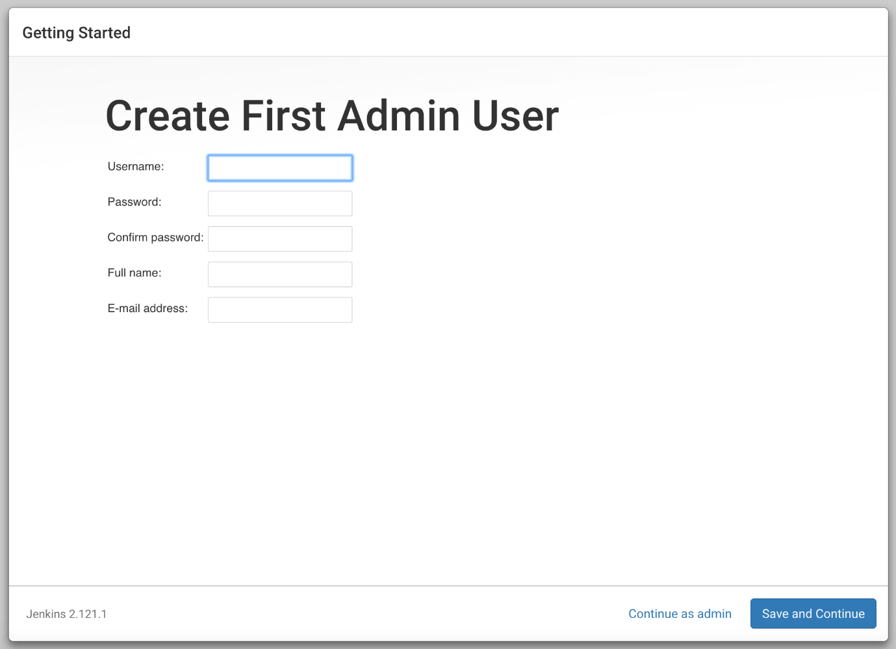

Enter the name and password for your user:

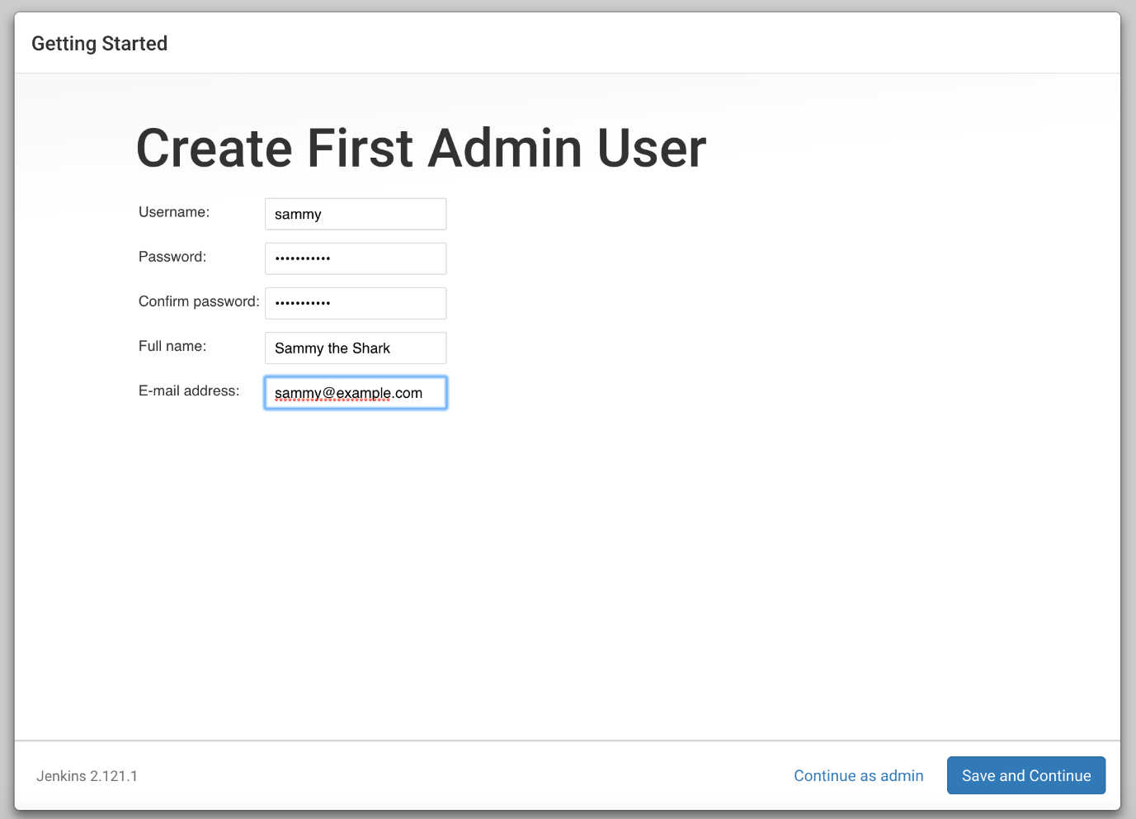

You will see an **Instance Configuration** page that will ask you to confirm the preferred URL for your Jenkins instance. Confirm either the domain name for your server or your server’s IP address:

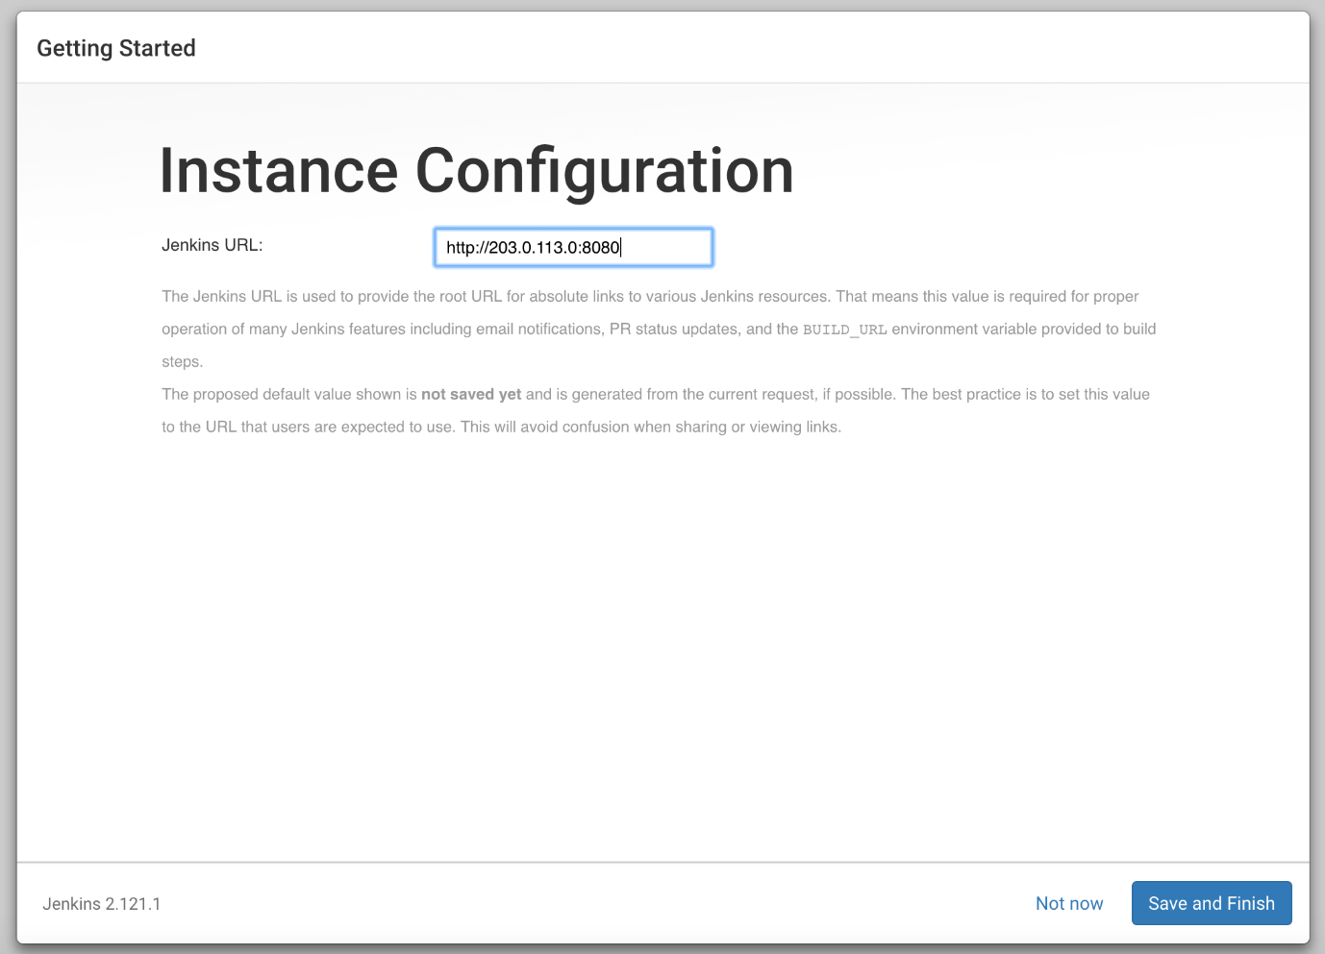

After confirming the appropriate information, click **Save and Finish**. You will see a confirmation page confirming that **“Jenkins is Ready!”**:

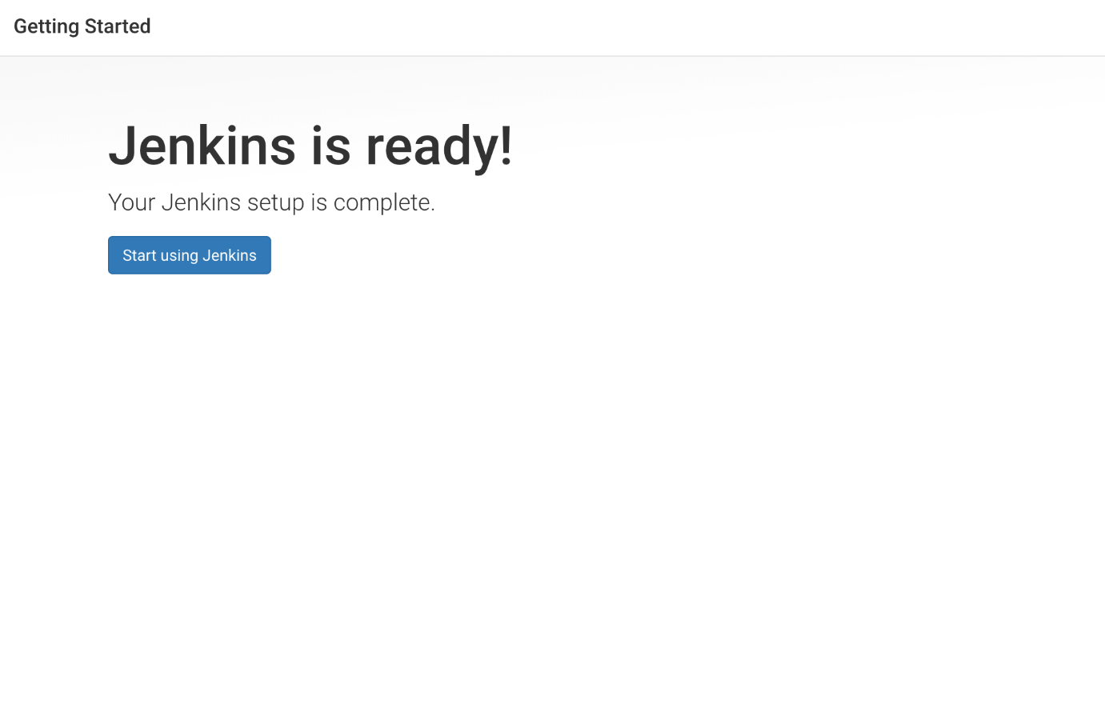

Click **Start using Jenkins** to visit the main Jenkins dashboard:

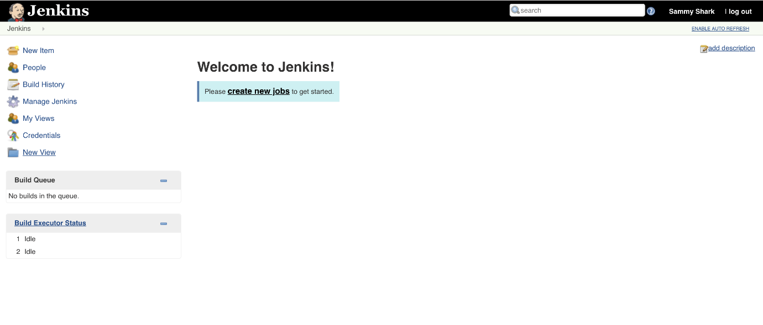

At this point, you have completed a successful installation of Jenkins.