Question(Single Choice)

Which of the following is the most important characteristic for a supervisor?



A. Approachable.

B. Qualified.

C. Honest.

D. Believable.

E.Successful.

Answer: C

Question(Multi Choice)

You are a system administrator for Microsoft Dynamics CRM Online.

You need to provision a user.

Which two steps should you perform? Each correct answer presents part of the solution.

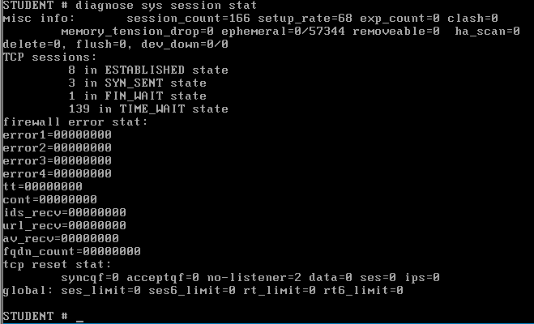

A. Add the user in the Microsoft Online Services Portal.

B. Configure the user with Read access mode.

C. Enable the user record in Microsoft Dynamics CRM Online.

D. Assign a Microsoft Dynamics CRM Online license to the user.

Answer: A,D

Question(Single Choice)

You install Microsoft Dynamics CRM on-premises.

The installation fails and you receive an installation error.

You need to access the installation log files to view the details about the error.

What should you do?

A. Query the Microsoft Dynamics CRM database and view the log table.

B. View the installation log files in the folder <SystemDrive>'\Program Files\Microsoft Dynamics CRM\Logs.

C. View the installation log files in the folder <SysremDnVe>:\Users\<L/serno/ne>\AppData\Roaming\Microsoft\MSCRM\Logs.

D. View the installation log files by opening the Event Viewer.

Answer: C