Hands-On Exercise 2: Basic Styling

Objective: After completing this exercise, you will execute understanding styling an element for:

1. Background
2. Text
3. Fonts
4. Links
5. Lists
6. Tables

Complete the following assignment:

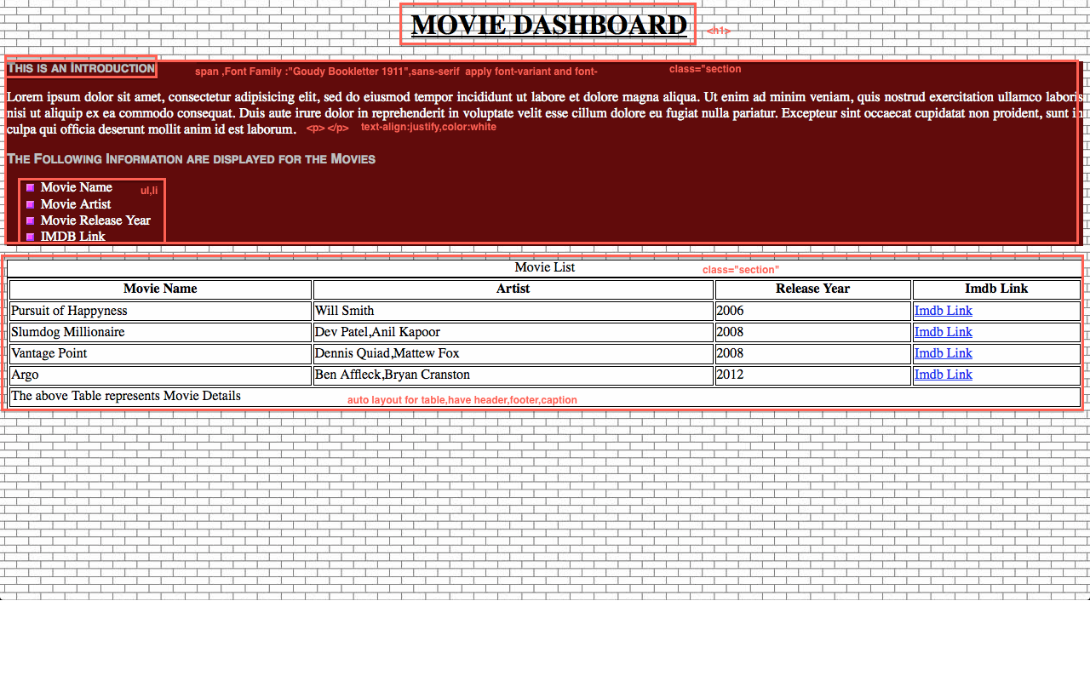

Create a HTML file with the following sections:

1. Create a HTML File “CSSBasics.html”
2. Use ‘images.jpg’ as background image and repeat it across the page.
3. Observe the Screen shot and follow the hints given in the Red Color Font to achieve the objectives

### To Submit: CSSBasics.html

Hands-On Exercise 3: Box Model

Objective: After completing this exercise, you will execute understanding box model by applying padding, margin, and border for the elements

Complete the following assignment:

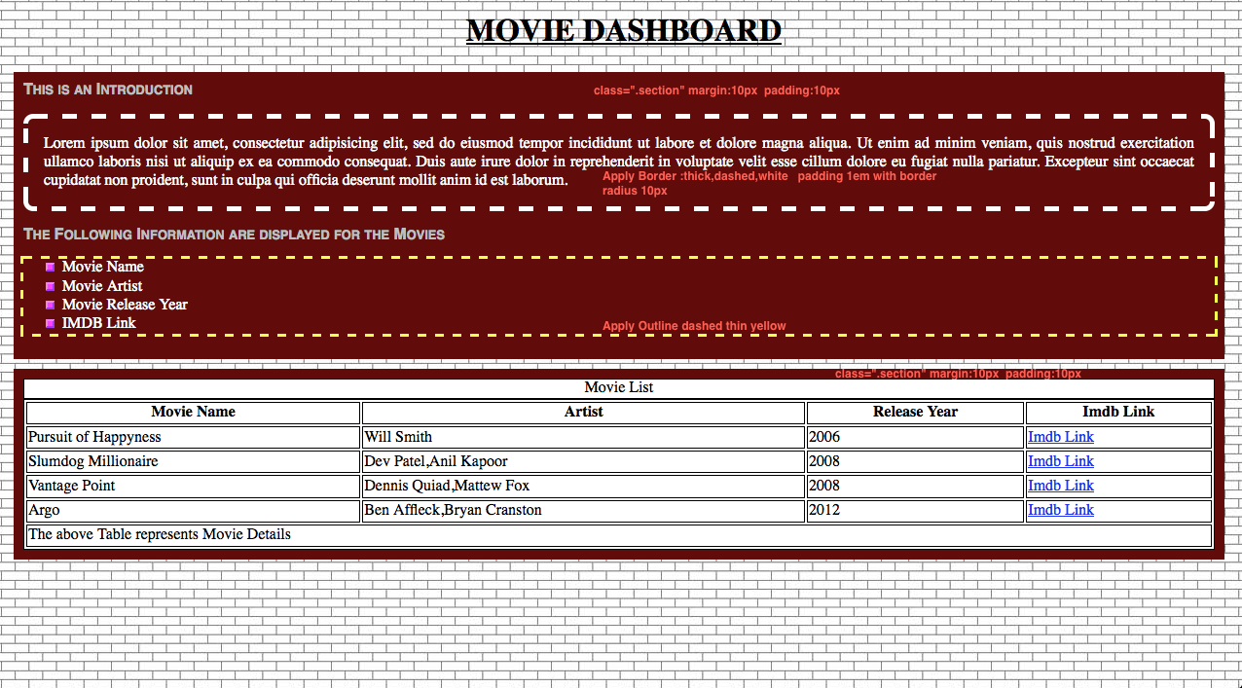

Create a HTML file with the following sections:

1. Copy the Content of the “CssBasics.html” into a new HTML File “CSSBoxModel.html”

### To Submit: CSSBoxModel.html

Hands-On Exercise 4: Advanced CSS

Objective: After completing this exercise, you will execute understanding concepts like Grouping, Nesting, Dimension, Offset, Positioning, Floating, Clear ,Align.

Complete the following assignment:

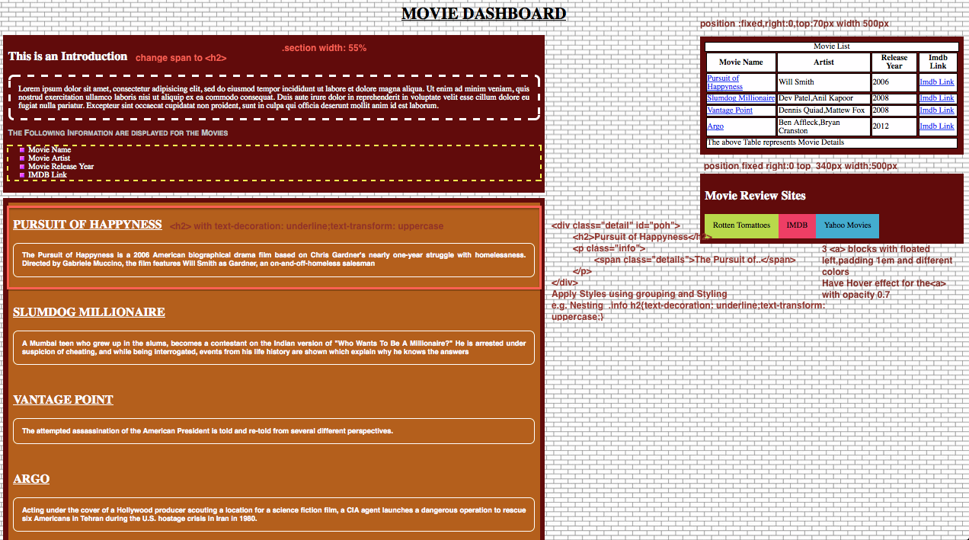

Create a HTML file with the following sections:

1. Copy the Content of the “CSSBoxModel.html” into a new HTML File “CSSAdvanced.html”
2. Here the Main Section developed in the previous exercise needs to be dimensioned with 55% width.(change it in .section class)
3. Have a new Section div for the Movie Description (As Displayed on the Orange color Background)
4. Each of the Movie Information div should have a recognizable id.
5. Now move the Table to the Right with fixed position as dictated on the Screenshot.
6. Similarly Develop a Movie Review Site (Below table section as a new section) and apply the position fixed property. The Contents of the section would be hyperlink to 3 sites as dictated.
7. Now when you scroll down, the right side would be fixed at the top and the left section would scroll down.
8. On the Table, Add Hyperlink to the Movie Name. This Hyperlink must have the href attribute pointing to the id attribute of the div, which contains information about the movie.

e.g.

in the div which contains the movie details

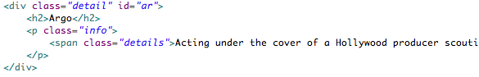

in the Table



<Please provide the list of documents that the trainees need to submit after completing the above exercise(s)>

Hands-On Exercise 5 CSS Image

Objective: After completing this exercise, you will execute understanding concepts like Grouping, Nesting, Dimension, Offset, Positioning, Floating, Clear ,Align.

Complete the following assignment:

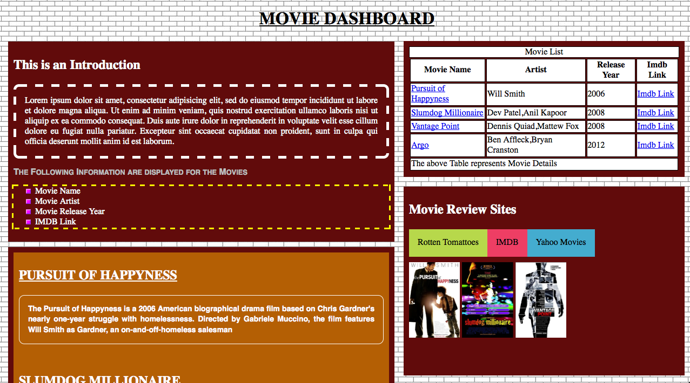

Create a HTML file with the following sections:

1. Copy the Content of the “CSSAdvanced.html” into a new HTML File “CSSImage.html”
2. In the Movie Review Site include 3 images for the movies. poh.jpg ,slm.jpg,vp.jpg as <img> and apply max-width 33% and max-height:70%
3. Wrap these 3 images together with a div.Give width 100% and height 200px for this div.