**Kubernetes Architecture:**

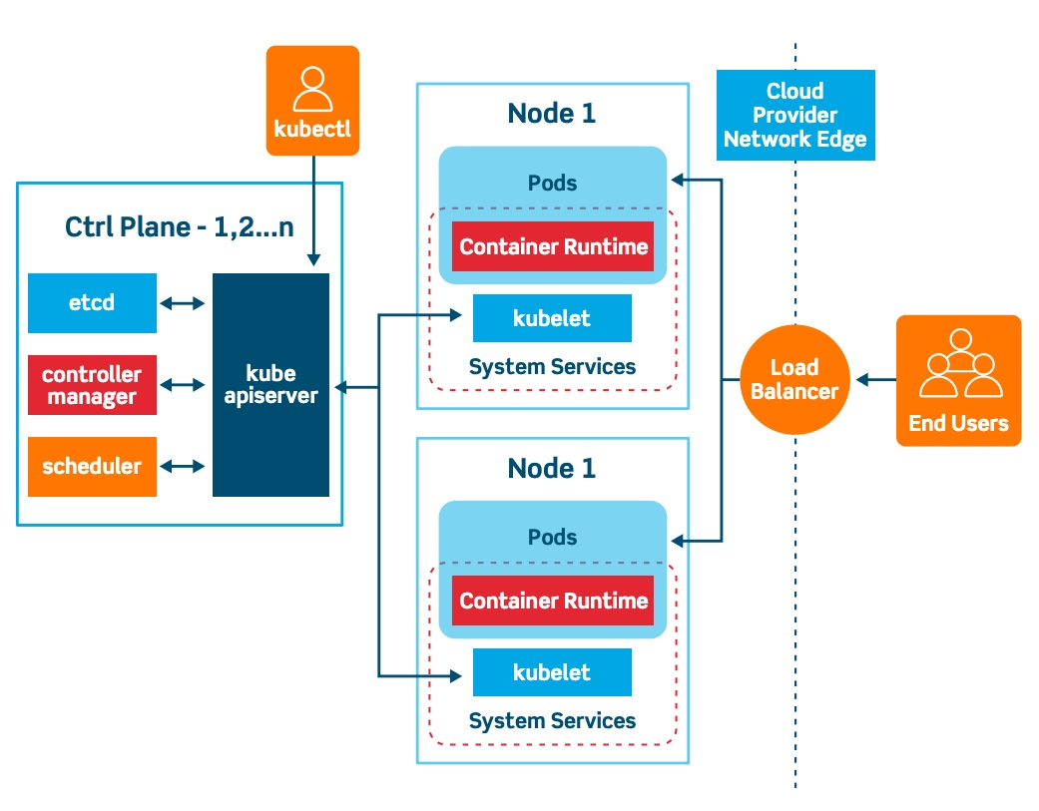

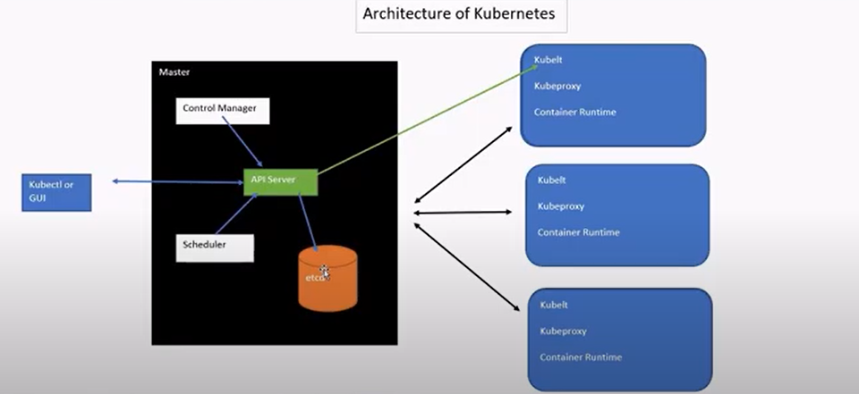

Different Components in Cluster:

Control plane

Master Nodes (1, 2 … n)

Data plane

Work Nodes (1, 2 … n)

**Control Plane:**

**API Server:**

Internal system components and external system components going through same API server.

**Etcd:**

Stores all cluster data (pods, nodes). Api server reads data from etcd

**Control Manager:**

Always maintains desire state nodes or pods(containers) . It takes data from api server maintains desire state like if node goes down it spin up new node and create existing pods into new node.

Node Controller:

Nodes go down

Replication controller:

Maintain current no of pods

Endpoint controller:

Join services and pods

Service Account controller:

Default service account

Token controller:

Default token

Cloud Controller manager:

**Schedular:**

Takes request from API server and assign those pods to health nodes if there is no node pods will be pending state. Based on resource requirements of pod(container) and policy like ( node affinity/taint) before placing pods to Node.

All control plane components also run itself as a pod in Master Nodes

**Work Node:**

**Kubelt:**

Maintains pods healthy. Managing

**Kube-proxy:**

Networking and maintains local routing tables

**Container Runtime(docker/rakt/CRLO/containerD):**

Pull images and start/stop containers

PODS:

What is POD:

Atomic unit of scheduling

Define your pod in manifest file (YAML or json)

Multiple containers inside the pod

