Mr. Ravi kanth Eragapati

Masters in Computer Science, Roosevelt University

Chicago, USA

[keragapati@mail.roosevelt.edu](mailto:keragapati@mail.roosevelt.edu)

**Introduction:** MedBox project is a Masters project designed to take care of your loved once by monitor their daily drug prescriptions from any part of the world. This MedBox is a Raspberry pi controlled medicine organizer with flexibility to set time to each bay and get feed to your phone (whether or not the medicine was taken on time).

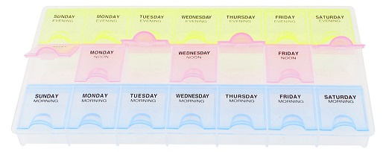In this project we used a 5V /2.5A powered raspberry pi 3 model B unit, although later on the custom built board will consume lesser power and can run on a battery.

This project requires internet connection to communicate with a phone, to send status messages to the guardian.

**Requirements:**

Raspberry pi computer  
Assembled Pi cobbler  
Bread Board  
Jumper Wires  
470 ohm resistors  
10K resistors  
LED’s  
Opt reflector aka Reflective IR sensor  
Photo cell CdS photo resistor  
MCP3008  
Raspbian Jessie OS (Debian based OS)

JAVA jdk  
Eclipse IDE  
Pi4j java library

**Raspberry Pi Computer:** Raspberry pi 3 model B was used during development of this project. Any raspberry pi computer can be used with this project as long as you configure the GPIO pin’s appropriately. Raspberry pi 3 model 3 is a credit card-sized single-board computer that runs on DC 5V 2.5A power supply. It has a 1.2GHz 64-bit quad-core ARMv8 CPU, 1GB RAM, 4 USB ports, 40 GPIO pins, Full HDMI port, Ethernet port, 802.11n Wireless LAN, Bluetooth 4.1, camera interface, display interface, a Micro SD card slot and Video Core IV 3D graphic core.

We have a lot of choice in selecting the OS for your Raspberry, but mostly used and recommended OS is Raspbian which is a Linux flavor, Debian based operating system. It is optimized for raspberry Pi’s hardware. You can even install windows 10 in your Pi if you wish to.

**Assembled Pi Cobbler:** It is a female to male 40 pinned cable run through raspberry pi board to a breadboard breaking out all those tasty power, GPIO, I2C and SPI pins without having to worry about soldering. This helps a lot when working on a project where you have to frequently connect to the pins on the motherboard, as there is a higher chance of bending or breaking those pins and making the Pi useless.

**Bread Board:** It is usually a white board with holes all over it.

**Jumper Wires:** These are short electrical wire with a solid tip at each end which is normally used to interconnect the components in a breadboard.

**470 ohm Resistors:** This is use to drop down the voltage so that the component doesn’t burn due to high voltage. In our project we use this with Reflective IR sensor on the anode pin. The 4 Band Color Code System for 470 Ω is Yellow, Violet, Brown, Gold.

**10K resistors:** The 4 Band Color Code System for 10k Ω is Brown, Black, Orange, Gold. This we use with both Reflective IR sensor & Photo cell CdS photo resistor. On the Emitter pi with Reflective IR sensor and on the negative end of CdS photo resistor.

**LED’s:**

**Opt Reflector / Reflective IR Sensor:**

**Photo cell CdS photo resistor:**

**MCP3008:**

**Raspberry Jessie OS:**

**Java JDK:**

http://www.webupd8.org/2014/03/how-to-install-oracle-java-8-in-debian.html

**Eclipse IDE:**

sudo apt-get install eclipse eclipse-jdt

**PI4J JAVA Library:**

**http://pi4j.com/download.html**