**MY-SQL-TASK-2**

**Model design for Guvi Zen Class DATABASE**

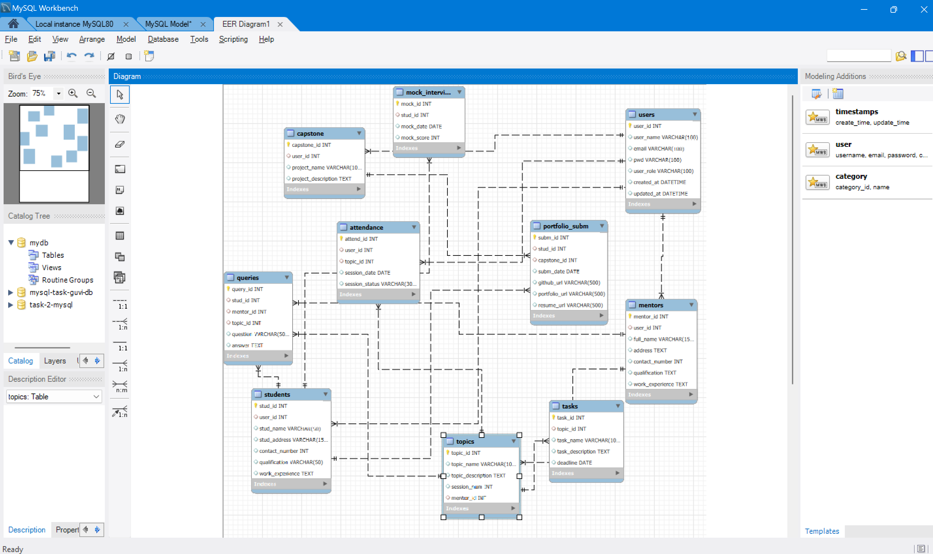

**Queries:**

CREATE TABLE users(user_id INT PRIMARY KEY,

user_name VARCHAR(100),

email VARCHAR(100),

pwd VARCHAR(100),

user_role VARCHAR(100),

created_at DATETIME,

updated_at DATETIME);

CREATE TABLE students(stud_id INT PRIMARY KEY,

user_id INT, FOREIGN KEY (user_id) REFERENCES users(user_id),

stud_name VARCHAR(50),

stud_address VARCHAR(150),

contact_number INT,

qualification VARCHAR(50),

work_experience TEXT );

CREATE TABLE mentors(mentor_id INT PRIMARY KEY,

user_id INT, FOREIGN KEY(user_id) REFERENCES users(user_id),

full_name VARCHAR(150),

address TEXT,

contact_number INT,

qualification TEXT,

work_experience TEXT);

CREATE TABLE topics(topic_id INT PRIMARY KEY,

topic_name VARCHAR(100),

topic_description TEXT,

session_num INT,

mentor_id INT, FOREIGN KEY(mentor_id) REFERENCES mentors(mentor_id) );

CREATE TABLE queries (query_id INT PRIMARY KEY,

stud_id INT, FOREIGN KEY (stud_id) REFERENCES students(stud_id),

mentor_id INT, FOREIGN KEY (mentor_id) REFERENCES mentors(mentor_id),

topic_id INT, FOREIGN KEY (topic_id) REFERENCES topics(topic_id),

question VARCHAR(500),

answer TEXT);

CREATE TABLE capstone(capstone_id INT PRIMARY KEY,

user_id INT, FOREIGN KEY (user_id) REFERENCES users(user_id),

project_name VARCHAR(100),

project_description TEXT);

CREATE TABLE attendance(attend_id INT PRIMARY KEY,

user_id INT, FOREIGN KEY (user_id) REFERENCES users(user_id),

topic_id INT, FOREIGN KEY (topic_id) REFERENCES topics(topic_id),

session_date DATE,

session_status VARCHAR(300));

CREATE TABLE tasks(task_id INT PRIMARY KEY,

topic_id INT, FOREIGN KEY (topic_id) REFERENCES topics(topic_id),

task_name VARCHAR(100),

task_description TEXT,

deadline DATE);

CREATE TABLE portfolio_subm(subm_id INT PRIMARY KEY,

stud_id INT, FOREIGN KEY (stud_id) REFERENCES students(stud_id),

capstone_id INT, FOREIGN KEY (capstone_id) REFERENCES capstone(capstone_id),

subm_date DATE,

github_url VARCHAR(500),

portfolio_url VARCHAR(500),

resume_url VARCHAR(500));

CREATE TABLE mock_interview(mock_id INT PRIMARY KEY,

stud_id INT, FOREIGN KEY (stud_id) REFERENCES students(stud_id),

mock_date DATE,

mock_score INT);