**MongoDB- Day-1-Task**

1. Find all the information about each products

**Query:**

**Db.products.find();**

**Screenshot:**

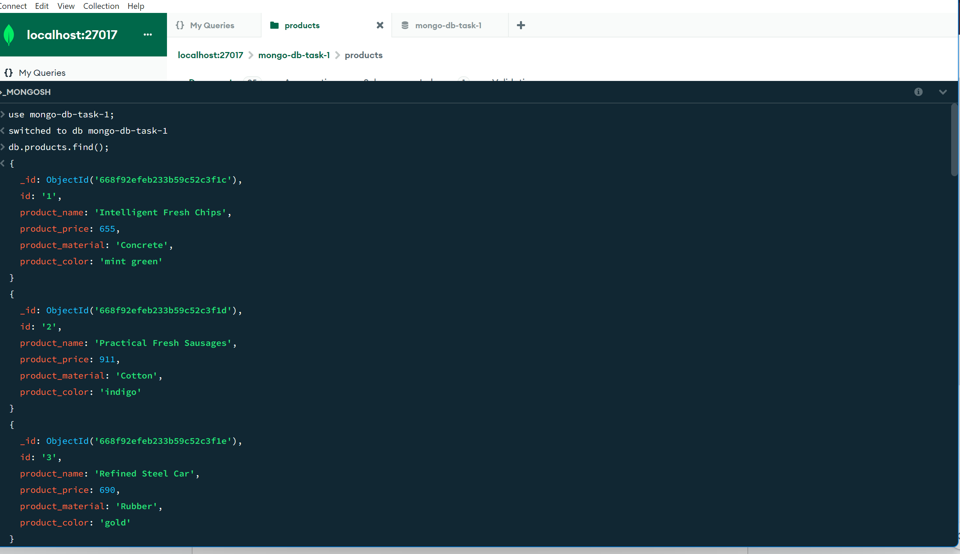

1. Find the product price which are between 400 to 800

**Query:**

**db.products.find({product_price:{$gte:400,$lte:800} });**

**Screenshot:**

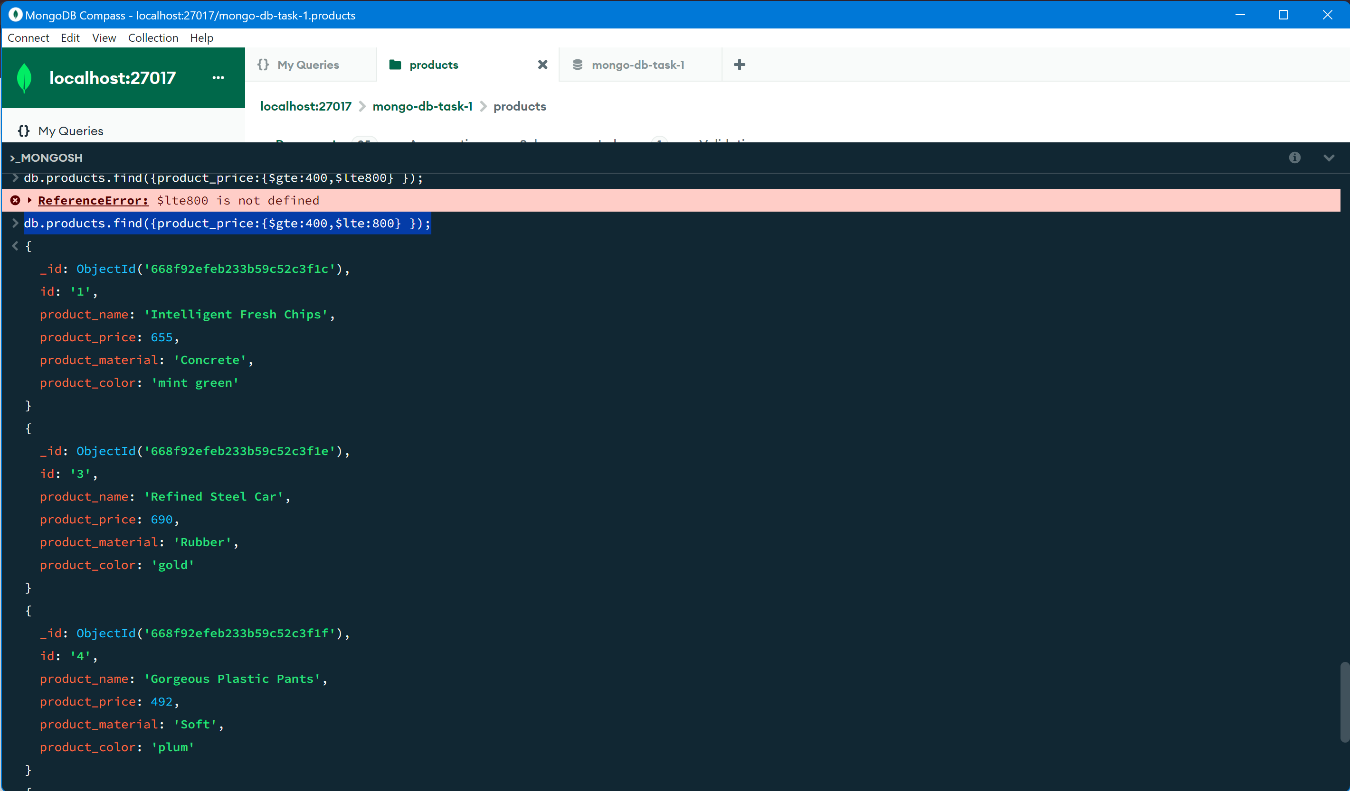

1. Find the product price which are not between 400 to 600

**Query:**

**db.products.find({product_price:{$not:{$gte:400,$lte:600}} });**

**Screenshot:**

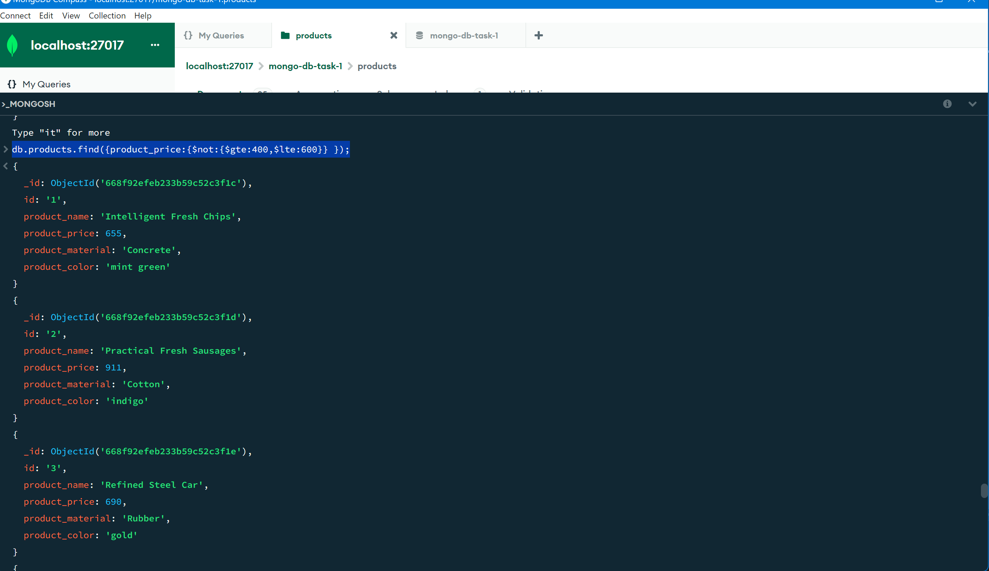

1. List the four product which are greater than 500 in price

**Query:**

**db.products.find({product_price:{$gt:500}});**

**Screenshot:**

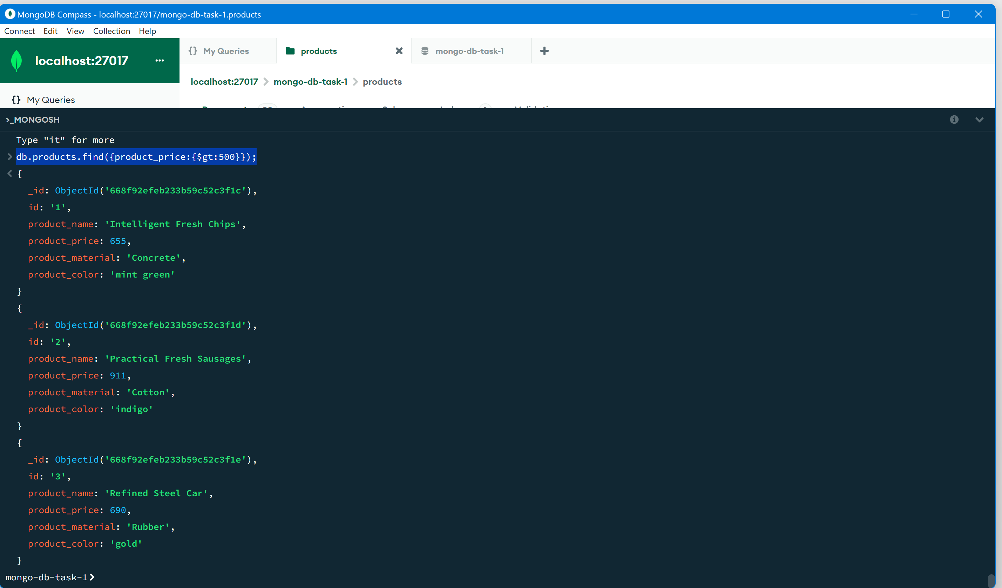

1. Find the product name and product material of each products

**Query:**

**db.products.find({},{product_name:1,product_material:1});**

**Screenshot:**

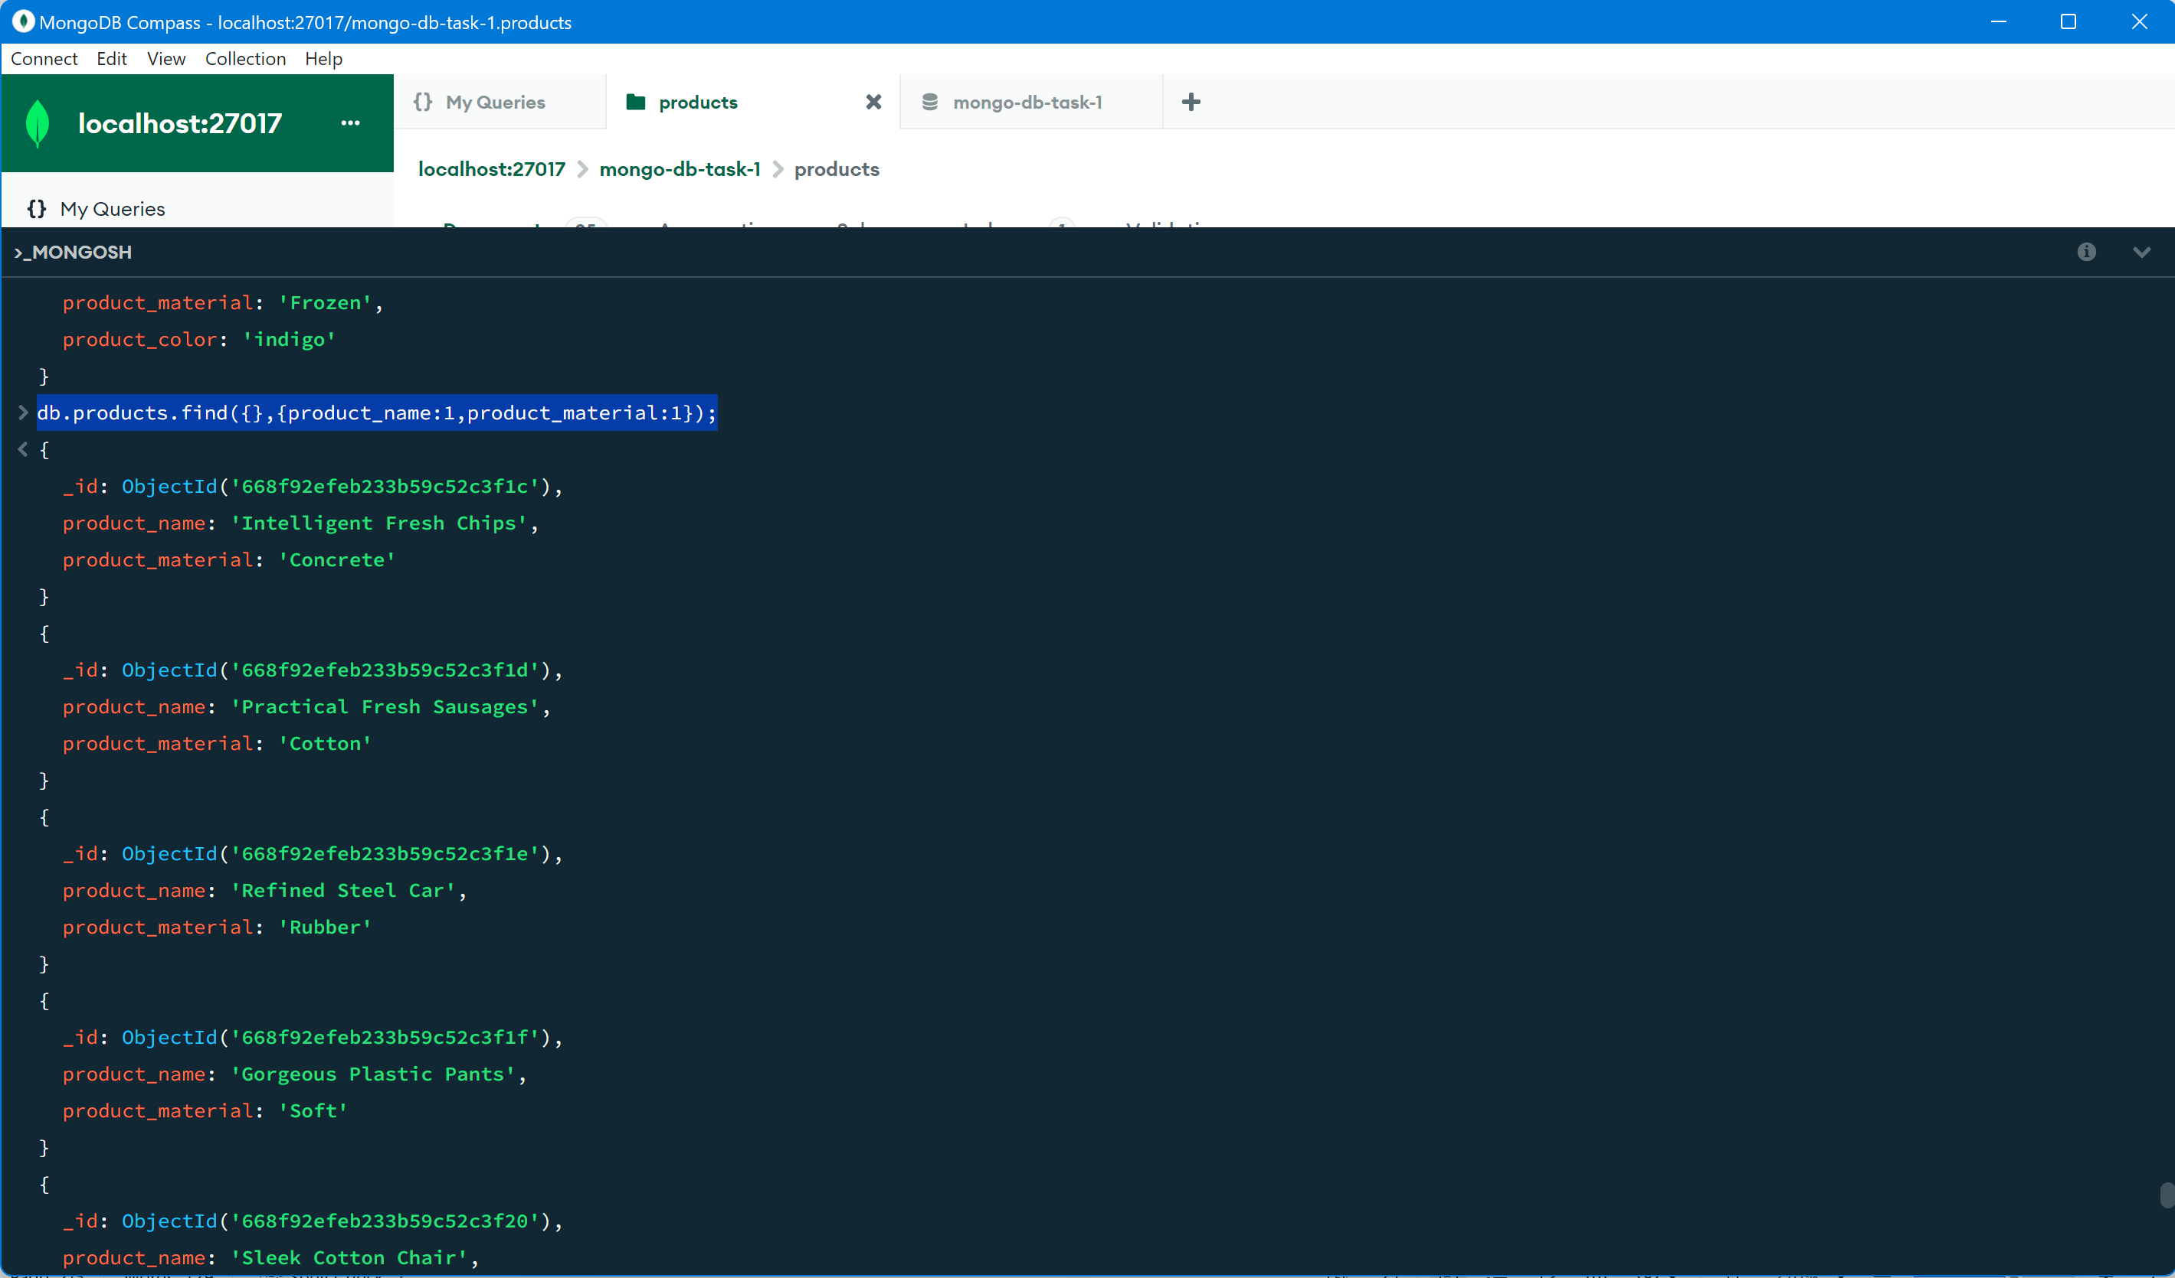

1. Find the product with a row id of 10

**Query:**

**db.products.find({id:"10"});**

**Screenshot:**

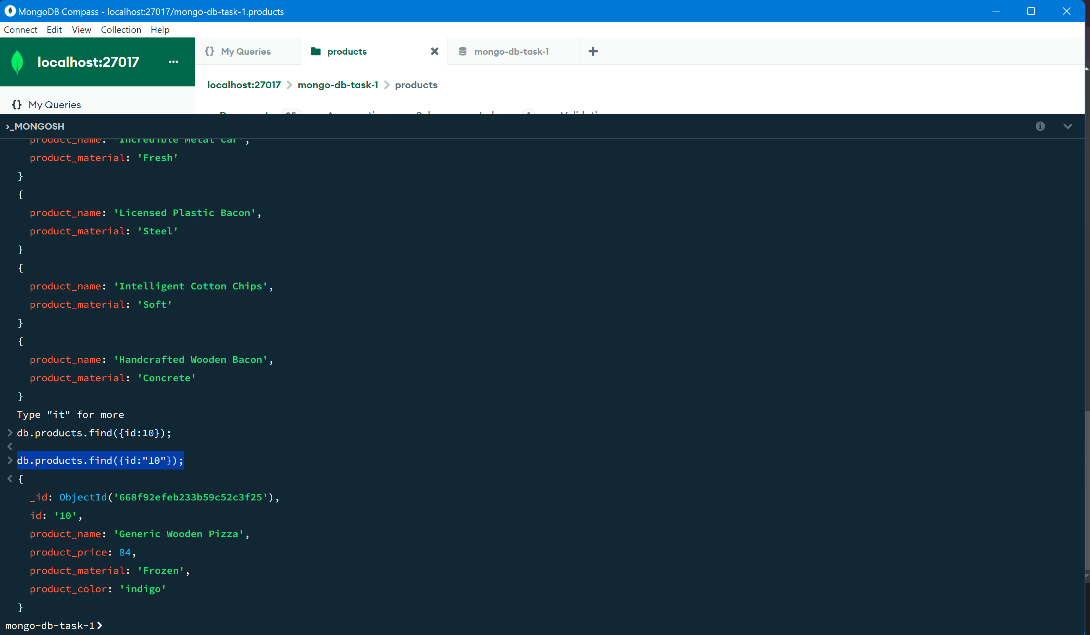

1. Find only the product name and product material

**Query:**

**db.products.find({},{_id:0,product_name:1,product_material:1});**

**Screenshot:**

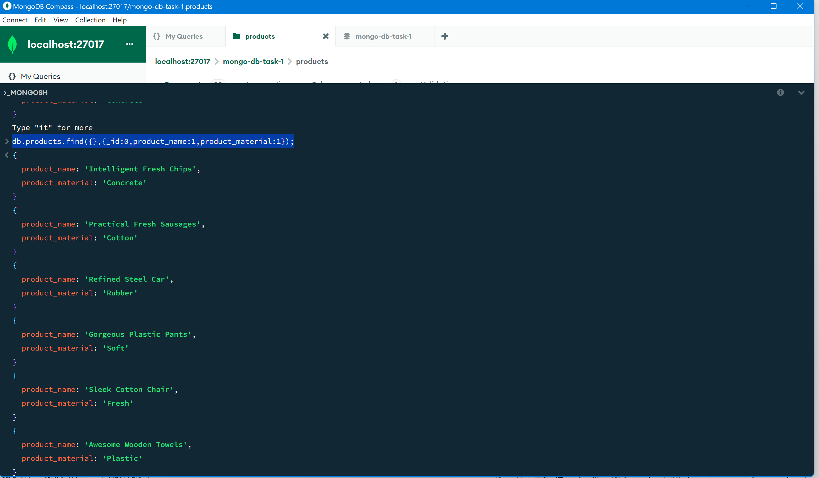

1. Find all products which contain the value of soft in product material

**Query:**

**db.products.find({product_material: {$eq:"Soft"}});**

**Screenshot:**

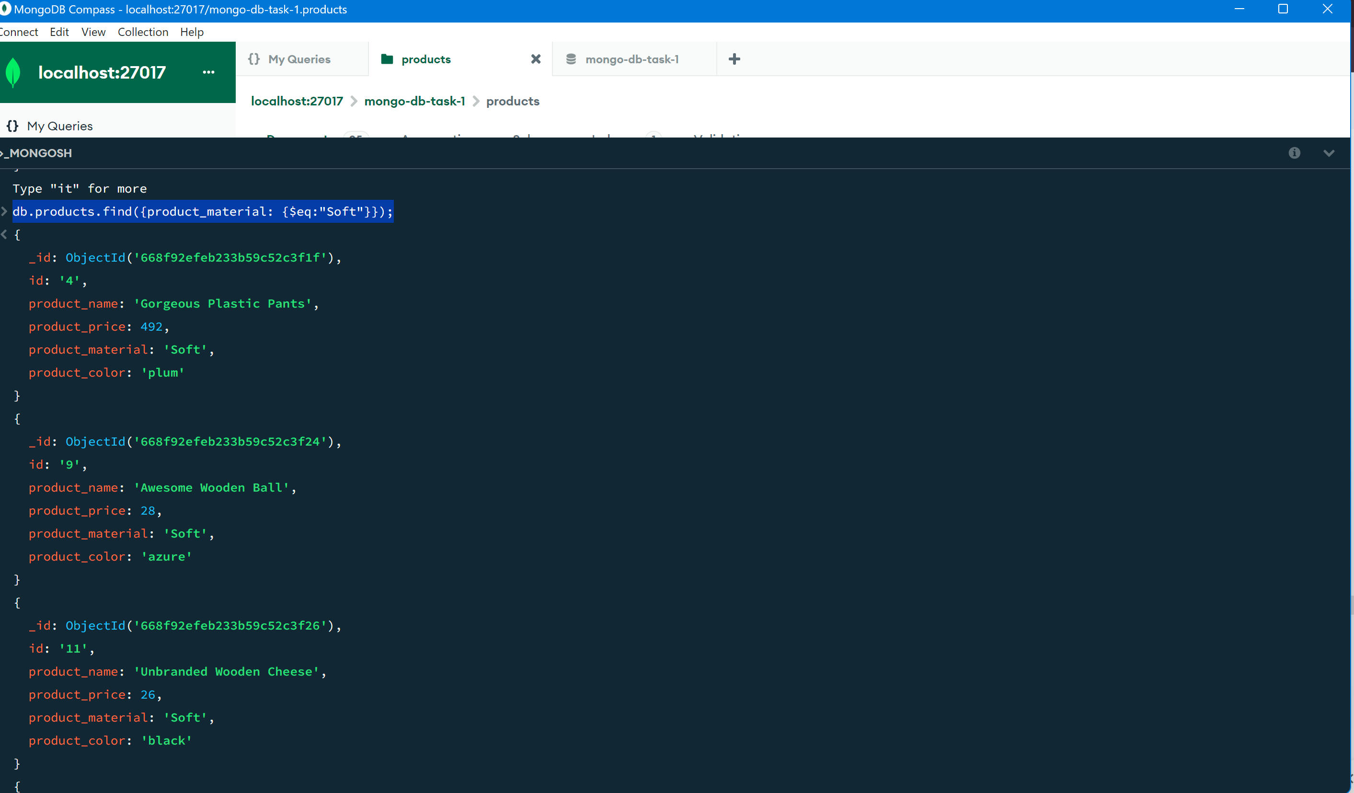

1. Find products which contain product color indigo and product price 492.00

**Query:**

**db.products.find({$or: [{product_color:"indigo"},{product_price:492}]});**

**Screenshot:**

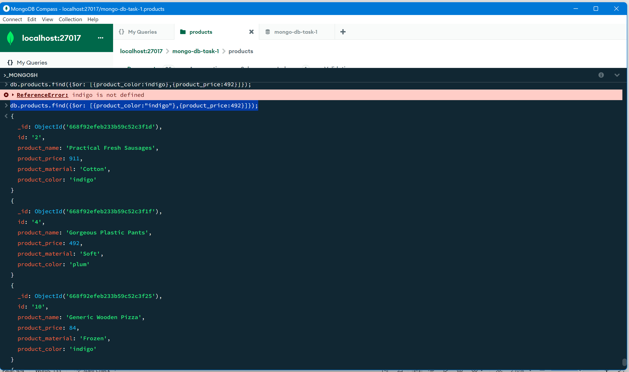

1. Delete the products which product price value are 28

**Query:**

**db.products.deleteOne({product_price:28});**

**Screenshot:**

