***Mongo-DB-Task-2***

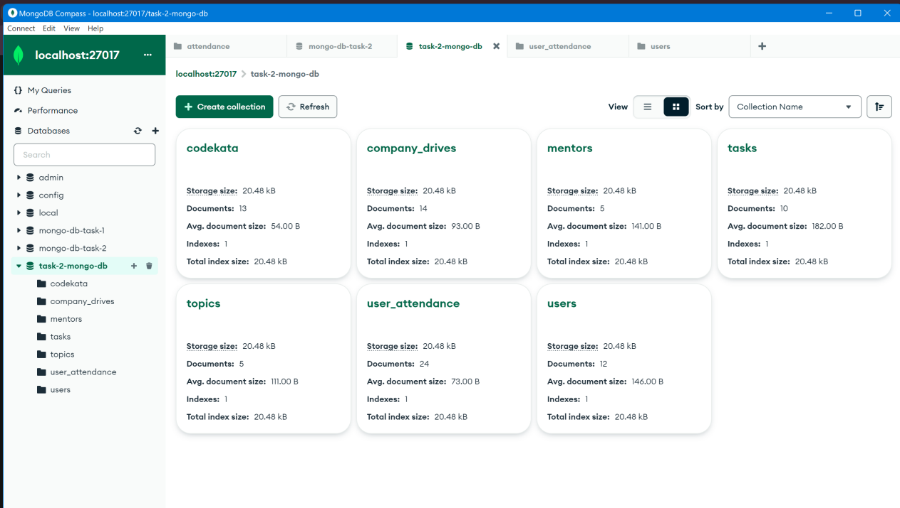

1. **Find all the topics and tasks which are thought in the month of October**

**Query:**

db.topics.aggregate([

{

$match: {

topic_held_on: { $gte: new Date('2020-10-01T00:00:00.000Z'), $lt: new Date('2020-11-01T00:00:00.000Z') }

}

},

{

$lookup: {

from: 'tasks',

localField: 'topic_id',

foreignField: 'Topic_id',

as: 'tasks'

}

},

{

$unwind: '$tasks'

},

{

$project: {

_id: 0,

topic_name: 1,

topic_id: 1,

topics_covered_by: 1,

topic_held_on: 1,

task: '$tasks.task',

task_status: '$tasks.task_status',

task_assigned_date: '$tasks.task_assigned_date',

task_dueDate: '$tasks.task_dueDate',

task_completed: '$tasks.task_completed',

submitted: '$tasks.submitted'

}

},

{

$sort: { topic_id: 1, task_assigned_date: 1 }

}

]).pretty()

**Screen Shot:**

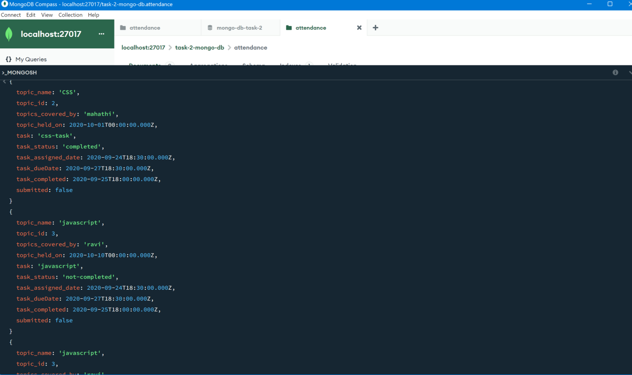

1. **Find all the company drives which appeared between 15 oct-2020 and 31-oct-2020**

**Query:**

db.company_drives.aggregate([

{

$match: {

date: { $gte: ISODate("2020-10-15T00:00:00.000Z"), $lte: ISODate("2020-10-31T23:59:59.999Z") }

}

},

{

$group: {

_id: '$companyName',

drives: { $push: { user_id: '$user_id', date: '$date', attendance: '$attendance' } }

}

},

{

$project: {

_id: 0,

companyName: '$_id',

drives: 1

}

},

{

$sort: { companyName: 1 }

}

]).pretty();

**Screen Shot:**

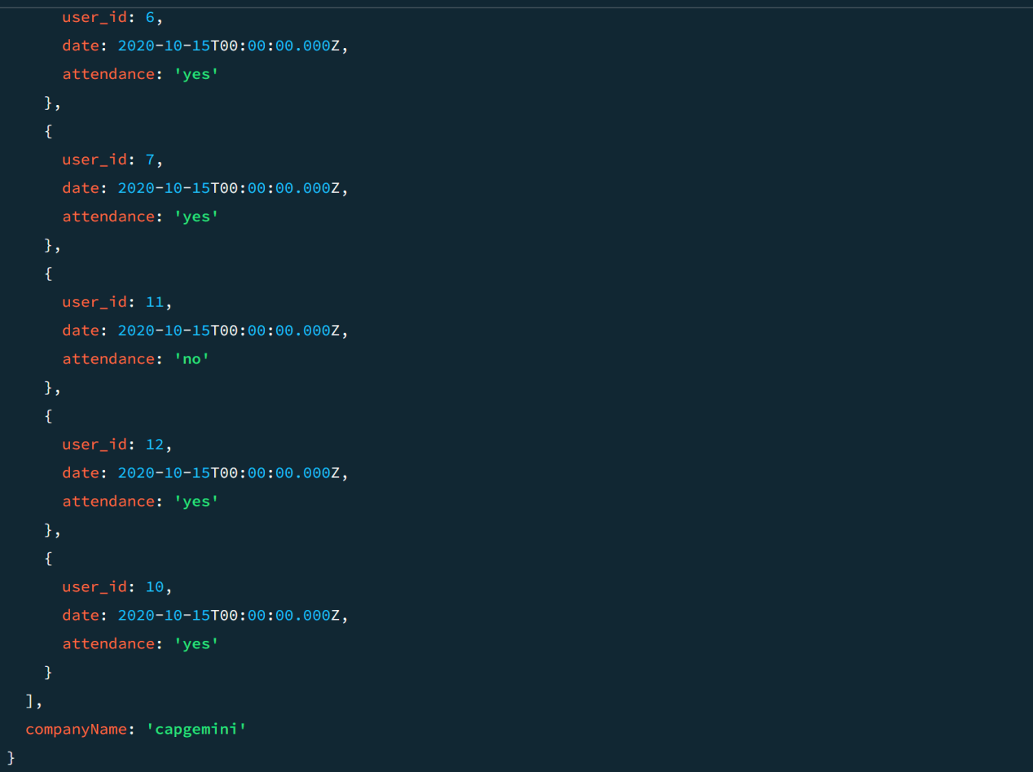

1. **Find all the company drives and students who are appeared for the placement.**

**Query:**

db.company_drives.aggregate([

{

$match: {

attendance: 'yes' }

},

{

$lookup: {

from: 'users',

localField: 'user_id',

foreignField: 'user_id',

as: 'user_info'

}

},

{

$unwind: '$user_info'

},

{

$group: {

_id: {

company_name: '$companyName',

user_name: '$user_info.user_name'

},

X` }

},

{

$group: {

_id: '$_id.company_name',

appeared_users: {

$push: {

user_name: '$_id.user_name'

}

}

}

},

{

$project: {

_id: 0,

companyName: '$_id',

appeared_users: 1

}

},

{

$sort: {

'companyName': 1

}

}

]).pretty();

**ScreenShot:**

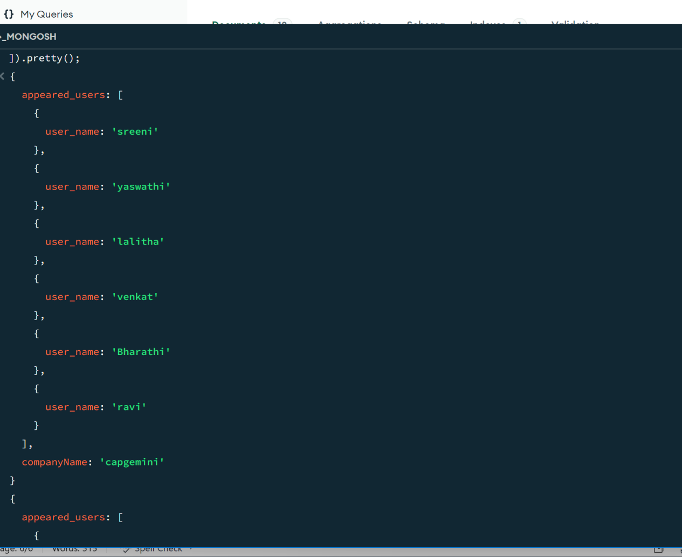

1. **Find the number of problems solved by the user in codekata**

**Query:**

db.codekata.aggregate([

{

$group: {

_id: '$user_id',

totalProblemsSolved: { $sum: '$problemSolved' }

}

},

{

$project: {

_id: 0,

user_id: '$_id',

totalProblemsSolved: 1 }

},

{

$sort: { 'user_id': 1 } }

]).pretty();

**ScreenShot:**

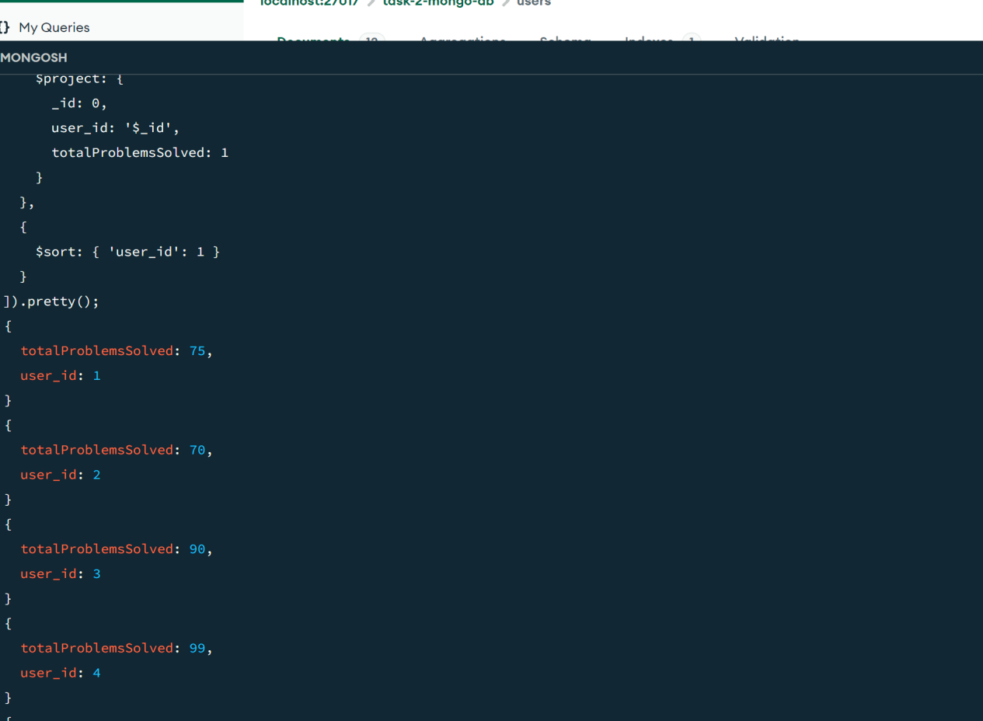

1. **Find all the mentors with who has the mentee's count more than 15**

**Query:**

db.mentors.find({ mentee_count: { $gt: 15 } }).pretty();

ScreenShot:

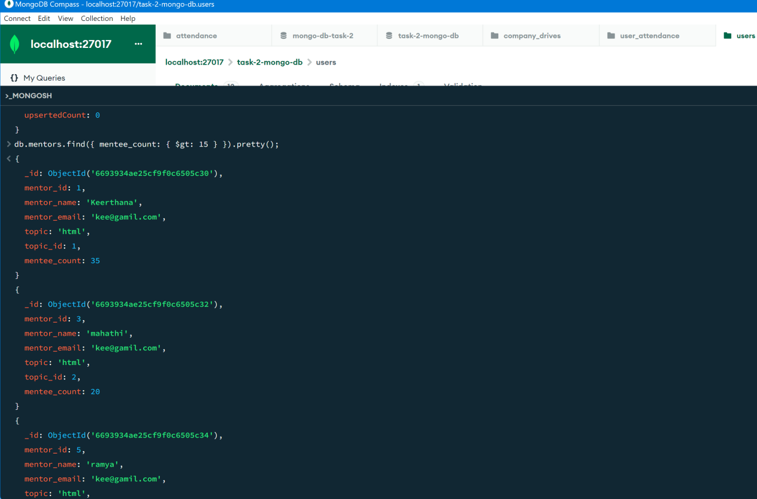

1. **Find the number of users who are absent and task is not submitted between 15 oct-2020 and 31-oct-2020**

**Query:**

db.attendance.aggregate([

{

$match: {

attendance: "absent",

date: {

$gte: new Date("2020-10-15T00:00:00.000Z"),

$lte: new Date("2020-10-31T23:59:59.999Z")

}

}

},

{

$lookup: {

from: "tasks",

localField: "user_id",

foreignField: "user_id",

as: "taskInfo"

}

},

{

$unwind: "$taskInfo" // Unwind to deconstruct the taskInfo array

},

{

$match: {

"taskInfo.submitted": false,

"taskInfo.task_due_date": {

$gte: new Date("2020-10-15T00:00:00.000Z"),

$lte: new Date("2020-10-31T23:59:59.999Z")

}

}

},

{

$lookup: {

from: "users",

localField: "user_id",

foreignField: "User_id",

as: "userInfo"

}

},

{

$unwind: "$userInfo" // Unwind to deconstruct the userInfo array

},

{

$project: {

_id: 0,

user_name: { $arrayElemAt: ["$userInfo.user_name", 0] },

attendance: 1,

user_id: 1,

"taskInfo.submitted": 1

}

},

{

$group: {

_id: "$user_id",

user_name: { $first: "$user_name" },

attendance: { $first: "$attendance" }, task_submitted: { $first: "$taskInfo.submitted" }

}

},

{

$count: "number_of_users"

}

]).pretty();