`COURSE PLAN
Semester | : | III | Year | : | 2024-2025
Course Title | : | Analog Signal Processing | Course Code | : | EE2101-1
L-T-P | : | 3-0-0-0 | Credits | : | 3
Duration of MSE | : | 1 Hour | CIE Marks | : | 50
Duration of SEE | : | 3 Hours | SEE Marks | : | 50
Prepared by | : | Ravikiran Rao M | Date | : | 11-07-2025
Checked by | : | Dr. Suryanarayana K, HOD | Date | : | 18-07-2025

Note: Lecture hours indicated is for teaching theoretical concepts. Illustrative examples and numerical problems are to be worked out in tutorial classes.
Prerequisites: Basic Electronics (EC1001-1)
Course Overview:
The course Analog Signal Processing (EE2101-2) aims to build a strong foundation in MOSFET-based circuit design and analog signal processing. It begins with the structure, characteristics, and biasing of MOSFETs, followed by their use as amplifiers and switches. Students explore small-signal models and single-stage amplifier configurations, leading into frequency response analysis and the impact of internal capacitances. The course introduces feedback concepts and oscillator circuits, reinforcing analog system behaviour. It concludes with differential and operational amplifiers, covering key applications such as precision rectifiers, clippers, filters, and waveform shaping circuits. Emphasis is placed on understanding, designing, and analysing analog circuits relevant to modern electronic systems..

Course objectives
1. To understand the structural properties, characteristics and operation of MOSFET
2. To study the MOSFET parameters when used as an amplifier and as a switch
3. To use MOSFET as a single stage amplifier and analyse its behaviour at various frequencies
4. To introduce the concept of feedback and analyse the oscillator circuits using MOSFET
5. To analyse the differential & operational amplifiers and various parameters associated with them
Program Outcomes→ | 1 | 2 | 3 | 4 | 5 | 6 | 7 | 8 | 9 | 10 | 11 | 12 | PSO
↓ Course Outcomes |  |  |  |  |  |  |  |  |  |  |  |  | 1 | 2
EE2101-1.1 | 1 | 2 | 3 |  | 2 |  |  |  | 1
EE2101-1.2 | 1 | 2 | 3 |  | 2 |  |  |  | 1 |  |  |  | 1 | 1
EE2101-1.3 | 1 | 2 | 3 |  | 2 |  |  |  | 1 |  |  |  |  | 1
EE2101-1.4 | 2 | 3 |  |  | 2 |  |  |  | 1 |  |  |  | 1 | 1
EE2101-1.5 | 1 | 2 | 3 |  | 2 |  |  |  | 1 |  |  |  | 1 | 1
Course Outcome (CO):
At the end of the course student will be able to
1. Analyze internal structure and working of MOSFET to infer the operating characteristics
2. Analyze the large-signal behavior of the MOSFET, design bias circuits to locate operating point and small-signal operation to obtain the transconductance
3. Analyze CS, CG & CD MOSFET single-stage amplifier circuits to obtain performance parameters
4 Perform frequency sweep on CS MOS amplifier circuit to obtain the response curve and analyze feedback concepts to design oscillator circuits
5. Analyze the differential and operational amplifiers to develop signal processing circuits
1: Low 2: Medium 3: High

Course Content
Course Code : EE2101-1
Course Title : Analog Signal Processing
Teaching Hours: 40
L – T – P : 3 – 0 – 0

Lecture/ Tutorial Hours | Topic | Text Book/ Ref Book | Teaching Methodology*
Unit – I
 | MOSFET: Introduction and Device structure | T1 5.1 | BB
 | Physical operation | T1 5.1 | BB
 | i-v Characteristics | T1 5.2 | BB/Demo
 | MOSFET as an amplifier and as a switch: Large signal operation | T1 5.4 | BB
 | Graphical derivation of the transfer characteristics | T1 5.4 | BB
 | Operation as a switch, Operations as a linear amplifier | T1 5.4 | BB
 | Analytical expressions and numerical | T1 5.4 | BB
 | Biasing in MOS Amplifier circuits: Biasing by Fixing V_{GS} | T1 5.7 | BB
 | Biasing by fixing V_{GS} and connecting a resistance in the source | T1 5.7 | BB/discussion in lab
 | Biasing using a Drain-to-gate feedback amplifier, Biasing using a constant current source | T1 5.7 | BB
 | Numerical on biasing circuits | T1 5.7 | BB
 | Small-signal operation and models: DC bias point | T1 5.5 | BB
 | Signal current in the drain terminal and voltage gain | T1 5.5 | BB
 | DC analysis and signal analysis, small signal equivalent | T1 5.5 | BB
 | Transconductance, T equivalent circuit model | T1 5.5 | BB
Unit – II
 | Single Stage MOS Amplifiers: Basic Structure, characterizing amplifiers | T1 5.6 | BB
 | Common source amplifier | T1 5.8 | BB
 | CS amplifier with a source resistance | T1 5.8 | BB
 | Common gate amplifier, Common drain amplifier | T1 5.8 | BB
 | Numerical examples | T1 5.8 | BB
 | MOSFET Internal Capacitances and high frequency model: Gate capacitive effect, junction capacitances, High frequency MOSFET model | T1 9.2.1 | BB
 | High frequency MOSFET model, Unity- Gain frequency | T1 9.2.1 | BB
 | Circuit operation of CMOS Logic Inverter | T1 13.2 | BB
 | High frequency response of CS amplifier | T1 5.5.6/  T1 9.3 | BB
 | Miller effect | T1 9.4.4 | BB
 | Low frequency response of CS amplifier | T1 9.1.1 | BB
 | Feedback Amplifiers & Oscillators: General Feedback structure | T1 10.1 | BB
 | Properties of negative feedback | T1 10.2 | BB
 | Feedback topology | T1 10.3 | BB
 | FET based RC phase shift oscillator | T1 17.2.2 | BB
Unit – III
 | FET Differential Amplifiers: MOS Differential pair with common mode and differential input voltage | T1 8.1 | BB
 | Small-signal operation of MOS Differential pair | T1 8.2 | BB
 | Operational Amplifier: Op-Amp internal architecture. Ideal and practical Op-Amp. Offset error voltages and currents | T2 2.1/ 2.2/ 2.3/ 2.4 | BB
 | Op-Amp as an AC Amplifier: Capacitor Coupled Voltage Follower, non-inverting amplifier | T2 4.1/4.3 | BB
 | Inverting amplifier, and difference amplifier | T2 4.5/4.7 | BB
 | Op-Amp in Signal Processing Circuits: Precision Half wave rectifiers, peak clipper, clamping circuits, sample and hold circuits. | T2 9.2/ 9.3/9.4/ 9.6 | BB
 | Op-Amps in Switching, Differentiating, and Integrating Circuits | T2 8.6/ 8.7 | BB
 | Crossing detectors, Schmitt trigger circuits | T2 8.1/ 8.2/ 8.3 | BB
 | Active filter: Types, first order & second order LPF design | T2 12.1/ 12.2/ 12.3 | BB
 | Numerical | T2 | BB

*BB – Black Board Work, PPT – Power Point Presentations

SEE Question Paper Pattern:
There will be 8 questions of 20 marks each in the question paper categorized into 3 Units as per the syllabi & contact hours. The student will have to answer 5 full questions, selecting 2 full questions each from Unit - I & Unit – II and 1 full question from Unit – III.

TEXTBOOKS:
1. Sedra /Smith, “Microelectronic Circuits” 6th Edition, Oxford University Press-New Delhi,2013.
2. David A Bell, Operational Amplifier and Linear IC’s, Oxford University Press-New Delhi, 3rd Edition, 2011
REFERENCE BOOKS:
1. Jacob Millman & Christos C. Halkias, “Integrated Electronics”, McGraw Hill Publications, 2nd Edition, 2011.
2. Nashelesky & Boylestead, “Electronic Devices & Circuit Theory”, PHI, 11TH Edition.2015.
3. Ramakanth Gayakwad, Operational Amplifier and Linear IC’s, 4th edition, Prentice Hall, 2000.
E-Books / MOOC:
1. https://onlinecourses.nptel.ac.in/noc22_ee11/preview
2. https://ocw.mit.edu/courses/6-101-introductory-analog-electronics-laboratory-spring-2007/
3. https://ocw.mit.edu/courses/6-012-microelectronic-devices-and-circuits-fall-2009/
4. https://onlinecourses.nptel.ac.in/noc20_ee89/preview
5. https://www.coursera.org/learn/mosfet

EVALUATION SCHEME
CIE |  | SEE
Mid Semester Examination (MSE) – I | 20 Marks
Mid Semester Examination (MSE) – 2 | 20 Marks
Task | 10 Marks | Exam Duration | 3 Hours
Task | 10 Marks | Total Marks | 100 Marks
Task | 10 Marks | Weightage | 50% =50 Marks
Total | 50 Marks | CIE + SEE | 100 Marks

Course Utilization for Mid-sem and Semester end exam
Unit | Content | Teaching Hours | Number of  Questions in |  | No. of questions in SEE
Unit | Content | Teaching Hours | MSE1 | MSE2 | No. of questions in SEE
I | MOSFET | 3 | 1 |  | 1
I | MOSFET as an amplifier and as a switch | 4 | 1 |  | 1
I | Biasing in MOS Amplifier circuits | 4 | 1 |  | 1
I | Small-signal operation and models | 4 | 1 |  | 1
II | Single Stage MOS Amplifiers | 4 |  | 1 | 1
II | MOSFET Internal Capacitances and high frequency model | 3 |  | 1 | 1
II | MOS Amplifiers | 4 |  | 1 | 1
II | Feedback Amplifiers & Oscillators | 4 |  | 1 | 1
III | FET Differential Amplifiers | 2 |  |  | 1
III | Operational Amplifier | 3 |  |  | 1
 | OP-AMP in Signal Processing Circuits | 5 |  |  | 1

Bloom’s Taxonomy Levels (BL) Planned in MSE and SEE:
Sl. No. | Bloom’s Taxonomy Levels (BL) | MSE 1 | MSE 2 | SEE
1 | Remember | 30% | 25% | 30%
2 | Understand | 30% | 25% | 30%
3 | Apply | 20% | 30% | 20%
4 | Analyze | 20% | 20% | 15%
5 | Evaluate | 0% | 0% | 5%
6 | Create | 0% | 0% | 0%

Unit wise plan
Topic |  | Planned Hours  L-T-P
UNIT- I
MOSFET: Introduction and Device structure |  | 3-1-0
Physical operation |  | 1-0-0
i-v Characteristics |  | 1-0-0
MOSFET as an amplifier and as a switch: Large signal operation |  | 4-0-0
Graphical derivation of the transfer characteristics |  | 1-0-0
Operation as a switch, Operations as a linear amplifier |  | 1-0-0
Analytical expressions and numerical |  | 1-0-0
Biasing in MOS Amplifier circuits: Biasing by Fixing V_{GS} |  | 4-0-0
Biasing by fixing V_{GS} and connecting a resistance in the source |  | 1-0-0
Biasing using a Drain-to-gate feedback amplifier, Biasing using a constant current source |  | 1-0-0
Numerical on biasing circuits |  | 1-0-0
Small-signal operation and models: DC bias point |  | 4-1-0
Signal current in the drain terminal and voltage gain |  | 1-0-0
DC analysis and signal analysis, small signal equivalent |  | 1-0-0
Transconductance, T equivalent circuit model |  | 1-0-0
Learning Outcomes: At the end of this unit students will be able to
- Understand the operation of MOSFET as an amplifier
- Plot the characteristics of MOSFET
- Analyze internal architecture of the MOSFET
- Analyze working of the MOSFET to compute circuit parameters

Review questions on Remembering (BTL1)
1.
2.
3.
4.
5.
6.
Review questions on Understanding (BTL2)
7.
8.
9.
10.
11.
12.
13.
14
15.
16.
Review questions on Applying (BTL3)
17.

MODEL QUESTION FOR MSE-1
USN

NMAM INSTITUTE OF TECHNOLOGY, NITTE
Off-Campus Centre of Nitte (Deemed to be University)
III Sem B.Tech (CBCS) Mid Semester Examinations - I, September 2024
EE2101-2 – ANALOG SIGNAL PROCESSING
(For EE)
Duration: 1 Hour Max. Marks: 20
Part – A: Multiple Choice Questions (1*4 = 4 marks)
Note: Answer all Four questions in the Answer Book. Each question carries equal marks.
1. | The condition which ensure MOSFET operating in saturation region is
 | A) | V_{DS}<V_{OV} | B) | V_{GD}<V_{th}
 | C) | V_{GS}<V_{th} | D) | V_{GS}<V_{OV}
2. | MOSFET under saturation acts as
 | A) | Voltage controlled voltage source | B) | Voltage controlled current source
 | C) | Current controlled voltage source | D) | Current controlled current source
3. | The biasing technique best suited for IC application is
 | A) | Fixed V_{GS} biasing | B) | Biasing with fixed V_{G} and R_{s}
 | C) | Constant current source biasing | D) | Biasing with gate to drain resistor
4. | MOSFET is operating in saturation has drain current I_{D} and overdrive voltage V_{OV}. If V_{OV} is doubled, the new value of drain current will be
 | A) | 4I_{D} | B) | 2I_{D}
 | C) | I_{D} | D) | 0.5I_{D}
Part – B: Descriptive Answer Questions (2*8 = 16 marks)
Note: Answer any One full question from each Unit.
 |  | Unit – I | Marks | BT* | CO* | PO*
1. | a) | With neat diagram explain construction aspects of MOSFET. | 4 | L1 | 1 | 3
 | b) | For the circuit shown Fig 1b, V_{DD} is 3.3V, V_{D}=0.6V, V_{t}=0.5V, k_{n}=1mA/V². Find the value of R.  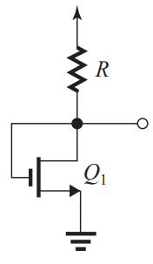  Fig 1b. | 4 | L3 | 1 | 3
2. | a) | Draw the output characteristic and elaborate significance of all the operating regions. | 4 | L2 | 1 | 3
 | b) | Consider a process technology for which Lmin = 0.4 μm, t_{ox} = 8 nm, μ_{n} = 550 cm²/V⋅s, and V_{t} = 0.8 V.  (a) Find C_{ox} and k_{n}’  (b) For a MOSFET with , calculate the values of V_{OV}, V_{GS}, and V_{DSmin} needed to operate the transistor in the saturation region with a dc current I_{D} = 150μA. | 4 | L3 | 1 | 3
 |  | Unit – II
3. | a) | Using analytical method deduce the equation for r_{DS} where MOSFET acts as switch. | 4 | L2 | 2 | 2
 | b) | It is required to design the circuit of Fig. 3b to establish a dc drain current I_{D} = 0.25mA. The MOSFET is specified to have V_{t} = 0.8V, k_{n}=1mA/V². Use a power-supply V_{DD} = 12V. Assume V_{D} and V_{S} 1/3 of V_{DD}.  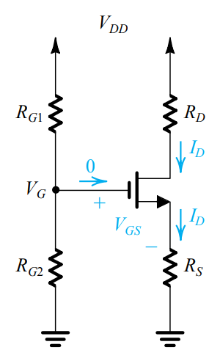  Fig. 3b | 4 | L3 | 2 | 2
4. | a) | Elaborate the biasing by fixing V_{GS} method. Also highlight its limitations. | 4 | L1 | 2 | 2
 | b) | An NMOS transistor is fabricated in a 0.4-μm process having μ_{n}C_{ox} = 100μA/V² and V_{A}’=50V/μm of channel length. If L = 0.8μm and W = 16μm, find V_{A} and λ. Find the value of I_{D} that results when the device is operated with an overdrive voltage V_{OV} = 0.6 V and V_{DS} = 1 V. Also, find the value of r_{o} at this operating point. | 4 | L3 | 2 | 2
BT* Bloom’s Taxonomy, L* Level; CO* Course Outcome; PO* Program Outcome

*****************

 | Topic |  |  | Planned Hours  L-T-P
 | UNIT II - Biasing in MOS Amplifier circuits: |  |  | 3-0-0
 | Biasing by Fixing V_{GS} |  |  | 1-0-0
 | Biasing by fixing V_{GS} and connecting a resistance in the source |  |  | 1-0-0
 | Numerical Problems |  |  | 0-1-0
 | Biasing using a Drain-to-gate feedback amplifier, Numerical Problems |  |  | 1-0-0
 | Biasing using a constant current source. |  |  | 1-0-0
 | Small-signal operation and models: |  |  | 4-0-0
 | DC bias point, signal current in the drain terminal, |  |  | 1-0-0
 | Voltage gain, small signal equivalent |  |  | 1-0-0
 | DC analysis, Signal analysis |  |  | 1-0-0
 | Transconductance, T equivalent circuit model |  |  | 2-0-0
 | Single Stage MOS Amplifiers: |  |  | 4-0-0
 | Basic Configurations, Characterizing amplifiers |  |  | 1-0-0
 | Common source amplifier, CS amplifier with a source resistance |  |  | 1-0-0
 | Numerical Examples |  |  | 1-0-0
 | Common gate amplifier, Common drain amplifier, Numerical Examples |  |  | 1-1-0
 | MOSFET Internal Capacitances and high frequency model: |  |  | 4-0-0
 | Gate capacitive effect, junction capacitances |  |  | 2-0-0
 | High frequency MOSFET model |  |  | 1-0-0
 | Unity- Gain frequency |  |  | 1-0-0
 | Circuit operation of CMOS Logic Inverter. |  |  | 1-0-0
Learning Outcomes: At the end of this unit students will be able to
- Use MOSFET in basic amplifier configurations.
- Understand the working of CS, CG, CD amplifier
- Analyze large signal behavior of MOSFET
- Design bias circuits to locate operating point and small signal operation to obtain trans conductance
- Analyze CS, CG and CD MOSFET single stage amplifier circuits to obtain performance parameters.
- Use MOSFET in basic amplifier configurations
- Appreciate the high frequency model of FET
 |  | Sl. No | Review questions on Remembering (BTL1)
 |  |  | Draw JFET amplifier using fixed bias configuration. |  | 06
 |  | 2. | Define FET transconductance. |  | 06
 |  |  | Review questions on Understanding (BTL2)
 |  |  | Consider a n-channel JFET using voltage divider bias. Explain its DC analysis. Also derive an expression for transconductance gm. |  | 06
 |  |  | Explain the small signal operation of the MOSFET amplifier. |  | 08
 |  |  | Explicate the small-signal operation of the MOS differential pair. |  | 10
 |  |  | Explain briefly FET transconductance. |  | 08
 |  |  | Explain the development of the T equivalent-circuit model for the MOSFET. |  | 06
 |  |  | Explain biasing by fixing VGS and connecting a resistance in the source. |  | 06
 |  |  | Explain biasing using a constant current source. |  | 06
 |  |  | How to characterize the performance of an amplifier as a circuit building block. |  | 06
 |  |  | Draw and explain the circuit of common-source amplifier fed with a signal vsig from a generator with a resistance Rsig |  | 08
 |  |  | Explain the working of Common-Gate (CG) Amplifier and draw equivalent circuit of the CG amplifier with the MOSFET replaced with its T model. |  | 07
 |  |  | Draw the circuit diagram of Source Follower and derive the equation for voltage gain. |  | 08
 |  |  | Review questions on Applying (BTL3)
 |  |  | Design the circuit of Fig. 2.1, that is, determine the values of R_{D} and R_{S}, so that the transistor operates at I_{D} = 0.4 mA and V_{D} = +0.5 V. The NMOS transistor has Vt = 0.7 V, μnCox = 100 μA/V2, L = 1 μm, and W = 32 μm. Neglect the channel-length modulation effect (i.e., assume that λ = 0).  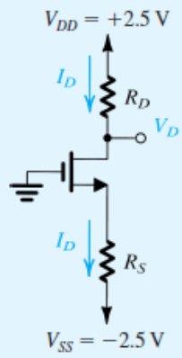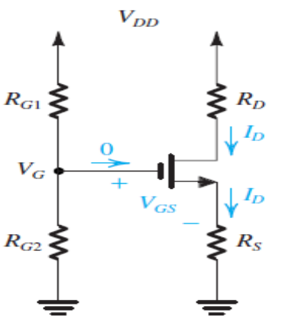  Fig. 2.1 Fig. 2.2 |  | 08
 |  |  | Explain the large signal operation of the MOSFET amplifier. |  | 08
 |  |  | Derive the expression for voltage gain from gate to source for the common-source amplifier with a source resistance. |  | 08
 |  |  | It is required to design the circuit of Fig. 2.2 to establish a dc drain current ID = 0.5 mA. The MOSFET is specified to have Vt = 1 V and 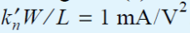. For plicity, neglect the channel-length modulation effect (i.e., assume λ = 0). Use a power-supply VDD = 15 V. Calculate the percentage change in the value of ID obtained when the MOSFET is replaced with another unit having the same but Vt = 1.5 V.
 |  |  | Review questions on Analyzing (BTL4)
 |  |  | Explain biasing using a Drain-to-gate feedback amplifier. |  | 06
It is required to design a source follower that implements the buffer amplifier shown in Fig. 3.1. If the MOSFET is operated with an overdrive voltage V, at what drain current should it be biased? Find the output signal amplitude and the signal amplitude between gate and source.
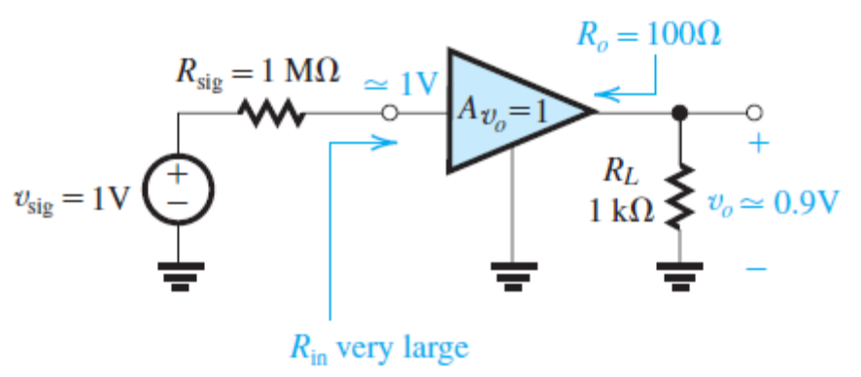

Further Reading: Solve Exercise Problems – T1

***************************************************************************

Further Reading:
Practice Problems – T2 and R3

MODEL QUESTION FOR MSE-2
USN

NMAM INSTITUTE OF TECHNOLOGY, NITTE
Off-Campus Centre of Nitte (Deemed to be University)
III Sem B.Tech (CBCS) Mid Semester Examinations - II, October 2025
EE2101-2 – ANALOG SIGNAL PROCESSING
(For EE)
Duration: 1 Hour Max. Marks: 20
Part – A: Multiple Choice Questions (1*4 = 4 marks)
Note: Answer all Four questions in the Answer Book. Each question carries equal marks.
1. | The common drain amplifier is also known as
 | a | Source follower | b | Voltage amplifier
 | c | Current amplifier | d | Resistor amplifier
2. | The primary property of negative feedback in amplifiers is to
 | a | Increase distortion | b | Improve stability
 | c | Decrease bandwidth | d | Increase power consumption
3. | In a common source amplifier, increasing the load resistance will
 | a | Decrease the gain | b | Increase the gain
 | c | Have no effect on the gain | d | Increase the output impedance
4. | For a common drain amplifier, the voltage gain is typically
 | a | Greater than one | b | Less than one
 | c | Zero | d | Infinite
Part – B: Descriptive Answer Questions (2*8 = 16 marks)
Note: Answer any One full question from each Unit.
 |  | Unit – I | Marks | BT* | CO* | PO*
1. | a) | Deduce amplifier characterizing factors of an amplifier used as voltage buffer. | 4 | L2 | 1 | 3
 | b) | A CS amplifier utilizes a MOSFET biased at Id= 0.1mA with VOV= 0.2V and RD=15k ohm. The device has r0=200k ohm and RG=4.7M ohm. The amplifier is fed with a source having Rsig=100k ohm and a 15k ohm load is connected at the output. Find Rin, Avo, Ro, Av and Gv. | 4 | L3 | 1 | 3
2. | b) | Deduce amplifier characterizing factors of an CS amplifier | 4 | L1 | 1 | 3
 | a) | Elaborate working of CMOS inverter | 4 | L3 | 1 | 3
 |  | Unit – II
3. | a) | With neat diagram elaborate any two types of feedback circuits | 4 | L2 | 2 | 2
 | b) | Explain working of RC phase shift oscillators | 4 | L2 | 2 | 2
4. | a) | Describe gate capacitance and junction capacitances of MOSFET. | 4 | L1 | 2 | 2
 | b) | With necessary equivalent circuit describe unity gain frequency of Common Source amplifier. | 4 | L2 | 2 | 2
BT* Bloom’s Taxonomy, L* Level; CO* Course Outcome; PO* Program Outcome

*****************

Topic | Planned Hours  L-T-P
Unit III: MOS Amplifiers: | 4-0-0
Frequency Response of CS amplifier with active load | 2-0-0
Miller’s Effect | 2-0-0
Feedback Amplifiers & Oscillators: | 4-0-0
General Feedback structure | 1-0-0
Properties of negative feedback, Feedback topologies | 2-0-0
FET based RC phase shift oscillator | 1-0-0
FET Differential Amplifiers: | 2-0-0
MOS Differential pair with common mode and differential input voltage | 1-0-0
Small-signal operation of MOS Differential pair | 1-0-0
Learning Outcomes: At the end of this unit students will be able to
1. Understand the need of feedback in the given system.
2. Perform frequency sweep on CS MOS amplifier circuit to obtain response curve
3. Analyze feedback concepts to design oscillator circuits
4. Know working concept of the oscillators.
5. Answer how the oscillators play a major role in the real time applications.
- Differentiate between ideal and practical op-amp parameters.
- Define offset voltage and offset current for an op-amp.
- Measure various practical op-amp parameters.
- Demonstrate the use of op-amp as an Inverting and non-inverting amplifier
- Set-up lower and upper cut-off frequencies when op-amp is used as amplifier
- Use Single polarity supply while designing op-amp ac amplifiers.
- Design and explain various op-amp based signal processing circuits like precision rectifier, limiting circuits, clamping circuits, peak detectors, sample and hold circuit.
- Design and explain the op-amp based zero crossing detectors, Schmitt trigger circuits

Sl. N0 | Review questions on Remembering (BTL1)
1. | Sketch of the frequency response of a CS amplifier. | 04
2 | Draw the general feedback structure and explain. | 07
3 | Explain the four basic feedback topologies. | 08
 | Review questions on Understanding (BTL2)
4 | Explain the low-frequency response of the common-source amplifiers. | 06
5 | Explain Miller’s effect | 10
6 | Explain the working of MOS differential pair with a common-mode input voltage. | 10
7 | Explain the working of MOS differential pair with a differential input voltage. | 08
 | Review questions on Applying (BTL3)
8 | Select appropriate values for the coupling capacitors CC1 and CC2 and the bypass capacitor CS for a CS amplifier for which RG = 4.7 MΩ, RD = RL = 15 kΩ, Rsig = 100 kΩ, and gm = 1 mA/V. It is required to have fL at 100 Hz and that the nearest break frequency be at least a decade lower. | 08
9 | A CS amplifier has CC1 = CS = CC2 = 1 μF, RG = 10 MΩ, Rsig = 100 kΩ, gm = 2 mA/V, RD = RL = 10 kΩ. Find AM, fP1, fP2, fP3, and fL. | 08
10 | For the MOS differential pair with a common-mode voltage VCM applied , let VDD = VSS = 1.5 V, 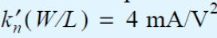, Vt = 0.5 V, I = 0.4 mA, and RD = 2.5 kΩ, and neglect channel-length modulation. Assume that the current source I requires a minimum voltage of 0.4 V to operate properly.  (a) Find VOV and VGS for each transistor.  (b) For VCM = 0, find VS, ID1, ID2, VD1, and VD2. | 08
11 | For the MOS differential pair specified in Example 5.1 find (a) the value of vid that causes Q1 to conduct the entire current I, and the corresponding values of vD1 and vD2; (b) the value of vid that causes Q2 to conduct the entire current I, and the corresponding values of vD1 and vD2; (c) the corresponding range of the differential output voltage (vD2 – vD1).  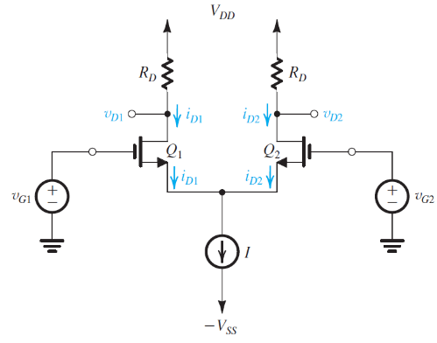  Fig. 5.1 | 08
12 | Figure 4.1 shows an ideal voltage amplifier having a gain -100 of with an impedance Z connected between its output and input terminals. Find the Miller equivalent circuit when Z is (a) a 1-MΩ resistance and (b) a 1-pF capacitance. In each case, use the equivalent circuit to determine Vo/Vsig.  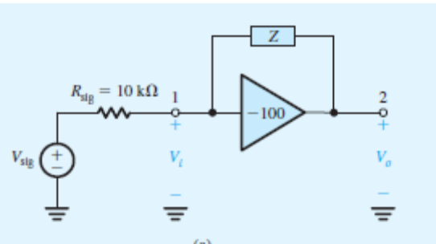  Fig. 4.1 | 07
13 | Explain the properties of negative feedback. | 08
 | Review questions on Analyzing (BTL4)
14 | With circuit diagrams explain CS amplifier with active load. | 10
15 | Draw the FET based RC phase shift oscillator and explain its working. | 08

Model Question Paper for SEE

USN

NMAM INSTITUTE OF TECHNOLOGY, NITTE
Off-Campus Centre of Nitte (Deemed to be University)
Third Semester B.Tech (ELECTRICAL & ELECTRONICS ENGINEERING) (CBCS) Degree Examinations
December 2024

EE2101-2 – Analog signal processing
Duration: 3 Hours Max. Marks: 100

Note:
Part – A: Multiple Choice Questions: Answer all Twenty questions in the OMR Sheet provided. Each question carries equal marks.
Part – B: Descriptive Answer Questions: Answer Five full questions choosing Two full questions from Unit – I & Unit – II each and One full question from Unit – III.

PART - A: MULTIPLE CHOICE QUESTIONS 20 Marks

 | MOSFET under saturation acts as
 | a | Voltage controlled voltage source | b | Voltage controlled current source
 | c | Current controlled voltage source | d | Current controlled current source
 | For , the MOSFET operates in which region
 | a | Cutoff region | b | Saturation region
 | c | Triode region | d | Linear region
 | To ensure the MOSFET is fully turned off as a switch, it is recommended to use a gate-to-source voltage (V_{GS}) below:
 | a | The threshold voltage | b | The breakdown voltage
 | c | The saturation voltage | d | The supply voltage
 | The threshold voltage (Vt) of a MOSFET is defined as
 | a | The voltage at which the channel is completely depleted | b | The voltage at which the drain current starts to increase exponentially
 | c | The voltage required to create an inversion layer in the channel | d | The voltage required to turn on the parasitic diode
 | In the MOSFET’s saturation region, the device operates as a
 | a | Conductor | b | Switch (OFF)
 | c | Amplifier | d | Switch (ON)
 | What is the role of the source resistance in MOSFET biasing?
 | a | Decreases the gain | b | Stabilizes the operating point
 | c | Increases the input resistance | d | Increases the output resistance
 | The flatness of the output characteristics curve in the saturation region indicates
 | a | High output resistance (r_{o}) | b | High transconductance (g_{m})
 | c | Low threshold voltage (V_{t}) | d | Low drain current (I_{D})
 | The saturation region of a MOSFET is characterized by:
 | a | Constant drain current (I_{D}) | b | Exponential increase in drain current (I_{D})
 | c | Zero drain current (I_{D}) | d | Non-linear relationship between I_{D} and V_{GS}
 | For a common drain amplifier, the voltage gain is typically
 | a | Greater than one | b | Less than one
 | c | Zero | d | Infinite
 | The common drain amplifier is also known as
 | a | Source follower | b | Voltage amplifier
 | c | Current amplifier | d | Resistor amplifier
 | The phase difference between the input and output of a Common Source (CS) amplifier is
 | a | 0° | b | 45°
 | c | 90° | d | 180°
 | The primary property of negative feedback in amplifiers is to
 | a | Increase distortion | b | Improve stability
 | c | Decrease bandwidth | d | Increase power consumption
 | Amplifier with less input impedance is
 | a | CS amplifier | b | CG amplifier
 | c | CD amplifier | d | CS amplifier with source resistance
 | The capacitance responsible for deciding low frequency response of CS amplifier is
 | a | Gate capacitance | b | Junction capacitance
 | c | Coupling and bypass capacitance | d | Body capacitance
 | If the transconductance (gm) of a MOSFET is increased, the amplifier's voltage gain will
 | a | Increase | b | Decrease
 | c | Remain unchanged | d | Depend on the capacitances
 | What is the typical use of a source follower?
 | a | Voltage amplification | b | Current amplification
 | c | Impedance matching | d | Frequency generation
 | What is the primary characteristic of an ideal operational amplifier?
 | a | Infinite input impedance and zero output impedance | b | Zero input impedance and infinite output impedance
 | c | Finite input impedance and finite output impedance | d | Zero gain and infinite bandwidth
 | What is the primary purpose of a differential amplifier?
 | a | To convert AC signals to DC | b | To amplify the difference between two input signals
 | c | To filter high-frequency signals | d | To amplify a single input signal
 | What is the main function of a sample and hold circuit?
 | a | To sample an input signal and hold its value for a specific time period | b | To filter high-frequency components from the signal
 | c | To amplify the signal continuously | d | To convert AC signals to DC
 | What is the role of capacitor in capacitor coupled amplifier
 | A | To block DC components and pass AC components of the signal | b | To increase the gain of the amplifier
 | C | To stabilize the amplifier's operation | d | To adjust the offset voltage

PART - B: DESCRIPTIVE ANSWER QUESTIONS

 |  | Unit – I | Marks | BT* | CO* | PO*
1. | a) | With reference to the different operating conditions in i-v characteristics, draw internal structure of MOSFET in each case. | 6 | L*2 | 1 | 3
 | b) | Consider an NMOS transistor fabricated in a 0.8 µm process with W= 16 µm, tox = 10nm, un = 500 cm2/V s. Find V_{OV} required to operate MOSFET in saturation with I_{D}= 0.2mA. | 5 | L*3 | 1
 | c) | With a neat circuit diagram explain biasing of the MOSFET with source resistance. | 5 | L*2 | 2 | 3  3
2. | a) | Deduce an expression for drain current i_{D} of n- channel MOSFET in saturation and triode region. | 6 | L*2 | 1 | 3
 | b) | With a neat circuit diagram explain biasing of the MOSFET with gate to drain resistance. | 5 | L*1 | 2 | 3
 | c) | Derive T equivalent model of CS amplifier. | 5 | L*2 | 2 | 2
3. | a) | Deduce the small signal model of MOSFET and elaborate significance of transconductance. | 6 | L*2 | 1 | 3
 | b) | With a neat circuit diagram explain current source biasing of the MOSFET. | 5 | L*1 | 2 | 2
 | c) | MOSFET circuit shown in figure 3c. has V_{DD} 3.3V, V_{D} 0.1V, V_{t}= 1V, kn =2mA/V². Find value of R_{D}.  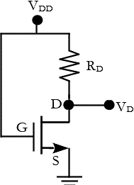  Figure 3c. | 5 | L*3 | 2 | 2
 |  | Unit – II
4. | a) | Describe amplifier characteristics and specific application of Common Gate amplifier. | 5 | L*2 | 3 | 3
 | b) | With necessary equivalent circuit describe unity gain frequency of CS amplifier | 5 | L*2 | 4 | 3
 | c) | A CS amplifier utilizes a MOSFET biased at I_{D} = 0.5 mA with V_{OV} = 0.25 V and R_{D}= 25kΩ. The amplifier is fed with a source having R_{sig} = 100kΩ, and a 25kΩ load is connected to the output. Find R_{in}, A_{vo} , R_{o} , A_{v} and G_{v}. | 6 | L*3 | 3 | 3
5. | a) | Describe different types of internal capacitances in MOSFET. | 5 | L*2 | 4 | 3
 | b) | With necessary equivalent circuit describe high frequency response of a CS amplifier. | 5 | L*1 | 4 | 3
 | c) | Describe the operation of a CMOS logic inverter. | 6 | L*1 | 3 | 3
6. | a) | With necessary equivalent circuit describe low frequency response of a CS amplifier. | 6 | L*2 | 3 | 3
 | b) | Describe shunt-shunt feedback amplifier for ideal condition | 6 | L*1 | 4 | 3
 | c) | A CG amplifier is designed with g_{m}=1mA/V, R_{D}=15kΩ, R_{L}=15kΩ, Rsig=100Ω. Find  - R_{in}  - A_{v}  - R_{o}  - G_{v} | 4 | L*3 | 3 | 3
 |  | Unit – III
7. | a) | With necessary equivalent circuit elaborate common mode gain and CMRR. | 8 | L*2 | 5 | 3
 | b) | With neat diagram explain the internal architecture of OPAMP. | 8 | L*2 | 5 | 3
8. | a) | Design a capacitor coupled inverting amplifier with a load resistor R_{L} of 2.2kΩ, gain 50, input voltage 20mV and lower cut-off frequency of 150Hz. Assume 741 opamp. | 6 | L*4 | 5 | 3
 | b) | Explain the operation of inverting Schmitt trigger circuit with neat circuit diagram and waveforms | 5 | L*2 | 6 | 3
 | c) | Discuss design steps of first order LPF. | 5 | L*2 | 5 | 3
BT* Bloom’s Taxonomy, L* Level; CO* Course Outcome; PO* Program Outcom

