**Stack-Heap Diagram**

**Code**

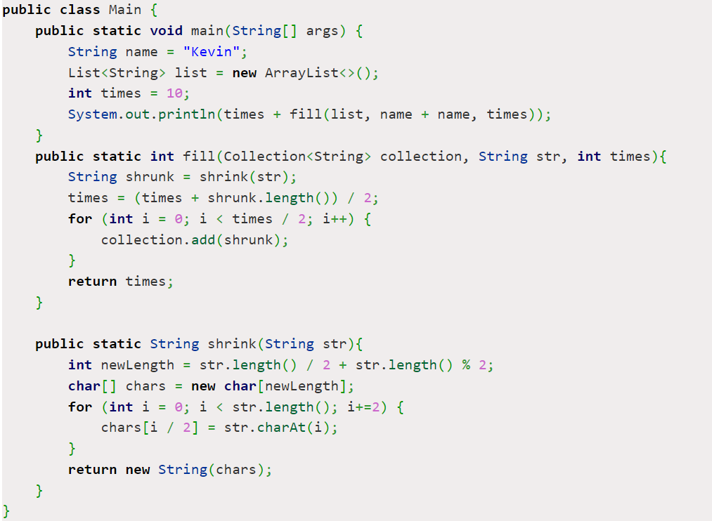

public class Main {

public static void main(String[] args) {

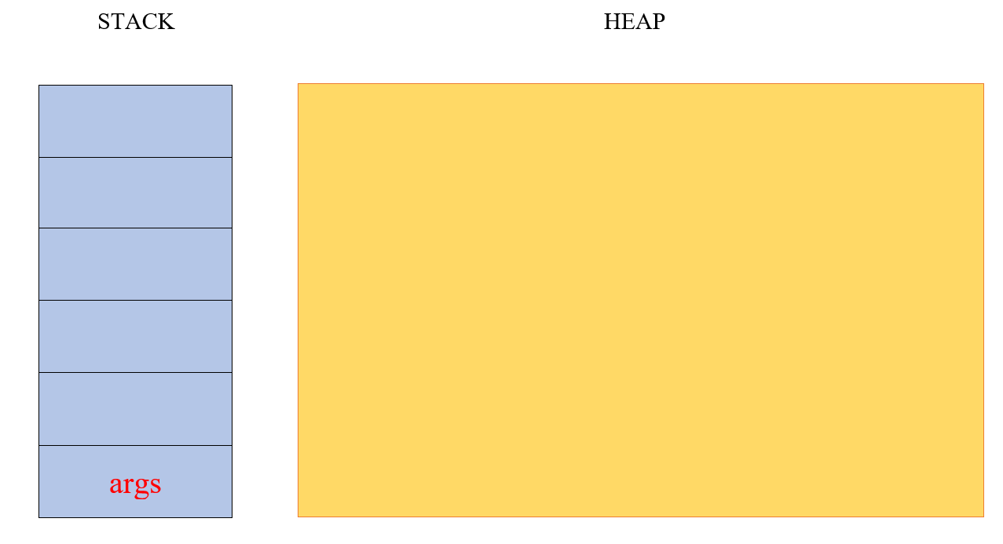

String name = "Kevin";

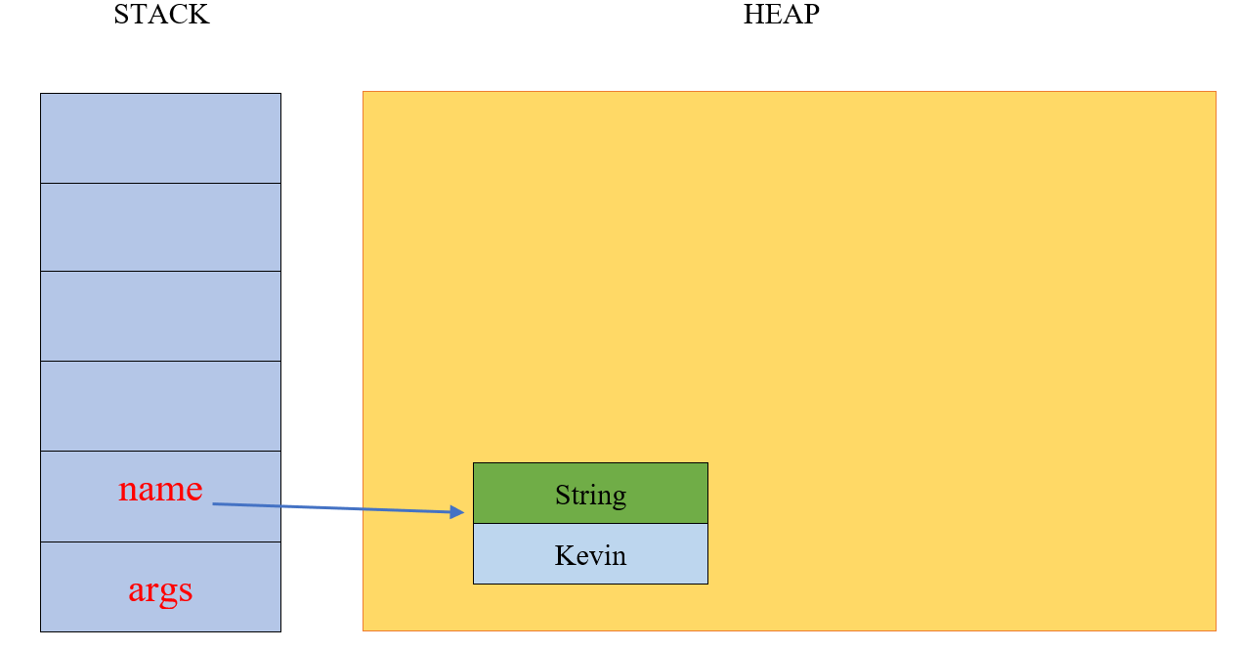

List<String> list = new ArrayList<>();

int times = 10;

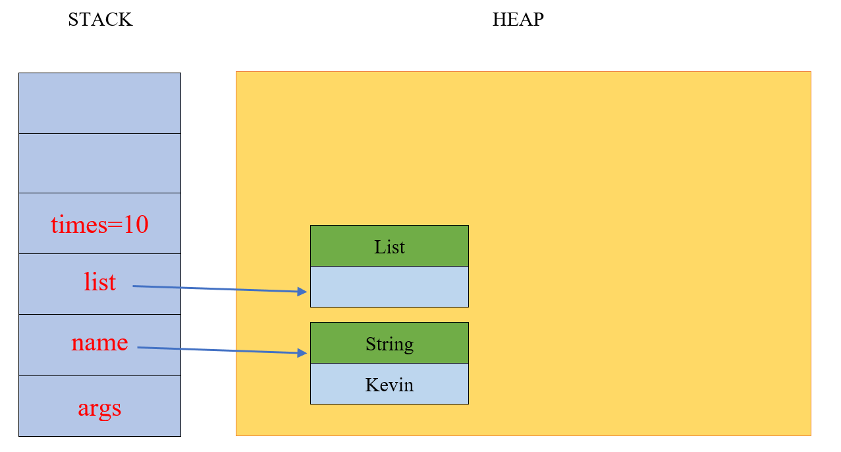

System.out.println (times + fill(list, name + name, times));

public static int fill(Collection<String> collection, String str, int times){

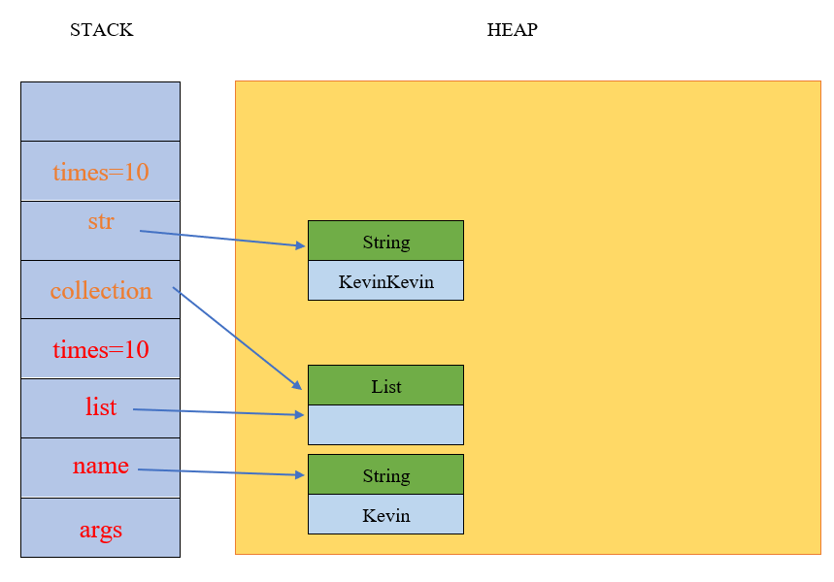

String shrunk = shrink(str);

public static String shrink(String str){

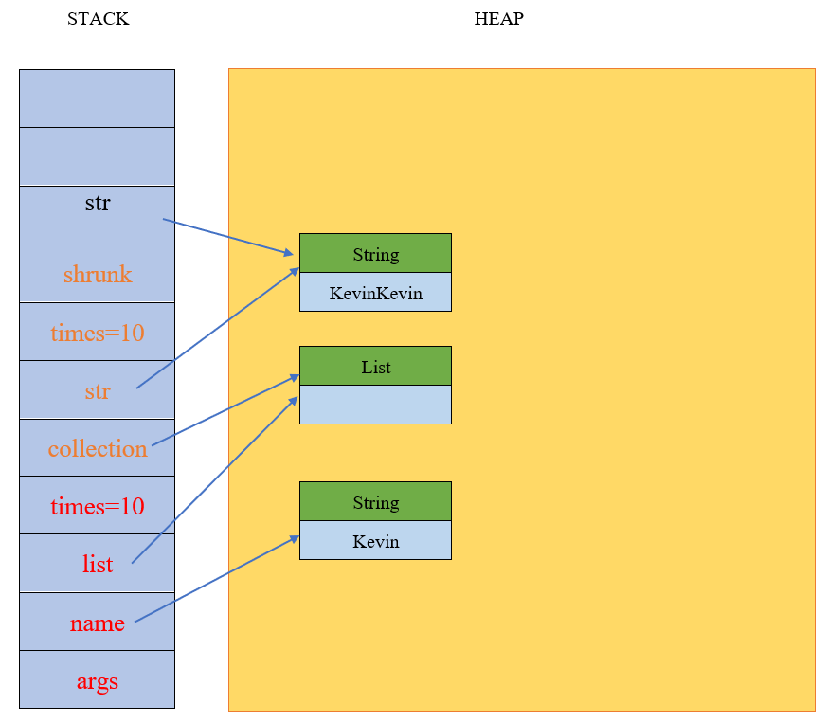

int newLength = str.length() / 2 + str.length() % 2;

char[] chars = new char[newLength];

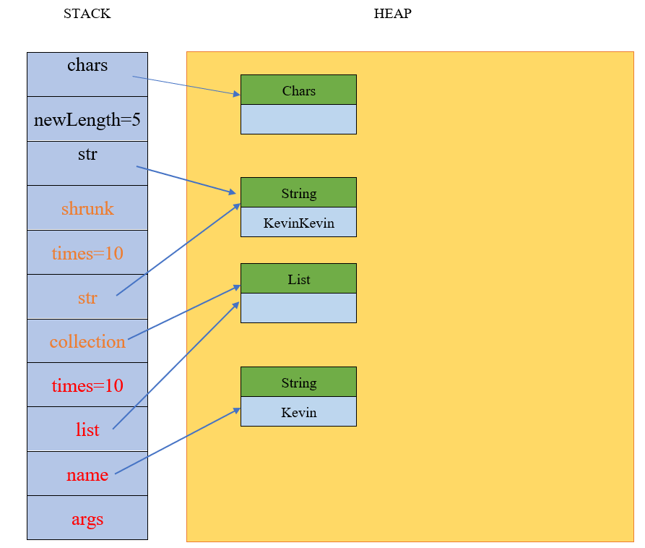

for (int i = 0; i < str.length(); i+=2) {

chars[i / 2] = str.charAt(i);

}

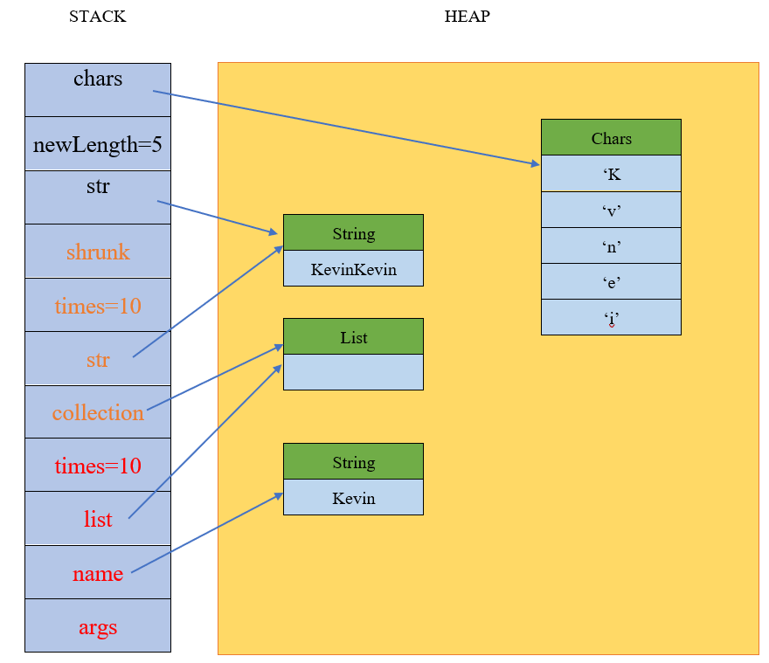

return new String(chars); }

String shrunk = shrink(str);

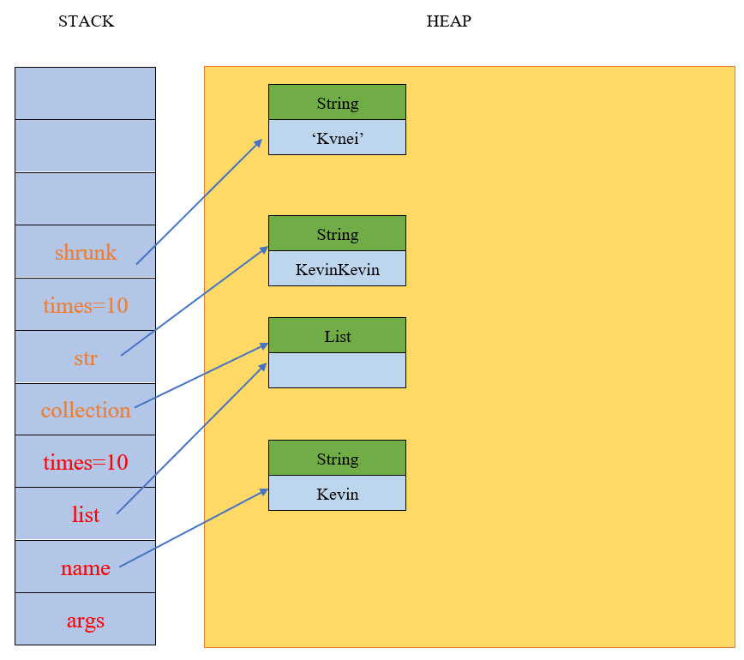

times = (times + shrunk.length()) / 2;

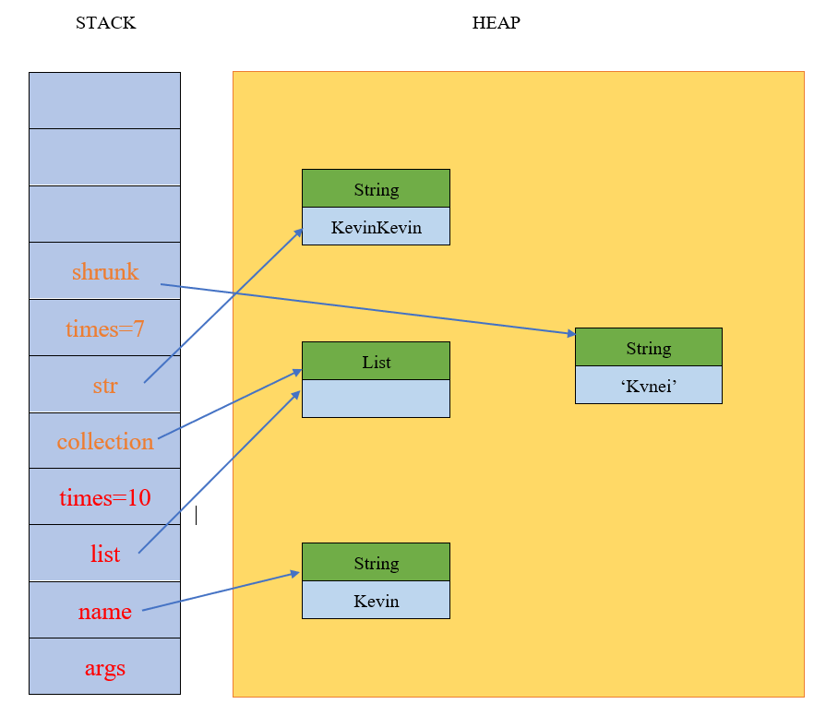

for (int i = 0; i < times / 2; i++) {

collection.add(shrunk);

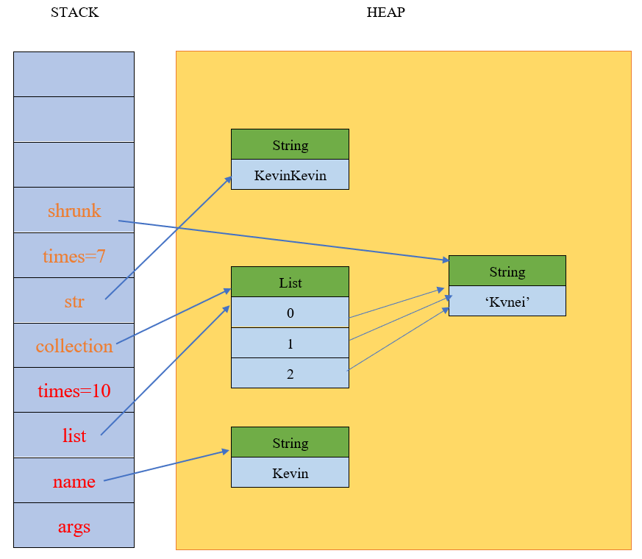

return times;

System.out.println (times + fill(list, name + name, times));

}

**Output: 17**