ARO Cluster Upgrade Automation
Rule-Based Ansible Automation for ARO Y-Stream Upgrades
Author: Ravikant Kispotta/ Abhishek Thakur
Date: August 2026
Version: 1.0
Status Legend:
PASS (Green) | WARN (Amber) | FAIL/HARD (Red)

Executive Summary
The ARO Cluster Upgrade Automation suite is a rule-based, deterministic Ansible automation solution designed to perform Y-stream (minor) upgrades of Azure Red Hat OpenShift clusters as ordered, sequential version hops (e.g. 4.18.09 → 4.19.15 → 4.20.08).
It addresses the risk, inconsistency, and lack of auditability inherent in manual upgrades. Key benefits include:
- - Deterministic: Rule-based, no AI in the execution path. All decisions are hardcoded rules.
- - Auditable: Produces dual .txt/.csv logs and colour-coded client HTML reports.
- - Dual-Version Safe: Runs unchanged on both Ansible 2.7.17 (test) and 2.14.18 (prod).
- - Safe-Fail: Login once, logout on any failure (via block/rescue). HARD gates halt execution.

Table of Contents
1. Executive Summary
2. Solution Overview
3. Architecture
4. End-to-End Workflow
5. Phase Deep-Dives
6. Validation Model
7. Upgrade Hop Mechanics
8. Monitoring & Notifications
9. Operator Upgrade & Validation
10. Reporting, Logging & Outputs
11. Dual-Version Compatibility & Migration
12. Build Units Reference
13. Appendix

Solution Overview
Goals: Automate multi-version Y-stream ARO upgrades deterministically without skipping minor versions. Enforce 13-check prevalidation, live monitoring, and 10-check postvalidation.
Core User Flow:
1. Define the upgrade path in vars.
2. Run CLI entrypoint (00_Run.sh).
3. Policy check & baseline.
4. Prevalidation hard gate.
5. Execute hops.
6. Monitor each hop.
7. Settle-gate between hops.
8. Postvalidation.
9. Deliver & log out.
In-Scope: Y-stream sequential hops, 13-check prevalidation, live monitoring, HTML reports, logs, snapshot.
Out-of-Scope: AI, GitOps/Argo, cluster backup/restore, Z-stream/X-stream upgrades.

Architecture
System structure relies on Ansible for orchestration, Bash for the CLI entrypoint, oc for cluster interfacing, jq for data parsing, and sendmail for notifications. All paths are dynamic and secrets are variable references.
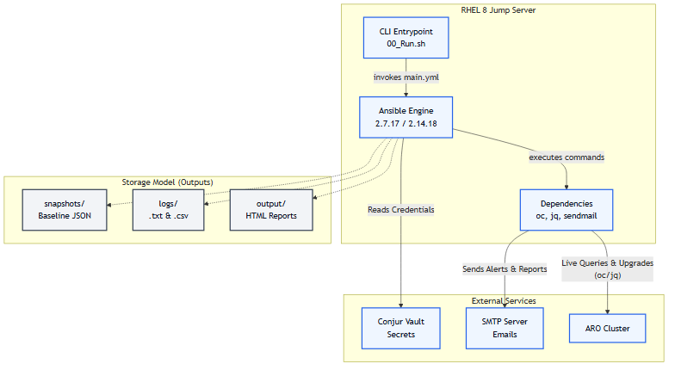
Invariants:
- No AI in execution path.
- Codebase runs unchanged on Ansible 2.7.17 and 2.14.18.
- Login once, logout on any failure.
- oc live queries only; no cross-phase state persistence (except Phase 01 snapshot).
- Minor versions are never skipped.
- HARD gates halt the chain.

End-to-End Workflow
The master workflow traverses the following lifecycle: Login → Snapshot → Secrets → Prevalidation Gate → Hop Loop → Postvalidation → Operator Upgrade → Logout.
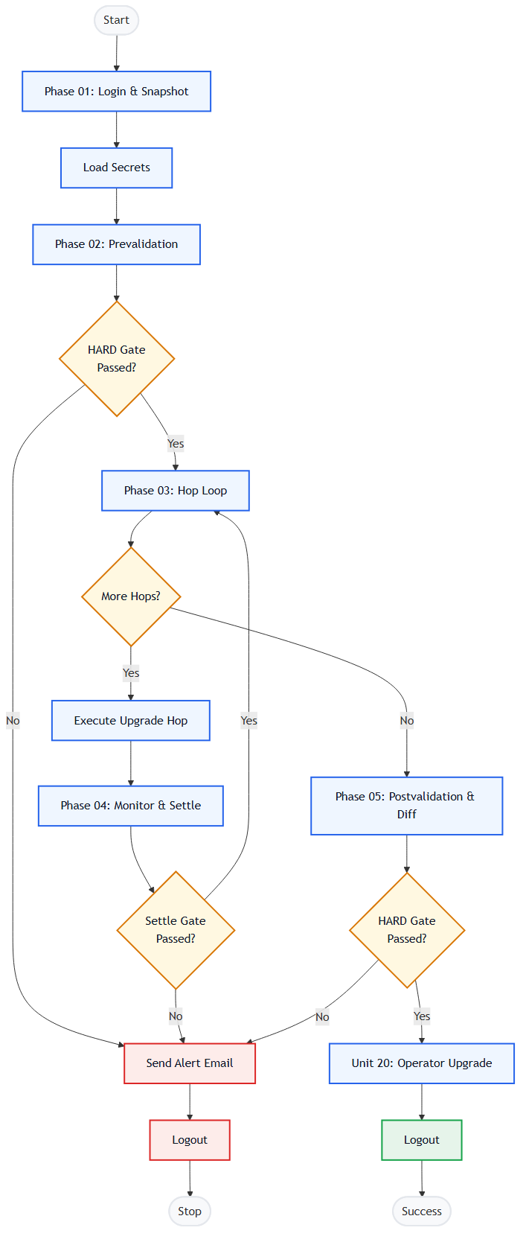

Phase Deep-Dives

Phase 01: Policy Check & Baseline
Purpose: Login once, capture baseline JSON snapshot, validate policy/edge.
Inputs: Secrets, upgrade_path.
Actions: oc login, oc get clusterversion/operators/nodes/routes -o json.
Gate: HARD if invalid edge.

Phase 02: Prevalidation
Purpose: 13-check hard gate before any upgrade.
Actions: oc/jq queries for CO, Node, MCP, etcd, etc.
Gate: HARD halts chain; WARN surfaces in report.

Phase 03 & 04: Upgrade Hops & Live Monitoring
Purpose: Trigger and monitor each hop.
Actions: oc adm upgrade --to, monitor cv/mcp/nodes every 2m.

Phase 05: Postvalidation
Purpose: 10-check postvalidation and baseline diff.
Gate: HARD.

Unit 20: Operator Upgrade
Purpose: Check OLM compatibility, approve InstallPlans, wait for Succeeded.

Validation Model
13 Prevalidation Checks:
# | Check | Rule | Gate
01 | ClusterOperators Health | Available=True, Degraded=False | HARD
02 | Node Health | Ready=True, Schedulable | HARD
03 | MachineConfigPool Health | Updated=True, Degraded=False | HARD
04 | etcd Member Health | Running/Ready, 0 degraded | HARD
05 | Admin Acknowledgements | Upgradeable condition / acks | HARD
06 | Target Upgrade Edge | Valid available/conditional edge | HARD
07 | Resource Utilization | CPU/Mem < 90% | HARD
08 | Pending CSRs | No unapproved CSRs | WARN
09 | Disk Pressure | No DiskPressure=True | WARN
10 | PDB Risk | Drain headroom available | WARN
11 | Node Drain Headroom | Utilization if largest node evicted | WARN
12 | Critical Pods | openshift-* pods Running | WARN
13 | Firing Alerts | No critical Prometheus alerts | WARN
10 Postvalidation Checks run after all hops, including a baseline diff.

Upgrade Hop Mechanics
Each hop executes natively via oc adm upgrade --to. Includes setting the channel, verifying the edge, applying admin-ack, triggering upgrade, monitoring, and passing the settle-gate (CV at target, CO Available, MCP Updated).
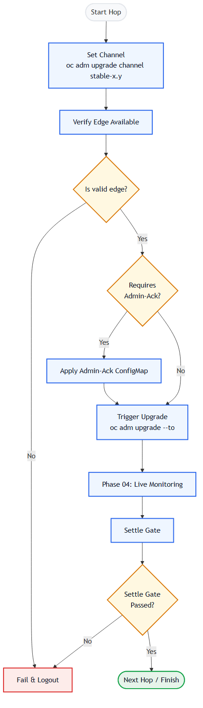

Monitoring & Notifications
Polling cadence is 2 minutes. HTML heartbeat emails are sent every 20 minutes, with immediate change alerts on state mutation. Timeout guard is typically 90 minutes per hop.
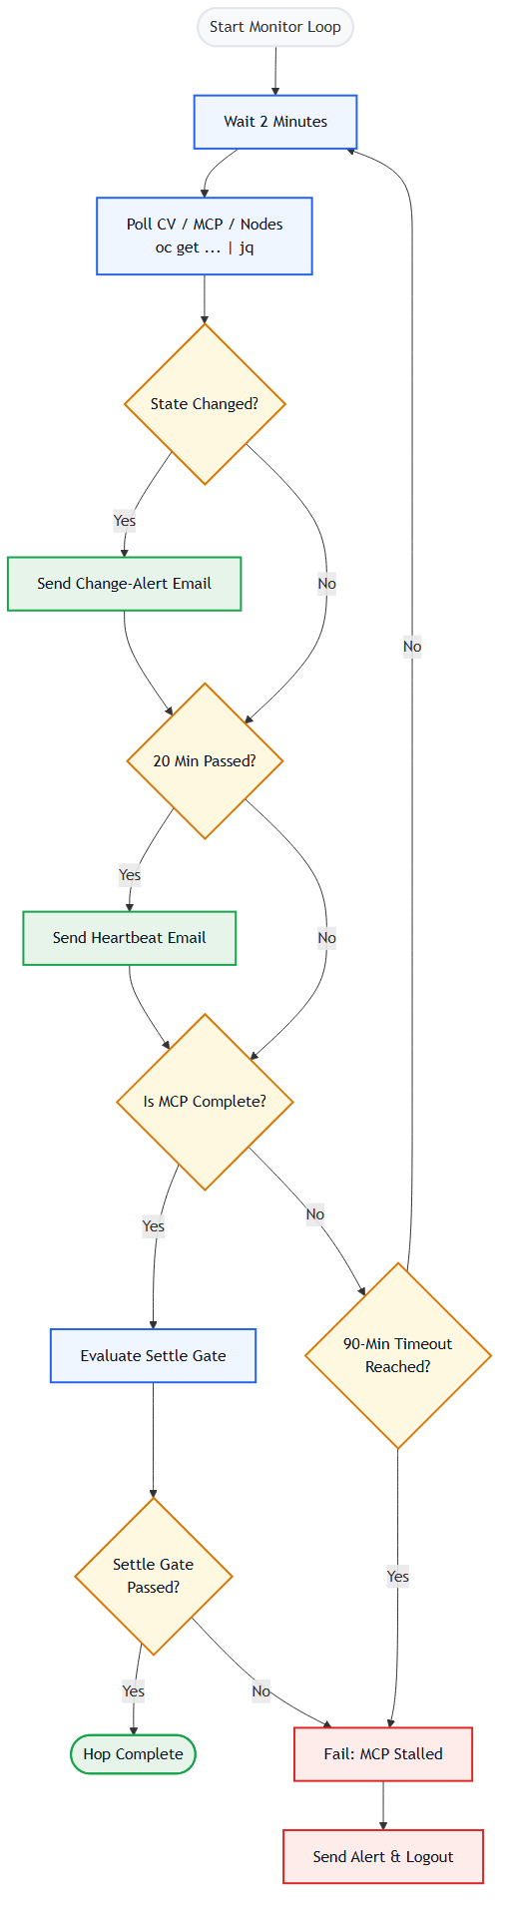

Operator Upgrade & Validation (Unit 20)
Compatibility scan → InstallPlan approval → CSV settle → final validation.
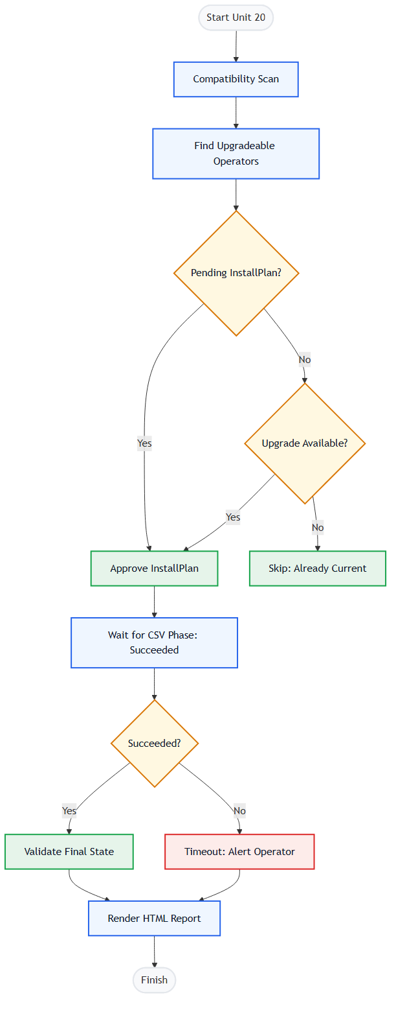

Reporting, Logging & Outputs
Reports: HTML prevalidation and postvalidation reports in output/.
Logs: Dual .txt and .csv run logs in logs/.
Snapshot: Baseline JSON snapshot in snapshots/.

Dual-Version Compatibility & Migration
Codebase runs on Ansible 2.7.17 and 2.14.18. Utilizes short module names, include_tasks, | default(''), and a dual-delivery sendmail contract.

Appendix
Glossary:
ARO: Azure Red Hat OpenShift
MCP: MachineConfigPool
CO: ClusterOperator
CSV: ClusterServiceVersion
InstallPlan: OLM upgrade instruction
Edge: Supported upgrade path between versions
Y-stream: Minor version release

