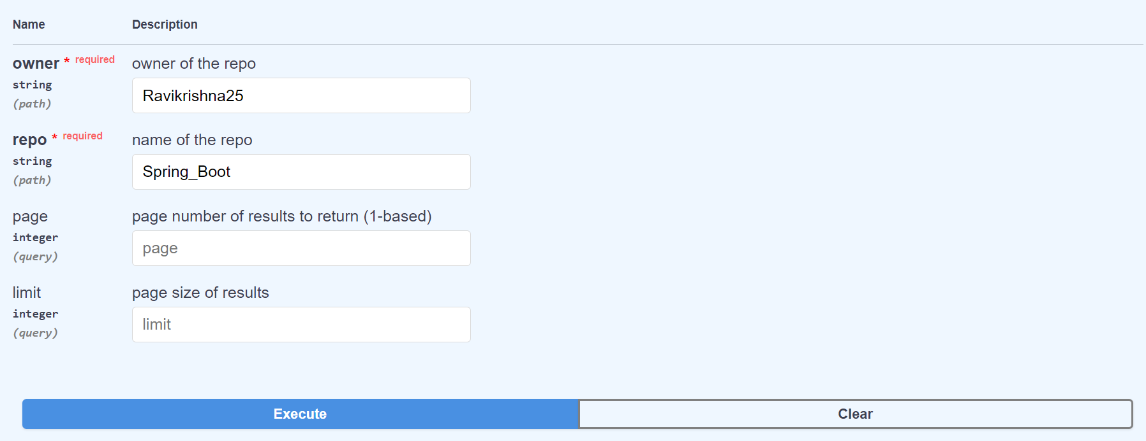

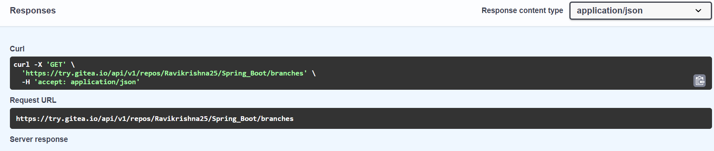

**[**

**{**

**"name": "branch1",**

**"commit": {**

**"id": "316f01c24ed10742111214ace352c555c951cd17",**

**"message": "Initial commit\n",**

**"url": "https://try.gitea.io/Ravikrishna25/Spring_Boot/commit/316f01c24ed10742111214ace352c555c951cd17",**

**"author": {**

**"name": "Ravikrishna25",**

**"email": "ravikrishna25@noreply.try.gitea.io",**

**"username": "Ravikrishna25"**

**},**

**"committer": {**

**"name": "Ravikrishna25",**

**"email": "ravikrishna25@noreply.try.gitea.io",**

**"username": "Ravikrishna25"**

**},**

**"verification": {**

**"verified": false,**

**"reason": "gpg.error.not_signed_commit",**

**"signature": "",**

**"signer": null,**

**"payload": ""**

**},**

**"timestamp": "2023-02-21T14:42:13Z",**

**"added": null,**

**"removed": null,**

**"modified": null**

**},**

**"protected": false,**

**"required_approvals": 0,**

**"enable_status_check": false,**

**"status_check_contexts": [],**

**"user_can_push": false,**

**"user_can_merge": false,**

**"effective_branch_protection_name": ""**

**},**

**{**

**"name": "branch2",**

**"commit": {**

**"id": "316f01c24ed10742111214ace352c555c951cd17",**

**"message": "Initial commit\n",**

**"url": "https://try.gitea.io/Ravikrishna25/Spring_Boot/commit/316f01c24ed10742111214ace352c555c951cd17",**

**"author": {**

**"name": "Ravikrishna25",**

**"email": "ravikrishna25@noreply.try.gitea.io",**

**"username": "Ravikrishna25"**

**},**

**"committer": {**

**"name": "Ravikrishna25",**

**"email": "ravikrishna25@noreply.try.gitea.io",**

**"username": "Ravikrishna25"**

**},**

**"verification": {**

**"verified": false,**

**"reason": "gpg.error.not_signed_commit",**

**"signature": "",**

**"signer": null,**

**"payload": ""**

**},**

**"timestamp": "2023-02-21T14:42:13Z",**

**"added": null,**

**"removed": null,**

**"modified": null**

**},**

**"protected": false,**

**"required_approvals": 0,**

**"enable_status_check": false,**

**"status_check_contexts": [],**

**"user_can_push": false,**

**"user_can_merge": false,**

**"effective_branch_protection_name": ""**

**},**

**{**

**"name": "main",**

**"commit": {**

**"id": "316f01c24ed10742111214ace352c555c951cd17",**

**"message": "Initial commit\n",**

**"url": "https://try.gitea.io/Ravikrishna25/Spring_Boot/commit/316f01c24ed10742111214ace352c555c951cd17",**

**"author": {**

**"name": "Ravikrishna25",**

**"email": "ravikrishna25@noreply.try.gitea.io",**

**"username": "Ravikrishna25"**

**},**

**"committer": {**

**"name": "Ravikrishna25",**

**"email": "ravikrishna25@noreply.try.gitea.io",**

**"username": "Ravikrishna25"**

**},**

**"verification": {**

**"verified": false,**

**"reason": "gpg.error.not_signed_commit",**

**"signature": "",**

**"signer": null,**

**"payload": ""**

**},**

**"timestamp": "2023-02-21T14:42:13Z",**

**"added": null,**

**"removed": null,**

**"modified": null**

**},**

**"protected": false,**

**"required_approvals": 0,**

**"enable_status_check": false,**

**"status_check_contexts": [],**

**"user_can_push": false,**

**"user_can_merge": false,**

**"effective_branch_protection_name": ""**

**}**

**]**

