**Projects Screeshots:**

1. **Food Delivering App**: These are some of the screenshots.
2. **HomePage:** The first Page is the Home Page where the user can order different food items.

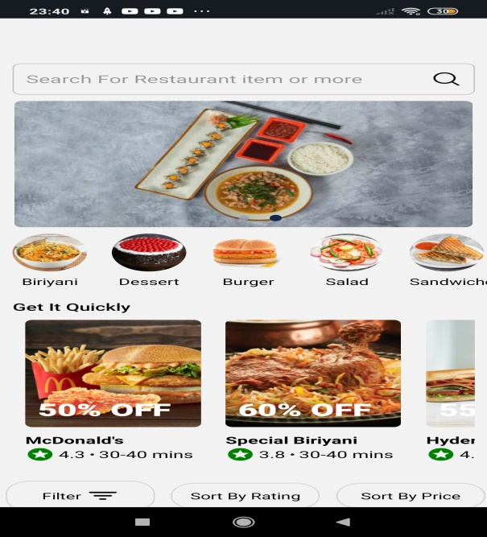

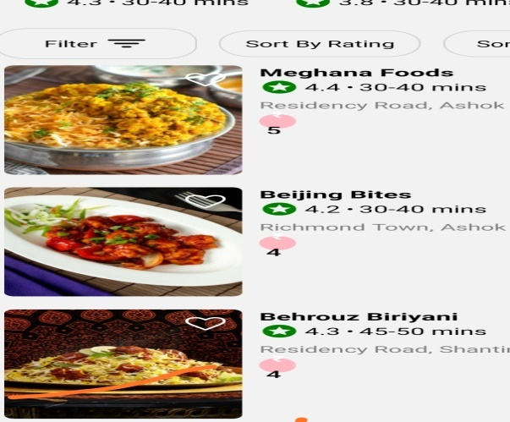

1. **Hotel** **Details Page:** This is where when I click on the hotel, the details of hotel & food items are present.
2. **Cart Details Page**: where you could select which items you want to select. The payment details are present here.

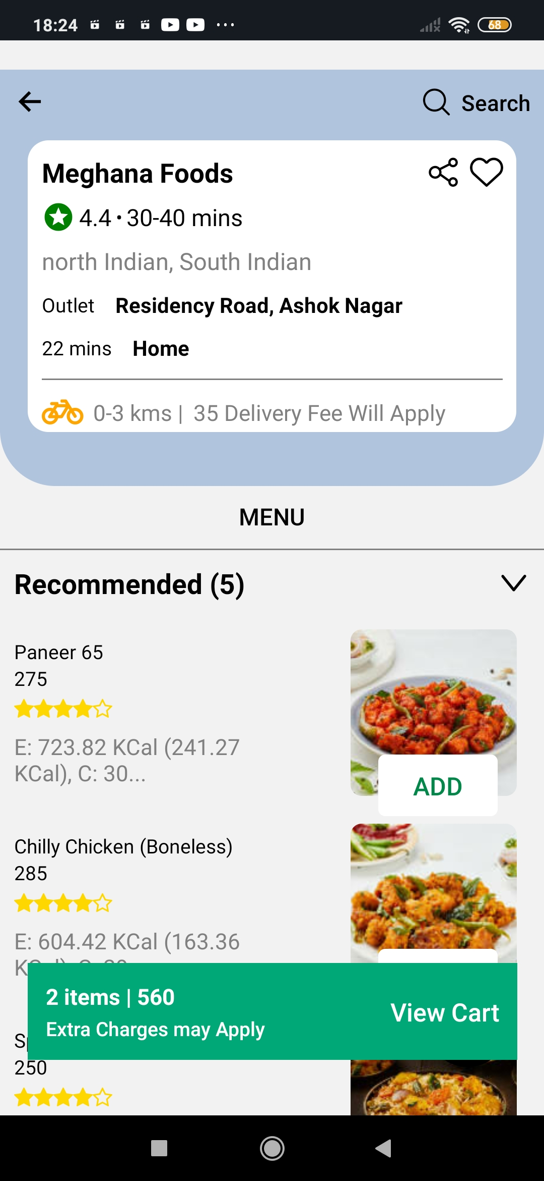

1. **Delivery Details Page**: where the food is been delivered.

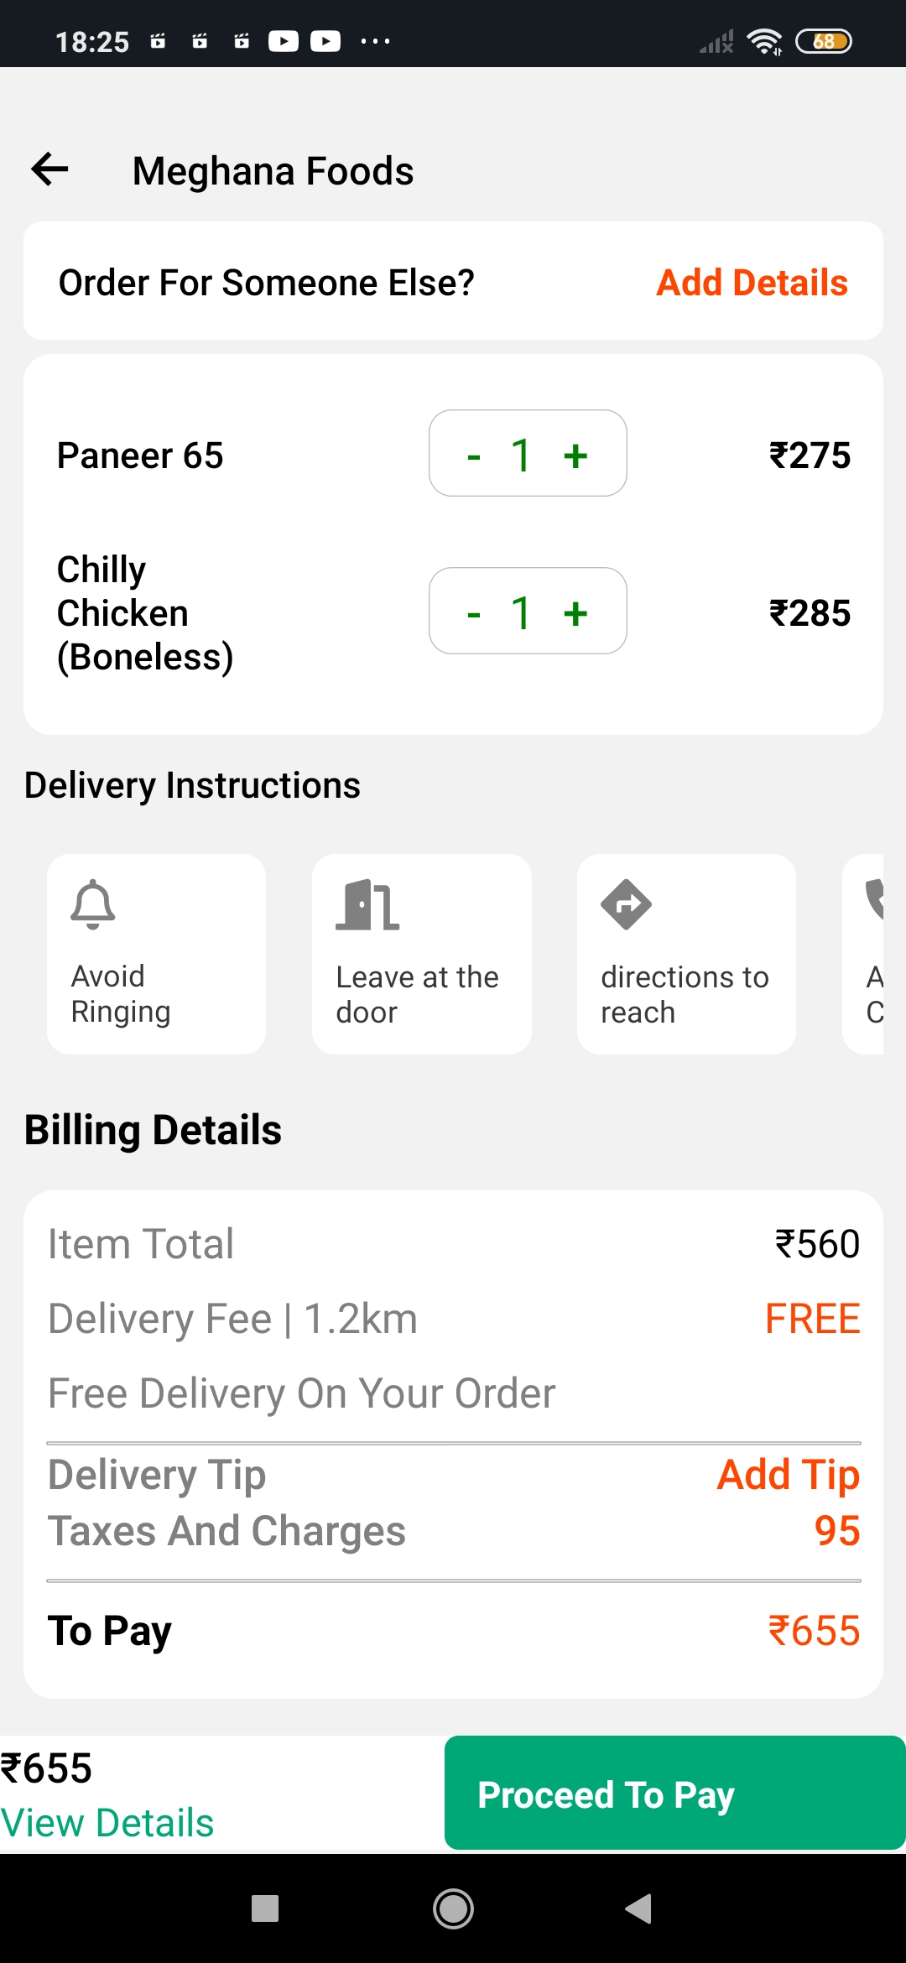

1. **Payment Details Page**: where the food is been delivered & payment is completed.

