**Projects Screeshots:**

1. **Movie Booking App**: These are some of the screenshots.
2. **HomePage:** The first Page is the Home Page where there are different movies displayed.

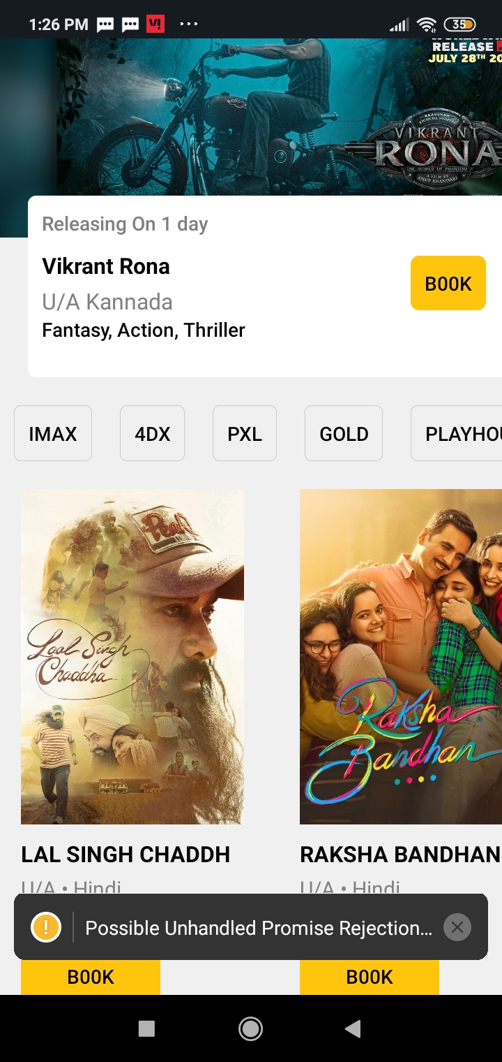

1. **Theater Details Page:** This is the second Page where you can see the different theatre names and dates of movies you want to book.

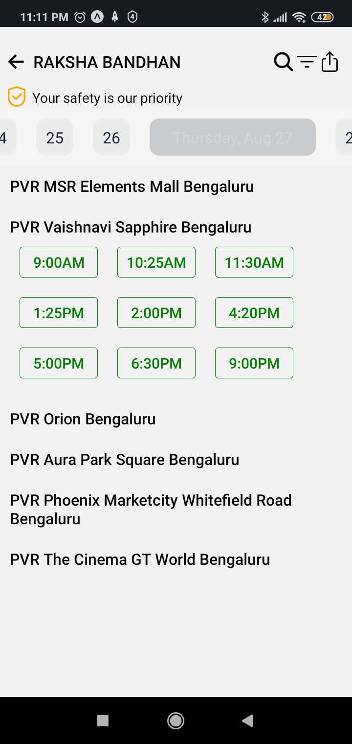

1. **Booking Details Page**: This is the page where you can is where you could select which seat to book.

