**Docker Task -3**

**Task Description:**

Create a custom docker image for nginx and deploy it using docker compose, where the volume bind mount should be at /var/opt/nginx location. Push the created custom docker image to your docker-hub.

Answer:

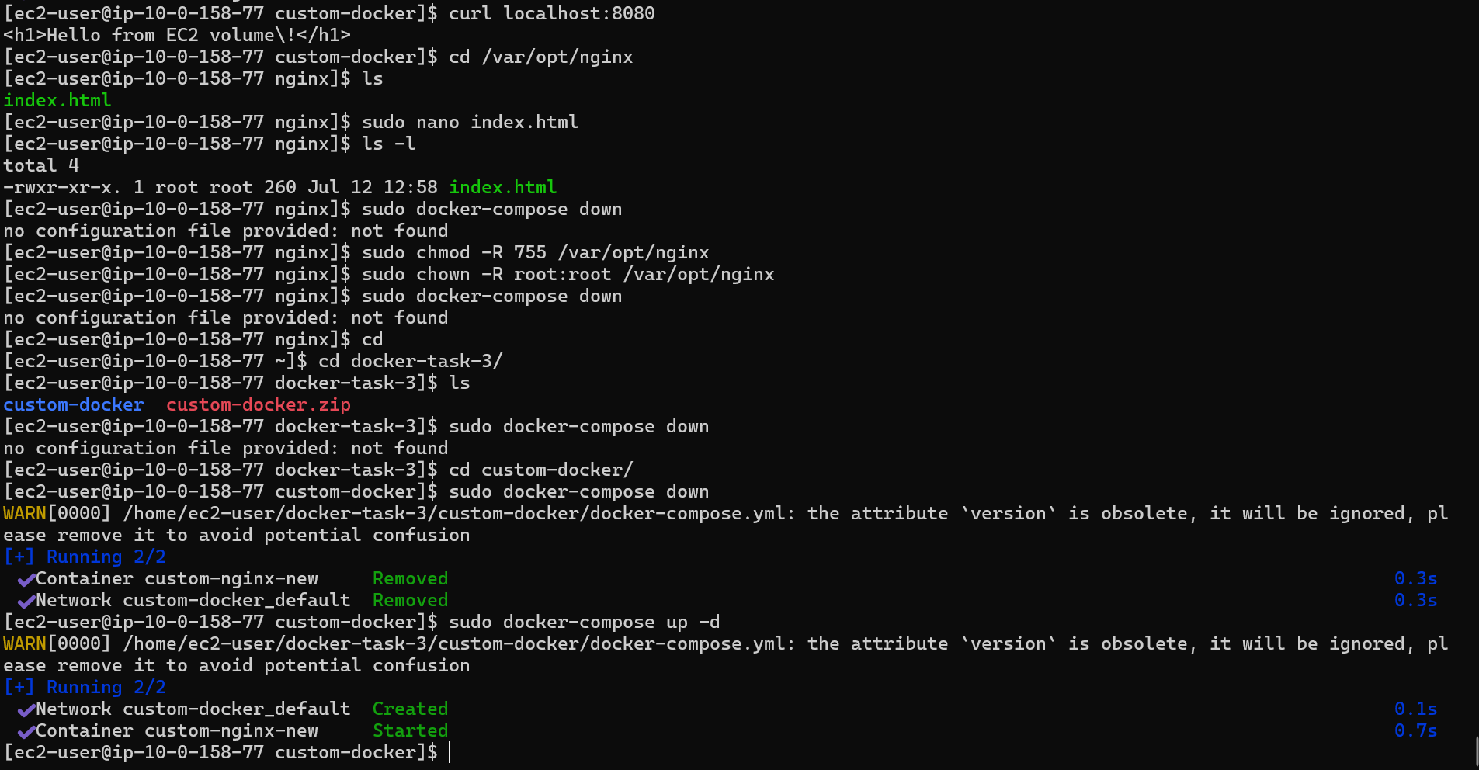

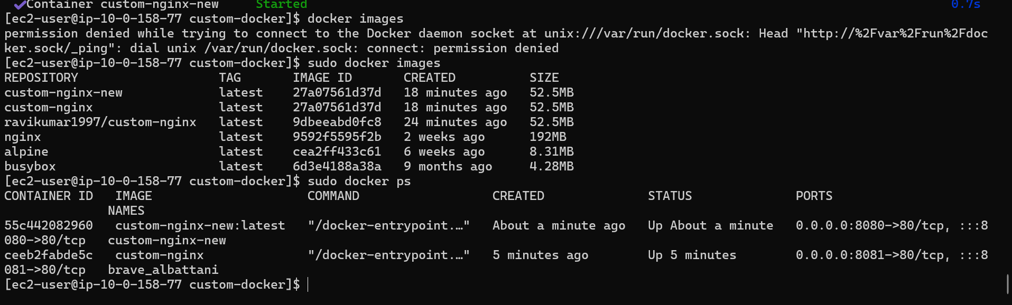

Here the custom volume bind is done at /var/opt/nginx

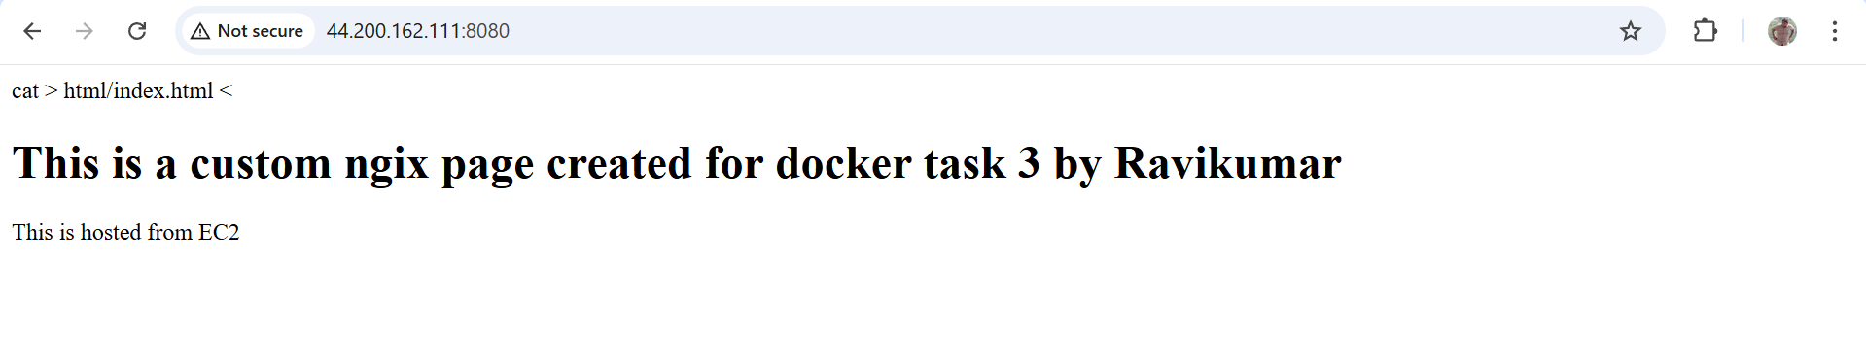

Pushing to docker hub

