How the copilot is helping us to summarize the PR

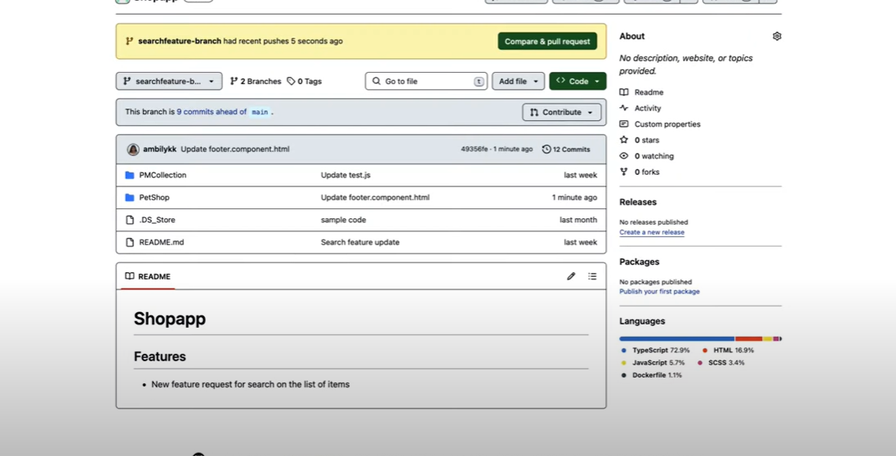

On Implementing functionality or bug fixes the development may have changed the source code file or multiple files for multiple times (multiple commit to future branch of the Repo)

Once the Future branch is ready for implementation after the modification and SDLC process of a change request (Jira or change request) to the production, PULL REQUEST is raised to merge the code to main branch.

During this process it is very difficult to maintain the details of the PR changes , commit history and the files changed for diiferent bugs or iterations. Even the development maintain comments it is very minimal and may not be suffiecient enough to look at the holistic changes and the summary

PR Changes may have multiple commits of a file or different files to future branch at different time

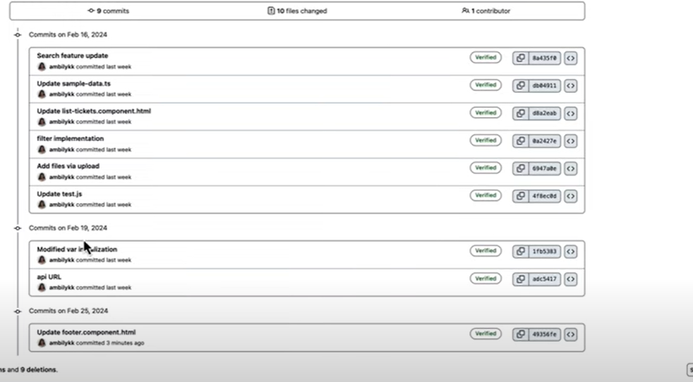

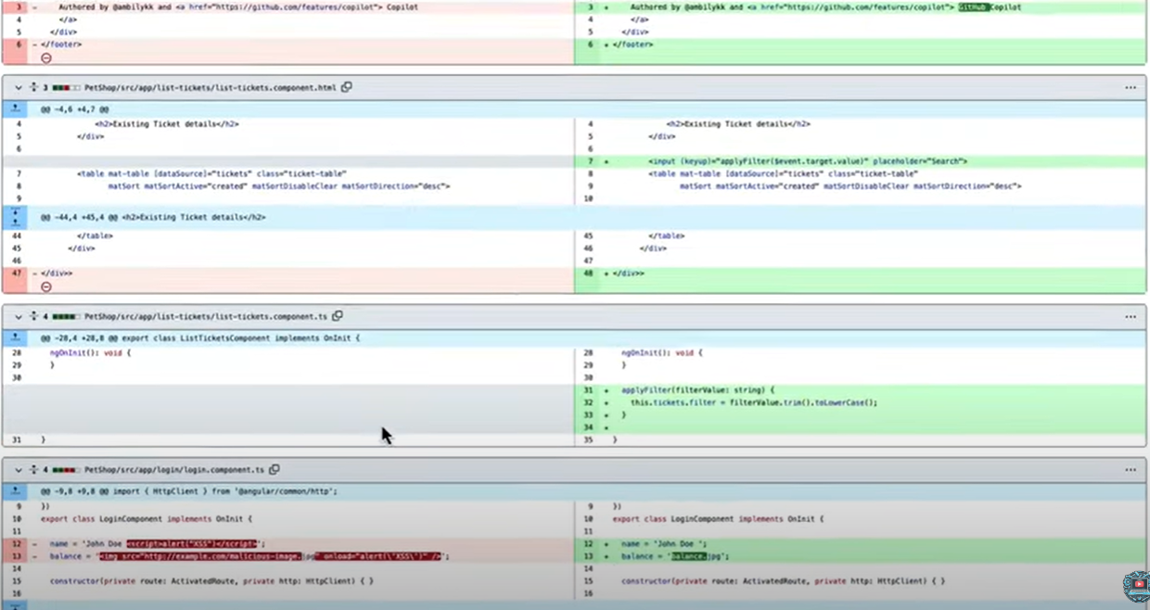

Copilot provide a feature that is essential to overcome the above challenges

Copilot action button as highlighted below and this feature is available for enterprise customers.

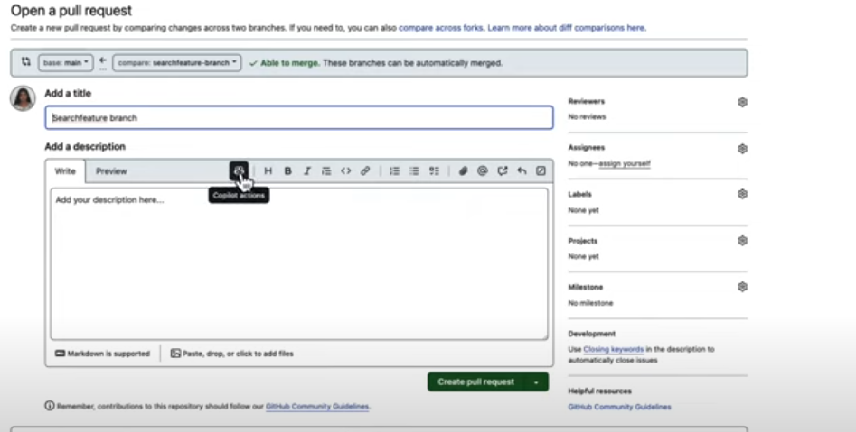



**Advantages:**

This feature provide the description of Pull request and is helpful to understand what kind of changes is done against which file

This feature list down the files and summary of changes.

Preview of changes provides the description of changes under different category (ex performance tuning, addition of functionality etc). As an example enhancement provide the details at each changes and the functionality

Copilot also added summary on top which is the summary of all the changes

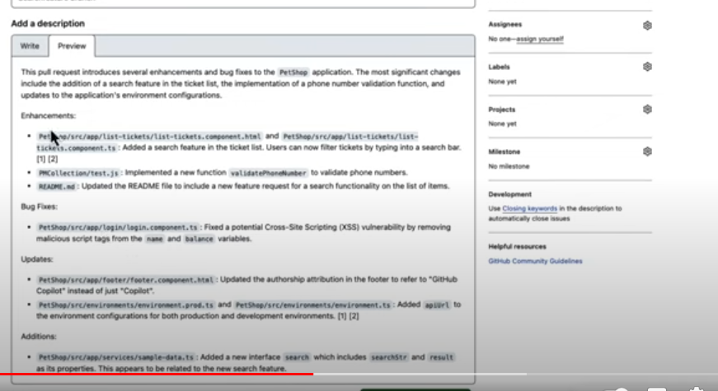

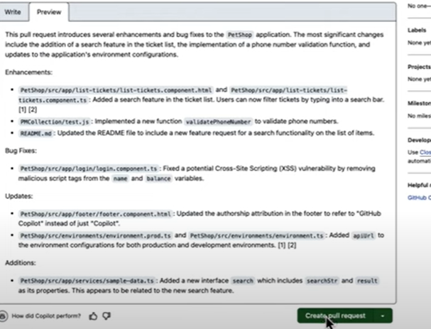

Copilot also provide the difference between two versions a file in description

