**Queries-1**

1. **Find out the SELLING COST AVERAGE for the packages developed in PASCAL?**

SELECT AVG (SCOST) FROM SOFTWARE WHERE DEV_IN LIKE 'PASCAL';

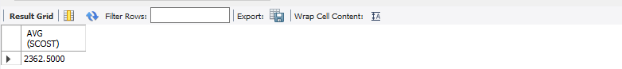

1. **Display the names and ages of all programmers.**

select name,floor(DATEDIFF(curdate(),dob)/365) as age from programmer;

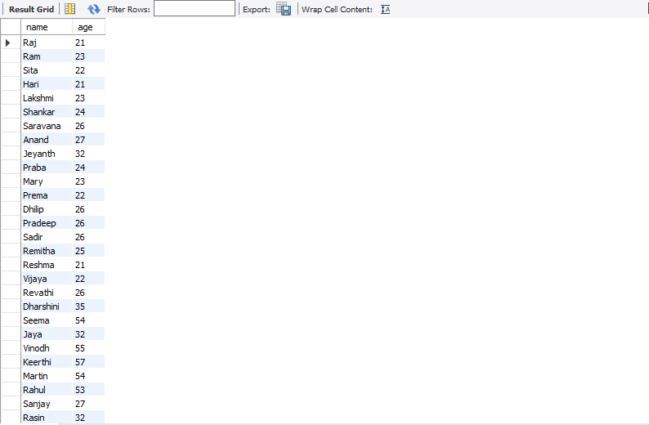

**3) Display the names and ages of all the programmers who have undergone training in DCS course.**

1. **What is the highest numbers of copies sold by a package?**

select max(sold) from software;

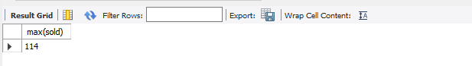

1. **Display the names and date of birth of all the programmer born in JANUARY.**

select dob,name from programmer where month(dob)=1;

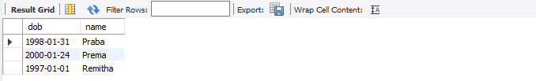

1. **Display lowest course fee.**

select min(ccost) from Studies;

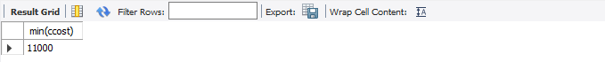

1. **How many programmer has done PGDCA course.**

select count(course) from Studies where course='Pgdca';

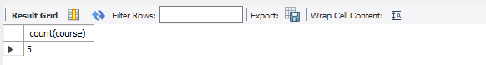

1. **How much revenue has been earned through sales of packages in C.**

select sum(sold*scost) from software where dev_in='c';

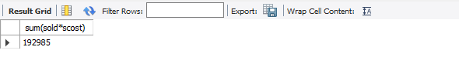

1. **Display the details of software developed by Ramesh?**

select * from software where name='Ramesh';

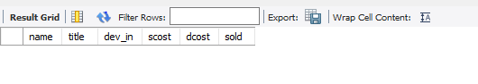

1. **How many programmers studied at SABHARI.**

select count(name) as noprogrammers from studies where splace='sabhari';

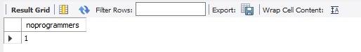

1. **Display the details of PACKAGES whose sales crossed the 20000 mark.**

select * from software where (sold*scost)>20000;

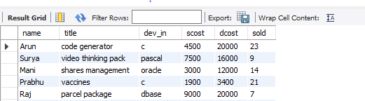

1. **Find out the number of copies which should be sold in order to recover the development cost of each package.**

select name,round(dcost/scost) from software where scost*sold;

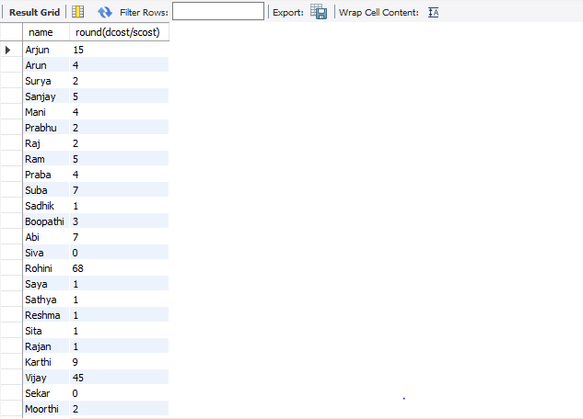

1. **What is the price of the costliest software developed in BASIC?**

select max(scost) from software where dev_in='basic';

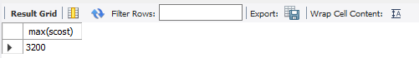

1. **Display the details of packages for which development cost has been recovered.**

select *from software where (sold*scost)>dcost;

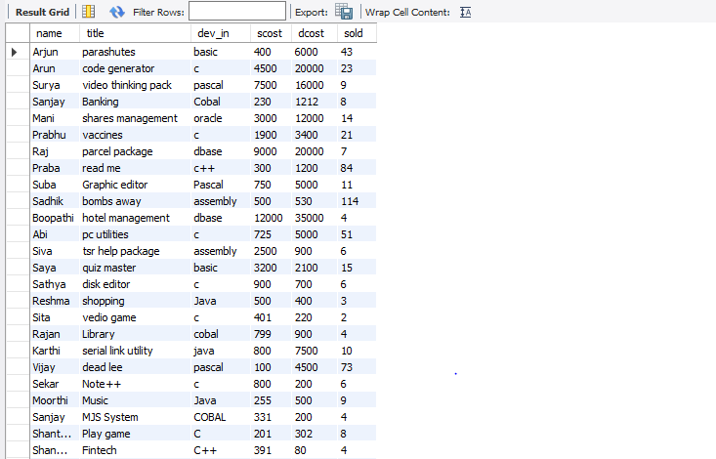

1. **How many packages were developed in dbase?**

select count(title) as total from software where dev_in='dbase';

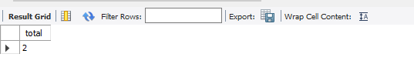

1. **How many programmers studies at paragathi?**

select count(name) as splace_from_pragathi from studies where splace='Pragathi';

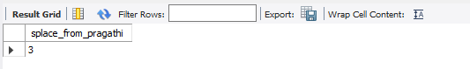

1. **How many programmers paid 5000 to 10000 for their course?**

select count(name) as no_of_programmers from studies where ccost>=5000 and ccost<=10000;

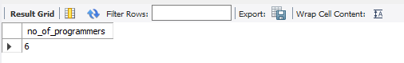

1. **What is the average course fee?**

select round(avg (ccost)) as averagecost from studies;

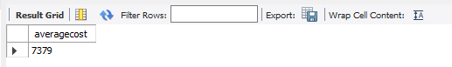

1. **Display the details of programmers knowing c?**

select * from programmer where prof1='c' or prof2='c';

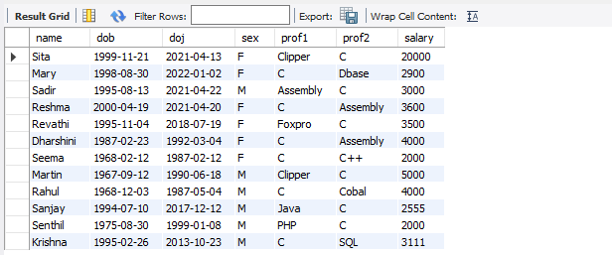

1. **How many programmers know either Cobol or Pascal?**

select count(name) as programmers from programmer where prof1 in ('cobol' ,'pascal' ) or prof2 in ('cobol' ,'pascal' );

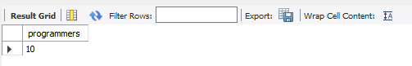

1. **How many programmers don't know Pascal & C?**

select count(name) as programmers from programmer where prof1 not in ('c','pascal') and prof2 not in ('c','pascal');

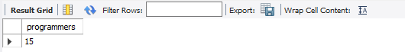

1. **How old is the oldest male programmers?**

select max(floor(DATEDIFF(CURDATE(),dob)/365)) as oldest_male from programmer where sex = 'M';

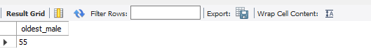

1. **What is the average age of female programmers?**

select floor(avg ((datediff(curdate(),dob)/365))) as average_female from programmer where sex = 'F';

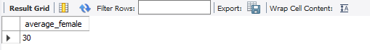

1. **Calculate the experience in years for each programmers and display along with the names in descending order?**

select name, floor (datediff(curdate(),doj)/365) as experience from programmer order by name desc;

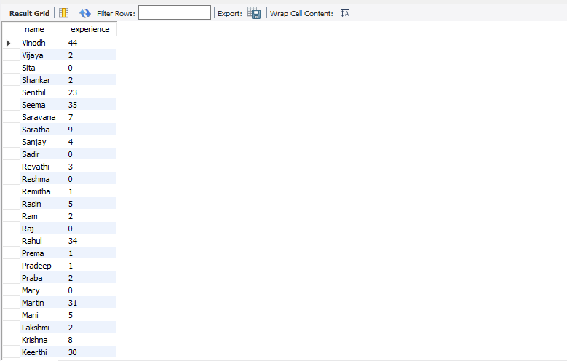

1. **Who are the programmers who celebrate their birthday during the current month?**

select name as birthday_current_month from programmer where month(dob)=month(current_date());

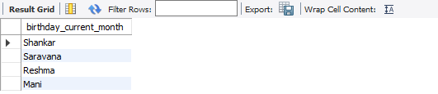

1. **How many female programmers are there?**

select count(name) female_prog from programmer where sex='f';

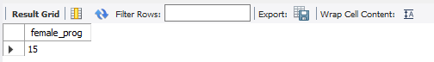

1. **What are the languages known by the male programmers?**

select distinct prof1 languages from programmer where sex='m' union select distinct prof2 from programmer where sex='m';

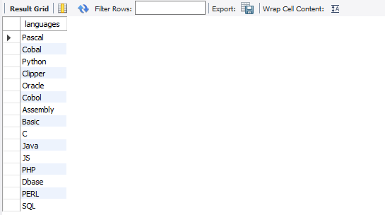

1. **What is the Average salary?**

select avg (salary) as avgsal from programmer;

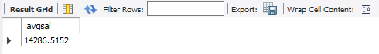

1. **How many people draw 2000 to 4000?**

select name from programmer where salary between 2000 and 4000;

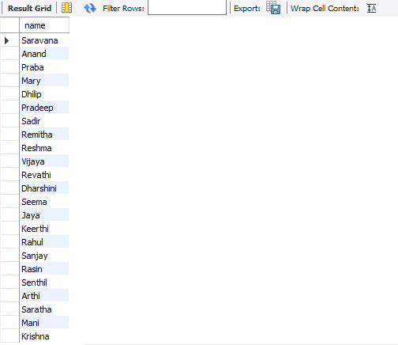

1. **Display the details of those who don't know Clipper, Cobol or Pascal?**

select * from programmer where prof1 not in ('clipper','cobol','pascal') and prof2 not in ('clipper','cobol','pascal');

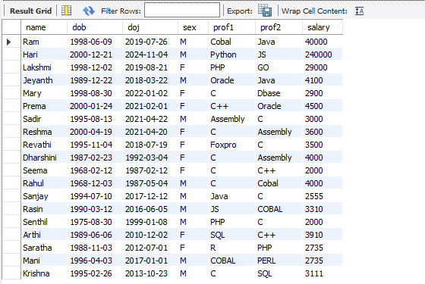

1. **How many Female programmers knowing C are above 24 years of age?**

select count(name) as Female_above_24 from programmer where sex='f' and (prof1='c' or prof2='c') and (datediff(curdate(),dob)/365) > 24;

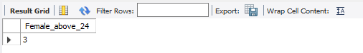

1. **Who are the programmers who will be celebrating their Birthday within a week?**

select name from programmer where week(dob) = week(curdate());

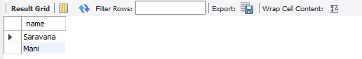

1. **Display the details of those with less than a year's experience?**

select * from programmer where (datediff(curdate(),doj)/365)<1;

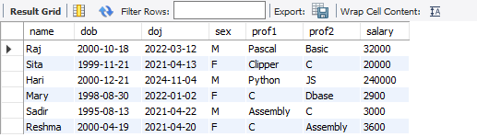

1. **Display the details of those who will be completing 2 years of service this year?**

select name from programmer where floor(datediff(curdate(),doj)/365)=2;

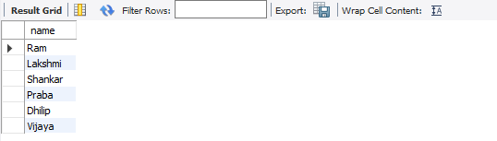

1. **Calculate the amount to be recovered for those packages whose development cost has not been recovered?**

select (dcost-(scost*sold)) as amount_to_be_recovered, title from software where (scost*sold)<dcost;

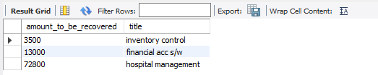

1. **List the packages which have not been sold so far?**

select title software from software where sold=0;

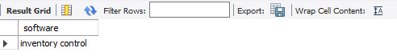

1. **Find out the cost of the software developed by Moorthi?**

select title, scost as softcost from software where name='mary';

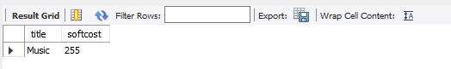

1. **Display the institute’s names from the studies table without duplicates?**

select distinct splace from Studies;

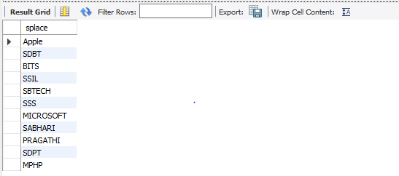

1. **How many different courses are mentioned in the studies table?**

select distinct course from studies;

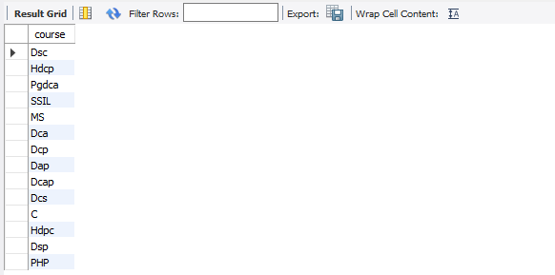

1. **Display the names of the programmers whose names contain 2 occurrences of the letter A?**

select name from programmer where name like '%a%a%';

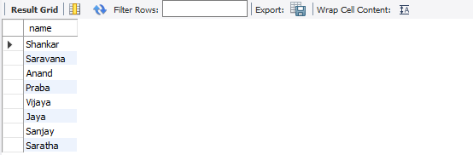

1. **Display the names of programmers whose names contain unto 5 characters?**

select name from programmer where length(name)=5;

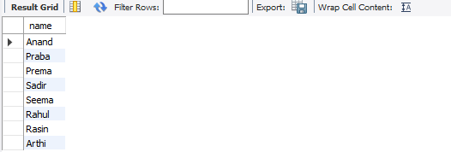

1. **How many female programmers knowing COBOL have more than 2 years experience?**

select name from programmer where floor(datediff(curdate(),doj)/365)<2 and sex='f' and (prof1='Cobol' or prof2='Cobol');

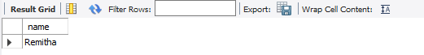

1. **What is the length of the shortest name in the programmer table?**

select min(length(name)) as smallest_name from programmer;

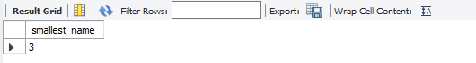

1. **What is the average development cost of a package developed in COBOL?**

select avg(dcost) avgerage_decost from software where dev_in='cobol';

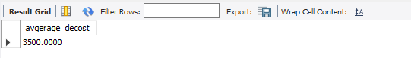

1. **Display the name, sex, dob (DD/MM/YY format), doj for all the programmers without using conversion function?**

select name, sex ,dob,doj from programmer;

1. **Who are the programmers who were born on the last day of the month?**

select name from programmer where last_day(dob) = dob;

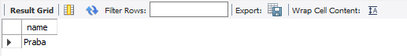

1. **What is the amount paid in salaries of the male programmers who do not know Cobol?**

select salary from programmer where sex='m' and (prof1!='cobol' or prof2!='cobol');

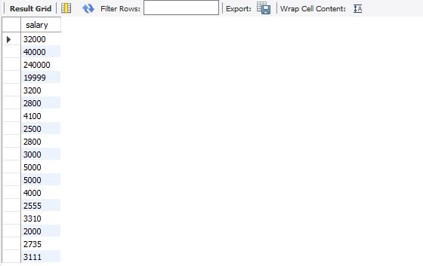

1. **Display the title, scost, dcost and difference between scost and dcost in descending order of difference?**

select title, scost, dcost, dcost -scost diff from software order by 4 desc;

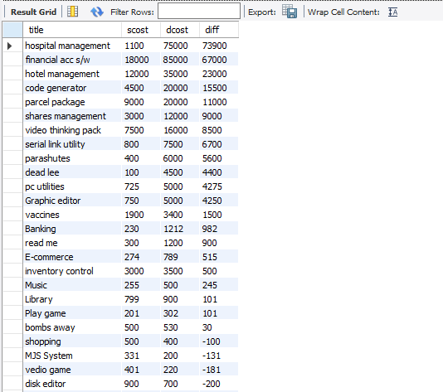

1. **Display the name, dob, doj of those month of birth and month of joining are same?**

select name from programmer where month(dob)=month(doj);

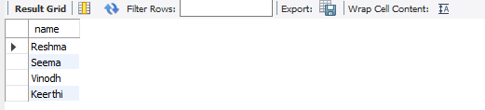

1. **Display the names of the packages whose names contain more than 1 word?**

select title from software where title like '% %';

