**Queries - 2**

1. **Display THE NUMBER OF packages developed in EACH language.**

select dev_in language,count(title) no_of_pack from software group by dev_in;

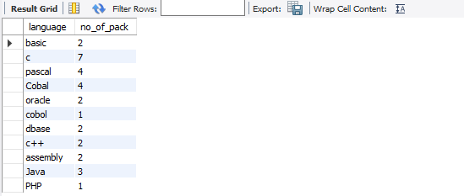

1. **Display THE NUMBER OF packages developed by EACH person.**

select name,count(title) no_of_pack from software group by name;

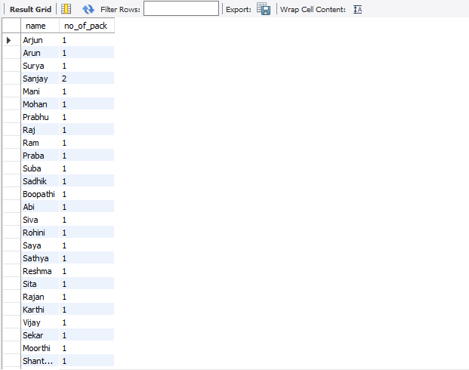

1. **Display THE NUMBER OF male and female programmer.**

select sex,count(name) from programmer group by sex;

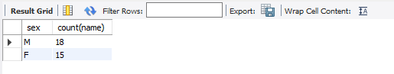

1. **Display THE COSTLIEST packages and HIGEST selling developed in EACH language.**

select dev_in,max(scost),max(sold) from software group by dev_in;

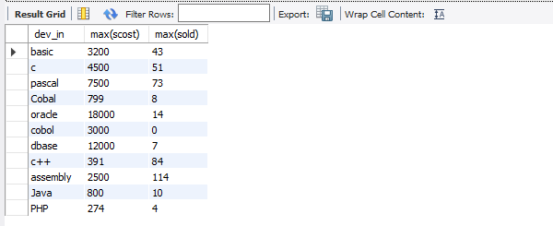

1. **Display THE NUMBER OF people BORN in EACH YEAR.**

select year(dob) as year,count(name) from programmer group by year(dob);

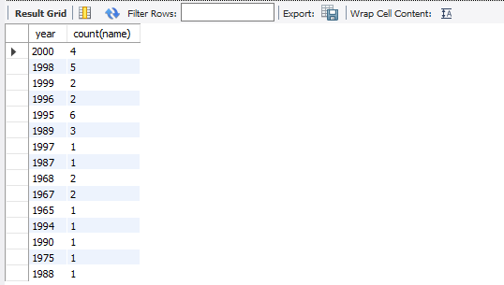

1. **Display THE NUMBER OF people JOINED in EACH YEAR.**

select year(doj) as year,count(name) from programmer group by year(doj);

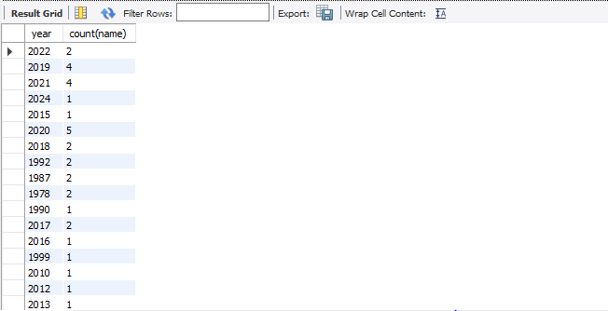

1. **Display THE NUMBER OF people BORN in EACH MONTH.**

select monthname(dob) as Month_People_Born ,count(name) from programmer group by month(dob);

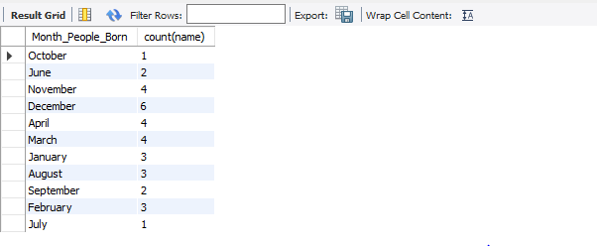

1. **Display THE NUMBER OF people JOINED in EACH MONTH.**

select monthname(doj) as Month_Of_Join,count(name) from programmer group by month(doj);

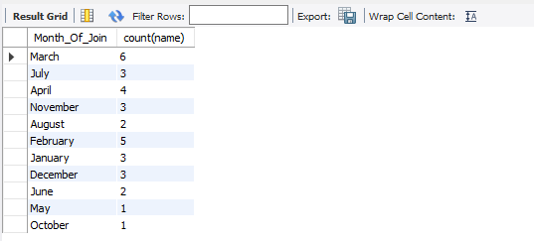

1. **Display the language wise COUNTS of prof1.**

select prof1, count(prof1) from programmer group by prof1;

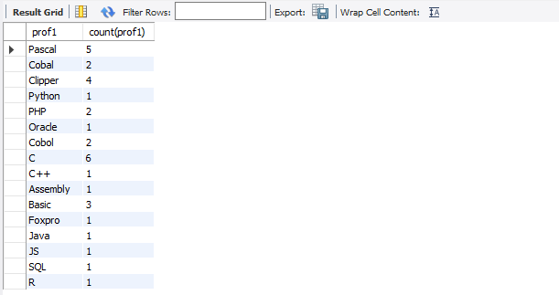

1. **Display the language wise COUNTS of prof2.**

select prof2, count(prof2) from programmer group by prof2;

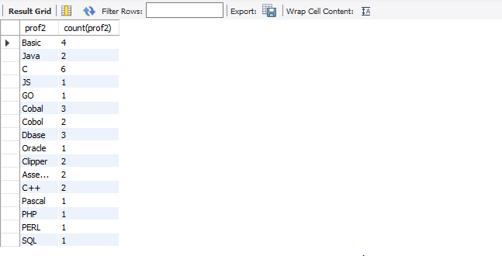

1. **Display THE NUMBER OF people in EACH salary group.**

select salary,count(name) from programmer group by salary;

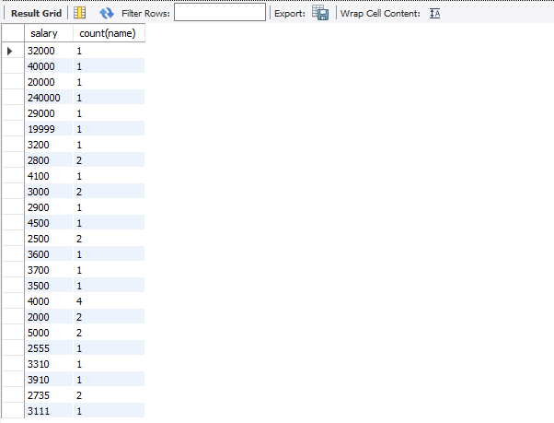

1. **Display THE NUMBER OF people who studied in EACH institute.**

select splace,count(name) from studies group by splace;

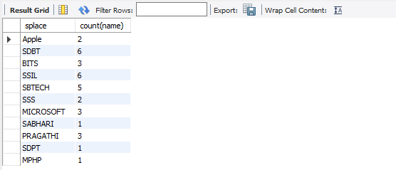

1. **Display THE NUMBER OF people who studied in EACH course.**

select course ,count(name) from studies group by course;

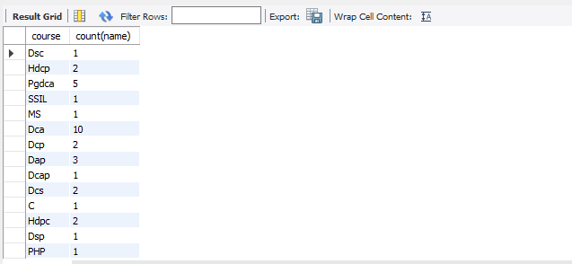

1. **Display the TOTAL development COST of the packages developed in EACH language.**

select dev_in lang,sum(dcost) total_cost from software group by dev_in;

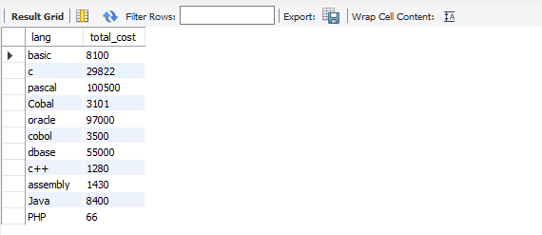

1. **Display the selling cost of the package developed in EACH language.**

select dev_in ,sum(scost) from software group by dev_in;

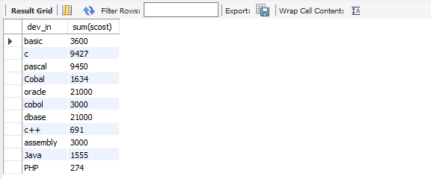

1. **Display the cost of the package developed by EACH programmer.**

select name,sum(dcost) as total_cost from software group by name;

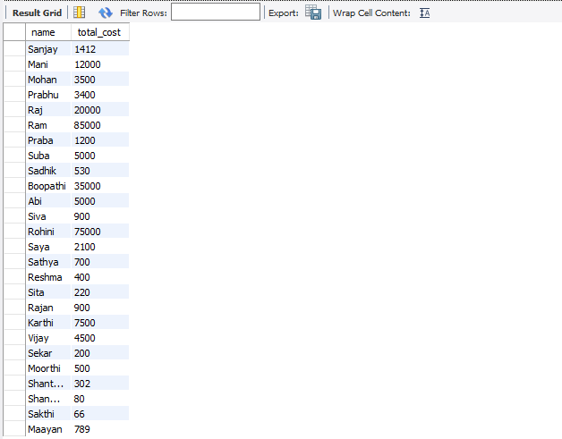

1. **Display the sales values of the package developed inEACH programmer.**

select name, sum(scost*sold) from software group by name;

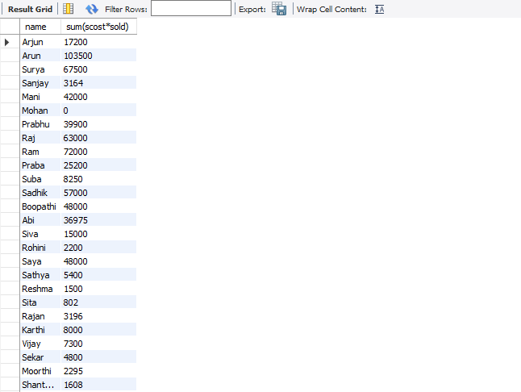

1. **Display the NUMBER of packages developed by EACH programmer.**

select name,count(title) as total_pack from software group by name;

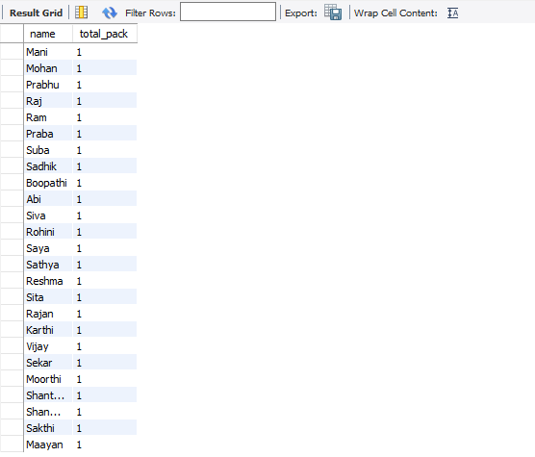

1. **Display the sales COST of packages developed by EACH programmer language wise.**

select dev_in, sum(scost) from software group by dev_in;

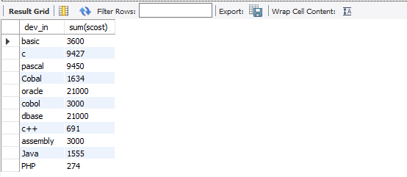

1. **Display EACH programmers name, costliest package and cheapest packages developed by Him/Her.**

select name,min(dcost),max(dcost) from software group by name;

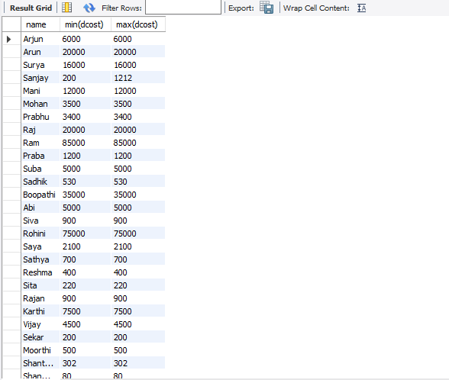

1. **Display EACH language name with AVERAGE development cost, AVERAGE cost, selling cost and AVERAGE price per copy.**

select dev_in,avg(dcost),avg(scost),avg(scost) from software group by dev_in;

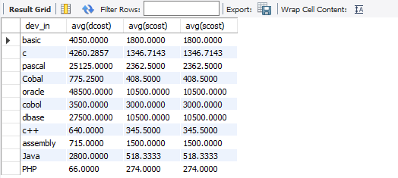

1. **Display EACH institute name with NUMBER of courses, AVERAGE cost per course.**

select splace,count(course), round(avg(ccost),2) from studies group by splace;

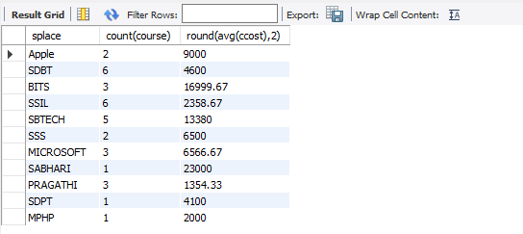

1. **Display EACH institute name with NUMBER of students.**

select splace,count(name) from studies group by splace;

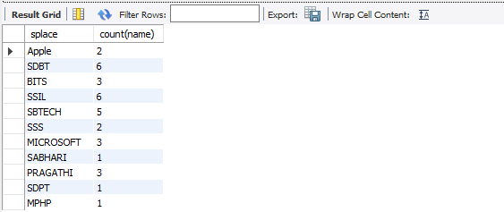

1. **Display names of male and female programmers.**

select name,sex from programmer order by sex;

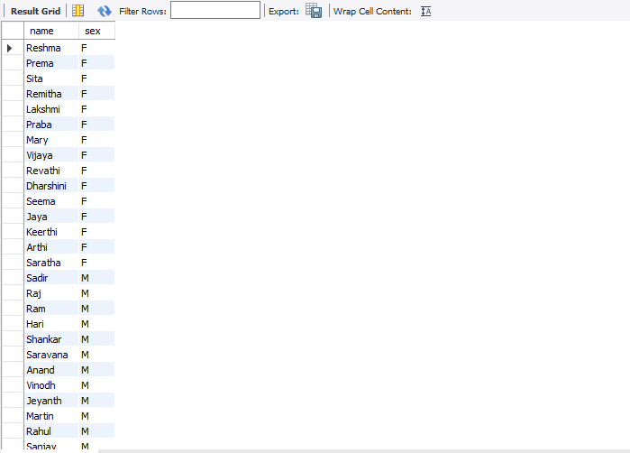

1. **Display the programmer's name and their packages.**

select name,title from software order by name;

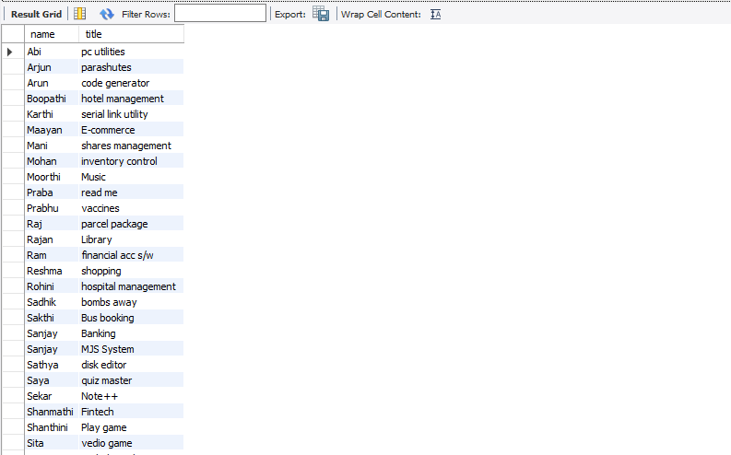

1. **Display the NUMBER of packages in EACH language.**

select count(title),dev_in from software group by dev_in;

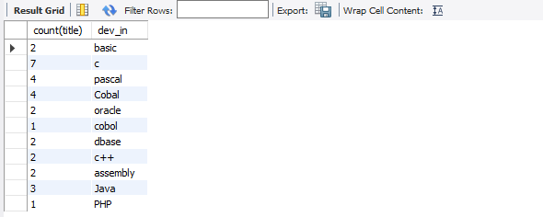

1. **Display the NUMBER of packages in EACH language for which development cost is less than 1000.**

select count(title),dev_in from software where dcost<1000 group by dev_in;

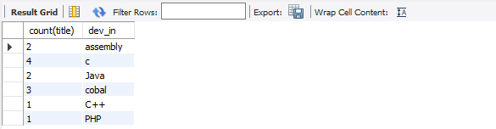

1. **Display the AVERAGE difference BETWEEN scost and dcost for EACH language.**

select dev_in,avg(dcost - scost) from software group by dev_in;

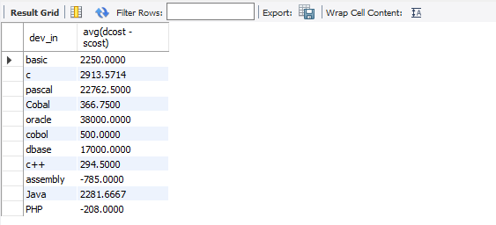

1. **Display the TOTAL scost, dcsot and amount TOBE recovered for EACH programmer for whose dcost HAS NOT YET BEEN recovered.**

select sum(scost), sum(dcost), sum(dcost-(sold*scost)) from software group by name having sum(dcost)>sum(sold*scost);

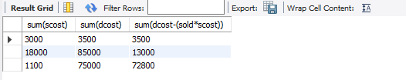

1. **Display highest, lowest and average salaries for THOSE earning MORE than 2000.**

select max(salary), min(salary), round(avg(salary),2) from programmer where salary > 2000;

