**Queries-3**

1. **Who is the highest paid C programmer?**

select * from programmer where salary=(select max(salary) from programmer where prof1='c' or prof2='c');

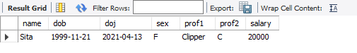

1. **Who is the highest paid female cobol programmer?**

select * from programmer where salary=(select max(salary) from programmer where (prof1='cobol' or prof2='cobol')) and sex='f';

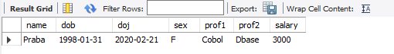

1. **Display the name of the HIGEST paid programmer for EACH language (prof1)**

select distinct name, salary, prof1 from programmer where (salary,prof1) in (select max(salary),prof1 from programmer group by prof1);

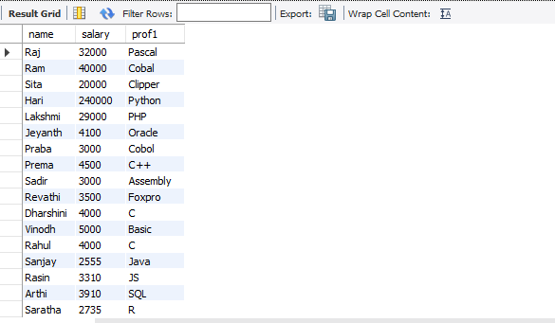

1. **Who is the LEAST experienced programmer?**

select floor(datediff(doj,curdate())/365) exp,name from programmer where floor(datediff(curdate(),doj)/365) = (select min(floor(datediff(curdate(),doj)/365)) from programmer);

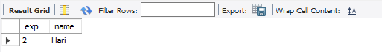

1. **Who is the MOST experienced programmer?**

select floor(datediff(doj,curdate())/365) exp,name,prof1,prof2 from programmer where floor(datediff(doj,curdate())/365) = (select max(floor(datediff(doj,curdate())/365)) from programmer);

1. **Which language is known by ONLY ONE programmer?**

select prof1 from programmer group by prof1 having prof1 not in (select prof2 from programmer) and count(prof1)=1 union select prof2 from programmer group by prof2 having prof2 not in (select prof1 from programmer) and count(prof2)=1;

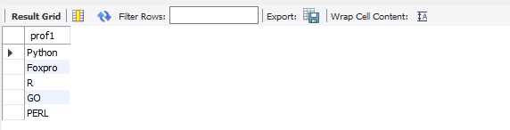

1. **Who is the YONGEST programmer knowing DBASE?**

select floor(datediff(curdate(),dob)/365) age, name, prof1, prof2 from programmer where floor(datediff(curdate(),dob)/365) = (select min(floor(datediff(date-dob)/365)) from programmer where prof1 like 'dbase' or prof2 like 'dbase');

1. **Which institute has MOST NUMBER of students?**

select max(splace) from studies;

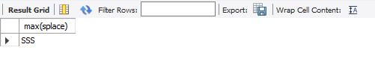

1. **Who is the above programmer?**
2. **Which female programmer earns MORE than 3000/- but DOES NOT know C, C++, Oracle or Dbase?**

select * from programmer where sex = 'f' and salary >3000 and (prof1 not in('c','c++','oracle','dbase') or prof2 not in('c','c++','oracle','dbase'));

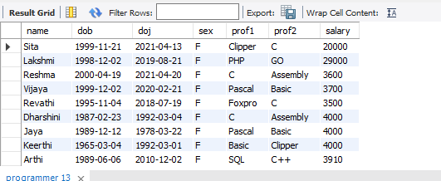

1. **Which is the COSTLIEST course?**

select course from studies where ccost = (select MAX(ccost) from studies);

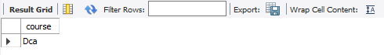

1. **Which course has been done by MOST of the students?**

select course from studies group by course having count(course);

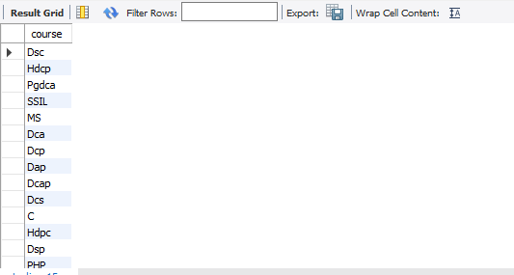

1. **Display name of the institute and course which has below AVERAGE course fee?**

select splace,course from studies where ccost < (select avg(ccost) from studies);

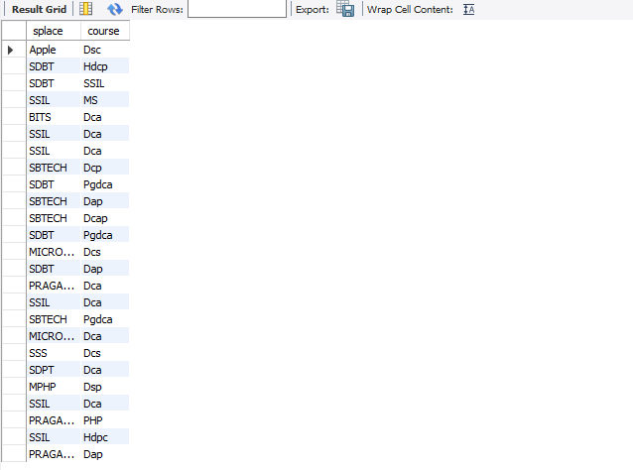

1. **Which institute conducts COSTLIEST course?**

select splace from studies where ccost = (select max(ccost) from studies);

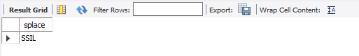

1. **Which course has below AVERAGE number of students?**
2. **Which institute conducts the above course?**
3. **Display names of the course WHOSE fees are within 1000(+ or -) of the AVERAGE fee.**

select course from studies where ccost < (select avg(ccost)+1000 from studies) and ccost > (select avg(ccost)-1000 from studies);

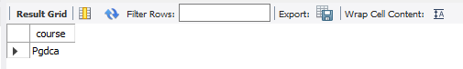

1. **Which package has the HIGEST development cost?**

select title,dcost from software where dcost = (select max(dcost) from software);

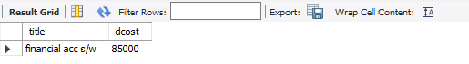

1. **Which package has the LOWEST selling cost?**

select title,scost from software where scost = (select min(scost) from software);

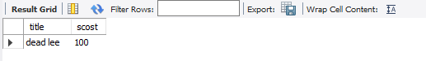

1. **Who developed the package, which has sold the LEAST number of copies?**

select name,sold from software where sold = (select min(sold) from software);

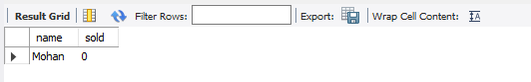

1. **Which language was used to develop the package WHICH has the HIGEST sales amount?**

select dev_in,scost from software where scost = (select max(scost) from software);

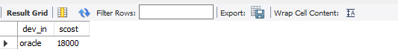

1. **How many copies of the package that has the LEAST DIFFRENCE between development and selling cost were sold?**

select sold,title from software where title = (select title from software where (dcost-scost)=(select min(dcost-scost) from software));

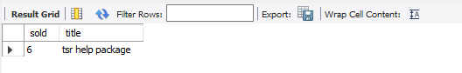

1. **Which is the COSTLIEAST package developed in PASCAL?**

select title from software where dcost = (select max(dcost) from software where dev_in like 'pascal');

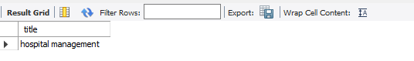

1. **Which language was used to develop the MOST NUMBER of package?**

select dev_in from software group by dev_in having max(dev_in) = (select max(dev_in) from software);

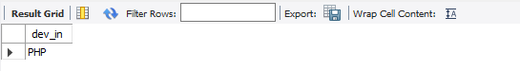

1. **Which programmer has developed the HIGEST NUMBER of package?**

select name from software group by name having max(name) = (select max(name) from software);

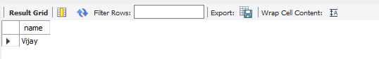

1. **Who is the author of the COSTLIEST package?**

select name,dcost from software where dcost = (select max(dcost) from software);

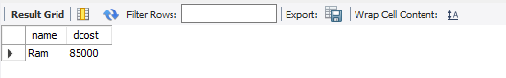

1. **Display names of packages WHICH have been sold LESS THAN the AVERAGE number of copies?**

select title from software where sold < (select avg(sold) from software);

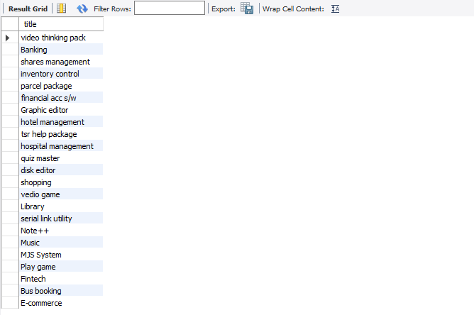

1. **Who are the female programmers earning MORE than the HIGEST paid male programmers?**

select name from programmer where sex = 'f' and salary > (select(max(salary)) from programmer where sex = 'm');

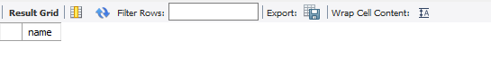

1. **Which language has been stated as prof1 by MOST of the programmers?**

select prof1 from programmer group by prof1 having prof1 = (select max(prof1) from programmer);

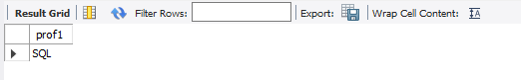

1. **Who are the authors of packages, WHICH have recovered MORE THAN double the development cost?**

select name from software where sold*scost > 2*dcost;

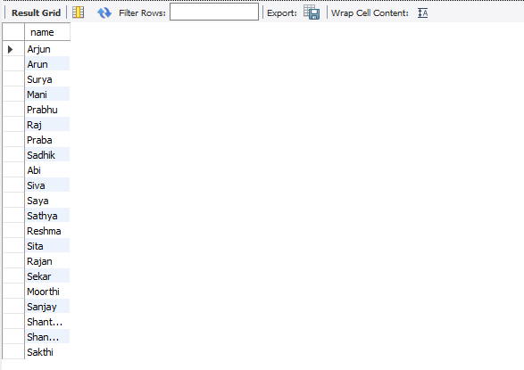

1. **Display programmer names and CHEAPEST package developed by them in EACH language?**

select name,title from software where dcost in (select min(dcost) from software group by dev_in);

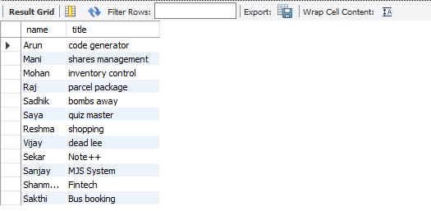

1. **Who is the YOUNGEST male programmer born in 1965?**

select name from programmer where dob=(select (max(dob)) from programmer where year(dob) ='1965');

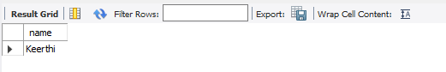

1. **Display language used by EACH programmer to develop the HIGEST selling and LOWEST selling package.**

select name, dev_in from software where sold in (select max(sold) from software group by name) union select name, dev_in from software where sold in (select min(sold) from software group by name);

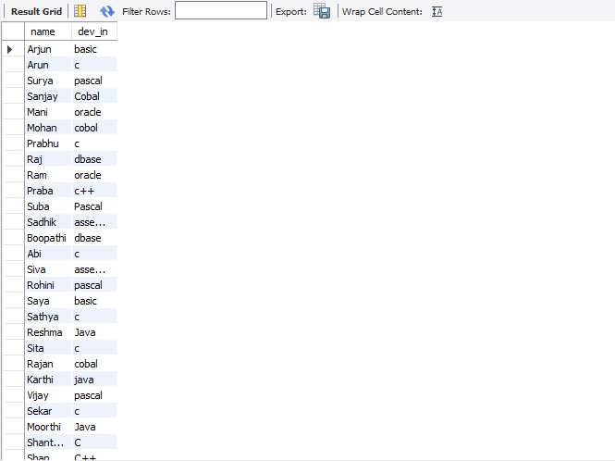

1. **Who is the OLDEST female programmer WHO joined in 1992 ?**

select name from programmer where doj=(select (min(doj)) from programmer where year(doj)=1992);

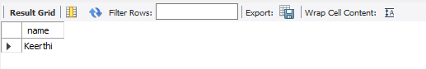

1. **In WHICH year where the MOST NUMBER of programmer born?**

select distinct year(dob) from programmer where year(doj) = (select min(year(doj)) from programmer);

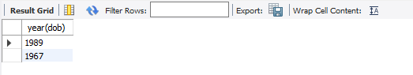

1. **In WHICH month did MOST NUMBRER of programmer join?**

select distinct month(doj) from programmer where month(doj) = (select max(month(doj)) from programmer);

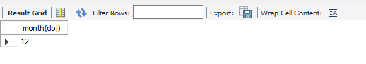

1. **In WHICH language are MOST of the programmer's proficient?**

select max(prof1)as highest_no_of_proficient_language from programmer;

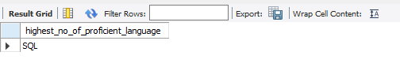

1. **Who are the male programmers earning BELOW the AVERAGE salary of female programmers?**

select name from programmer where sex = 'm' and salary < (select(avg(salary))from programmer where sex = 'f');

