Linux
Mainly contains 3 families
RHEL | SUSE | Debian
CentOs, Fedora | OpenSuse | Ubuntu

Linux terminologies

Kernel: It is the brain of the Linux OS responsible for controlling hardware and make it interact with applications.
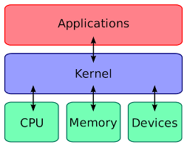

Distribution: Collection of software combined with Linux kernel to make Linux based OS.
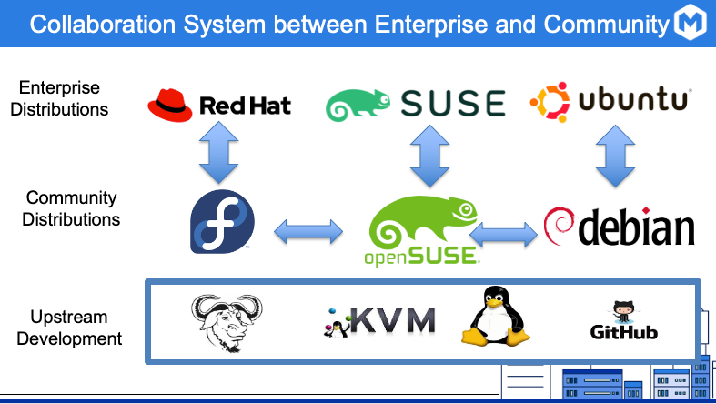
Boot Loader: Program that boots the operating system.
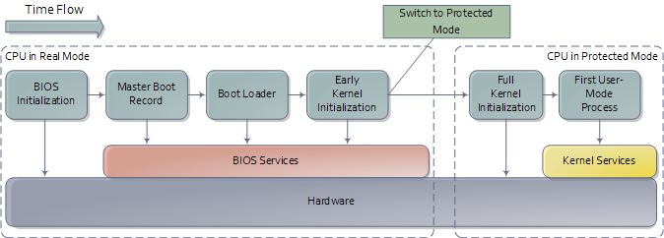
EX: ISO Linux, GRUB

Service: A program that runs in background.
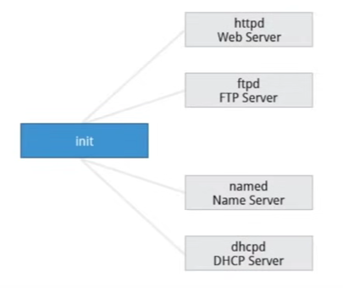

Command line: Interface for typing commands on top of OS.
Shell: CLI that interprets the command line input and instructs the OS to perform tasks or commands.
EX: bash, tcsh, zsh
Partitions: A partition is a contiguous section of a disk
File System: A method of storing or finding files in a file system.

Filesystem Hierarchy Standard (FHS)
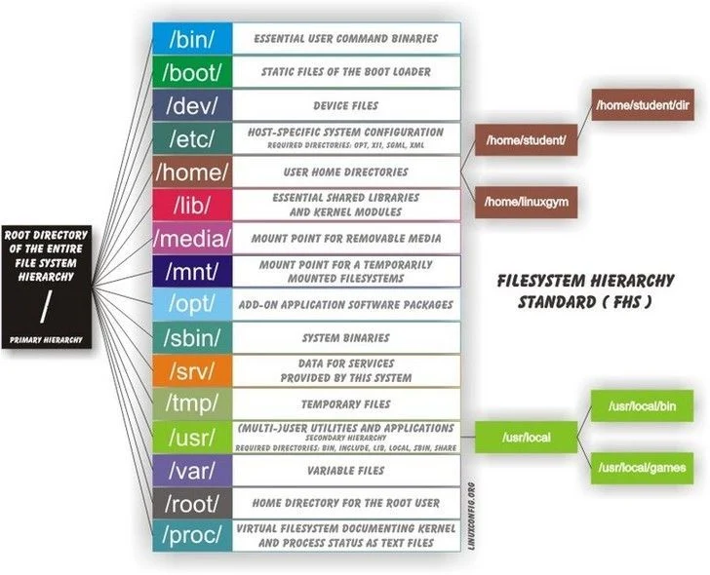

Package management
There are 2 levels of package management
- Low level: unpacking packages
  - Debian: dpkg
  - Red hat, Suse: rpm
- high level: gets group of packages from respective vendors
  - Debian: apt-get (older, stable useful for docker), apt (on top of apt-get)
  - Red hat: yum, dnf for new
  - Suse: zypper
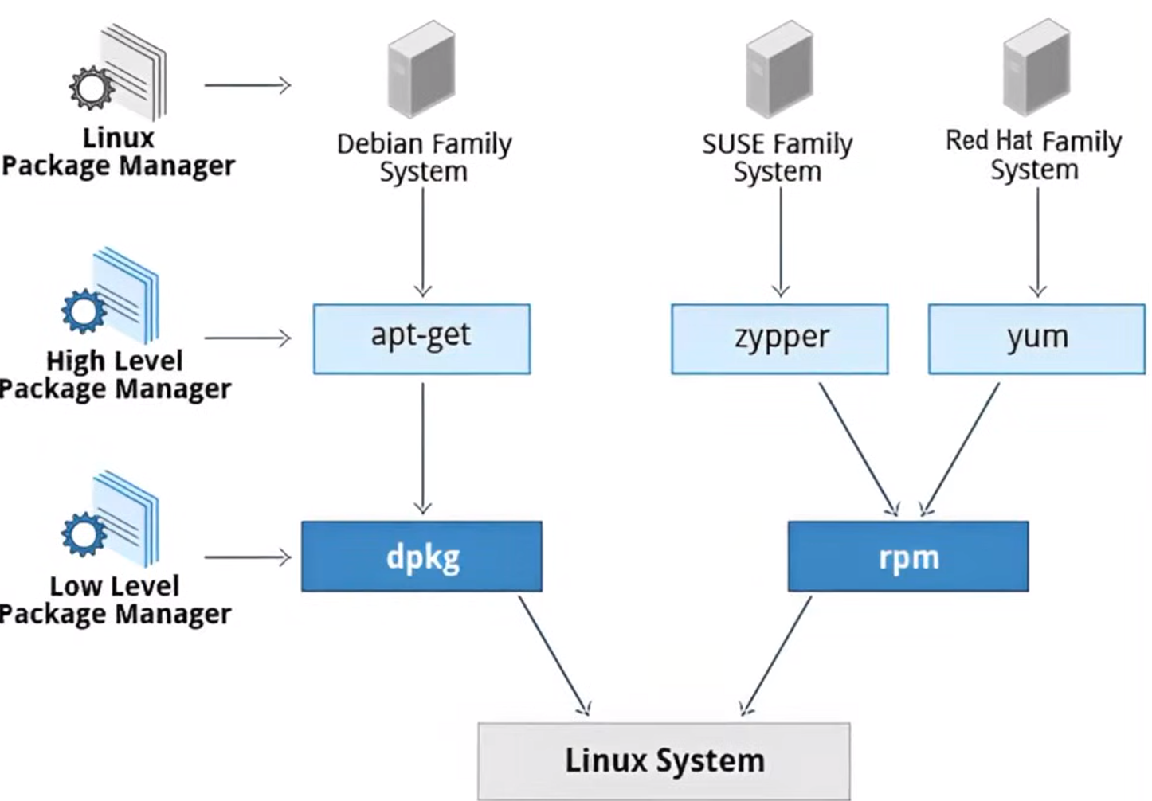

Command Line Interface
command | -options | arguments
ls | -a | /home/ravikumar/

cat: view file content, -n for line numbers, less command for page wise view
head: show first few lines of a file
tail: last few lines
man: used to view documentation
shutdown: to close the computer, -h to halt, -r to reboot, -h 10:00 ‘scheduled maintanace’
which: for looking at executable files
whereis: more detailed version of which
cd: change directory, - previous, ~ home, .. parent
touch: create empty file, -t for timestamp setting
mkdir, rmdir: make or remove directory
rm: remove files or dirs, -rf for recursive remove forcefully (dangerous), use -i for removing interactively
mv: move or rename a file
locate, find: for file searching with wildcards
grep: filter inside file or output stream.
Du: disk usage for any file

