CO2AT1 -R.Bhanu prakash 192325066
Q1.A real estate company collected the following training data:(15Marks -20 Mins)
House No Area (sq.ft) Bedrooms Price (₹ Lakhs)
1 1000 2 50
2 1500 3 75
3 800 2 40
4 1200 3 60
5 2000 4 90
(i) Construct a linear regression model of the form
(ii) Estimate the regression coefficients.
(iii) Interpret the meaning of each coefficient.
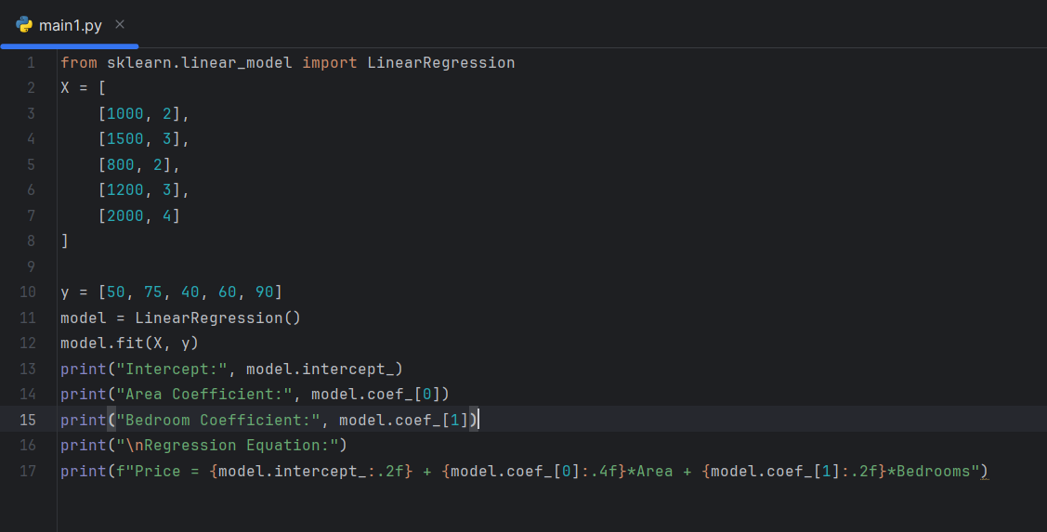
Output:
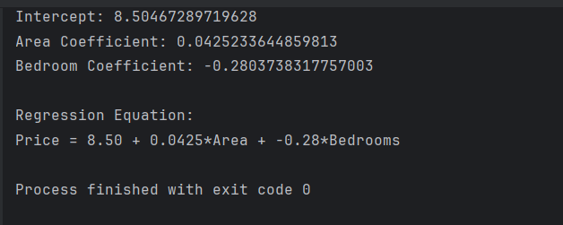
Q2.An email system uses the following feature values:(15Marks -20 Mins)
Email Word Frequency (Offer) Word Frequency (Win) Spam (1/0)
1 3 2 1
2 2 1 1
3 1 0 0
4 3 3 1
5 0 1 0
(i) Construct a linear classification model.
(ii) Determine the decision boundary.
(iii) Classify a new email with: Offer = 2, Win = 1.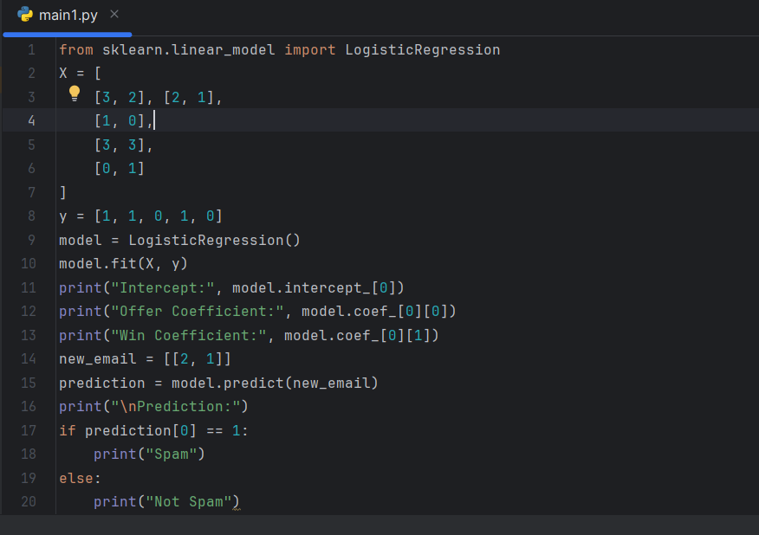
Output:
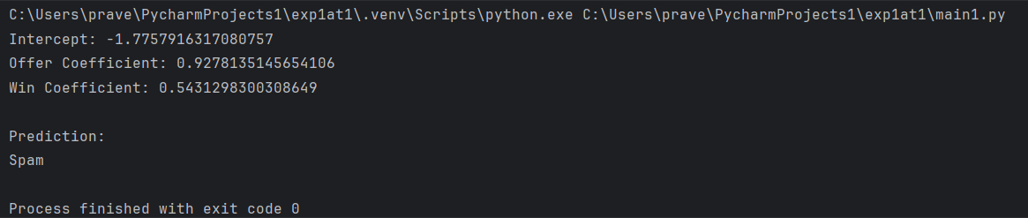
Q3.A medical dataset is given:(15Marks -20 Mins)
Patient Fever (1/0) Headache (1/0) Disease (Yes/No)
1 1 1 Yes
2 1 0 Yes
3 0 1 No
4 1 1 Yes
5 0 0 No
(i) Compute prior probabilities.
(ii) Compute conditional probabilities.
(iii) Estimate the probability that a patient with Fever = 1 and Headache = 0 has the disease.
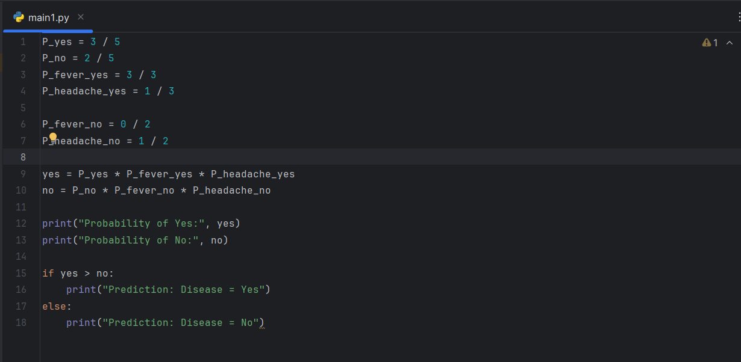
Output:
